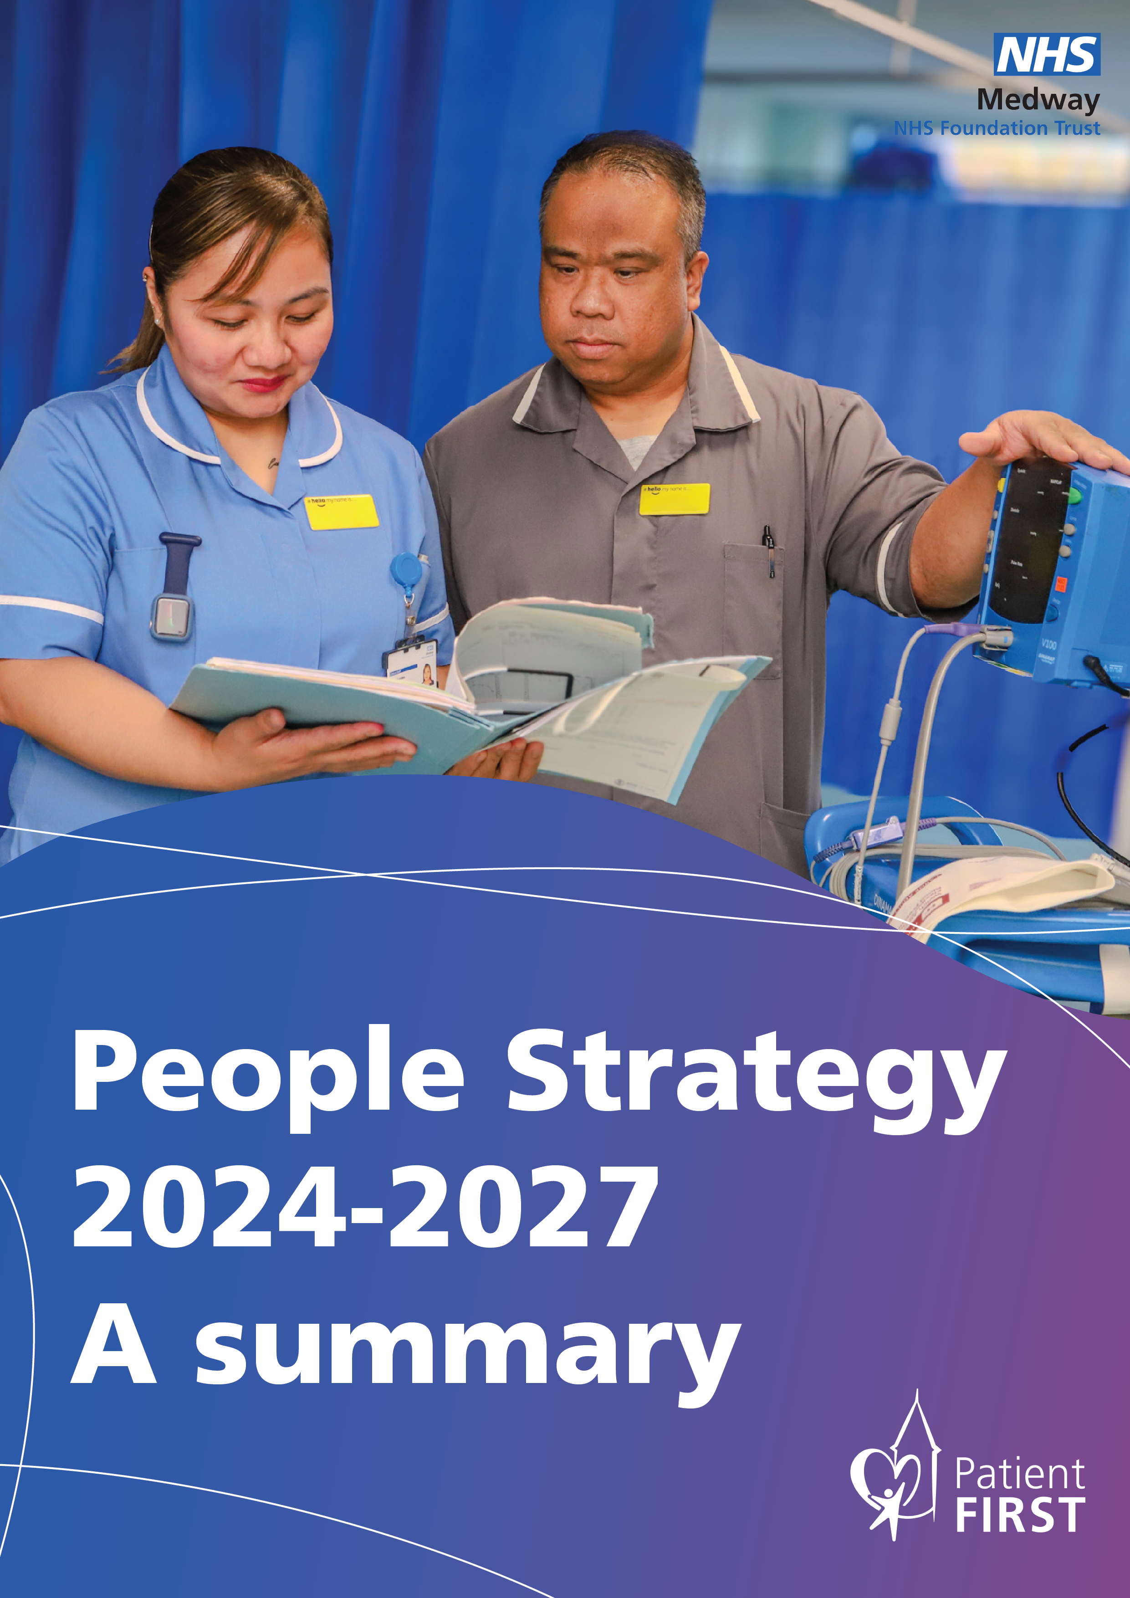

People Strategy 2024 -2027: A summary

Foreword

I am very proud of our People Strategy. This crucial document states loud and clear that we recognise that our people are our greatest asset; without them, we could not deliver quality care to more than 427,000 people across Medway and Swale when they need it most.
We know that the best patient care comes from staff who feel valued and rewarded. We will strengthen and grow our existing networks for inclusivity, which support, represent and empower colleagues; we also focus on how we will improve employee experience, culture and wellbeing, so that more staff choose to stay with us for longer. It is so important that we nurture and develop our staff so that each can reach their full potential.
In developing this Strategy, we spoke to many people about what matters most to them and what we need to do to make sure we have a strong, caring and skilled workforce.
Thank you to all who supported us with this feedback.

Leon Hinton,
Chief People Officer

Introduction

Here at Medway NHS Foundation Trust, we have over 5,000 staff working across clinical and non-clinical roles to deliver healthcare to the people of Medway and Swale. We know that our staff are doing exceptional work, in sometimes difficult circumstances, and they are dedicated to putting our patients at the heart of everything we do. Our workforce has evolved significantly since the publication of our last People Strategy in 2019 and we must ensure our commitment to providing the best of care, through the best of people is reflected in the way we deliver care in the future.
The Trust currently has its main hospital site in Gillingham and an outlier at Sheppey Frailty Unit at Minster Community Hospital on the Isle of Sheppey. We are one of Medway’s largest employers and have an important role to play in creating employment opportunities and careers for residents. The hospital is an anchor institution in terms of the services and products it procures and is an integral part of the community with more than 10,300 residents registered as members of the Trust so that they can receive regular updates and get actively involved in our activities and services. The Trust is configured to provide clinical care over four directorates (Medicine and Emergency Care; Surgery and Anaesthetics; Women Children and Young People; and Cancer and Core Clinical Services) with one non-clinical directorate (Central Operations). NHS Staff Survey results highlight 53.46 per cent of staff would recommend our Trust as a place to work, and we want to increase this to attract a diverse range of people.
Workforce numbers by staffing groups

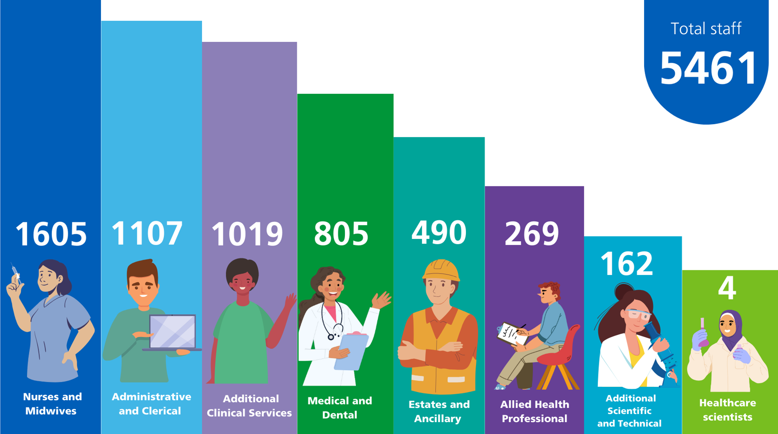

Sex, Ethnic Group and Disability status statistics for the Trust’s workforce

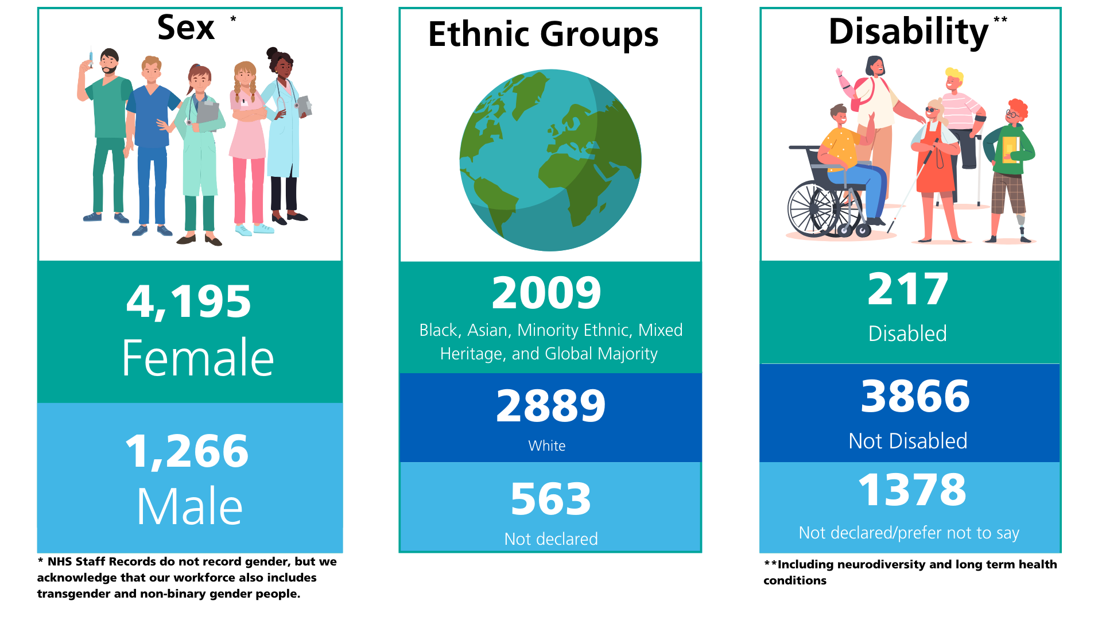
The number of NHS staff has grown over the last 10 years, however healthcare needs have also grown significantly, driven by ageing and increasing morbidity, outstripping the growth in workforce full time equivalent (FTE). As a Trust we understand that we are facing clear and pressing workforce challenges.
While we recruit a large number of staff over various specialist professional groups we experience challenges with attraction and retention of the necessary levels of workforce with appropriate skills required to ensure safe staffing levels and quality of care. This in turn has led to a high reliance on temporary staff to ensure we are providing a safe level of staffing for our patients. We acknowledge that our bank spend is too high, and we are working hard to increase our permanent workforce, using innovative approaches to respond to local and national challenges with hard to recruit posts.
We also understand that people experiencing health inequalities can develop long-term conditions earlier, accumulate them faster and live with them longer. We are committed to delivering the very highest standards of access and care to patients from diverse cultures, different age groups and a range of abilities and needs, ensuring we promote equality and best practice in line with equality and human rights legislation.

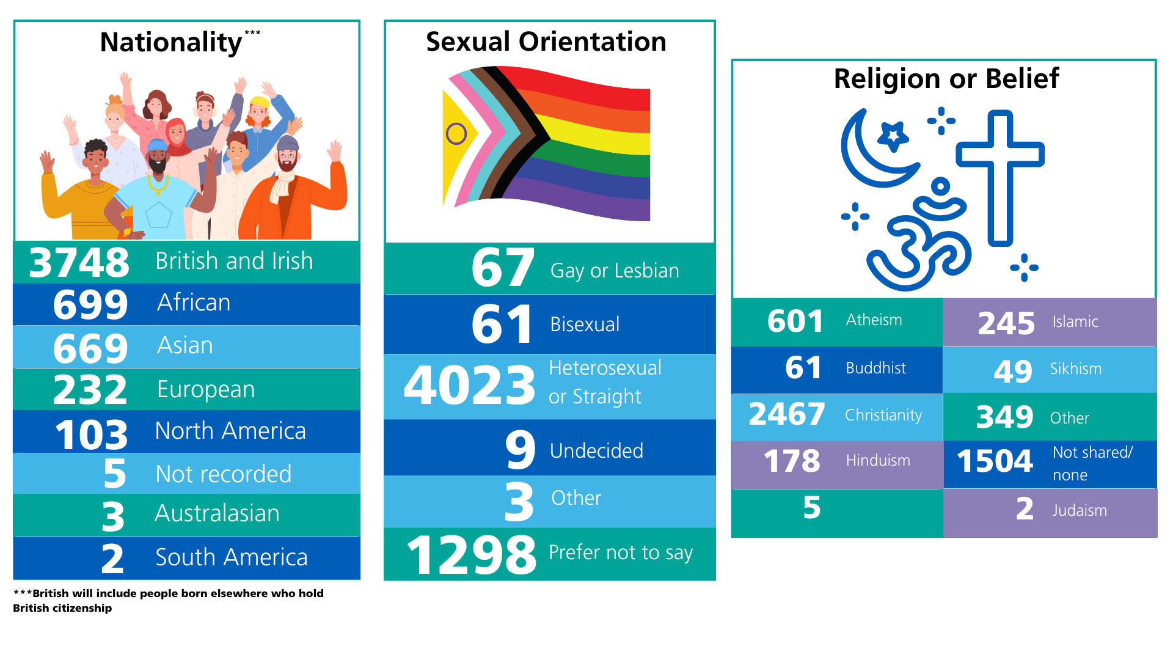
Sexual Orientation, Religion or Belief and Nationality status for the Trust’s workforce

Core Vision and Values

Strategy summary reflecting Trust-wide priorities
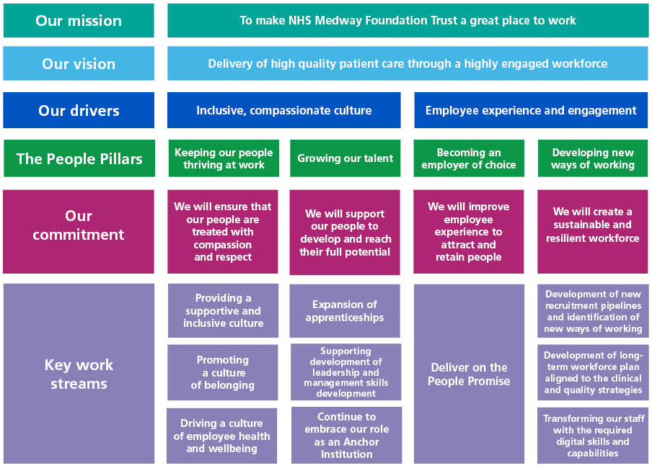
Our values put our patients first and inspire us to be the BEST.
We expect our staff to work to these values in the delivery of safe, consistent and high quality patient care:
- Bold – We are inspiring and ambitious
- Every Person Counts – We are respectful and supportive
- Sharing and Open – We are open and speak up
- Together – We are inclusive and responsible
Our vision for this strategy is the delivery of high quality patient care through a highly engaged workforce, supporting the Trust to be an employer of choice and to recruit and retain the best people. We aim to do this by having a culture of staff–led improvement and innovation. In achieving this vision, the Trust’s staff engagement score, measured through the National Staff Survey, will improve and will be within the top 25 per cent of Trusts nationally.

Under our Patient First Strategy, we have achieved an early objective for 90 per cent of all staff to have a regular appraisal with their line manager including a wellbeing check. This is now understood and embedded. We have since refreshed our priorities and decided to focus on employee experience and how it affects staff turnover in the first 24 months of employment.
As part of this objective, we would like to better understand the reasons why our employees decide to apply for roles within the Trust and what we can do better to improve their experience and retention. We are developing processes to support this objective, including the new ‘Intention to Leave’ process and the renewed focus on ‘Stay Conversations’ and ‘Exit Interviews’.

National and Local Drivers

Our Clinical Strategy highlights our aim to be an employer of choice, ensuring excellent training and support in developing and acquiring new skills for all staff, as well as providing excellent health and wellbeing support to improve retention rates.
The NHS England People Plan, published in July 2020, sets out the main themes for workforce development across the NHS in England. This plan has been considered in developing our direction of travel, agreed pillars and key priorities for the next three to five years, alongside our other Trust strategies
Our People Strategy supports both the NHS England (NHSE) People Plan and the NHS Long Term Workforce Plan.

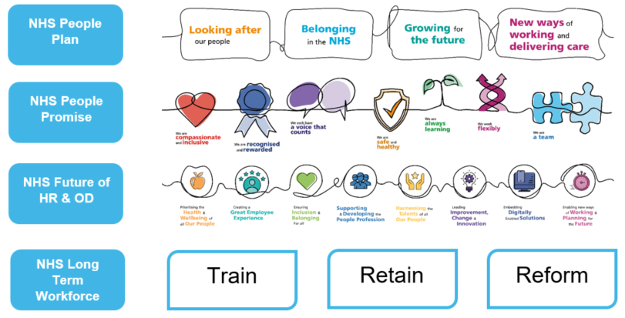
A summary of the key themes and ambitions of the overarching NHS People Strategies.

Mission and Aspirations

Our mission is to improve the experience of the Trust’s workforce, resulting in better engagement, motivation and retention levels. This in turn will increase the quality of care our patients receive and improve their experience while in our care.
Our ways of working, as outlined below, will support us to meet these aspirations:

We will ensure that our people are treated with compassion and respect
Through the development of an inclusive and compassionate culture, where people are treated with dignity and respect and feel that they belong and thrive at work (Pillar 1), employees will experience:
- compassionate and inclusive leadership by leaders who model these behaviours
- motivation to participate in staff surveys to share their feedback and see improvements
- wellbeing support that will be easily accessible and will address employees’ current needs
- access to support and advice to raise concerns at work and confidence that issues are being resolved fairly
- behaviours that are consistent with our Trust values, and confidence that those who do not display these values are challenged.

We will support our people to develop and reach their full potential
By ensuring that all employees have equal access to professional development and career advancement opportunities (Pillar 2), employees will experience:
- new colleagues being fully supported during their first year of employment and as they progress in their career
- appraisal conversations delivering clarity, value and a tailored commitment to professional development
- equal opportunities to access personal development and career progression
- support to acquire new skills, undertake training and achieve relevant qualifications
- talent management processes which offer clarity and facilitate development plans and succession planning.

We will improve employee experience to attract and retain people
By improving the experience of our employees at work (Pillar 3), they will:
- recommend the Trust as an employer of choice to their families and friends
- commit to making improvements in their local areas and engage with staff surveys to provide feedback
- value “Stay Conversations” and use them to improve their experience at work
- experience improved internal Human Resource processes, ensuring colleagues are treated as valued members of staff
- have locally agreed arrangements which offer them an opportunity to work flexibly, reducing reliance on agency and temporary staff and providing staff with an improved work/life balance.

We will create a sustainable and resilient workforce
Through transformation of our workforce and introduction of new types of roles, we will develop a resilient workforce, with a varied and value-adding skill mix (Pillar 4) that will enable employees to:
- feel supported to acquire new skills and qualifications to move into new roles and opportunities
- have opportunities to join and lead on research and innovation projects
- be able to access new ways of working, fully utilising technological opportunities
- see changes to the traditional job roles with new roles and ways of working.

SWOT Analysis

This strategy has been co-designed with our colleagues, trade union representatives and senior management as well as the Trust Board, and engagement will continue with all stakeholder groups.
As part of the Trust’s overarching Clinical Strategy we developed an evidence-based service level report to understand the current position and establish strategic direction and priorities.
The strengths, weaknesses, opportunities and threats (SWOT) analysis provided us with key feedback highlighting concerns around workforce and ensuring a compliant and resilient service, the need to strengthen clinical leadership and improve culture, staff motivation and training opportunities.
From our engagement sessions and research, we identified key themes under the SWOT headings (see below) and we have already started to implement changes arising from this to drive our People Strategy.
Full details of our engagement activity to support this strategy, and other key themes identified in the SWOT exercise, are provided in the full strategy document.

Objectives and Key Results

The four key themes and principles (Pillars) that emerged as priority areas throughout our engagement for our People Strategy over the next three years are highlighted below.
It is important to identify and quantify how we are going to measure our success in delivering our four strategic commitments and the measures we aim to monitor our performance against. Details of how each one will be measured are outlined in the full document.
Pillar 1 – Keeping our people thriving at work.
Our commitment: We will ensure that our people are treated with compassion and respect.
We will deliver this commitment through the following key priorities:
- Providing a supportive and inclusive culture
- Promoting a culture of belonging
- Driving a culture of employee health and wellbeing.

Pillar 2 – Growing our talent.
Our commitment: We will support our people to develop and achieve their full potential.
We will deliver this commitment through the following key priorities:
- Expansion of apprenticeships
- Supporting development of management and leadership skills
- Continuing to embrace our role as an Anchor institution in the local community.

Pillar 3 – Becoming an employer of choice.
Our commitment: We will improve employee experience to attract and retain people.
We will deliver this commitment through the following key priority:
- Delivering on the People Promise

Pillar 4 – Developing new ways of working.
Our commitment: We will create a sustainable and resilient workforce.
We will deliver this commitment through the following key priorities:
- Development of new recruitment pipelines and identification of new opportunities for new ways of working.
- Developing a long-term workforce plan aligned to the clinical and quality strategies.
- Transforming our staff with the required digital skills and capabilities to transform our ability to prevent, diagnose, treat and manage diseases, supporting a shift towards better prevention of disease and more personalised care outside hospital.

Metrics and Key Performance Indicators
For this strategy to be meaningful for our patients, the implementation must be measured on its delivery. A detailed implementation plan will be developed, setting out the key activities, success measures and timescales to achieve our aims and will include a range of people-based data metrics, incorporating staff feedback received through surveys and other engagement methods. The plans will be reviewed and refreshed in parallel with the annual business planning cycle to ensure they remain aligned with the Trust’s vision and emerging priorities.
Key Priorities
Our full Strategy lists our key priorities for the next three years and provides a plan of how we will achieve them. As this is a summary document, the priorities only are listed here; details of three year plans to achieve each one are provided within the full strategy.

Key Priority 1 – Providing supportive and inclusive culture
Objectives:
- Utilise the Strategic Initiative (Leadership behaviours and staff engagement) to drive cultural change.
- Ensure employees and leaders are provided with skills and competencies required to support inclusivity, equality and fairness in their day-to-day roles.

Key Priority 2 – Promoting a culture of employee belonging at work
Objectives:
- Develop employee experience to ensure our people feel welcomed, known, included, supported and connected.

Key Priority 3 – Driving a culture of employee health and wellbeing
Objectives:
- Develop our wellbeing offer providing psychological, physical support and financial wellbeing guidance.
- Develop the Occupational Health and Wellbeing function to improve its performance.
- Review and improve the way we recognise our employees for their work.

Key Priority 4 – Supporting development of leadership and management skills
Objectives:
- Define and mandate leadership and management competencies and skills for all roles with management responsibilities.
- Ensure talent management and succession plans support development of leadership and management competencies.
- Consolidate all elements of the talent management process to ensure we have secure leadership pipelines, succession and talent plans to lead our services in the future.

Key Priority 5 – Expansion of apprenticeships
Objective:
- Expand apprenticeship routes to help address key workforce shortages and progression to more advanced clinical roles.

Key Priority 6 – Continuing to embrace our role as an Anchor institution in the local community
Objective:
- Make a difference as an employer in a local area through recruitment and retention of employees and delivery of positive impact on our people, their welfare and career prospects.

Key Priority 7 – Delivering on the People Promise
Objectives:
- Identify and develop new or improved ways of embedding elements of the NHS People Promise.

Key Priority 8 – Development of new recruitment pipelines and identification of new ways of working
Objectives:
- Develop an inclusive, robust strategic resourcing and attraction plan that attracts high-calibre candidates.

Key Priority 9 – Workforce transformation and the development of digital skills and capabilities
Objectives:
- Ensure the delivery of the Clinical Strategy is underpinned by sustainable workforce models and plans that consider the future digital and technology skills required to deliver genomics and personalised medicine.

Conclusion
The first ever comprehensive NHS Long Term Workforce Plan alongside the Trust’s Clinical Strategy and the NHS People Promise have been integral in guiding the content of this strategy.
The future is very exciting for the Trust. Continuing to deliver the best of care, with the best of people must remain at the forefront of the organisation’s mind, as we look to design a workforce that supports the long-term sustainability of our hospital.
If you would like a copy of the full Strategy, please contact our Strategy and Partnerships Team: medwayft.strategyandpartnerships@nhs.net

