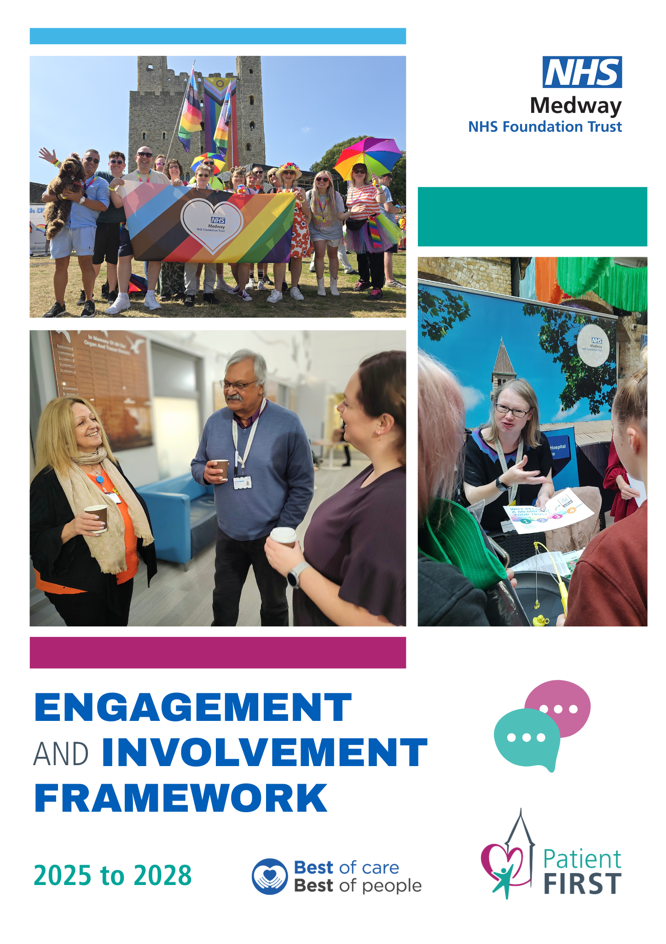
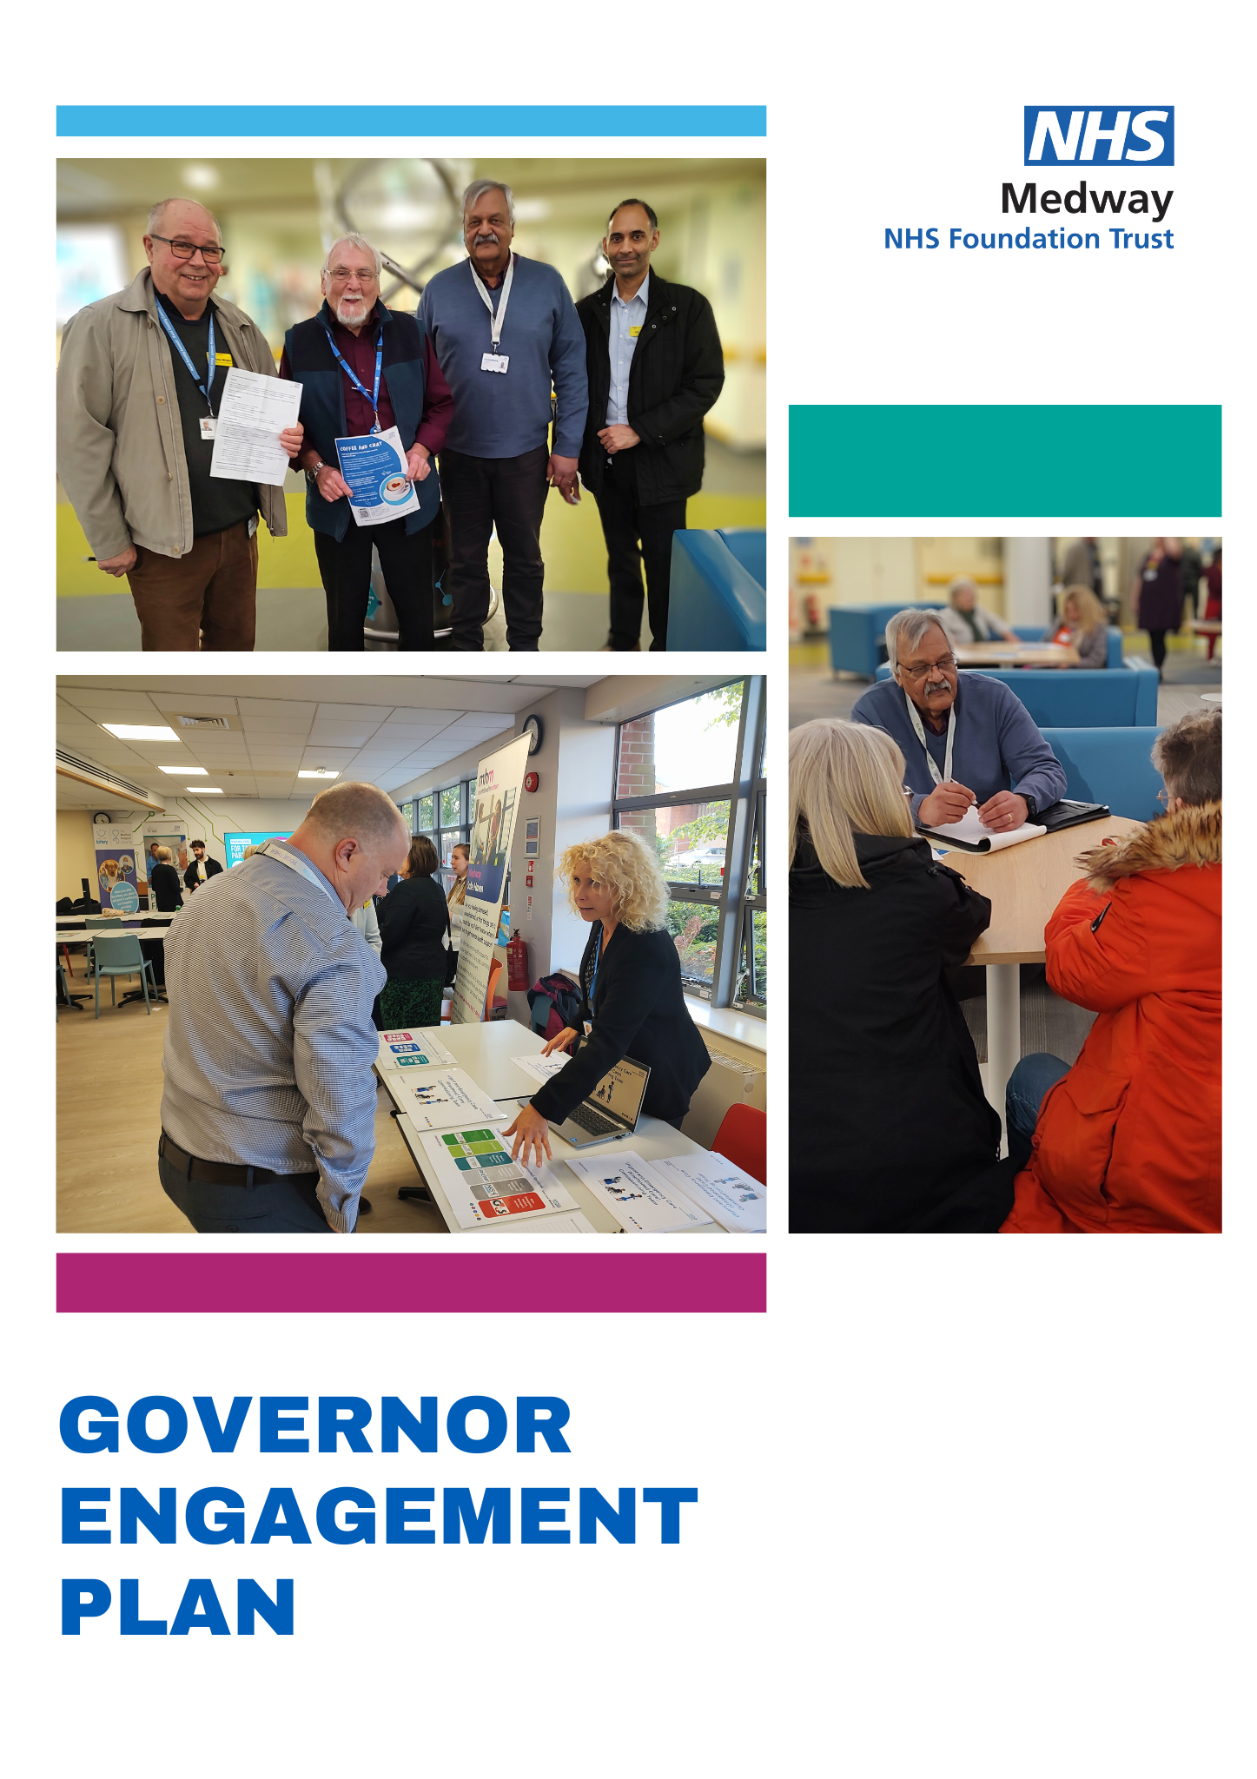

Governor Engagement Plan

1. Introduction
1.1 This Governor engagement plan outlines the vision and methods for building an effective, responsive and representative Council of Governors (CoG) that is well equipped to carry out its engagement function with constituents.
1.2 The Governors hold the Non-Executive Directors (NEDs) to account for the performance of the Trust Board. The Trust Board is responsible for the strategy, operational management and decision-making of the Trust and must take into account the Governors’ views when setting the strategy for the organisation. The CoG contributes to the strategic direction of the Trust.
1.3 Governors provide an important link between the Trust and the community it serves – its members, patients, partners, carers, families, volunteers, local population and staff – ensuring patients and public have a voice within the organisation. This helps strengthen accountability and is reflected in our commitment to our improvement programme Patient First, which puts the patient at the heart of everything we do.
1.4 Governors also represent the views of their constituents and provide an objective oversight of how the Board is meeting its strategic objectives and the requirements of the regulator.
1.5 In order for Governors to fulfil their role, the Trust must support them in their involvement, identifying appropriate opportunities for Governors to be engaged and to engage with their constituents, so that they can identify concerns to be raised at the Board.
1.6 Staff Governors need to be supported by their managers to carry out their role, including allowing time during working hours where needed.
1.7 How the Governors carry out their role is not defined in legislation and is therefore open to interpretation at a local level. At Medway it is considered to be about:
- acting as ambassadors for the Trust
- being a link between the Trust and the community it serves
- for staff Governors, being a link with staff
- feeding back to the Trust on the views of members and staff. This can be through formal channels such as raising questions at Board meetings through the Governor Board representative, or through the Patient Experience Group, or more informally with the support of the Trust’s Engagement Team or the Patient Advice and Liaison Service (PALs)
- sharing information on performance and service improvements and/or changes with members and staff.
- receiving information on the Trust’s performance, changes and plans, and gaining assurance on how the Non-Executive Directors are carrying out their roles.
The role description for Governors is appended to this document.

2. Objectives
2.1 This plan outlines what the Trust needs to do to ensure effective involvement of Governors, make best use of their skills, knowledge and expertise, and to support them to engage effectively.
2.2 The aim of the plan is to:
- support the Council of Governors in its engagement and involvement
- ensure Governors’ skills, knowledge, expertise and interests are taken into account
- ensure their feedback is properly channelled back into the Trust for improvement and decision-making.

3. Providing Governors with assurance
3.1 At the heart of the NHS Foundation Trust model is local accountability in relation to which Governors play a pivotal role. Governors are elected individuals who represent members and service users, and appointed individuals who represent other stakeholder organisations. Together they form the Council of Governors.
3.2 Although Governors do not have an operational role, it is important that they are able to see services in action and to meet staff, so that they can perform their role with a level of insight.
3.3 They do not have a right to inspect services or hospital areas, or to conduct quality reviews. However, the Trust will ensure programmes of activity are in place to:
- support Governors in gaining assurance about the role and performance of Non-Executive Directors.
- help Governors understand the context within which the Trust operates so they are equipped to contribute to the Trust’s strategic direction.
- ensure Governors are able to support communication and engagement with members.

4. Links with other strategies and documents
4.1 The Governor involvement plan links with and takes account of the following documents:
- NHS and Trust Constitutions
- Governor Code of Conduct
- Membership Engagement Strategy
- Community Engagement Strategy
- Communications and Engagement Strategy
- Patient First Strategy
- Patient Experience Strategy
- Quality Strategy
- Volunteering
- Trust’s charitable fundraising strategy
- People Strategy
- Equality and Diversity Strategy

5. The involvement cycle
5.1 The diagram below illustrates the Governor involvement cycle. This demonstrates how Governors gather feedback from patients, staff or from their own observations, which they then feed into the Trust. They, in turn, are provided with information and assurance which they then communicate to patients and members.
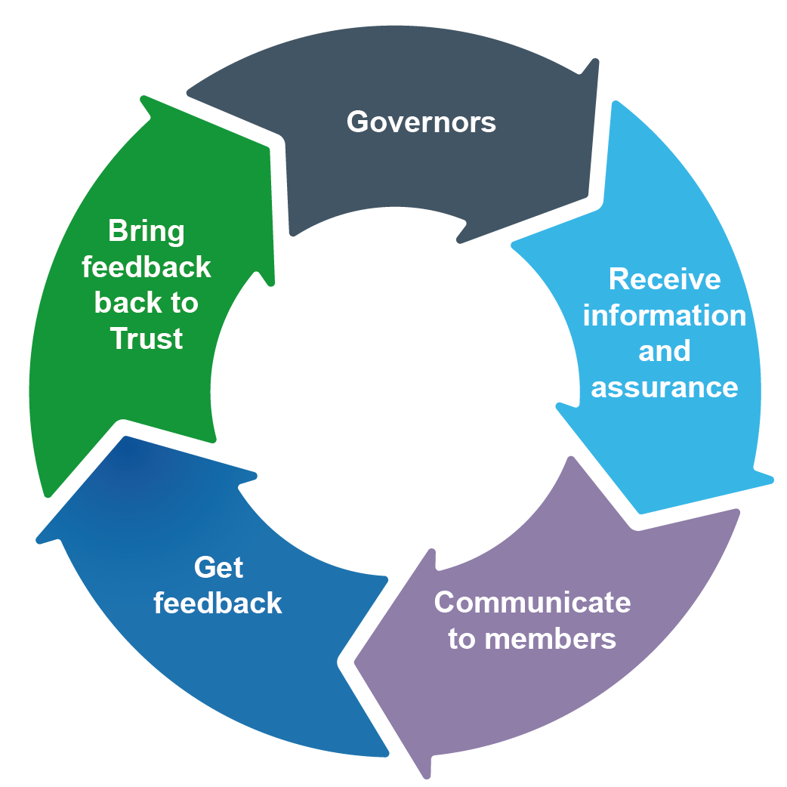
5.2 The following are examples of how the Governors can develop their own knowledge:
- Receipt of Trust activity reports, trends and performance metrics
- Support the development of operational/strategic plans
- Attendance as designated members or observers at Trust committees/groups
- Observing Board meetings held in public
- Discussion of Patient First strategies and plans
- Attend the weekly Patient First: In the Spotlight sessions
- Discussion of the Quality Account Priorities
- Attendance at the annual Quality Priorities public event
- Engagement in the quality agenda, including Patient-Led Assessments of the Care Environment (PLACE) and preparations for Care Quality Commission (CQC) inspection
- Involvement in the Ward Accreditation programme
- Supporting the Friends and Family Test process, by encouraging service users and carers to provide their feedback
- Understanding the service user experience
- Regular organised interface with Trust staff in clinical areas, where possible
- Regular attendance at Council of Governor meetings and the Annual Members’ Meeting
The Trust will also:
- involve Governors in planning communications and engagement with members
- provide updates through reports, briefings, newsletters and presentations
- facilitate information sharing with the community through briefings, events, magazines, website and social media
- support Governors to build knowledge and gain assurance through observation of meetings, participation in walkabouts and shadowing, and participation in involvement programmes.
- facilitate training and development
- highlight external engagement and networking opportunities
- manage the generic governor email account: medwayft.governors@nhs.net and handle inquiries and questions appropriately

How Governors can actively engage
- Attend Governor Coffee and Chat sessions organised by the Engagement Team where they can directly meet with and talk to patients and visitors for the purpose of gathering feedback in order to help them to better represent their views
- Attend community engagement events and stands both on-site and in the community
- Attend regular Patient First improvement huddles and driver meetings (with prior agreement)

6. Evaluation
6.1 In order to determine whether the methodologies outlined in the plan are working, progress against the framework will be discussed and reviewed annually by the Council of Governors.

Appendix 1: Governor Role Description

Title: Public, Staff and Partner Governor for Medway NHS Foundation Trust

Accountable to: Medway NHS Foundation Trust and its members

Remuneration: Governors are not paid a salary, but are entitled to claim reasonable travel expenses

Key Working Relationships
Members of the Trust, Chair of the Trust, the Board of Directors, the Senior Independent Director, the Chief Executive and the Company Secretary, Communications and Engagement staff.

Key Duties and Responsibilities

Statutory

As part of the Council of Governors for Medway NHS Foundation Trust you will have a number of statutory duties which include:

- Representing the interests and views of members of Medway NHS Foundation Trust and the local communities
- To appoint and if appropriate remove the Chair and Non-Executive Directors
- To decide the remuneration, allowances and conditions of employment for the Chair and Non-Executive Directors
- To approve (or not) the appointment of the Chief Executive
- To appoint and if appropriate remove Medway NHS Foundation Trust’s external auditors in conjunction with the Integrated Audit Committee
- To receive the Trust’s annual report and accounts and auditor’s report
- To hold the Non-Executive Directors to account for the performance of the Board
- To approve significant transactions
- To approve any application by Medway NHS Foundation Trust to enter into a merger, acquisition, separation to dissolution
- To approve amendments to the Trust’s Constitution
- To encourage members of the local communities to become members of Medway NHS Foundation Trust
- To oversee the Medway NHS Foundation Trust’s Membership Strategy
- To attend the Council of Governors meetings, Annual Members Meeting and training/development days
- To actively engage with Medway NHS Foundation Trust members and local communities – including attending some of the regular engagement activities and events arranged by the Engagement Team
- (for Partner Governors) To represent the interests of and report back to the appointing organisation

Additional Duties

As part of the Council of Governors for Medway NHS Foundation Trust you would also have a number of individual duties and responsibilities to fulfil, which include:

- To abide by the Governors’ Code of Conduct
- To abide by the Trust’s Constitution
- To uphold the values of the Trust
- To comply with the Trust’s policies and procedures

As part of the role of Governor for Medway NHS Foundation Trust, the following time commitments apply:

- Attending the quarterly Council of Governors meetings, the Annual Members’ Meeting, and any extraordinary Council of Governors meetings that are called
- To attend any Board Committees or Interest Groups to which you are a designated attendee
- To attend any training or development days
- Attending engagement events and activities organised by the Engagement Team
There are also some limitations to the role of Governor for Medway NHS Foundation Trust, which include:

- The Council of Governors cannot veto or over-rule a decision made by the Board of Directors other than as defined in paragraphs 8 and 9 above
- The Council of Governors will not be involved in the day to day running of the Trust, setting budgets, staff pay or other operational matters
- The Council of Governors has no role in considering the appointment or dismissal, appraisal, pay levels or conditions of services of Executive Directors
- Governors do not raise complaints or act as advocates on behalf of individuals.

Appendix 2: Methodologies
Governor involvement – methodologies | Ambassadorial role | Receiving information on performance/changes and gaining assurance on the performance of the NEDs | Sharing information on performance and changes with members | Feedback to the Trust on members’ views
Having an input into Trust objectives and strategy
Input into the development of the operational/strategic plan through the Council of Governors |  | X
Attendance as designated attendees or observers at Trust committees/groups |  | X
Input into the Quality Account Priorities |  | X
Involvement in the community engagement agenda | X |  | X | X
Input into the Governor Engagement Plan |  | X | X
Involvement in the Membership Engagement Strategy | X
Engagement in the quality agenda, including Patient-Led Assessments of the Care Environment (PLACE) and preparations for Care Quality Commission (CQC) inspection |  | X
Supporting the Friends and Family Test process, by encouraging service users and carers to provide their feedback | X |  |  | X
Understanding the service user experience | X |  |  | X
Receiving regular information
Receipt of Trust activity reports, trends and performance metrics |  | X
Reading performance Board reports |  | X
External reports such as from the CQC and associated action plans |  | X
Chief Executive’s weekly email |  | X
News updates from the Chair and Lead Governor |  | X
Board feedback via the Governor Board representative |  | X
News at Medway |  | X
Training and development |  | X
Engagement and sharing information
Annual Members’ Meeting |  |  | X
Member events | X |  | X
Governor and member recruitment sessions | X |  | X
Regular organised interface with Trust staff in clinical areas. |  |  |  | X
Involvement in the planning of patient events such as open days and charity fairs | X |  | X
Taking part in engagement events organised by other health and care organisations across Medway and Swale | X |  | X | X
Connecting with the community through Governors’ own networks | X |  | X | X
Forging links with Governors in other Trusts to adopt best practice | X |  | X
Forming relationships with Healthwatch | X |  | X | X
Presenting to local voluntary and community groups to share information about the Trust and gain feedback | X |  | X | X
Taking part in service redesign groups |  |  | X | X
Governors developing building their own knowledge, gaining assurance and providing feedback
Preparing for Council of Governor meetings by reading background reports |  | X
Observing Board meetings held in public |  | X
Attending Board sub-committees as members and observers |  | X
Participating in Trust events | X |  | X
Buddying with Executive Directors to participate in walkabouts |  | X
Taking part in CQC mock inspections |  | X
Taking part in PLACE assessments |  | X
Building links with volunteers | X |  | X | X

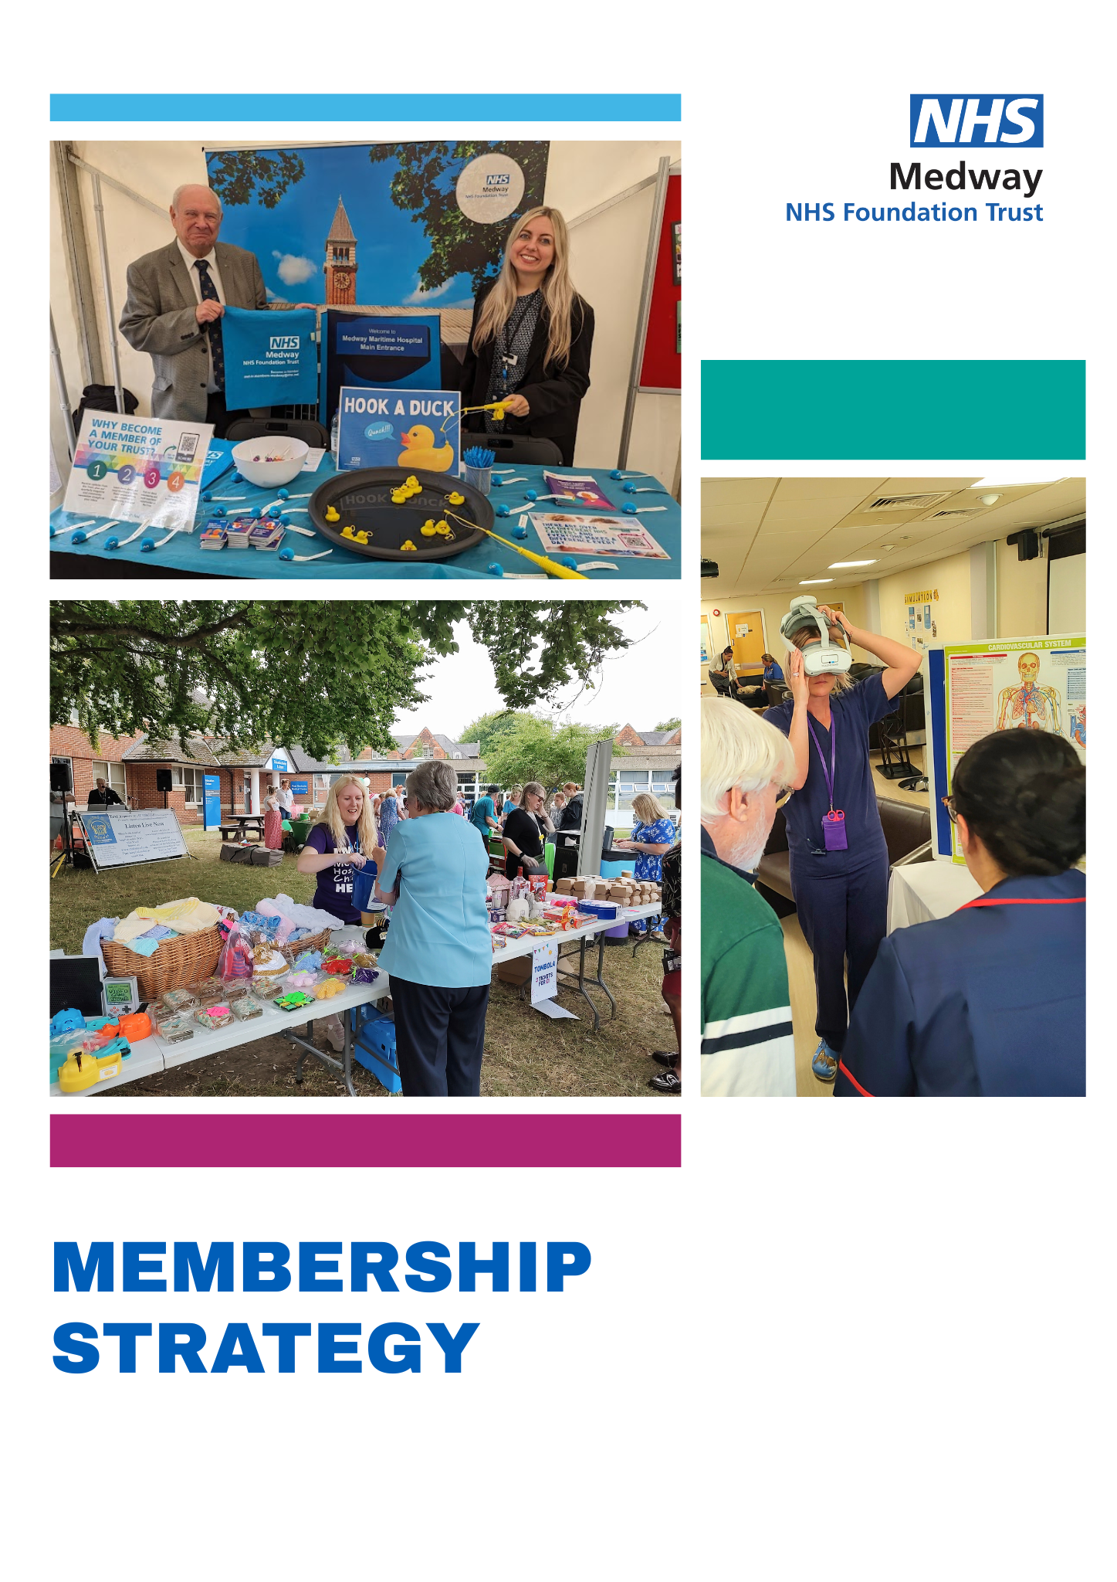

Membership Strategy

About the strategy
The purpose of our Membership Strategy is to outline how Medway NHS Foundation Trust will build on membership recruitment and engagement activities, and how we will support, sustain and communicate with our membership and involve members as far as possible in our activities, to give them meaningful opportunities to engage with the hospital. This strategy builds on the success of membership recruitment and engagement to date and outlines the Trust’s membership plans over the period 2025 to 2028.
The strategy outlines the Trust’s three areas of focus:
- Recruiting and retaining members
- Communicating with members
- Engaging with members

Membership

Why do we have members?
All foundation trusts have a duty to engage with their local communities and encourage local people to become members of the organisation (ensuring that membership is representative of the communities that they serve). Annex A details the demographic information of our community and membership.
Becoming a member provides the opportunity to get involved, by sharing views and opinions which contribute to and support service improvement at the Trust. The Trust values its members and keeps them involved through regular updates, and by inviting members to take part in various groups, surveys, consultations and events. Members are also invited to put themselves forward as candidates when vacancies arise on the Council of Governors and to vote for representatives on the Council of Governors when elections are held.
Medway NHS Foundation Trust enjoys a high level of membership. Under our constitution we are required to have a minimum of 400 members. Our membership stands at more than 11,000 and includes public and staff members, therefore representing a healthy position.
We also have an increasing number of young members, thanks to proactive efforts to target this cohort in membership recruitment, for example through renewed links with Medway Youth Council and attendance at university freshers’ fairs.
More important than the number of members, is the level of engagement. We have greatly increased the engagement with our members through regular email updates and outreach activity.

Governor elections
Members elect the majority of representatives on the Trust’s ‘Council of Governors’, which in turn appoints the Chair and other non-Executive Directors to the Board of Directors. The Council of Governors’ job is to formally represent the interests of the membership and the wider public and to hold the Trust’s Non-Executive Directors to account for the performance of the Trust’s Board of Directors.
Each answers to the previous
Members
Governors
Non-Executive Directors
Executive Directors
Each appoints to the next
A representative and engaged membership will help our Trust to continue to maximise its potential as a foundation trust and is an important objective for the Council of Governors.
Public governors have a responsibility to represent the interests of the trust members who elected them as well as other members of the public. Public Governors provide an important link between the hospital and the local community, enabling us to gather views from local people and to feed back what is happening within the Trust. They reflect members' interests and work on their behalf to improve health services for the future. By passing on ideas and suggestions members also can help Governors carry out their role effectively.
Staff governors have the same role as public governors in that they are responsible for holding the non-executive directors, individually and collectively, to account for the performance of the board of directors, and for representing the members of the staff constituency and the members of the trust as a whole. As employees of the trust, staff governors bring a unique understanding of the issues faced by an NHS foundation trust.
Partner governors are appointed by the bodies they represent – these include charities, local councils and local universities.

What membership means to us
Membership enables people to gain access to information, allows people to acquire knowledge and understanding about new and future developments and offers a way to influence services by providing feedback.
Membership provides a way for the trust to connect with patients, carers and the public and gives us the opportunity to communicate with those who are interested in our work. It means we can keep people up to date with the latest events and developments and can reach out directly to the membership if we are looking for patient input into service change; for example, a patient representative was recruited in this way to support the redesign of our Frailty unit.
We recognise people want different things from membership, depending on their needs and reason they became members. Many want to be informed, others more involved, and some want to take a lead.
We categorise the different levels of membership as follows:
- Informed - Receive regular newsletters, information and updates.
- Involved - Informed as well as consulted on the Trust’s plans and invited to participate in events, surveys, focus groups
- Taking a lead - Informed and involved as well as standing for election as a governor, participating in formal service user representative forums, volunteering or attending special feedback groups

Recruiting and retaining our members

Becoming a member
Recruitment of members is currently achieved through membership recruitment stands, public events, social media and our Trust website, and individual recruitment by Governors. We have also added details of Trust membership to the end of the Friends and Family Test which has greatly increased membership take up. It is also mentioned on our clinic letters, and advertised in each edition of The Net magazine. Posters are also displayed around the hospital.
We will continue to organise recruitment stands within the hospital and at external venues and continue our efforts to maintain the current level of membership. Our recruitment activities will be published on the membership section of the website (https://www.medway.nhs.uk/membership/), in our Community Engagement newsletter and promoted through social media.

Next steps:
- We will look to identify opportunities in new locations where potential membership may be attracted (for example healthy lifestyle related clubs)
- We will continue to encourage people to sign up online through our application form, whilst having paper forms available where needed to enable us to sign up as many members as possible
- Since transferring to a new membership database in May 2023, we are now able to track the referral methods by which we recruit new members. The table below shows our main referral methods by which new members have been recruited.
Referral Source | Members
Engagement Stands | 104
Friends and Family Test | 61
Hospital Letter | 56
Trust website | 53
Please note – these figures only include members who named a referral source and are still active members.

Retaining our membership
We will aim to retain existing members by continuing to communicate and engage through the activities described in the following sections and, importantly, communicating how member engagement has had an impact.
- A comparison of public membership figures since 2023 shows an overall decrease of 3,498 members. This is mainly due to a data quality project in 2023 which identified a large number of members who had moved away from their given address. They were subsequently removed from the system as we had no way of contacting them. A number of members are also removed following elections when letters are returned as undelivered, meaning they no longer reside at their given address.
- A small number of members are regularly removed as they have passed away (around six per month), and some ask to be removed as they are no longer interested in membership. An average of 1.8 people unsubscribe following each email to members. Members receive an average of 2.6 emails per month.
- The potential current reach by email to public members stands at 43 per cent (previously 25 per cent). The absence of email addresses for many members relates to historic recruitment. New members are strongly encouraged to provide an email address as this is the main form of communication. A number of historical members with no email address remain, but a large number were removed from the database during the data cleanse. This has contributed to the significant increase in percentage of members with email addresses.

Through this strategy:
- We will look to streamline the routes of engagement between members, staff and the Trust, members and Governors and Governors and the Trust to avoid duplication and to ensure issues are addressed in a timely manner
- We will ensure a consistent service in responding to communication from members through whatever route they raise issues, ensuring the most appropriate team responds to the enquiry
- We will find ways to highlight where issues raised by members have been addressed and the impact this has had
- We will continue to increase opportunities for Staff Governor engagement and communication with staff members.

Eligibility for membership
Public membership is available for any individual member of the public aged 16 and over who lives in Medway, Swale or the rest of England and Wales. Members are invited to “opt in” by completing a paper or electronic application form. Members are required to abide by the Trust’s code of conduct and public service values, and members may be disqualified if they do not comply .
We are keen to involve our current and past patients and their families, carers and other members of our local community. We are also keen to involve those who live outside our community and who wish to become involved because they live within easy travelling distance, have some current or past connection with the Trust or may use health care services provided by the Trust.
Staff Membership – individuals are eligible to become members of the Staff constituency if they have a permanent contract, a 12 month or longer fixed term contract, have an honorary contract, or exercise functions for the purposes of the Trust otherwise than under a contract of employment with the Trust and have done continuously for at least 12 months (for example, Trust volunteers). Employed individuals will automatically become members unless they opt out.

Communicating with members
- News at Medway
The Trust distributes a quarterly magazine, News at Medway.
- Community Engagement magazine
Members receive the regular Community Engagement newsletter by email.
- Message from the Chair
Members also receive a regular e-bulletin from the Trust Chair.
- Member newsletters
Regular updates are sent to members who have provided email addresses. Data from the last year (1 April 2024 to 31 March 2025) indicates that the average open rate for all emails to members is 36.3 (36.3 per cent of recipients opened the email at least once).
- News updates and invitations
The Trust will share any news updates and also send invitations to take part in engagement opportunities and events.
- Website
We have a membership section on our Trust website https://www.medway.nhs.uk/get-involved/become-a-member/ and members are able to contact us through the membership office by phone or email.
- Social media
We will continue to use all our social media channels to promote members’ activities and opportunities to engage.

Engaging with members
Member engagement is currently undertaken through the Annual Members’ Meeting and a series of public events throughout the year, often involving our Governors and teams from across the Trust.
The Annual Members’ Meeting provides an opportunity for members to meet governors (their representatives) and senior staff of the Trust. It provides a good opportunity for the trust to promote itself to increase membership.
A number of public events take place throughout the year, the purpose of which is to inform, consult and engage with members, patient, stakeholders and local people. These may be held at the hospital in person or virtually, or in the community.
In addition, the Trust offers opportunities for members to get involved in service change or development.

New for this strategy
- In response to member feedback, we have started to hold tours in parts of the hospital to give members an opportunity to see ‘behind the scenes.’ These have proved very popular and will remain a key part of our event calendar
- Our Summer Fun Day is now a regular event on the calendar, bringing in families and local people to the hospital grounds. It is also very popular with staff.
- We will continue to work towards advertising events well ahead of time. We continue to find new avenues through which to advertise our events.

Community Engagement
Aligned with our vision and values and our aim to deliver the best of care, our community engagement approach is focused on listening to the people who use and care about our services. We want to better understand their diverse health needs, respond to what matters to them, and by harnessing their information, intelligence and expertise, plan, design and deliver improved services for a better patient experience.
Our Engagement Team and Governors will continue to proactively engage with our local community. Through this work we continue to build strong trusting relationships and establish a presence within charitable and voluntary sector organisations, youth and carer groups, schools, as well with Black, Asian and Minority Ethnic (BAME) communities, LGBTQIA+ groups and religious groups.

Evaluating and reviewing our work with members
A quarterly report is submitted for the Public Council of Governors meetings, providing a summary of engagement and governor activities. Governors are invited to suggest future engagement activities and ways in which we can improve engagement and membership uptake.

Membership support
The trust has a responsibility to communicate with members. To this end the trust and its Council of Governors will champion and promote membership as widely as possible.
We need to adequately resource our membership function and to ensure that it is appropriately integrated within the organisation. This requires a commitment to providing membership services over the long term, developing them as required and supporting skills development.
The trust has a Membership Office, staffed by the Engagement Team.

Annex A – Membership Data

Who our members are – local demographics
Public membership is available for any individual member of the public aged 16 and over who lives in Medway, Swale or the rest of England and Wales. We are eager to involve our current and past patients and their families, carers and other members of our local community. We would also like to involve those who live outside our community and who wish to become involved because they live within easy travelling distance, have some current or past connection with the Trust or may use health care services provided by the Trust.

Distribution of current membership
 | Membership as at April 2023 | Membership as at April 2025
Medway  Swale  Rest of England and Wales | 6,128  1,614  2,098 | 4,137  1038  1,167
Total Public | 9,840 | 6,342
Staff | 4,055 | 5,063
Total | 13,895 | 11,405

Profile of current membership compared to local area
Please note – demographic data is not always provided; this analysis is based on the following percentage of members for each category:
Age – 76.3 per cent
Gender – 99.99 per cent
Ethnicity – 78.9 per cent
 | % of Membership | % of local area (Medway) | Difference (%)
Age
16-19 | 0.4 | 3.7 | -3.3
20-29 | 4.4 | 12.3 | -7.9
30-39 | 15.7 | 14.2 | +1.5
40-49 | 13.4 | 12.9 | +0.5
50-59 | 16.9 | 13.6 | +3.3
60-69 | 15.9 | 10.2 | +5.7
70-79 | 17.7 | 7.8 | +9.9
80+ | 15.6 | 4.0 | +11.6
Gender
Male | 31.7 | 49.0 | -17.3
Female | 68.3 | 51.0 | +17.3
Ethnicity (broad)
Asian | 7.4 | 5.9 | +1.5
Black | 6.1 | 5.6 | +0.5
Mixed | 1.4 | 2.8 | -1.4
Other | 0.3 | 1.4 | -1.1
White | 84.7 | 84.3 | +0.4

Analysis of the data indicates that our membership base is older than the local average and represents females by almost 18 per cent more than the local population.
People aged 16-29 are slightly under-represented, and people aged 60 upwards are increasingly over-represented as the age bracket increases. We are aware of this and have been working to improve uptake of membership by young people over the past few years.
Member ethnicity profile matches the local population to within 1.5 per cent in all categories, indicating that all ethnicities are appropriately represented.

Approved by Council of Governors – 22 May 2025
Approved by Trust Board – 23 July 2025
Review date: April 2025
Next review date: April 2028

Public Members may be disqualified if - They have perpetrated a serious incident or violence in the past five years, towards any hospital or healthcare facilities or against any of the Trust’s , Non-Executive Directors, Council of Governors, in accordance with the relevant Trust’s policy for withholding treatment from violent/aggressive behaviour - They have been confirmed as a “persistent complainant” in accordance with the relevant Trust’s policy - Breached the Trust’s code of conduct Staff members may be disqualified on the same basis as public members. In addition a staff member may be asked to temporarily cease membership activities during any period of suspension under the Trust’s code of conduct and associated staff policies and professional codes.

