

***Infection Prevention & Control Annual Report* 2024/25**

*Michelle Clarke*

*IPC Matron (Acting)*

Mona Keren

*IPC Clinical Nurse Specialist (Acting)*

*Elizabeth Salisu*

*IPC Nurse*

*Deborah Esan*

*IPC Nurse*

Contents

Tables and figures 2

Glossary 3

1 Director of IPC Introduction 4

2 background 5

3 The IPC Team and structure 6

4 Board Assurance Framework 9

5 PATIENT SAFETY INCIDENT RESPONSE FRAMEWORK (PSIRF)- A NEW APPROACH TO RESPONDING TO PATIENT SAFETY INCIDENTS………………………………………………………10

6 Methicillin Resistant Staphylococcus Aureus (MRSA) 12

7 METHICILLIN SENSITIVE STAPHYLOCOCCUS AUREUS (MSSA) 18

8 *clostridioides (clostridium) difficile* 19

9 GRAM NEGATIVE BACTERAEMIA INFECTIONS (GNBI’S) 23

10 Respiratory infections (COVID 19/INfluenza/rsv) 27

11 PERIOD OF INCREASED INCIDENCE……………………………………………………………………..30

12 OUTBREAKS ………32

13 SURGICAL SITE INFECTION SURVEILLANCE (SSIS) 34

14 IPC Gthr AUDITS 36

15 HOSPITAL CLEANLINESS 39

16 DECONTAMINATION 40

17 COMMODE AUDITS 42

18 EDUCATION AND TRAINING 43

19 LINK PRACTITIONERS 45

20 FIT TESTING 47

21 ESTATES/ipC/HOUSEKEEPING WALK ABOUTs 49

22 NEXT STEPS…………………………………………………………...……………………………………...50

23 CONCLUDING REMARKS 51

### Tables and figures

|  |  |  |
| --- | --- | --- |
|  |  | Page |
| 1 | Compliance Criterion of the Code of Practice | 5 |
| 2 | New Trust Governance Structure | 6 |
| 3 | The IPC Team Structure | 6 |
| 4 | IPC Continuing Professional Development | 7 |
| 5 | IPC Board Assurance Action Overview | 9 |
| 6 | MRSA Bacteraemia comparisons 2024/25 against 2023/24 | 13 |
| 7 | MRSA acquisitions Comparison for 2024/25 and 2023/24 | 14 |
| 8 | Ward Breakdown of MRSA Acquisitions | 15 |
| 9 | 2024/25 MRSA Acquisitions by Divisions. | 16 |
| 10 | 2024/25 MRSA Screening Divisional Breakdown. | 17 |
| 11 | 2023/24 and 2024/25 MSSA infection comparison. | 18 |
| 12 | 2023/24 and 2024/25 MSSA infection comparison. | 18 |
| 13 | Cumulative CDI HOHA/COHA Cases for 2024/25 | 20 |
| 14 | 2023/24 and 2024/25 CDI case comparison. | 20 |
| 15 | Ward breakdown of CDI cases for 2024/25. | 21 |
| 16 | Care Group breakdown of CDI cases for 2024/25. | 21 |
| 17 | Divisional breakdown of CDI cases for 2024/25. | 22 |
| 18 | 2024/25 Trustwide Stool Chart Documentation Audit. | 22 |
| 19 | 2024/25 GNBSI Possible Source Overview | 24 |
| 20 | 2023/24 and 2024/25 Escherichia Coli Comparison data. | 25 |
| 21 | 2023/24 and 2024/25 Klebsiella Comparison data. | 25 |
| 22 | 2023/24 and 2024/25 Escherichia Coli Comparison data. | 26 |
| 23 | MFT COVID-19 inpatient cases for 2024/25 | 27 |
| 24 | MFT Influenza inpatient cases for Winter 2024/25. | 28 |
| 25 | MFT Influenza B inpatient cases for Winter 2024/25. | 29 |
| 26 | MFT RSV inpatient cases for Winter 2024/25. | 29 |
| 27 | MFT Symptom Checker Audit Compliance Comparison. | 30 |
| 28 | 2024/25 Overview of Wards on a Period of Increased Incidence. | 31 |
| 29 | MFT Influenza inpatient cases for Winter 2024/25. | 32 |
| 30 | 2024/25 Q1-Q3 Overview  of TKR/THR cases and the number of SSI’s. | 34 |
| 31 | 2024/25 Q1-Q3 Overview of Colorectal cases and the number of SSI’s. | 35 |
| 32 | 2024/25 Q1-Q3 Overview of TKR/THR cases and number of missed follow-ups. | 36 |
| 33 | Hand Hygiene Compliance Score (Trustwide). | 36 |
| 34 | Hand Hygiene Facilities Audit Compliance (Trustwide). | 37 |
| 35 | Staff Role Audited for Hand Hygiene | 37 |
| 36 | Bare Below the Elbows Overall Compliance Data (Trustwide) | 37 |
| 37 | Bare Below the Elbows Compliance Breakdown Data (Trustwide) | 38 |
| 38 | Commode and Sluice Facilities Audit (Trustwide) | 38 |
| 39 | Trustwide Peripheral Cannula Audits 2023/24 and 2024/25 comparison | 38 |
| 40 | Friend and Family Test Cleanliness Scores (Trustwide). | 40 |
| 41 | The number of UV cleans in 2024/25. | 40 |
| 42 | 2023/24 & 2024/25 Commode Cleanliness Audit Comparison(Trustwide) | 43 |
| 43 | 2024/25 Overview of Trust IPC Training Compliance. | 43 |
| 44 | 2024/25 Overview of Fit Testing sessions and DNAs | 48 |
| 45 | 2024/25 Fit Tested Staff Breakdown. | 49 |

### 

### Glossary

|  |  |
| --- | --- |
| Glossary Term | Meaning |
| ADIPC | Associate Director of IPC |
| AMS/AMR | Antimicrobial Stewardship/Resistance |
| AMSG | Antimicrobial Stewardship Group |
| BAF | Board Assurance Framework |
| CPE | Carbapenemase Resistant Enterobacteriaceae |
| DIPC | Director of IPC |
| DDoN | Divisional Director of Nursing |
| FFT | Friends and Family Test |
| GNBSI’s | Gram negative bacteraemia Infections |
| Gthr | Trust audit tool |
| HoIPC | Head of IPC |
| HoN | Head of Nursing |
| HR | High Risk |
| ICB | Integrated Care Board |
| IPCT | Infection Prevention and Control Team |
| IPC | Infection Prevention and Control |
| PII | Period of increased incidence |
| POCC | Peri-op and Critical care |
| PIR | Post Infection Review |
| PPE | Personal Protective Equipment |
| QIP | Quality Improvement Plan |
| RSV | Respiratory Syncytial Virus |
| SSIS | Surgical Site Infection Surveillance |
| SMART | Surgical, Medical and Acute Response Team |
| UKHSA | United Kingdom Health Security Agency |
| VHR | Very High Risk |

### 

# Director of IPC Introduction

* 1. This annual report covers a summary record of all activities relating to practices in Infection Prevention and Control (IPC) at Medway NHS Foundation Trust during the period April 2024 – March 2025.
  2. As Chief Nursing Officer and the Director of Infection Prevention and Control, it is a privilege and a proud moment to present Medway NHS Foundation Trust’s Annual Infection Prevention and Control Report. The last year has continued to build on previous years improvements:
     + Staff across the Trust work closely with the IPC Team to ensure that during the busy winter period IPC standards are consistently maintained to ensure patient safety and experience with clear processes for infection management embedded.
     + Embedding PSIRF methodology within reviews of all Hospital Acquired Infections using learning to develop first IPC Quality Improvement Plan
     + Continued development of simulation training to support wards that have hospital acquired infections and implementing intensive support for wards on Periods of Increased Incidence
     + Working with the EPR team to add the Diarrhoea Assessment Tool as part of stool documentation on EPR to ensure patients are being sampled appropriately
     + The second annual link practitioner showcase.
     + Created an IPC condensed audit on Gthr.
  3. The report shows how the Trust continues to make improvements around IPC, and that it is still high on our agenda. Our challenges this year have been not meeting our targets around Methicillin-resistant Staphylococcus aureus (MRSA) and Clostridium difficile (C. diff) for the 3rd year. This continues to reflect the national picture and the IPC team have been an integral part of the Kent and Medway System Collaborative identifying actions to reduce these infections in 2025/26. We continue to work hard to make sure we reduce infections which is a key part of keeping our patients safe and ensuring they have a positive experience while in our care.

Kind regards

Sarah

**Sarah Vaux**

**Interim Chief Nursing Officer and Director of Infection Prevention and Control (IPC)**

**Medway NHS Foundation Trust**

# background

* 1. The code of practice for the prevention of infections, 2015 uses 10 criterion (Figure 1) by which a registered provider will be monitored and judged on how it complies with the registration requirements placed upon them for cleanliness and infection control within an organisation.
  2. The code stipulates the importance of the Director of Infection Prevention and Control (DIPC) to regularly report to the board of directors. This includes the formation of an annual written report summarising the work undertaken by the Infection Prevention and Control Team (IPCT) over the year, reports on key Infection Prevention and Control (IPC) issues and progress around the Trust’s annual IPC work programme.
  3. The IPCT’s annual work programme for 2024-25 was based on Health and Social Care Act 2008: *Code of Practice on the prevention and control of infections and related guidance* and would cover complete remit of the IPCT in controlling and managing infections throughout the Trust.
  4. There was continued work on the IPC Board Assurance Framework (BAF) from the last financial year which was then reviewed in May 2024 following an updated version being published.

Figure 1: Compliance Criterion of The Code of Practice on the prevention and control of infections and related guidance

**The Compliance Criterion of The Code of Practice on the prevention and control of infections and related guidance outlines the 10 criterion that the Trust needs to show that they demonstrate and provide assurances to the Board and ICB that these have been met.  The criterion that need to be met are as follows:
1. Systems to manage and monitor the prevention and control of infections. 
2. Provide and maintain a clean and appropriate environment in managed premises that facilitates the prevention and control of infections. 
3. Ensure appropriate antimicrobial use to optimise patient outcomes and to reduce the risk of adverse events and antimicrobial resistance. 
4. Provide suitable accurate information on infections to service users, their visitors and any person concerned with providing further support or nursing/medical care in a timely fashion. 
5. Ensure prompt identification of people who have or are at risk of developing an infection so that they receive timely and appropriate treatment to reduce the risk of transmitting infection to other people. 
6. Systems to ensure that all care workers (including contractors and volunteers) are aware of and discharge their responsibilities in the process of preventing and controlling infection. 
7. Provide or secure adequate isolation facilities. 
8. Secure adequate access to laboratory support as appropriate. 
9. Have and adhere to policies, designed for the individual's care and provider organisations that will help to prevent and control infections. 
10. Providers have a system in place to manage the occupational health needs and obligations of staff in relation to infection. **

# The IPC Team and structure

* 1. Delivery of Infection Prevention and Control sits within all departments and clinical services since it is fundamental to patient care. To enable this delivery, the Trust has an organisational structure which oversees required actions. These are outlined in the Trust Governance structure (Figure 2) and the IPC team reporting structure (Figure 3).

Figure 2: Trust Governance Structure

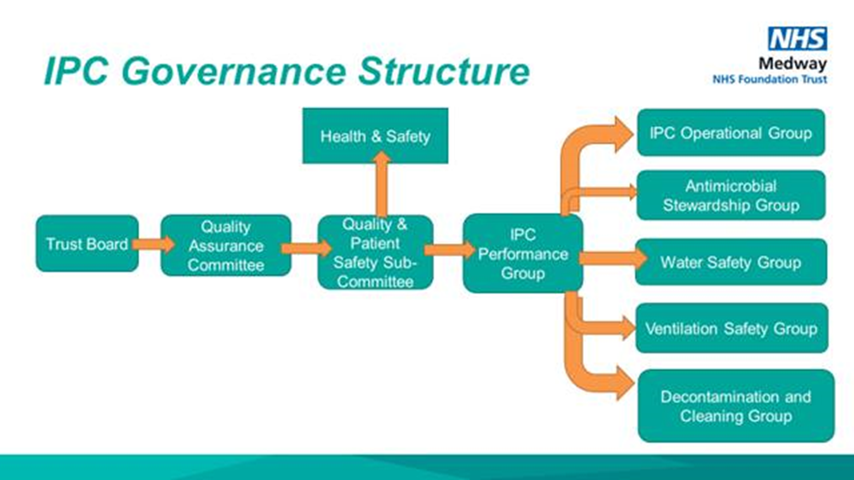

Figure 3 - The IPC team Structure

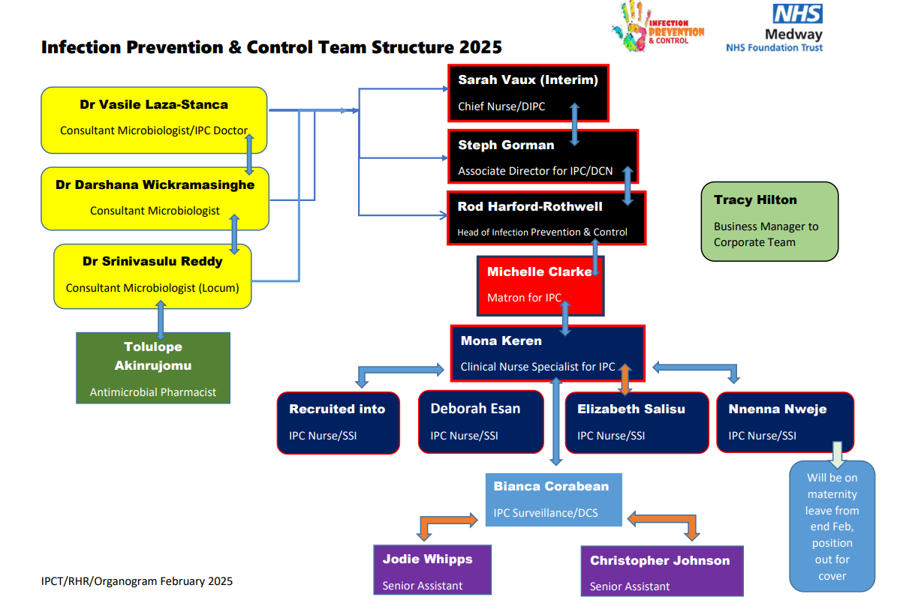

* 1. The team had been fully recruited into in early 2022-23 but following some internal promotions within the Trust opportunities presented for members of the team to act into more senior roles.
  2. With the promotion of the ADIPC to act as the Deputy Chief Nursing Officer in a dual role capacity this created opportunities for some internal secondment placements. Firstly the previous Matron became the Head of Service, the IPC CNS to Matron, then IPC Nurse to IPC CNS, with the IPC Nurse vacancy being filled by an internal Trust seconded position.
  3. IPC Team continued to expand and develop their knowledge base by attending the courses listed below during 2024/25 (Figure 4).

Figure 4 – IPC Team Continuous Professional Development

|  |  |  |
| --- | --- | --- |
| **Role** | **Course** | **Completion date** |
| IPC Clinical Nurse Specialist | Mary Seacole Programme | May 2025 |
| IPC Nurse | RCN Infection Prevention & Control Programme | July 2024 |
| IPC Nurse | RCN Infection Prevention & Control Programme | October 2024 |
| IPC Nurse | UKHSA Surgical Site Surveillance | June 2024 |
| IPC Nurse | UKHSA Surgical Site Surveillance | September 2024 |
| IPC Surveillance Nurse | UKHSA Surgical Site Surveillance | December 2024 |
| IPC Surveillance Nurse | DipHE Infection Control | February 2025 |
| IPC Nurses | IPS Conference – Liverpool | September 2024 |
| IPC Senior CSW | Trainee Nursing Associate | Due to complete August 2025 |

* 1. The IPC Strategic Assurance Group (IPCSAG) name changed to become the IPC Programme Group (IPCPG) and continues to meet monthly with a slightly altered structure to reflect alternative reporting of full report or data reporting only. The change does not affect how it reports to the Quality and Patient Safety Sub-Committee (QPSSC) chaired by the Chief Nursing Officer and the Chief Medical Officer. This then is reported to the Trust’s Quality Assurance Committee (QAC).
  2. With the divisional restructure to create 4 divisions the IPC team is no longer split into 2 teams to cater for the Planned and Unplanned divisions. The IPC Matron and IPC Clinical Nurse Specialist continue to represent and report at Divisional Governance meetings for divisions split between them.
  3. Clinical audit of the care environment is a good indication of quality, and all IPC audits are uploaded to the live data system Gthr. The data system is used by the Trust to capture and highlight good practice and where improvements are needed to help plan and guide additional resource. All wards have access to all their audit information and reported on within their respective care groups and again at Trust level.
  4. The IPC operational group (IPCOG) was developed from a need to have a better understanding of the issues facing ward leaders/|Matrons enabling them to understand their audit data better, identify themes and trends in an open forum, sharing best practice through peer support and helping to drive-up standards across the Trust to keep our patients safe whilst in our care. The IPCOG, although paused for a few months, in order to review and ensure that it was delivering what it set out to do, is always well attended and has proved a useful tool to engage staff. This group reports bi-monthly to the IPCPG.
  5. The Antimicrobial Stewardship Group (AMSG) is chaired by a medical consultant and supported by a consultant microbiologist, the IPCT are frequent attenders and participants at these meetings but attendance not been consistent by divisional members. A bi-monthly antimicrobial report is presented at IPCPG.
  6. The decontamination group is chaired by the Head of IPC following successful completion of a City and Guilds Decontamination Leads course at Eastwood Park training centre. The Approved Engineer for Decontamination (AED) conducts annual audits on site offering assurance. The decontamination group was changed to reflect the incorporation of the cleaning group following implementation of the National Cleaning Standards of Healthcare Cleanliness and reports to the IPCPG.
  7. Following the relaunch of the water safety group a renewed focus on establishing all water safety requirements across the Trust and better reporting of issues has occurred. The appointment of an Approved Engineer for Water (AEW) has strengthened this group and reports back to the IPCPG and the Health and Safety and Security Group (HSSG) and up to board level.
  8. The relaunch of the Ventilation group has occurred following the need to re-look at the Trust’s estate to ensure that current ventilation systems are adequate or where improvements can be made. Where no mechanical ventilation systems are in place the procurement of suitable air-flow systems can be discussed and effectively planned for. This group reports to the IPCPG and the HSSG.

# Board Assurance Framework

* 1. The Board Assurance Framework template was produced in June 2020 by NHSE/I to all NHS providers to help aid compliance with the Health and Social Care Act 2008, *Code of Practice* and compliance with the then national COVID-19 strategies, policies and guidelines.
  2. Following several NHSE & Clinical Commissioning Group (CCG) now Integrated Care Board (ICB) visits in 2020/21 the DIPC had initiated and led on a collaborative discussion to combine the previous 4 previous improvement plans into one single plan aligning it to the BAF.
  3. Originally 216 actions were identified within the Trust’s 2021 IPC BAF improvement plan. This reduced to 145 actions by September 2023 and an action plan developed.
  4. The board assurance framework (BAF) action plan has reported bi-monthly and enabled an update on the number of actions closed within month, the number of actions on track for delivery, the number that are off track and then those that are overdue awaiting completion.
  5. The latest version of the BAF (May 2024) is our last as it becomes amalgamated into the Trust’s Quality Improvement Plan (QIP).
  6. The remaining actions will be closed down and transferred to the corresponding IPC related meeting action logs or the IPC QIP. On closing down the BAF, Figure 5 shows the status of the actions that are Completed, On Track, Off Track, and Overdue.

Figure 5: Overview of BAF actions.

# PATIENT SAFETY INCIDENT RESPONSE FRAMEWORK (PSIRF)- A NEW Approach to responding to patient safety incidents.

* 1. The framework represents a significant shift in the way the NHS responds to patient safety incidents and is a major step towards establishing a safety management system across the NHS. It is a key part of the NHS patient safety strategy.
  2. The PSIRF supports the development and maintenance of an effective patient safety incident response system that integrates four key aims:
* Compassionate engagement and involvement of those affected by patient safety incidents.
* Application of a range of system-based approaches to learning from patient safety incidents.
* Considered and proportionate responses to patient safety incidents.
* Supportive oversight focused on strengthening response system functioning and improvement.

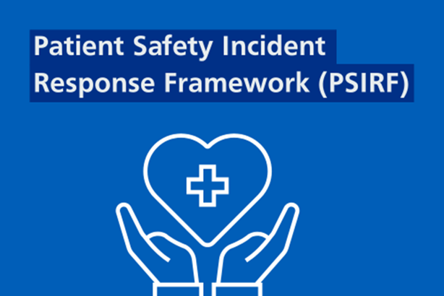

* 1. Patient safety incidents are unintended or unexpected events (including omissions) in healthcare that could have or did harm one or more patients. PSIRF sets out new guidance on how NHS organisations respond to patient safety incidents and removes the ‘Serious Incidents’ classification and the threshold for it. Instead, it recognises that things do not always go to plan and supports a patient safety culture by focusing on understanding how incidents happen, including the impact of systems and human factors which contribute to them, rather than attributing blame or liability to a person.
  2. This allows for more effective learning, and improvement, and ultimately safer care for patients. PSRIF also ensures greater involvement, support, and compassion for patients, families and staff involved in, and affected by, patient safety incidents.
  3. Although there will be fewer formal investigations of incidents, colleagues are more likely to be involved in a learning response so they can learn from incidents and improve patient safety in their area of work.
  4. PSIRF promotes the use of various learning response approaches instead of formal investigations:
* Local investigation: Involves collecting accounts of those involved and identifying improvements.
* SWARM: A facilitated discussion on an incident or event to analyse what happened, how it happened and decide what needs to be done immediately to reduce risk. It enables understanding and expectations of all involved and allows for learning to be captured and shared more widely.
* After Action Review (AAR): A structured, facilitated discussion of an event, the outcome of which gives the individuals involved in the event an understanding of why the outcome differed from that expected, and generates learning to assist improvement. It focuses on four key questions with everyone involved given an equal ability to contribute.
* Patient Safety Incident Investigation (PSII): An in-depth investigation that could take up to six months to complete. They will be targeted at areas of known concern in the organisation where contributory factors to an incident are not fully understood. Those leading patient safety investigations will be offered training by the Patient Safety Team.
* Some other types of review may occur such as thematic reviews for groups of cases, and a Structured Judgement Review (SJR) for deaths.



* 1. Integration into IPC: The IPCT has adopted the PSIRF methodology within its QIP. A move away from traditional Root Cause Analyses (RCA) allows for a more holistic systems-based approach. All actions arising from PSIRF-aligned reviews initiated from June 2024 onwards are systematically recorded and monitored within the QIP.

# Methicillin Resistant Staphylococcus Aureus (MRSA)

* 1. Since April 2018, cases of MRSA bacteraemia have been reported based on the timing of infection onset in relation to hospital admission. These cases are classified and recorded by the UK Health and Safety Agency (UKHSA) through the Healthcare- Associated Infection (HCAI) Data Capture System (DCS) as follows:
* hospital-apportioned where the infection onset is >2 days after admission
* Community-apportioned where the infection onset / blood culture collection is < 2 days after admission
  1. In 2024/2025 reporting period, the Trust reported 2 cases of HOHA and 3 cases of COHA MRSA bacteraemia against a national zero tolerance policy for such infections. This represents an increase from the 4 total cases reported in the previous year (2023/2024) as seen in Figure 6.

Figure 6: MRSA Bacteraemia Comparisons for 2023/24 and 2024/25.

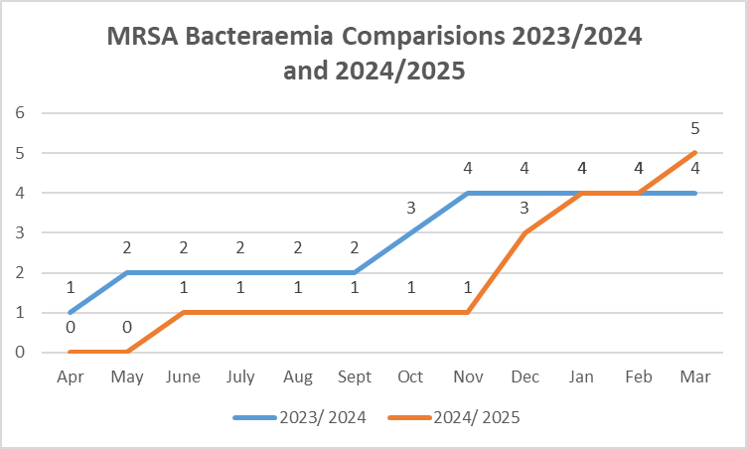

* 1. AARs were conducted to investigate the acquisition of MRSA bacteraemia cases. Of the 2 HOHA cases reported in December 2024, one was linked to lower UTI. The second case had an unidentified source as patient presented with multiple wounds, was wearing a neck brace, and there were concerns regarding the efficacy of decolonisation due to complexity of the case.
  2. AAR was undertaken for 3 COHAs reported in June, January and March, the cases were linked to upper and lower UTIs, while the third had an unidentified source. Although a direct cause of bacteraemia could not be established in that case, inadequate documentation regarding cannula and catheter care raised concerns about compliance with best practice.
  3. MRSA acquisitions, where MRSA is detected in patients on admission or through weekly screening, is recorded and overseen by the IPC team. Admission screening is usually swabbing of the nose and groin but should also include any wounds, cannula sites that look infected and pressure sores. A urine sample should also be obtained from a catheter if also identified at time of admission.
  4. There is no national reporting process regarding the acquisition of MRSA within the clinical areas therefore there is no national threshold set by NHSE.
  5. MRSA acquisition equates to a near miss scenario for MRSA bacteraemia as acquisition increases the risk of developing a bacteraemia through poor hand hygiene compliance at the point of care (especially when managing invasive devices), incorrect use of Personal Protective Equipment (PPE) and cleanliness of equipment and the environment.
  6. The Trust has not set any objectives for the reduction of MRSA acquisitions for 2024/25, but the IPC Team continue to monitor acquisition numbers and ward locations throughout the year and has a set target outlined in the QIP.
  7. The number of Hospital MRSA acquisitions has been collated across the year as cumulative in the graph below (Figure 7).

Figure 7: MRSA Acquisitions Comparison for 2023/24 and 2024/25.

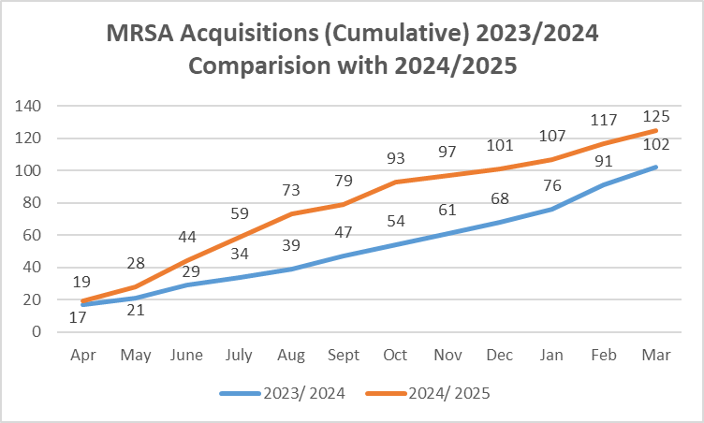

* 1. The data collected in 2024/25 will be reviewed in the upcoming year to identify potential reductions in MRSA bacteraemia acquisition, and to determine areas where increase in acquisition have been seen, prompting remedial action.
  2. Any ward reporting three or more cases within a rolling 28-day period will be placed under a Period of Increased Incidence (PII), provided there is evidence of cross-contamination. Under a PII, the clinical area is placed on enhanced monitoring, including focused audits, weekly visits by the Infection Prevention and Control team, and simulation-based training sessions. A targeted action plan is also developed to support the ward or department in achieving full IPC compliance.
  3. The graph above illustrates an increase in MRSA acquisitions, rising to 125 cases in 2024/2025, which exceeds the 102 cases recorded in 2023/2024. Most detections were made through routine nose and groin screening, while the remaining cases were identified from wound swabs, sputum, endotracheal tube secretions, line swabs, conjunctival samples, and serous fluid collections.
  4. The data collected has also enabled a comprehensive review and monitoring of acquisition locations, with further analysis to determine the percentages by Division and by individual care group.

Figure 8: Ward Breakdown of MRSA Acquisitions.

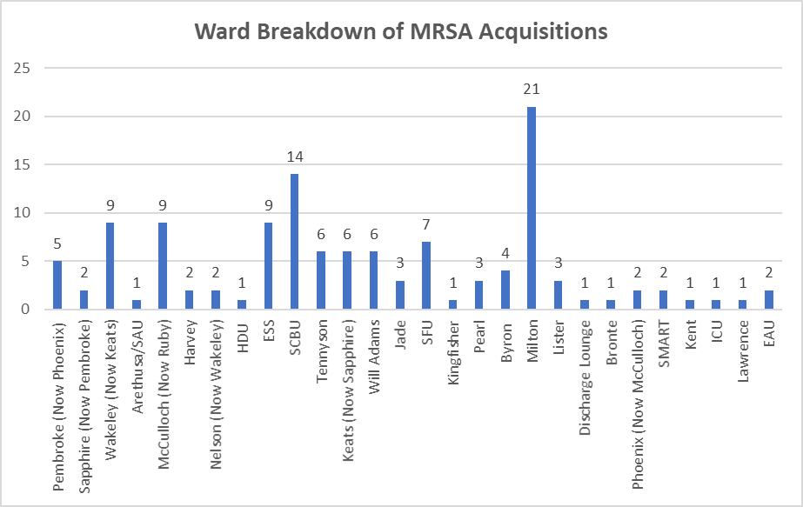

6.14 The graph above (Figure 8) shows the distribution of MRSA acquisitions by ward during the 2024/25 period. The highest number of acquisitions occurred on Milton Ward between July and October, during which an outbreak was declared. Key findings from the outbreak review included:

* A delay in laboratory reporting of results (exceeding 48 hours), which was subsequently added to the risk register.
* Changes to the enhanced cleaning process, which the IPC Team had not been made aware of.
* Environmental issues, including clutter and insufficient storage space, contributing to IPC non-compliance.
* Gaps in the IPC internal reporting process, highlighting areas for improvement in communication and escalation.
  1. Figure 9 shows the percentage of acquisitions by divisions across the Trust.

Figure 9: 2024/25 MRSA Acquisitions by Divisions.

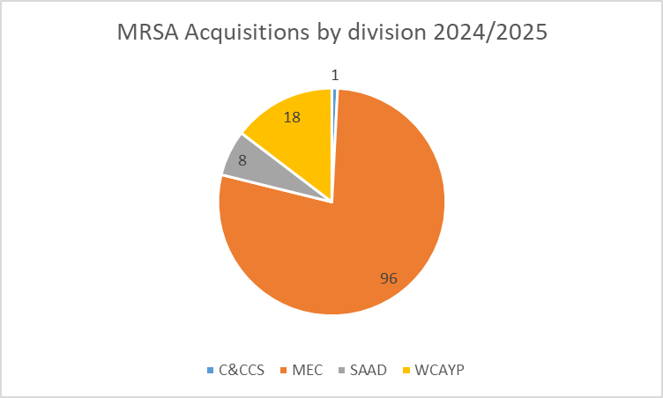

* 1. The highest number of MRSA acquisitions occurred within the Medicine and Emergency Division (MEC), reflecting the complex nature of the services provided within this group. Milton Ward and the frailty bed base recorded the highest acquisition rates, with many patients identified through weekly screening and lacking clear criteria to reside. The IPC team will continue to monitor these areas closely throughout the forthcoming year to support ongoing improvement in MRSA screening compliance. Results are reviewed and discussed monthly at both the IPCOG and the IPC PG meetings to inform ongoing monitoring and improvement efforts.
  2. Below (Figure 10) shows the MRSA screening audit compliance for each Division, compared to Trust wide.

Figure 10: 2024/25 MRSA Screening Divisional Breakdown.

The table shows a breakdown for each Division for MRSA Screening compliance for 2024/25.  Cancer and Core Clinical Services showed poor compliance remaining below 77% for most of the year, only improving in September (96%) and in October (81%) before decreasing again to 33% in March. 
Medicine and Emergency Care fluctuated between amber and green scoring between 84% and 93%. 
Surgery and Anaesthetics fluctuated between green and amber, scoring between 80% and 94%.  
Women, Children and Young People started the year off with scores as low as 13% in May, increasing to between 91%-100% by the end of the year. 
Overall the Trust has fluctuated between 83% and 93% for 2024/25. 

* 1. Throughout the year, this 90% MRSA screening compliance target was not consistently achieved. The MEC division demonstrated relatively stable compliance, while the CCCS Division only met the target in September. There is a review of the questions for WCYP division as they are non-compliant on questions about documentation and there is an action plan for CCCS to ensure completion of screening audit. The divisions continue to report to IPCPG with an update on their data. The IPC Operational Group continue to review the main issues for non-compliance around swabbing of wounds and IV devices.
  2. To address these gaps, the IPC Team will provide ongoing education and support across clinical areas, with assistance from IPC link practitioners.

# METHICILLIN SENSITIVE STAPHYLOCOCCUS AUREUS (MSSA)

* 1. There is no national threshold for MSSA bacteraemia.
  2. In 2024/25 the Trust reported 26 cases during this operational year. This was a decrease of 9 cases on the previous year’s total of 35. The percentage of reduction is 26% in comparison to the previous financial year.
  3. Figures 11 and 12 show a comparison of MSSA infections for 2023/24 and 2024/25.

Figure 11: 2023/24 and 2024/25 MSSA infection comparison.

The table shows a comparison of the cumulative number of MSSA cases for the Trust for 2023/24 and 2024/25. 
It shows that although the year started higher at 4 cases compared to 2 cases in the previous year, it remained low and ended with 26 cases on a comparison of 30 cases in the previous year.      

Figure 12: 2023/24 and 2024/25 MSSA infection comparison.

The graph shows a comparison of the cumulative number of MSSA cases for the Trust for 2023/24 and 2024/25. 
It shows that although the year started higher at 4 cases compared to 2 cases in the previous year, it remained low and ended with 26 cases on a comparison of 30 cases in the previous year.      

* 1. A new review process for Gram Negative Blood Stream Infections (GNBSI’s) including MSSA was implemented in November 2023 and has been in place since introduced and this includes MSSA. This process involves a rapid case review to identify common themes, contributory factors, and key learning points.
  2. As the Trust now holds a full year’s worth of data, the process is currently under review to assess how it can be made more effective and beneficial. This includes determining how best to utilise the data collected to drive improvement. As a result, new key objectives have been incorporated into the IPC Quality Improvement Plan.
  3. The IPC team expanded the Period of Increased Incidence (PII) criteria to include any ward with two GNBSI acquisitions from the same source, or three acquisitions from different sources, including MSSA cases. When these thresholds are met, the ward is provided with intensive support, including targeted simulation-based training focused on addressing the key themes and emerging trends identified through case reviews.

# *clostridioides (clostridium) difficile*

* 1. *Clostridoides difficile* infection (CDI) is classified under 4 headings.
* **Hospital onset / healthcare associated (HOHA):** onset > 48 hours of admission (>2 days). These cases are Trust-apportioned
* **Community onset / healthcare associated (COHA)**: cases that occur in the community (or within 2 days of admission) but have been an in-patient in the previous 4 weeks. These cases are Trust-apportioned.
* **Community onset / Indeterminate acquisition (COIA):** cases reported by an NHS acute trust not determined to be Hospital-Onset Healthcare Associated but where the patient was discharged from the reporting organisation within 83 days prior to the current specimen date (where date of discharge is day 1).
* **Community onset, community associated (COCA)**: cases that occur in the community (or within 2 days of admission) when the patient has not been an inpatient in hospital in the previous 12 weeks. These cases are apportioned to the Integrated Care Board (ICB) formally the CCG.
  1. From 2021/22 Trust level thresholds include all healthcare associated cases (ie HOHA and COHA).
  2. Nationally there has been a surge in hospital acquired infections with many acute Trusts nationally breaching their thresholds.
  3. The Trusts threshold for 2024/25 was 53 cases with a breach of 11, ending the financial year with 64 cases. As seen in figure 13, the Trust breached the threshold in January 2025. The Trust saw a 21% breach on our threshold and a 34% increase on last year.

Figure 13: Cumulative CDI HOHA/COHA Cases for 2024/25

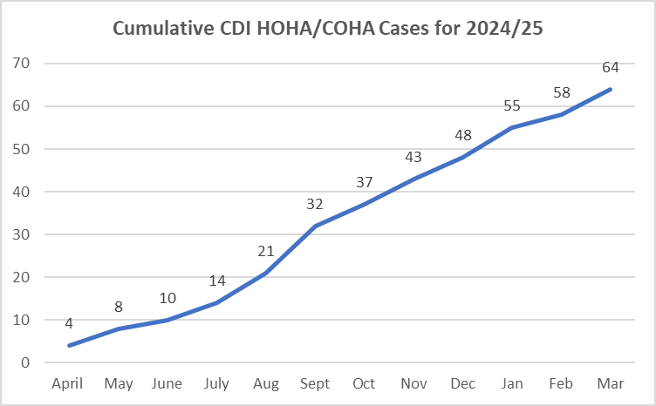

8.5 Comparing the cases from 2024/25 with 2023/24 (figure 14), there is no clear correlation with the time of year for cases.

Figure 14: 2023/24 and 2024/25 CDI case comparison.

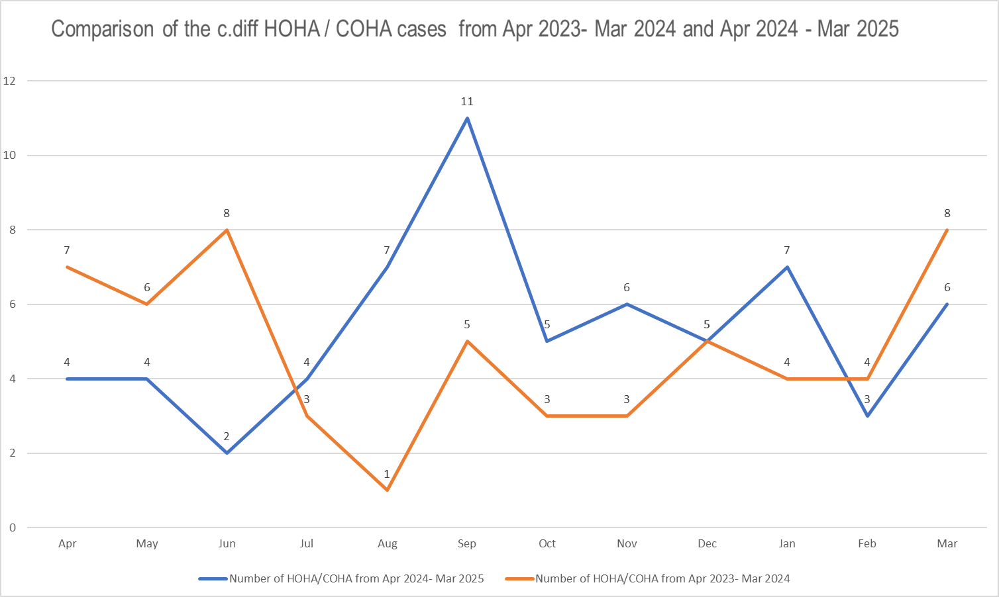

8.6 A breakdown of the Wards (Figure 15), Care Groups (Figure 16) and Divisions (Figure 17) can be found below. Due to ward movements throughout the year, there may be discrepancies with the attributions of the cases, however the total number is accurate.

Figure 15: Ward breakdown of CDI cases for 2024/25.

The graph shows a breakdown per ward of the CDI cases for 2024/25.  The cases were attributed as follows:
McCulloch 5 cases. 
ED, Emerald, Kingfisher. Lawrence, Lister, Phoenix, and Will Adams 4 cases.
Arethusa and Keats 3 cases.  
Byron, Harvey, Milton, Nelson, Tennyson and Trafalgar 2 cases. 
ADL, Bronte, CCU, Dolphin, EAU, Jade, Pembroke, Pembroke (Sapphire), Ruby, RSU, Sapphire, Victory and Wakeley 1 case. 

Figure 16: Care Group breakdown of CDI cases for 2024/25.

The pie chart shows a breakdown of the CDI cases for 2024/25 by Care Group as follows:
Cancer and Access 4%
Specialist Medicine 14%
Surgical Services 20%
Children and young People 0%
Acute and Emergency Medicine 9%
Frailty 14%
Theatres and Anaesthetics 1%
Women's Care 0%

Figure 17: Divisional breakdown of CDI cases for 2024/25.

The pie chart shows the CDI cases breakdown for 2024/25 per Division as follows: 
Medicine and Emergency Care 37%
Surgery and Anaesthetics 22%
Women, Children and Young People 1%
Cancer and Core Clinical Services 4% 

8.7 Mini Post Infection Reviews (PIR)/SWARMS were carried out for HAI cases throughout the year between the IPC team and Consultant Microbiologist.

8.8 For cases that needed further investigation or where major learning was found, a SWARM is completed. An invitation to attend the meeting goes to the ward manager, consultant overseeing the care, Microbiology Consultant, Matron, HoN, IPC team and ICB colleagues.

8.9 Following the completion of the investigations for 2024/25 only 1 of these cases was avoidable, which is a reduction on previous years. This was due to inappropriate sampling in ED. Of those determined HOHA 6 cases may have been community acquired if they had been sampled earlier. The remainder were unavoidable as these patients had complex medical or surgical issues with a need for antimicrobials or no sources found.

8.10 Although the cases were largely unavoidable, some lapses in care were established from case reviews, which did not impact their positive result, but will have led to discomfort, isolation and potentially extended lengths of stay. These have added to the actions within the IPC Quality Improvement Plan for 2025/26.

8.11 The most frequent lapses in care were to do with sampling, isolation, stool chart, treatment and antimicrobial duration or usage.

8.12 On review of the Stool Chart Documentation audit (Figure 18), it showed clear gaps in compliance for completing the documentation as seen in the data below for 2024/25.

Figure 18: 2024/25 Trustwide Stool Chart Documentation Audit.

|  |  |  |  |  |  |  |  |  |  |  |  |
| --- | --- | --- | --- | --- | --- | --- | --- | --- | --- | --- | --- |
| April | May | June | July | Aug | Sept | Oct | Nov | Dec | Jan | Feb | Mar |
| 66 | 61 | 66 | 74 | 69 | 79 | 76 | 72 | 80 | 79 | 83 | 74 |

8.12 Actions taken in the year to improve on the previous year’s results are

* Working with AMSG to ensure antimicrobial stewardship remains a top priority for the organisation.
* Intense Support, for wards with the infection, where the IPC team go round to all patients with the nurse in charge and review associated documentation to ensure completion is compliant, which includes stool documentation.
* The addition of the Diarrhoea Assessment Tool into the stool chart on EPR to aid in assessing patients as to whether a stool sample is required.
* Continue to hold SWARMs to ensure learning is understood for any lapses of care and omissions led by ADIPC or IPC Matron.
* Monthly IPCOG Gthr & PIR learning discussion: led by HON & HoIPC.
* Continued roll out one standardised easy clean commode for inpatient areas.
* Commode cleaning competencies developed for all frontline staff
* *C.difficile* numbers & PIR outcomes to DIPC and DDoN’s of new cases for oversight.
* Continued implementation of CDI ward rounds weekly with microbiologist and IPC team reviewing all cases of C.difficiles and new Glutamate dehydrogenase (GDH) positive result.
* Simulation training led by IPC team for wards on a Period of Increased Incidence.

8.13 The IPC team worked closely with system partners within Kent and Medway and are part of the CDI collaborative led by the ICB IPC team looking at actions from all Trusts to learn from each other. What was reassuring was that as a system we were reporting similar themes and trends and were doing many of the same initiatives.

8.14 MFT are currently working on the Green Card scheme to capture patients who are GDH +ve and therefore high-risk patients for a CDI, at the earliest opportunity and ensure that they receive the appropriate antibiotics where needed. In addition, we are looking at rapid enteric testing for the upcoming winter as a system.

# GRAM NEGATIVE BACTERAEMIA INFECTIONS (GNBI’S)

* 1. *Escherichia coli (E. coli),* Klebsiella and Pseudomonas are all gram-negative bacteraemia and are now required to be reported nationally through the data capture system (DCS). All these organisms have a significant impact on the health of the patient and affect Kent and Medway Healthcare systems.
  2. During 2024/25, the IPC team raised a Datix for all HCAI GNBSI, completed documentation of care regarding the case using a structured rapid review document. Following this, the case was reviewed with the Consultant Microbiologist and IPC nurses to find out the root cause, source of infection and common themes and trends (See Figure 19).
  3. The completed document is attached to the Datix for the ward manager to review and action the identified learning for improvement.
  4. In November 2024, the IPC team introduced a decision checklist for reviewing patients with HCAI GNBSIs. Using this document, the IPC nurses reviewed the patient with the Consultant Microbiologist, and decided if the case required a SWARM meeting involving the ward manager, managing consultant and the ward IPC link practitioner. Following this, the form is attached to the Datix for the final approval by the IPC CNS or Matron.
  5. Any identified actions from the reviews were added to the IPC Quality Improvement Plan.
  6. Figure 19 shows the identified possible source of infection for the HCAI GNBSIs in 2024/25. Although, half of this cases are yet to be discussed.

Figure 19: 2024/25 GNBSI Possible Source Overview.

The graph shows the possible source of infection for the acquired GNBSI cases in 2024/25.  
The key areas are have been highlighted as sources are Hepatobiliary, Upper Urinary Tract and Unknown sources. 

* 1. Of the 3 main GNBSI organisms only E. coli achieved a reduction on the previous year’s total by 24.97%. Klebsiella increased by 5 cases and Pseudomonas by 2 cases. However, they are all within the allocated threshold for the year 2024/25.
  2. *E. coli – (*figure 20) ended 2024/25 with 60 cases against a threshold of 88 resulting in a 31.82% reduction below the trajectory while 2023/24 ended 6.85% below the set trajectory of 73.
  3. Although the two years remained within the set threshold, the percentage improvement in 2024/25 shows significant progress in reducing E. coli bacteraemia.
  4. Medicine and Emergency division accounts for the 55% of these cases in 2024/25.

Figure 20: 2023/24 and 2024/25 Escherichia Coli Comparison data.

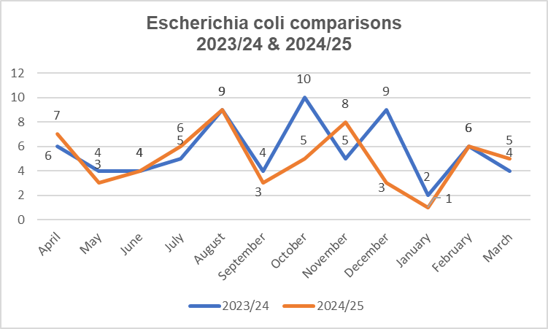

* 1. Klebsiella – (figure 21) there was a total of 27 cases in 2024/25 against a threshold of 27 which surpassed 2023/24 by 5 cases.

Figure 21: 2023/24 and 2024/25 Klebsiella Comparison data.

The graph shows a comparison of Klebsiella cases for 2023/24 and 2024/25. 
The trend shows that the cases peaked in the first part of the year compared to 2023/24, the cases were fairly similar October to December and ended in March with less cases than the previous year by 8 cases. 

* 1. 2024/25 data for Pseudomonas showed that we ended the year with 13 cases against a threshold of 15 cases which is 13.33% below trajectory while 2023/24 ended the year with 8.33% below trajectory having 11 cases against the threshold of 12. A comparison against the previous year can be found in Figure 22.

Figure 22: 2023/24 and 2024/25 Escherichia Coli Comparison data.

The graph shows a comparison of Pseudomonas cases for 2023/24 and 2024/25. 
The trend shows that cases remained lower than the previous year for the majority of the time only increasing in comparison in October to January. 

* 1. The Trusts IPC strategy aimed to reduction of Hospital Acquired Infections in year. The year 1 deliverable was to maintain the status quo which was partially achieved with a reduction in GNBSI’s, but also looked to understand the lapses and the learning. The year 2 deliverable for 2024/25 was to reduce GNBSI’s by 5%. This 5% reduction was achieved only in E. coli cases. However, the team will continue to utilise the Quality Improvement Plan and the ward teams to achieve reduction in the Trust GNBSI’s cases further.
  2. A new process for monitoring GNBSI’s for 2024/25 was introduced mid financial year. The criteria set was if a ward had 2 or more cases within a 28-day period, they required an immediate review by the IPC nurses to ascertain the source of the bacteraemia, any delays and to ensure appropriate management.
  3. Additionally, these cases will also trigger the ward to be placed on Period of Increased Incidence (PII).

# RESPIRATORY INFECTIONS (COVID-19/INFLUENZA/RSV)

* 1. COVID-19 had presented a significant challenge to the delivery of health services and the Trust over the recent pandemic, but we have now returned to business as usual since the removal of all COVID restrictions.
  2. Current epidemiology suggests that the virus although still circulating in the community is associated with less mortality and morbidity because of an increase immunity in the population following the mass vaccination programme and the development of therapeutic interventions.
  3. Although cases reduced considerably, the IPC team continued to review each COVID-19 case to determine if they are Trust attributed. in addition, any COVID-19 related deaths required an internal infection review. Determination of hospital acquired transmission was as below

**Hospital Acquired Infection (HAI)** - Patients swabbed for COVID-19 8 days from admission to the Trust. Other respiratory infections would be classed as post 48 hours from admission to the Trust.

**Community Acquired Infection (CAI)-** Patients swabbed within 7 days of admission to the Trust. Other respiratory infections would be classed as cases swabbed within 48 hours from admission to the Trust.

* 1. Figure 23 below shows the total number of COVID-19 cases per month and demonstrates peaks in April, May, June and October for positive results and a clear reduction in July 2024 and January 2025.

Figure 23: MFT COVID-19 inpatient cases for 2024/25.The graph shows the total COVID cases per month for 2024/25, with a breakdown of HAI and CAI.  
It shows that the Trust has had more CAI COVID cases than HAI cases. 
It shows that compared to the previous year, the Trust has seen less cases, only peaking in October above previous years figures. 

* 1. An overview of Influenza A cases for Winter 2024/25 can be seen in figure 24. Cases appeared to spike in December 2024 and January 2025, which is in line with the flu season.

Figure 24: MFT Influenza inpatient cases for Winter 2024/25.

The graph shows a snap shot of the Influenza A inpatient cases for November to February for 2024/25. 
The figures show that the Trust had more cases from December to January than the previous year. Followed by lower cases from January to February. 

10.6 For Winter 2024/25 the Trust continued to use its established respiratory pathways for both paediatric and adult patients to ensure patient safety by correctly cohorting patients with respiratory symptoms and therefore reducing the risk of a nosocomial transmission and outbreaks.

10.7 The pathways are supported by the Rapid Testing Service who provided the Polymerase Chain Reaction (PCR) testing to identify four main respiratory infections, COVID-19, RSV (paediatrics), influenza A and influenza B, which means that swabs are tested on site for a faster turnaround.

* 1. The IPC team attend the daily morning site team call 7 days a week and report on any COVID-19, Influenza A, Influenza B and RSV cases. Additionally, highlighting any of these patients who have not already been isolated, and where potential side rooms are.
  2. The data is also sent to the Business Intelligence team who collate the information and report externally as required.
  3. A monthly overview of the respiratory figures is found below, with November to January being the months with the most cases overall (Figure 25 and Figure 26).

Figure 25: MFT Influenza B inpatient cases for Winter 2024/25.

The graph shows a breakdown of Influenza  B cases for 2024/25. 
The cases were as follows:
June 1, July 1, December 3, January 8, February 4, and March 8. 

Figure 26: MFT RSV inpatient cases for Winter 2024/25.

The graph shows the RSV inpatient figures for 2024/25. 
The figures display as follows: 
July 2, September 6, October 35, November 74, December 85, January 41, February 19, and March 7. 

* 1. This data shows that both Influenza and RSV peaked in line with national data. This had an impact on the use of side rooms within the hospital over the winter period which at times restricted flow within the Trust. The IPC team supported the site team with appropriate use of side rooms across 7 days..
  2. The Trust symptom checker document was added to the Electronic Patient Record over the last year, making it easier for staff to access. The purpose of the document is to enable staff to identify and document daily if a patient has developed any respiratory symptoms, and ensure they can be effectively managed to prevent the disruption of vital services.
  3. Compliance with the completion of the symptom checker has continued to be an issue but has improved over the financial year. A comparison of compliance through the symptom checker audit for 2023/24 and 2024/25 can be found in figure 27.

Figure 27: MFT Symptom Checker Audit Compliance Comparison.

|  |  |  |  |  |  |  |  |  |  |  |  |  |
| --- | --- | --- | --- | --- | --- | --- | --- | --- | --- | --- | --- | --- |
|  | April | May | June | July | Aug | Sept | Oct | Nov | Dec | Jan | Feb | Mar |
| 2024/25 | 80.2 | 85.5 | 89.2 | 89.3 | 88.8 | 90 | 89.8 | 90 | 92.2 | 84 | 89.7 | 89.7 |
| 2025/26 | 86.9 | 91.8 | 84.6 | 85.9 | 85.1 | 83.2 | 85.4 | 88.6 | 83.3 | 87.4 | 87.9 | 84.7 |

* 1. Patients who trigger are sampled and isolated in a timely manner whilst awaiting a result, remaining in isolation for 5 days if positive.

# Period of Increased Incidence

* 1. Placing a ward on a period of increased incidence is triggered by a criteria set by the IPC team.
  2. It is an opportunity to give the ward tailored and focussed support in order to ascertain the perceived lapses in documentation or hand hygiene compliance for example, and supporting staff to improve in these areas.
  3. A breakdown of the criteria for a PII and the support given is shown below.

**CDI:**

* One case with new learning. The ward will be placed on PII.
* If two cases within 28 days then the ward is automatically placed on PII.
* 4 weeks of audits to be carried out in full then step down based on the performance of the Ward.

**GDH:**

* Two cases within 28 days with significant learning. The Ward will be placed on PII.
* Continue audits for 2 weeks and then step down based on the performance of the Ward.

**MRSA (colonisation):**

* If there are 3 cases within 28 days, we then ask the following questions:

1. Are there signs of clear cross contamination?
2. Are we really concerned about these infections?

* If yes to the above questions, then the ward is placed on PII. If not, we continue to monitor for further cases.

**MRSA (Bacteraemia):**

* If one case, then the ward is automatically placed on a period of increased incidence for 4 weeks.
* The ward can be stepped down based on the performance after 4 weeks

**MSSA:**

* If there are 2 cases within 28 days the ward is placed on PII.
* Continue audits for 2 weeks and then step down based on the performance of the Ward.

**GNBSIs:**

* If 2 cases within 28 days with the same source of infection, then the ward is placed on PII
* If different sources, then threshold of 3 is allowed before a ward is placed on PII.
* Audits to be carried out 1st and 3rd week. If significant concerns, then this will be modified.
  1. The audit scores are reviewed weekly and an email notification with recommendations for improvement, sent to the ward manager, matron and Head on Nursing.
  2. Following this stage, the ward is provided with intensive support by the IPC team in collaboration with the ward manager and the Nurse in charge, for 4 weeks with the objective of sustainable improvement.
  3. Figure 28 shows a weekly overview of the wards that were placed on a PII within the 2024/25 financial year. While Ruby ward was on PII for 2 weeks due to good compliance and audit scores, Byron ward was on PII for 13 weeks due to poor compliance.
  4. Sapphire ward continues to be on a PII into the new financial year, as the audit scores are still not at an acceptable level for hand hygiene.

Figure 28: 2024/25 Overview of Wards on a Period of Increased Incidence.

The graph shows the wards that have been on a period of increased incidence and the number of weeks under this monitoring. 
The findings are as follows: 
Nelson 7
Milton 9
Byron 10
Ruby 2
Harvey 4
Wakeley 8
Phoenix 8
Will Adams 7
NICU 4
Keats 5
McCulloch 3
Kingfisher 10
Lawrence 11
Lister 7
HDU 3
Sapphire 9

11.8 Figure 29 shows the list of wards with acquired infections that qualified them to be placed on PII. Byron, McCulloch, Phoenix, Will Adams, Milton wards have all been on PII on two different occasions due acquiring more than one infection in different month.

Figure 29: MFT Influenza inpatient cases for Winter 2024/25.

|  |  |
| --- | --- |
| **Wards** | **Themes** |
| Byron | ESBL,  MRSA Bacteraemia |
| Harvey | ESBL, |
| HDU | C. Diff |
| Keats | GDH |
| Kingfisher | C. Diff, MRSA Bacteraemia |
| Lawrence | GDH |
| Lister | C.Diff |
| McCulloch | C. Diff, ESBL |
| Milton | GDH, C. Diff, MRSA, E. coli, Klebsiella |
| Nelson | C. Diff, ESBL |
| NICU | MRSA colonisation |
| Phoenix | MRSA Bacteraemia, GDH, C. Diff |
| Ruby | MRSA Colonisation |
| Sapphire | MRSA Bacteraemia |
| Wakeley | MRSA Colonisation |
| Will Adams | MRSA Colonisation, GDH, C. Diff |

# OUTBREAKS

11.1 During 2024/25 the Trust had 3 outbreaks for COVID-19, CPE and MRSA colonisation.

11.2 Throughout Winter 2024/25 reporting period MFT was and remained under pressure which saw most of that period escalating at Opel level 3 or 4. Entering into business continuity only once, to support flow through the hospital, which impacted on side room availability.

11.3 Any ward where an outbreak was declared, the IPC team started enhanced cleaning measures, a PII, Intense support and an outbreak meeting was convened to identify learning and where improvements can be made.

11.4 On 6th April 2024 there was a CPE outbreak on Sapphire Ward involving 4 direct patients. The incidence occurred through the index case, who was repatriated internationally, and not appropriately isolated on the ward due to unawareness of policy although highlighted by the nurse in charge.

11.5 Learning from the CPE incidence set in motion an increase in education surrounding this organism. The IPC team have incorporated it into any teaching sessions delivered, and further work was carried out with EPR to establish and move the location of the Infection Admission Assessment to highlight patients with a history of an infection or high-risk patients.

11.6 In addition, a reliance on the need for contact tracing was highlighted further due to Extramed being removed, which makes it difficult to trace which patients have been in contact with an index case during their inpatient journey. this has been added to the risk register as an issue, pending work by the Teletracking team.

11.7 On 8th April 2024 there was a COVID outbreak on Will Adams Ward involving 14 patients, 8 who became positive. The index case was positive on 1 day, followed by the remaining 7 patients testing positive the next day, as they were symptomatic. No further cases tested positive after this date, and the outbreak was closed after 20 days as per policy. At the time of this testing, national guidelines advised that contact tracing was not required.

11.8 On 25th July 2024 we had an MRSA Colonisation outbreak on Milton Ward, involving 19 patients. Delays were found in lab results coming back and was added to the Risk Register. The outbreak was linked to a wandering index patient and poor cleaning practices. Improvements have since occurred and positive outcomes seen.

11.9 As part of the outbreak actions a deep clean was implemented using UVc, the bays were decanted one at a time into Christina Rosetti. Through good collaboration with ward, IPC, estates and facilities along with the clean the estates team were able to replace the old sinks in each bay to new ones with correct taps and bowl drainage.

11.9 Actions plans were devised and monitored through the outbreak meetings to reduce the effect outbreaks have on the patient, the clinical areas and also the organisation to aid flow.

# SURGICAL SITE INFECTION SURVEILLANCE (SSIS)

* 1. The IPC Team took over the administration of the mandatory SSI surveillance monitoring from the Surgical, Medical and Acute Response Team (SMART) in July 2022
  2. SSI data for mandatory hip and knee reporting is submitted once a quarter to the United Kingdom Health Security Agency (UKHSA) data capture system (DCS) and the minimum requirement is one submission per year. The original aim of the IPC Team was to continuously monitor hip and knee surveillance and report for the whole year has been achieved with 4 submissions a year.
  3. While the goal is to implement surveillance monitoring across all surgical sites, the initial focus was on elective hip and knee surgeries. This approach allowed the team to establish a robust surveillance system, which has since been successfully expanded to include the Colorectal service. Data for Quarter 3 of 2024–25 (October–December 2024) has been fully submitted, and the submission for Quarter 4 (January–March 2025) is currently in progress.
  4. Below shows the data for the number of patients on the list for surveillance, and the number of surgical site infections (SSI) noted per quarter for both elective THR/TKR (Figure 30) and colorectal (Figure 31) procedures.

Figure 30: 2024/25 Q1-Q3 Overview of TKR/THR cases and the number of SSI’s.

The graph shows a breakdown per quarter of the number of elective TKR/THR patients for surveillance and the number of surgical site infections (SSI). 
The data displays as follows:
Quarter 1: 153 patients and 1 SSI
Quarter 2: 159 patients and 0 SSI
Quarter 3: 149 patients and 2 SSI

Figure 31: 2024/25 Q3 Overview of Colorectal cases and the number of SSI’s.

The graph shows a breakdown for quarter 3 of the number of colorectal patients for surveillance and the number of surgical site infections (SSI). 
The data displays as follows:
October: 20 patients and 5 SSI
November: 27 patients and 3 SSI
December: 25 patients and 4 SSI

* 1. Part of the surveillance programme is to contact patients at 30 days post procedure via telephone to determine if after discharge there was any infection at the surgical site.
  2. The team continues to face challenges in contacting patients for the 30-day follow-up, as some do not answer their phones, making it difficult to assess post-operative concerns. This is reflected in the national Data Capture System.Graph below shows the total number of patients per quarter and the number of patient that did not answer the phone for elective SSIS.
  3. The graph below (Figure 32) illustrates the total number of patients per quarter alongside the number of patients who did not answer phone calls regarding elective SSIS. To minimise missed contacts, a second attempt is made if the initial call goes unanswered. For patients who are readmitted, the IPC Team conducts ward visits to complete the PDQs. Additionally, SMART Team notes are reviewed to ensure that patients who were missed for PDQs did not develop an infection during their time in the community under SMART care.

Figure 32: 2024/25 Q1-Q3 Overview of TKR/THR cases and number of missed follow-ups.

The graph shows an overview for quarter 1-3 of the number of elective patients for surveillance and the number of patients who could not be contacted.  The data is displayed as follows:
Quarter 1: 153 patients 32 uncontactable.
Quarter 2: 159 patients, 47 uncontactable.
Quarter 3: 149 patients, 40 uncontactable. 

* 1. Version 2 of the Elective SSIS pathway has been created, and collaborative discussions are ongoing. Given the similarities with the Trauma Orthopaedic pathway, efforts are being made to integrate common steps and processes with support from the Transformational Team. The IPC and Transformational Team are working together to finalise the pathway.
  2. A document has been created to review deep and organ-space SSIs. It has been shared with the Team and consultants for feedback and amendments before implementation.

# IPC Gthr AUDITS

* 1. The Gthr system was adopted by the Trust to capture all audit data from February 2022 where wards can input see and access their results in real time whilst offering assurance on compliance to the board.
  2. The IPC dash board on Gthr has allowed specific questions to be devised and tailored looking at the ward environment; hand hygiene; bare below the elbows and also includes the Friends and Family Test (FFT) cleanliness data.
  3. Hand hygiene compliance scores have remained consistent over 2024/25 – Figure 33 and 34)

Figure 33 -Hand Hygiene Compliance Score (Trustwide).

|  |  |  |  |  |  |  |  |  |  |  |  |
| --- | --- | --- | --- | --- | --- | --- | --- | --- | --- | --- | --- |
| April | May | June | July | Aug | Sept | Oct | Nov | Dec | Jan | Feb | Mar |
| 95 | 95.4 | 92.2 | 95.7 | 94.1 | 95.3 | 93.9 | 94.5 | 96.8 | 95.2 | 95.2 | 95.8 |

Figure 34 – Hand Hygiene Facilities Audit Compliance (Trustwide).

|  |  |  |  |  |  |  |  |  |  |  |  |
| --- | --- | --- | --- | --- | --- | --- | --- | --- | --- | --- | --- |
| April | May | June | July | Aug | Sept | Oct | Nov | Dec | Jan | Feb | Mar |
| 97.7 | 98.4 | 98 | 99.3 | 96.6 | 98.7 | 95 | 99.1 | 96.9 | 94.4 | 97.7 | 97.7 |

The information listed above in the two metrics show that hand hygiene compliance is good across the organisation generally, but challenges still remain with some compliance around bare below the elbows within some clinical areas this is further examined in the bare below the elbows compliance section of this report.

* 1. A breakdown of staff observed for hand hygiene over 2024/25 can be found in Figure 35.

Figure 35: Staff Role Audited for Hand Hygiene

The graph shows a breakdown of the different staff who were audited for hand hygiene in 2024/25. 
The data shows that the majority of staff reviewed were nurses, followed by nursing staff, doctors, allied health professionals, housekeepers and then others. 

* 1. In addition to the data captured from assessing hand hygiene compliance, bare below the elbows within the clinical environment is another key metric that has remained consistent throughout 2024/25 as seen in Figure 36 and Figure 37.

Figure 36: Bare Below the Elbows Overall Compliance Data (Trustwide)

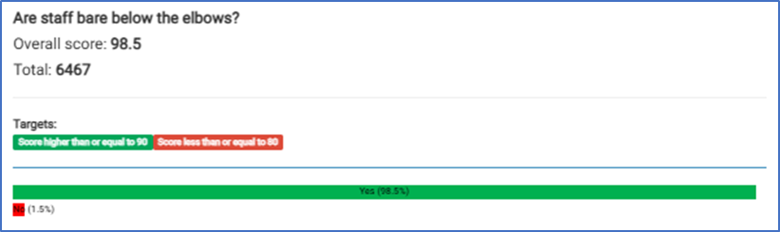

Figure 37: Bare Below the Elbows Compliance Breakdown Data (Trustwide)

|  |  |  |  |  |  |  |  |  |  |  |  |
| --- | --- | --- | --- | --- | --- | --- | --- | --- | --- | --- | --- |
| April | May | June | July | Aug | Sept | Oct | Nov | Dec | Jan | Feb | Mar |
| 98.8 | 98.7 | 98.2 | 97.8 | 99.3 | 97.7 | 98 | 98.9 | 98.5 | 98.3 | 98.9 | 98.8 |

* 1. The IPC team continues to challenge practice that falls below the standard expected when seen and offers support and guidance to staff so that they understand the importance complying with the hand hygiene and bare below the elbow’s when in the care environment.
  2. In 2024/25 the IPC team promoted World Hand Hygiene Day on 5th May by

carrying out trolley dashes across the hospital and putting on displays in the main entrance of the hospital. The IPC team used visual aids, handing out information, doing light box refresher sessions, using games and challenges to educate staff about the importance of hand hygiene in keeping patient’s safe and reducing the risk of cross-contamination to others across the organisation by refocusing attention through a less formal route. These sessions are always well attended not only by staff but have helped to remind visitors to the Trust of the important part they also play in minimising infection.

* 1. Following the commode audit in 2023 the Trust significantly invested in replacing it’s varying commode types for one single ‘easy clean’ variant. Since the roll out, the Trust has seen a noticeable improvement in GTHR audits scores.
  2. The commode and sluice facilities audit continues to show consistent positive results as seen in Figure 38.

Figure 38: Commode and Sluice Facilities Audit (Trustwide)

|  |  |  |  |  |  |  |  |  |  |  |  |
| --- | --- | --- | --- | --- | --- | --- | --- | --- | --- | --- | --- |
| April | May | June | July | Aug | Sept | Oct | Nov | Dec | Jan | Feb | Mar |
| 96.4 | 92.8 | 94.1 | 97.6 | 96.5 | 97.1 | 98.8 | 99 | 99 | 98.8 | 97.7 | 98.4 |

13.10 Peripheral cannula audits have been consistently under the Trust standard during 2024/25 but show an improvement on the previous financial year as shown in Figure 39. From IPC audits it has demonstrated that some falls in compliance is down to not dating IV devices post insertion and also not completing Saving Lives documentation. The IPC Team have addressed these issues with the respective clinical areas to prevent re-occurrence.

Figure 39: Trustwide Peripheral Cannula Audits 2023/24 and 2024/25 comparison

|  |  |  |  |  |  |  |  |  |  |  |  |  |
| --- | --- | --- | --- | --- | --- | --- | --- | --- | --- | --- | --- | --- |
|  | April | May | June | July | Aug | Sept | Oct | Nov | Dec | Jan | Feb | Mar |
| 23/24 | 88.8 | 87.6 | 85.5 | 85.1 | 87.4 | 81.7 | 81.7 | 80.5 | 79.6 | 81.9 | 85.4 | 84.2 |
| 24/25 | 83.6 | 83.8 | 78 | 87.2 | 89.4 | 88.2 | 87.5 | 88.6 | 90.4 | 89.3 | 87.8 | 92 |

Also through auditing it showed that planned date for removal and lack of documentation on continued need for the cannula was missing. The IPC team continues to work with EPR team to resolve these issues.

13.11 Gthr has also become an integral part of the reporting by wards and departments to the IPC operational group. Wards have to present their areas of challenge to allow for discussion from other areas who have good practice. This is a forum for sharing ideas and solutions.

13.12 Over the last year, a task and finish group was held in order to review the audits that ward managers undertake. The group initially focussed on IPC audits which saw 10 audits being reduced to 3 for inpatient areas and ED. The remaining audits that these areas were expected to complete are Hand Hygiene and Commodes weekly, and then Environmental audit on a monthly basis.

13.13 In March 2025, the IPC team absorbed the remaining audits into a condensed audit for inpatient areas and a separate one for the Emergency department which is to be conducted monthly by the IPC team.

13.14 Going forward these audits will be presented by the IPC team at Divisional meetings, IPCOG and IPCPG, which will feed into board level meetings.

# HOSPITAL CLEANLINESS

* 1. In April 2021 the NHS published the *National Standards of Healthcare Cleanliness* which would apply to all healthcare environments and replaced the *National specifications for cleanliness in the NHS* 2007
  2. These standards have now been fully implemented across the Trust as healthcare providers must clearly demonstrate how and what standard should be achieved by setting out clear accountability and responsibilities for cleaning the clinical environment
  3. Regular discussion at the Decontamination Group and the IPC Programme Group meetings highlight that cleaning staff needed further training which is currently in the process of pre roll out.
  4. In recent months, the IPC team have been working more closely with the senior housekeeping team to close the gap on any issues raised during the cleaning audits. Alongside this collaborate working to produce training for both housekeeping and department staff which will be introduced in the new financial year.
  5. The Friends and Family Test Gthr scores are an indicator for where further work is needed as it focuses on how clean the patients found the location where they were being cared for. The overall monthly scores for the Trust can be found below in Figure 40. An ongoing theme in these audits is the cleanliness of the toilets.

Figure 40 – Friend and Family Test Cleanliness Scores (Trustwide).

|  |  |  |  |  |  |  |  |  |  |  |  |
| --- | --- | --- | --- | --- | --- | --- | --- | --- | --- | --- | --- |
| April | May | June | July | Aug | Sep | Oct | Nov | Dec | Jan | Feb | Mar |
| 86% | 85% | 87% | 88% | 89% | 88% | 87% | 87% | 87% | 86% | 87% | 87% |

* 1. UV cleans continue to be the Trusts chosen method for decontaminating patient areas that have been exposed to infections. However, this method is only used in areas that can be completely sealed off, therefore will not be carried out in open Nightingale wards or nurses' stations.
  2. As seen in the graph in Figure 41, the UV cleans decrease during the summer months, which is in line with the winter escalation period when we see more cases of COVID-19 and diarrhoea related infections.

Figure 41 – The number of UV cleans in 2024/25.

The graph shows a breakdown per month of the number of UV cleans carried out in 2024/25.  The data shows as follows: 
April: 89
May: 59
June: 112
July: 45
August: 33
September: 41
October: 38
November: 62
December: 98
January 101
February: 60
March: 60

# DECONTAMINATION

* 1. The purpose of the Decontamination group is:
     + To implement and monitor compliance with the decontamination policy as defined in Health Technical Memorandum (HTM) 0101 Management and decontamination of surgical instruments (medical devices) used in acute care (Part A: Management and Provision), and the Health and Social Care Act 2008.
     + To ensure there are appropriate systems and processes in place for effective decontamination of patient environment and all patient equipment.
     + To monitor compliance with assessing risks against the Health and Safety at Work regulations for Trust employees and service users.
     + To ensure compliance with the Control of Substances Hazardous to Health (COSHH) regulations
     + To action UKCA/EU directives regarding medical devices
     + Review all audit data metric and actions in a timely manner
  2. The Decontamination group meets monthly and is chaired by the HoIPC. It reports into the IPCPG bi-monthly. The aim of the group is to move to bi-monthly meetings but after a prolonged period of monitoring to assure compliance.
  3. The core membership of the group is chaired by the Head of IPC and includes housekeeping lead, facilities team, ward managers, Matron’s, department managers and HoN’s.
  4. The group discusses the cleaning audit results for each clinical area, the participation scores for each area with ward staff supporting the audit alongside the housekeeping team and then any areas of concern.
  5. The Friends and Family Test Gthr scores are also discussed during this meeting, focussing on how clean the patients found the location where they were being nursed. This helps triangulate the audit data with the information patients are providing.
  6. The Trust appointed an Approved Engineer for Decontamination (AED) who liaises closely with the Decontamination Lead and authorising engineer on all matters relating to testing and verification of results. The AED also conducts an annual audit of the decontamination service to ensure it meets the required IHEEM standards.
  7. A continued programme of audit is planned throughout the forthcoming year using an audit tool looking at standards of cleaning and sterilization of equipment used within the hospital. These audits will provide valuable data to be reviewed at the group.
  8. The laundry department reports into this meeting, updating members on the number of washes carried out, issues with the machines and risks highlighted within the department. Numerous episodes of items being found in laundry including dentures, pads and needles has also been highlighted.
  9. For theatre equipment there have been issues throughout the year with sterile procedure trays holes or tears and therefore the sterility breached, however there were minimal reported by the latter part of 2024/25.
  10. Waste is an essential component of this meeting, which refers to the 2022 edition of the HTM 07-01: Safe and sustainable management of healthcare waste. Waste leads highlight that the effective segregation of waste is essential to ensure both statutory compliance (by preventing the mis-consigning of waste) and also to prevent waste from being treated using expensive processes when not required. The current TWM contracts prices per tonne for waste disposal are:

Dry mixed recycling: £55.00 + VAT per tonne

General waste: £130.63 + VAT per tonne

Offensive waste: £345.87 + VAT per Tonne

Infectious waste: £422.73 + VAT per Tonne

High Temp Incineration waste: £661.00 + VAT per tonne

* 1. A trial has taken place this year with SharpSmart in a bid to reduce the number of sharps injuries and look at potentially fully roll it out across the Trust.
  2. The Water Safety Group also feeds into this meeting and updates members on the regular legionella testing trust wide, where we have positive results and updates on further readings. Shower head changes are also discussed in this meeting, and areas within the Trust that due to inactive use of showers or taps, require regular flushing. They also reported on water temperatures and ensure that they meet the high and low levels.

# COMMODE AUDITS

* 1. Audits provides assurance to the Trust on the cleanliness, suitability, safety and durability of a device. Uploading audit data to Gthr enables effective review and monitoring of all data captured.
  2. A Trust wide commode audit was completed by the IPC team in June 2024 which showed continued improvement in the commode cleanliness compliance from its previous state.
  3. As of 2023, there were six different commode designs which posed various cleaning issues and technical concerns.
  4. In June 2024, 82 commodes were audited and a total of 25 commodes were identified to require replacements due to damages to lids, arms, seats, rusting of frames, commode liners holder, flaky paints etc.
  5. The ‘Clinell easy-clean' commode is becoming the primary model across the Trust, with only a small number of older units in circulation. These remaining units are being phased out and replaced as part of ongoing equipment upgrades.
  6. Since the introduction of the new commodes, the following actions have been implemented:
     + Ward/Department Managers are responsible for regular review of commode cleanliness within their clinical areas to ensure thorough cleaning and raise staff awareness of the potential IPC risks associated with soiled commodes.
     + Commode training was delivered to all staff on the ward, with link practitioners empowered to act as IPC champions, cascading key messages and reinforcing best practices.
     + Majority of the broken, damaged and outdated commodes have been replaced in line with the Trust’s standards as planned. The new models (Clinell) are easier to clean supporting efforts to reduce mismanagement and faecal pathogen growth.
     + Regular unannounced commode audits are carried out by the IPC team.
     + The “Commode Cleaning: 10 Point Plan” posters are also clearly displayed in all ward / department sluice(s), with Ward Managers responsible for ensuring their visibility and upkeep.
  7. As of 2024, there are 82 commodes in use across the Trust, following a reduction and standardisation process which began in 2023. The commode cleanliness scores have since steadily improved, supported by targeted interventions and continued IPC support as evidenced in Figure 42.

Figure 42 – 2023/24 & 2024/25 Commode Cleanliness Audit Comparison(Trustwide)

|  |  |  |  |  |  |  |  |  |  |  |  |  |
| --- | --- | --- | --- | --- | --- | --- | --- | --- | --- | --- | --- | --- |
|  | April | May | June | July | Aug | Sept | Oct | Nov | Dec | Jan | Feb | Mar |
| 24/25 | 96.3 | 87.4 | 88 | 94.7 | 93.9 | 95.3 | 93.8 | 93.5 | 98.2 | 93 | 95.7 | 96.8 |
| 23/24 | 81 | 78.8 | 87.7 | 90.4 | 86.2 | 89 | 92.5 | 84.8 | 95.1 | 94.4 | 91.5 | 93.3 |

# EDUCATION AND TRAINING

* 1. The *Code of Practice* requires that all staff undertake mandatory infection prevention and control training on a regular basis. The specific requirement is:

*‘That relevant staff, contractors and other persons whose normal duties are directly or indirectly concerned with patients’ care receive suitable and sufficient training, information and supervision on the measures required to prevent and control risks of infection’.*

* 1. Level 1 training, delivered via e-learning, is completed by non-clinical staff, while Level 2 training is required for all clinical and patient-facing staff.
  2. Training compliance by division has been reviewed at both IPCPG and Divisional Governance Care Group meetings, and the information has been incorporated into the divisional reports. Figure 43 shows the compliance data for all staff group as of the end of the 2024/25 period.

Figure 43: 2024/25 Overview of Trust IPC Training Compliance.

|  |  |  |  |  |
| --- | --- | --- | --- | --- |
|  | Column Labels |  |  |  |
|  | **Compliant** |  | **Compliance (%)** |  |
| Staff Group / Subject | Yes | No | Yes | No |
| **Add Prof Scientific and Technic** | 127 | **23** | 84.67% | **15.33%** |
| Infection Prevention L1 | 9 | 1 | 90.00% | 10.00% |
| Infection Prevention L2 | 118 | 22 | 84.29% | 15.71% |
| **Additional Clinical Services** | 942 | **72** | 92.90% | **7.10%** |
| Infection Prevention L1 | 15 | 2 | 88.24% | 11.76% |
| Infection Prevention L2 | 927 | 70 | 92.98% | 7.02% |
| **Administrative and Clerical** | 994 | **57** | 94.58% | **5.42%** |
| Infection Prevention L1 | 980 | 51 | 95.05% | 4.95% |
| Infection Prevention L2 | 14 | 6 | 70.00% | 30.00% |
| **Allied Health Professionals** | 218 | **20** | 91.60% | **8.40%** |
| Infection Prevention L1 | 2 | 0 | 100.00% | 0.00% |
| Infection Prevention L2 | 216 | 20 | 91.53% | 8.47% |
| **Estates and Ancillary** | 470 | **17** | 96.51% | **3.49%** |
| Infection Prevention L1 | 458 | 15 | 96.83% | 3.17% |
| Infection Prevention L2 | 12 | 2 | 85.71% | 14.29% |
| **Healthcare Scientists** | 3 | **2** | 60.00% | **40.00%** |
| Infection Prevention L1 | 2 | 1 | 66.67% | 33.33% |
| Infection Prevention L2 | 1 | 1 | 50.00% | 50.00% |
| **Medical and Dental** | 560 | **175** | 76.19% | **23.81%** |
| Infection Prevention L1 | 1 | 0 | 100.00% | 0.00% |
| Infection Prevention L2 | 559 | 175 | 76.16% | 23.84% |
| **Nursing and Midwifery Registered** | 1498 | **87** | 94.51% | **5.49%** |
| Infection Prevention L1 | 2 | 0 | 100.00% | 0.00% |
| Infection Prevention L2 | 1496 | 87 | 94.50% | 5.50% |
| **OVERALL SUMMARY** | 4812 | **453** | 91.40% | **8.60%** |

* 1. The IPC team provides placements for student nurses and Student Nurse Associates (SNAs), lasting between 4 to 8 weeks. These placements have proven to be highly valuable in enhancing students’ understanding of infection prevention and control, as well as the broader management practices essential for maintaining safe and effective hospital services.
  2. The team continues to make ongoing improvements to enhance the student experience, guided by feedback from previous placements. A welcome booklet has been developed and is sent out prior to the students’ arrival. It includes key information such as working hours, team contact details, and an overview of what to expect during the placement.
  3. Students placed with the IPC Team are allotted time with various members of the team to understand the depth and wealth of the work undertaken by the IPC Team. They are also given opportunities to shadow professionals from the wider multidisciplinary team, both those directly and indirectly involved in IPC, to gain a well-rounded understanding of collaborative approaches in clinical practice.
  4. The IPC Team delivers Hand Hygiene training every Wednesday as part of the Trust induction program. This session uses a combination of simulation and discussion-based teaching methods to engage staff effectively.
  5. The IPC Team has been included in the annual doctors' induction each August. During the session, simulation and observational methods are employed to focus on the principles of infection control.
  6. The IPC Team has also provided additional training to Year 12 students and students at Mid-Kent College, focusing on the fundamentals of infection prevention and control.
  7. During the 2024/25 financial year, the IPC Team delivered simulation-based training across 10 wards, with a primary focus on the Medicine and Emergency divisions. The sessions were attended by a multidisciplinary group of staff, including nurses, doctors, phlebotomists, and clinical support workers (CSWs), with a total of 279 participants. The training covered key infection prevention topics such as MRSA colonisation, GDH, *Clostridioides difficile* (C. difficile), and Carbapenemase-Producing Enterobacteriaceae (CPE).

# IPC LINK PRACTITIONERS

* 1. IPC Link practitioner training was re-established in July 2022. IPC Link practitioners are required to attend regular updates provided by the IPC Team and be an active participant at these meetings.
  2. Each ward and department have signed up to provide a minimum of one practitioner (Trained or Untrained) who will represent their respective clinical area attending at least 75% of these sessions, which run for a half day quarterly throughout the year.
  3. IPC Link sessions are chaired by the IPC Matron and external speakers also provide content and support delivering additional updates on products being used or planned for introduction into the hospital. Housekeeping have a fix slot every meeting.
  4. Subjects covered can include but not limited to:
     + The Infection Admission Assessment becoming mandatory.
     + Checking results on iLab and not relying on the IPC team for notifications.
     + Re-iteration on how to use the Diarrhoea Assessment Tool.
     + Correct sharps bin use and Sharps safety.
     + Cannula care across the Trust, checking devices, completing documentation daily and removing devices that are not needed.
     + What Antimicrobial Stewardship is, its importance and whether they want to become AMS Champions.
     + What IPC Standard Precautions are, their importance and what is happening within the Trust regarding these standards.
     + What CPE is and all the components around it.
     + The latest housekeeping issues and updates across the Trust
     + A reflection on the upcoming Links Annual Showcase in October and what to expect.
  5. The Kent and Medway ICB IPC conference runs annually and offers places for IPC Link Practitioners throughout Kent and Medway to attend in addition to the education sessions provided by the Trust.
  6. In October 2024 the IPC team presented its second IPC Link Practitioners showcase, which concludes the annual Infection Prevention week. The links were asked to prepare a presentation of an improvement that they had implemented or tried to implement within their work area. The event was attended by 19 link practitioners with 10 wards presenting on the day. The presentations were judged by a panel of the Deputy Chief Nursing Officer/Associate Director for IPC and a member of the NHSE IPC team.
  7. Awards were given for 1st, joint 2nd, and 3rd and for presentations demonstrating

innovation and passion. A breakdown can be seen below.

|  |  |  |  |
| --- | --- | --- | --- |
| **Award** | **Link Practitioner** | **Ward** | **Project Description** |
| 1st Place | Irish Carandang | SDEC | The improvement project was called ‘If You Care, Clean the Chair’. The department introduced a sliding sign above each patient chair space to indicate whether it had been cleaned, and proved to be a successful intervention. |
| 2nd Place | Issac Motte | Kingfisher | ‘Appropriate Usage of Personal Protective Equipment’  This project looked at re-educating the staff on the ward on what PPE to wear, when to wear it and how to DON and DOFF it. They used the slogan ‘See it, Say it, Sort it’. |
| 2nd Place | Eduardo Vargas | Main Theatres | The focus of this project was more wide spread within the department, and looked at where they are in relation to IPC and what they aim to do going forward to make further improvements. They looked at Hand hygiene, Dress code, Appropriate waste segregation and tidying up their waste disposal area, with positive improvements. In addition, they looked at a potential IPC safety audit available. |
| 3rd Place | Paul Oldak | Phoenix | ‘Safer Environment Safer Care’  General issues on the ward were explored and improvements were made as follows:   * Removal of clean linen off of the cupboard floor and more shelves built in. * 2 hourly toilet checklist to ensure they are clean and in good working order. |

* + - The Ward with the Longest Infection Free Period – Awarded to Emerald Assessment Unit.
    - Most Improved Ward – Awarded to McCulloch Ward.
    - Most Engaged Department – Awarded to Sheppey Frailty Unit.
    - Long service as a link practitioner – Awarded to Nuala Brady-Murphy.
  1. The day was well received by all including ward and care group teams who attended to support.
  2. The IPC team are planning to continue to make this an annual event and have already started planning for this year.

# FIT TESTING

* 1. FFP 3 Fit-testing principles for Acute Hospital Trusts introduced in June 2021 became mandatory and forms part of EPRR Core standard 12 and being a legal requirement in August 2022. The Trust must have arrangements in place to respond to an infectious disease outbreak within the organisation or the community it serves, covering a range of diseases including high consequence infectious diseases (HCIDs).
  2. Initially, 3,209 hospital workers were required to undergo FIT testing as part of their training profile during the pandemic. However, with the relaxation of COVID-19 guidelines and a decrease in COVID cases, a review of the staff numbers was conducted, reducing the total to nearly 1,600. A further review of the staff groups requiring FIT testing is currently underway.
  3. The IPC Team continue to manage the mandatory fit-testing programme following Ashfield’s departure from the Trust and the IPC Team were all re-trained to undertake qualitative fit testing using either a bitter or sweet fit testing solution. Face2fit undertook the training for all IPC team members and sessions were rostered for all staff identified following a staffing review.
  4. The procurement team has worked alongside the IPC Team in the development of mask procurement to ensure that they are UK sourced and that the Trust has adequate stocks of all mask types within the clinical areas.
  5. Currently, staff undergo FIT testing with an FFP3 mask from the approved product range. In instances where staff are unable to pass the fit test due to factors such as altered facial features, beards for religious reasons, or sensitivity to the masks, the IPC Team offers specialised training on the use of half masks as an alternative.
  6. The graphs below (Figure 44 and Figure 45) present data on the total number of staff trained, DNA (Did Not Attend) rates, and the fit mask testing across different staff groups The DNA rates for the last financial year was 45%. Out of the 674 sessions that were offered only 368 attended the Fit Testing sessions.

Figure 44: 2024/25 Overview of Fit Testing sessions and DNAs.

The graph shows the total number of Fit Mask sessions per month versus DNAs.  The information is displayed as follows:
April: 74 sessions, 17 DNA
May: 59 sessions, 22 DNA
June: 42 sessions, 21 DNA
July: 64 sessions, 15 DNA
August: 69 sessions, 20 DNA
September: 49 sessions, 25 DNA
October: 50 sessions, 30 DNA
November: 53 sessions, 43 DNA
December: 35 sessions, 34 DNA
January: 71 sessions, 31 DNA
February: 78 sessions, 34 DNA
March: 30 sessions, 14 DNA

Figure 45: 2024/25 Fit Tested Staff Breakdown.

The graph gives a breakdown of the number of each of the staff groups that were fit tested per month. 
The staff groups captured are: Doctors, Nurses, CSWs, AHP and Others. 

* 1. The IPC Team has procured a Porta Count machine to reduce dependence on traditional fit testing solutions, which were often found to be unpleasant by staff. Team members are scheduled to undergo training in its use within the forthcoming year.

# ESTATES/IPC/HOUSEKEEPING WALK ABOUTS

* 1. The joint IPC/Housekeeping and Facilities bi weekly walkabouts sought to address and remedy estates and cleaning issues.
  2. The programme began in June 2022 and consisted of representatives from Estates team (Director), ADIPC or IPC Matron, an estates team representative, Building, Electrical, Ventilation/water, Housekeeping/Hotel services, and then as needed Fire and Health and safety, Ward Manager/Matron.
  3. Fast forward to 2024/25 and the walkabouts are now carried out by the IPC Matron, a Housekeeping team leader/supervisor or associate manager and a member of the Senior Estates team. Information is then cascaded back to the corresponding teams in relation to any minor work that needs completing.
  4. These walkabouts have been successful in highlighting and addressing the problems within the Trust’s estate generating a lot of actions.
  5. The latest ward to be refurbished was Ruby Ward in April 2024, when the Trust took it over in 2024.
  6. It enables the teams involved to look at the fabric of the estate and seek to put right any issues or damage seen making the environment cleaner and safer for patients.
  7. To facilitate the visits, the IPC team developed an audit schedule to highlight the areas that need reviewing and ensure that all areas are covered. The information collected is then uploaded to Gthr.
  8. The previous year focused on the inpatient areas. In 2024/25 we changed to assessment and review of all outpatient areas and other areas across the Trust including stairwells and corridors.
  9. The flooring across the Trust has been highlighted as a major job that needs reviewing to ascertain what areas are most in need of replacement as due to budget constraints not all areas can be remedied straight away.
  10. A plan is in place to do a toilet Gemba across the Trust in 2025/26, as this is a theme highlighted in the Trust Friends and Family test feed back

# NEXT STEPS

21.1 Finalisation of Process Mapping: The process mapping for Elective Total Hip Replacement (THR) and Total Knee Replacement (TKR) will be finalised to standardise procedures and ensure consistency across the pathway.

21.2 Collaboration with BD: A joint initiative with BD will be undertaken to develop a Practice Versus Guidance (PVG) review. This will inform ongoing improvement efforts, culminating in the development of a case study to support shared learning and best practice dissemination.

21.3 Quality Improvement: Transmission-Based Precautions: A quality improvement project is underway to address staff understanding of transmission-based precautions. Following a recent staff survey piloted on Harvey Ward, education and training initiatives are being developed to address identified knowledge gaps.

21.4 Targeted Training on Clostridioides difficile (C. diff): Focused teaching sessions on C. diff have commenced, including the identification of 'C. diff Champions' to drive adherence to IPC standards. This initiative, which began in March, is currently focused on frailty wards where incidence rates have been highest.

21.5 CAUTI Reduction Project: Engagement with Urology Specialist Nurses is planned to explore strategies for reducing catheter-associated urinary tract infections (CAUTIs), with potential for a dedicated project aimed at further reduction.

21.6 Train the IPC team on the new Porter Count machine in order to continue supplying a FIT Testing service to the Trust and increase the number of Fit Testers within the team.

21.7 Developing an IPC web page with links to all of the surveillance data, organism of the month and key messages with learning from SWARMs and AARs.

21.8 Continue to work with the housekeeping team to ensure Standards of Cleanliness are met. In addition, collaborate on a teaching toolbox for Day Surgery and Diagnostics to enable them to competently clean patient spaces between a fast-paced patient turnover reducing the need for the bed turnaround team, which will free them up to attend to inpatient discharges resulting in faster paced bed availability.

# CONCLUDING REMARKS

* 1. This year like most others have had its challenges and the IPC Team have risen to the challenge by continuing to build and forge great links with all clinical teams across throughout the organisation including working well with Estates and Facilities make changes to both cleanliness and the fabric of the Trust’s estate.
  2. The IPC team have achieved a great deal in 2024/25 by further building and developing the FIT testing service so that it meets the needs of our regulatory responsibilities and the organisation as a whole.
  3. SSIS has continued to grow and has ensured closer working relationships with the surgical team in gathering information to ensure safer surgery in particular the orthopaedic team. The IPC team took on colorectal SSI data collection, but it paused intermittently to allow for staff recruitment and will continue as able,
  4. The team remain committed to delivering a robust and adaptable IPC service to the Trust and are fully integrated into the divisions and care groups with an IPC team member regularly in attendance at these meetings. We are also very visible within the clinical areas supporting, nurturing and advising all grades of staff working for the Trust and for the benefit of our patients using our services.
  5. The team are fully committed to working collaboratively incorporating facilities, clinical and procurement teams in trialling new products, reviewing practices and implementing new processes in the fight against infection.
  6. A successful relaunched IPC link practitioner programme was rolled out 3 years ago and continues with good participation from staff around the Trust. This year we ended the International IPC week with our 2nd Annual Link Practitioner Showcase event to celebrate and reward the vital support work that they do. The showcase event also saw link practitioners present a project that they implemented or attempted to, with information shared about barriers met. We had external stakeholders at this event where prizes were awarded to the most innovative subject. We thank Jackie Dalton from NHSE/I IPC team and our Deputy Chief Nurse/Associate Director for IPC for their time and helping to judge this event.
  7. Due to the increase in Clostridioides difficile cases nationally the IPC team have devised a simulation training programme which is additional to our usual supportive processes which aims to make staff stop, think and focus on what measures should be taken, these sessions used the simulation training room when it was available, to mock a scenario to focus minds on best practice thus trying to avoid needless harm to patients and a disruption of our services. Primary feedback from teams proved encouraging and our progress is being followed by NHSE/I for possible national rollout.
  8. The IPC service continues over 7 days to further support the vital work of our nursing and clinical colleagues. Since its inception staff have really embraced this service and we hope to build on what we can offer the teams moving forward. However, due to staff vacancies the weekends have only been covered in the mornings until further notice.
  9. Although the use of the Quality Improvement Plan was fairly new to us this year, we have developed it from key themes and trends from investigations in 2024/25 to drive improvements across the Trust and to support delivery of the IPC strategy.

ENDS.