  - Patient Safety Partner
  - JOB DESCRIPTION

  - About the Trust

Medway NHS Foundation Trust serves a population of more than 424,000 across Medway and Swale (Sittingbourne and the Isle of Sheppey). In 2022, we provided care for more than 125,000 patients in our Emergency Department and more than 88,000 inpatients on our wards. More than 278,000 outpatient appointments took place, and in our maternity care services, more than 5,000 babies were born in the hospital and community. As an NHS Foundation Trust, we have a 26-strong Council of Governors with more than 10,000 public members. We employ 4,400 staff, making us one of Medway’s largest employers.

At Medway NHS Foundation Trust, we are dedicated to putting our patients first, at the heart of everything we do. Every time we interact with our patients, their families and carers, we should ensure our interactions are prompt and positive. This requires both listening to the patient and working together with colleagues as a team to provide the right care, in the right place, at the right time.

  - Mission, Vision and Aspirations

  - Our vision and values are a really important statement of the healthcare provider we want to be and of the way we work together. They have been shaped by feedback following engagement with more than 600 members of staff, through surveys, workshops and focus groups. Our staff live these values every day.

Our mission is to provide the “best of care by the best of people”, providing excellent care every time. By 2028, our vision is to deliver the best care outcomes through brilliant people, and be a leading partner within an integrated system of health and social care, providing a patient experience without boundaries.

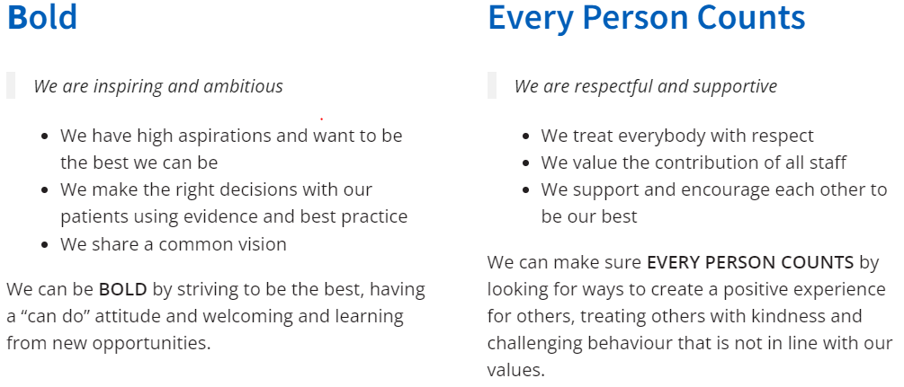

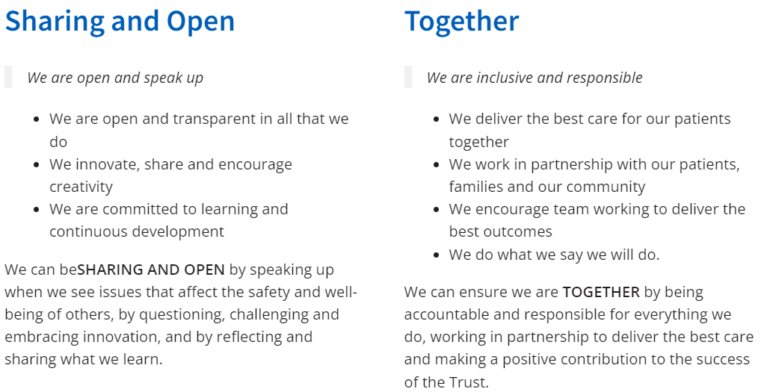

Patient First highlights our core commitment to putting the patient first every time. We do this by focusing on continuous improvement, delivering the best of care through the best of people. The Trust’s values underpin everything we do and we all work to these values in the delivery of safe, consistent and high quality patient care.

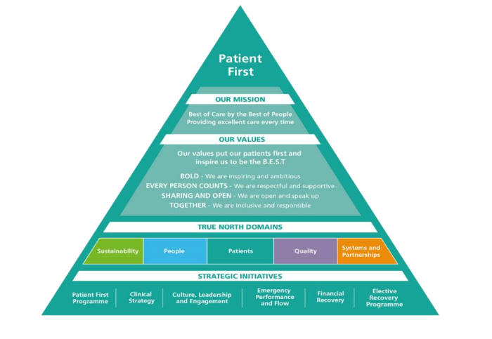

‘Patient First’ is a combination of our mission, Trust values, True North domains, supported by strategic initiatives, breakthrough objectives and corporate projects. In order to deliver these, a management system is in place, alongside a set of principles around leadership behaviours.

Building on our strategy ‘triangle’, our True North domains have the following ambitions and visions:
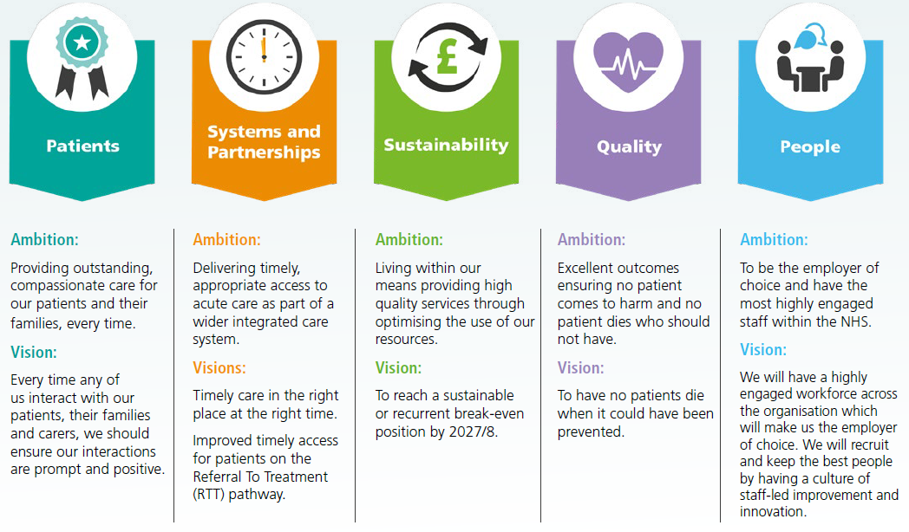

  - Job Description

Job title | Patient Safety Partner
Division | Integrated Governance, Quality and Patient Safety
Responsible to | Head of Patient Safety
Accountable to | Deputy Director of Integrated Governance, Quality and Patient Safety
Type of contract
Hours per month | 15
Location | Medway Maritime Hospital or Medway Community Healthcare
Job Summary
The role of a Patient Safety Partner (PSP) is to support the design of safer healthcare at all levels in the organisation and will be involved in key projects related to patient safety. At Medway NHS Foundation Trust, our Patient Safety Partners will reflect the voice and needs of the people that use our hospital and community-based health services to help us develop safer services in partnership with patients, families and carers.

PSPs will sit on committees to support safety improvement by exploring how safety issues should be addressed and providing appropriate challenge to ensure learning and improvement. PSPs will also be involved in the development and implementation of relevant strategy and policy.

The successful candidate will need to comply with relevant policies and maintain strict confidentiality in respect to discussions and information when required.
Key Tasks

Attendance at relevant Quality and Safety committees to contribute to and support compliance with monitoring and improvement.

Acting as an adviser/critical friend to the Clinical Governance team in the development and delivery of the Patient Safety Strategy.

Putting forward views on behalf of the wider Community/Groups of Patients/Service Users (not own opinion only) through the Patient Experience team.

Evaluating a range of information and evidence and communicating with senior leaders about strategic issues, as an advocate for patient safety.

Championing Quality and Safety improvements to support the Trust in implementation of the relevant strategy and policy.

Roles and Responsibilities

Skills and experience
- Understanding of and broad interest in patient safety.
- Ability to communicate your view and feedback about patient safety reports, polices and guidelines.
- Ability to understand and evaluate a range of information and evidence.
- Confidence to communicate well verbally with senior leaders about strategic issues, as an advocate for patient safety.
- Ability to provide a patient, carer, or lay perspective and to put forward views on behalf of the wider community/groups of patients (not own opinion only).
- Experience of championing health improvements; able to be a critical friend.
- Interaction with multiple stakeholders including NHS staff, voluntary sector and community groups e.g. Health watch and patient user groups
- Experience of working in partnership with healthcare organisations or programmes.
- Sound judgement and an ability to be objective.
- Personal integrity and commitment to openness, inclusiveness and high standards.

Training
There is a requirement for Patient Safety Partners to be trained in patient safety knowledge when needs are identified and training is available. Where possible and appropriate this training will be with staff. Mandatory training may also be required, including in one or more of the following:
- Patient Safety Syllabus
- Information governance
- Equality and diversity
- Safeguarding level 1
- Infection prevention including hand hygiene.

Further training will be available to PSP’s to support them to be effective in their role.

What support will you receive?

- You will have a named person who will meet you regularly to discuss your experience and tackle any concerns.
- We will reimburse expenses for reasonable out of pocket expenses in accordance with the relevant Trust policies.
Personal
- Adhere to the principles of the PSP agreement.
- Inform relevant person if unable to attend meetings or undertake any other identified activities.
Communication
- Report any safety incidents to staff.
- Ensure that patient confidentiality is always maintained.
Equality and diversity
- Have an understanding of individual patients’ needs; consideration for cultural and religious requirements.
- Act in accordance with trust’s policy and procedures.
General

This job description may be subject to change according to the varying needs of the service. Such changes will be made after discussion between the post holder and his/her manager.

All duties must be carried out under supervision or within Trust policy and procedure. You must never undertake any duties that are outside your area of skill or knowledge level. If you are unsure you must seek clarification from a more senior member of staff.

Additional Information

This post will be subject to an enhanced disclosure check with the Disclosure and Barring Service. For more information regarding the DBS please access the following web site, www.gov.uk/disclosure-barring-service-check.

Person Specification

Job title | Patient Safety Partner

Evidence for suitability in the role will be measured via a mixture of application form and interview.
Essential: E Desirable: D

Trust Values
Putting patients first | E
Responsive to, and supportive of, patients and staff | E
Open, welcoming and honest | E
Unfailingly kind, treating everyone with respect, compassion and dignity | E
Determined to develop our skills and continuously improve the quality of care | E

Requirements
Live, work, study or have connections with Medway or the area of Medway and Swale | E
Commit to the role for a minimum of 1 year | E

Experience
Experience of championing health improvements; able to be a critical friend | E
Experience of working in partnership with healthcare organisations or programmes | D

Skills and knowledge
Ability to communicate well in writing and read comprehensive reports | E
Ability to understand and evaluate a range of information and evidence | E
Confidence to communicate well verbally with senior leaders about strategic issues, as an advocate for patient safety | E
Ability to provide a patient, carer, or lay perspective and to put forward views on behalf of the wider community/groups of patients (not own opinion only) | E
Competent in using Microsoft Office and Excel and the internet | D
Interaction with multiple stakeholders at senior management level | D

Personal qualities
Sound judgement and an ability to be objective | E
Personal integrity and commitment to openness, inclusiveness and high standards | E
Interest in patient safety | D

