

Quality Strategy 2024-2027: A summary

I am delighted to introduce this summary of our Quality Strategy for the next three years, highlighting our visions and aspirations for providing high quality care, reducing harms and improving patient experience and outcomes.
This strategy supports the Trust’s philosophy of Patient First, delivering on two key areas (which we call True North domains):
- Quality: Excellent outcomes, ensuring no patient comes to harm and no patient dies who should not have, and
- Patients: Providing outstanding, compassionate care for our patients and their families or carers every time
It has been compiled with our local system partners and aligns to the Kent and Medway Integrated Care Board Strategy to ensure we work collaboratively. My thanks to everyone involved.


Jayne Black
Chief Executive Officer

Introduction

We have improved our Quality Governance arrangements, systems and processes and are now in a position to devise a strategy for continued improvement.
Following the Covid-19 pandemic, there were a number of national backlogs across the integrated governance and quality agenda. This is because business as usual systems and processes were placed on hold while our staff were focused on Covid-19.
As we reduce these backlogs and return to business as usual, and in implementing the National Patient Safety Strategy, we have opportunities to review, revise and improve the business as usual systems and processes to provide clear and concise quality governance and assurance.
Our Quality Strategy, along with the different initiatives arising from it, will enable us to embed important and substantial quality improvements.
Our strategy is a critical and key part of our aspirational journey to provide care and treatment rated as ‘Outstanding’ by the Care Quality Commission (CQC).

Core Values

Patient First highlights our core commitment to putting the patient first every time. We do this by focusing on continuous improvement, delivering the best of care through the best of people. The Trust’s values underpin everything we do and we all work to these values:
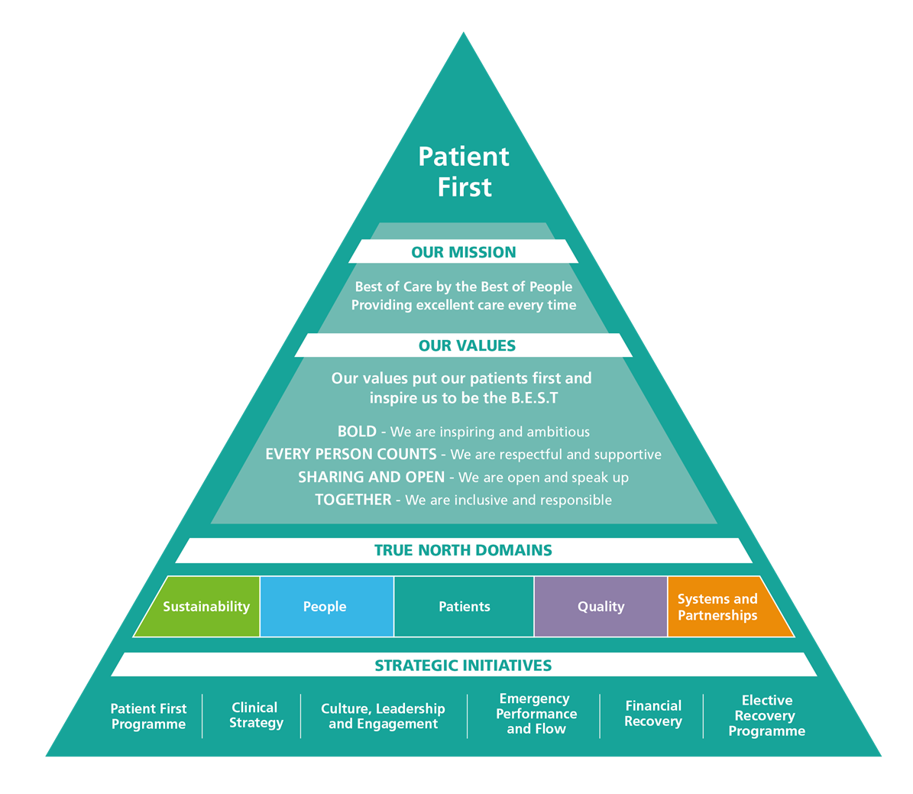

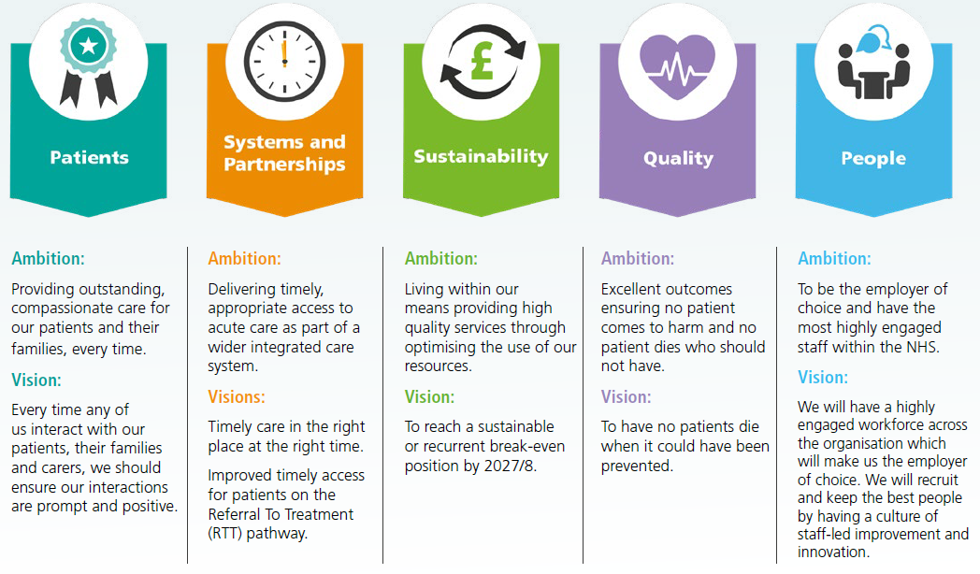
The Quality Strategy will help us to achieve our Quality ambition and vision within the Patient First triangle (above.) The Quality Strategy aligns to our True North Domain of Quality.

Further to this, there are a number of relevant strategies and policies Trust-wide that link into the Quality Strategy, (such as the Patient Experience Strategy and Infection Prevention and Control Strategy). Together, our strategies will deliver a number of initiatives to ensure that all patients receive high quality care for improved outcomes.

SWOT (Strengths, Weaknesses, Opportunities, Threats) Analysis
In preparation of this strategy, we worked closely with staff, patients and external stakeholders through a number of listening events and engagement sessions, to create a strategy that was fit for purpose.
From this activity, we highlighted strengths, weaknesses, opportunities and threats to our Quality Strategy, all of which are outlined in the full strategy document.

Mission, Vision and Aspirations
We are dedicated to putting our patients first by continually improving. All staff are responsible for ensuring the safety of our patients, challenging poor practice and reporting and learning from incidents. Keeping our patients safe from harm is everyone’s business.
We know that there is still work to be done to recover from the Covid-19 backlogs, implement and embed the NHS Patient Safety Strategy and improve evidence-based practice and outcomes for our patients.
This strategy will make sure that we:
    - reduce harm to patients and create a culture of safety responding to and learning from patient safety incidents
    - provide the best experiences of care for our patients, families and carers and respond appropriately when we get this wrong
    - provide evidence based and best practice care
    - develop, implement and monitor quality improvement plans.
This strategy supports the Patient First methodology and is our structured approach and plan to enhance our quality practices and improve quality of care.

Our Governance, Leadership and Regulation
We have been working to embed a strong system of quality and professional governance including accountability, authority and responsibility for quality, safety and experience at individual, team, service and organisational levels. We are committed to ensuring that we continue to embed and develop this oversight model.
Full details of the Governance, Leadership and Regulation model are contained within the full strategy.

Objectives and Key Results
The Quality Strategy has been broken down over three years with the following Objectives and Key Results in each year:
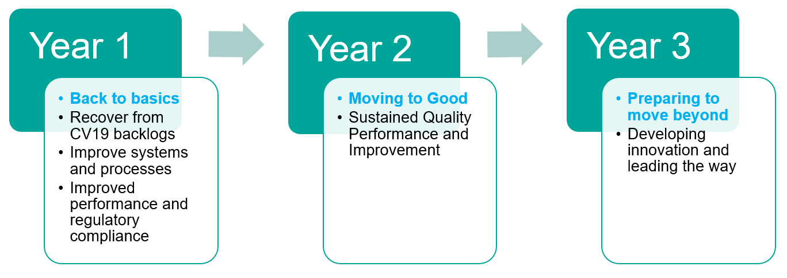
The strategy is underpinned by four key priorities:
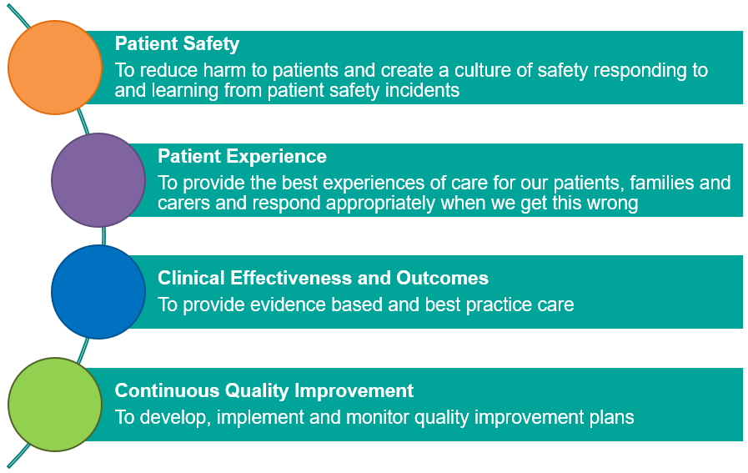
In addition to the above key areas the Trust is also committed to fully implementing national priorities such as the Implementation of the NHS Patient Safety Strategy.

Metrics and Key Performance Indicators
For this strategy to be meaningful for our patients, the implementation must be measured on its delivery. A detailed delivery plan has been developed, which sets out the key activities, success measures and timescales to achieve our aims. The plan will be continually reviewed, responding to new and emerging priorities as well as assuring delivery of Key Performance Indicators (KPIs) by 2026. Further details are available in the full strategy.

Further information
A copy of our full strategy is available by contacting our Strategies Team on medwayft.strategyandpartnerships@nhs.net

