Meeting of the People Committee

Wednesday, 31 July 2024

Workforce Race Equality Standard Data Report for 2024

Report Author Alister McClure, Head of Equality and Inclusion

Lead Director Leon Hinton, Chief People Officer

Executive Summary

1.1 The main purpose of the Workforce Race Equality Standard (WRES) is:
    - to help local, and national, NHS organisations (and other organisations providing NHS services) to review their data against the nine WRES indicators,
    - to produce action plans to close the gaps in workplace experience between white and Black and Ethnic Minority (BME) staff, and,
    - to improve BME representation at the Board level of the organisation.
1.2 The WRES assessment has been prepared following revised technical guidance published by NHS England in 2021. There are 9 performance indicators.
[For indicators 2, 3 and 4, a score of 1.00 equals equity. A score of greater than 1.00 shows an advantage to White staff; a score of less than 1.00 shows an advantage to BME staff.]
1.3 It is a mandatory requirement in NHS standard contracts (Schedule 6a) to report on the WRES, and publish the data by 31 August each year, and publish a WRES Action Plan by 30 September.
- KEY FINDINGS

  - The WRES data report has been prepared following revised technical guidance published by NHS England in 2021. There are 9 performance indicators, [For indicators 2, 3 and 4, a score of 1.00 equals equity. A score of greater than 1.00 shows an advantage to White staff; a score of less than 1.00 shows an advantage to BME staff.] Indicator 9 (Board representation is not included in this report, is in the online data report.

  - Indicator 1 – Workforce profile

Staff in each of the Agenda for Change (AfC) Bands 1-9 and VSM (including Executive Group members) compared with staff in the overall workforce.
This information is required to be broken down not only by band, but also separating clinical non-medical, medical and dental and non-clinical staff. The data shows that there points in progression between grades where the proportion of BME staff in the workforce is lower than expected. For example, there is a dip in representation from Bands 6 and 7, (prior to 2023 the dip was between Bands 5 and 6) and progressively from Bands 5 through to 8a in the non-medical clinical workforce. The Trust’s workforce is considerably more diverse than the local population, and the representation of staff for Black, Asian and Minority Ethnic (BME) backgrounds is similar to the local population from Bands 5 to 7 of the non-clinical workforce.
There is significantly higher representation of people from BME backgrounds in medical and dental roles, which is reflective of the profile of their professions.

Cluster (Bands) | Non-Clinical | Clinical
- 1-4 | 14.8% | 29.8%
2. 5-7 | 16.2% | 48.3%
3. 8a-8b | 12.3% | 23.1%
4. 8c-VSM | 7.5% | 11.8%
Average | 14.8% | 40.9%

Cluster | Medical and Dental
Trainees | 50.0%
Non-Consultant | 75.5%
Consultant | 63.6%
Total | 64.2%
  - Indicator 2 - Relative likelihood of staff being appointed from shortlisting across all posts.
Performance in 2024: 0.49
In 2015/16, White people shortlisted for interview were 2.58 times more likely than BME people to be appointed. By 2020 this gap narrowed to 1.1 times, and widened by 2022 to 1.52 times. The ratio for 2024 appears to be 0.49, which suggests that White people are less likely to appointed from shortlist compared to Black, Asian, and Minority Ethnic/Global Majority people.
2023 | 2024 | Comment
1.67 | 0.49 | Improvement in terms of positive action; deterioration in terms of equity. BME staff more likely to be appointed White staff; however, BAME people still less evident in senior appointments

However, significant work at the Band 5/6 threshold has been done to promote the development of nursing staff. Additionally, Indicator 2 needs to be read in conjunction with indicator 1, the workforce profile, which continues to identify under-representation of Black, Asian and Minority Ethnic staff.
For clarity, in accordance with the technical guidance this indicator does include international nurse recruitment (consistent with previous reports).

  - Indicator 3 - Relative likelihood of staff entering the formal disciplinary process, as measured by entry into a formal disciplinary investigation. Performance in 2024:1.66
This is deterioration from 2023
Likelihood of staff entering the formal disciplinary process, as measured by entry into a formal disciplinary investigation
WRES year | White employees | BME employees | Relative likelihood (ratio)  (1.00 = equality)
2024 | 0.59% | 0.98% | 1.66
2023 | 0.58% | 0.62% | 1.06
2022 | 0.5% | 0.4% | 0.80
2021 | 0.74% | 0.76% | 1.03
2020 | 1.53% | 0.90% | 0.59
2019 | 2.23% | 1.25% | 0.56

  - Indicator 4 - Relative likelihood of staff accessing non-mandatory training and CPD.
Performance in 2022: 1.00
NHS organisations set and are expected to explain their definition of non-mandatory training. The Trust defines access to non-mandatory training as being all training available via My ESR (the training platform that is part of the NHS Electronic Staff Record) with the exception of Statutory and Mandatory training courses under the Core Training Standards Framework, and courses regarded as essential training (including FIT testing). Continued Professional Development (CPD) is defined as formal courses provided by Universities and other external providers. In house professional development specific to individual clinical disciplines and medical education are not included. The take up of either CPD or Non-mandatory training is compared for White and BME staff, and the data taken from the Electronic Staff Record (ESR)
The data for this indicator shows that the performance on this indicator shows that 100%% of BME staff and White staff accessed non-mandatory training. This creates a relative likelihood of uptake at 1.00. Discussion at the Equality and Inclusion Steering Group concluded that this indicator does not provide valuable insights, but the Trust should instead develop a local indicator on Continuous Professional Development.

Table - Indicator 4 – NON-MANDATORY TRAINING
Likelihood of staff accessing non-mandatory training and CPD
Year | White employees | BME employees | Relative likelihood  (ratio)  (1.00 = equality)
2024 | 100% | 100% | 1.00
2023 | 97.48% | 97.46% | 1.00
2022 | 86% | 82% | 1.05

Note: Up to 2020, and in 2022, essential training was included in the definition of non-mandatory training. However, the uptake of non-mandatory training in 2020 was artificially inflated by the inclusion of Covid-19 related training in January to March 2020. Therefore, universal essential training was removed from the calculations in 2021 only

Indicators 5-8 – Staff Perception indicators
These were reported at a previous meeting, of the Committee, and do not need to be submitted again.

Indicator 9 – Board Representation
White | BME | Comment
10% over | 18% under | May be affected by 3 of 16 Board members not declaring ethnicity

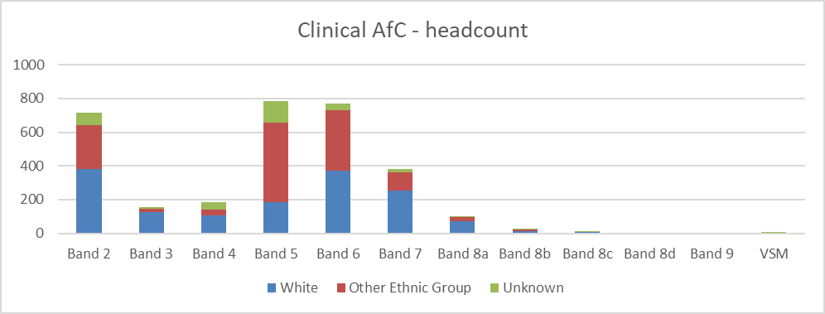Appendix 3A – Indicator 1 Charts

