r

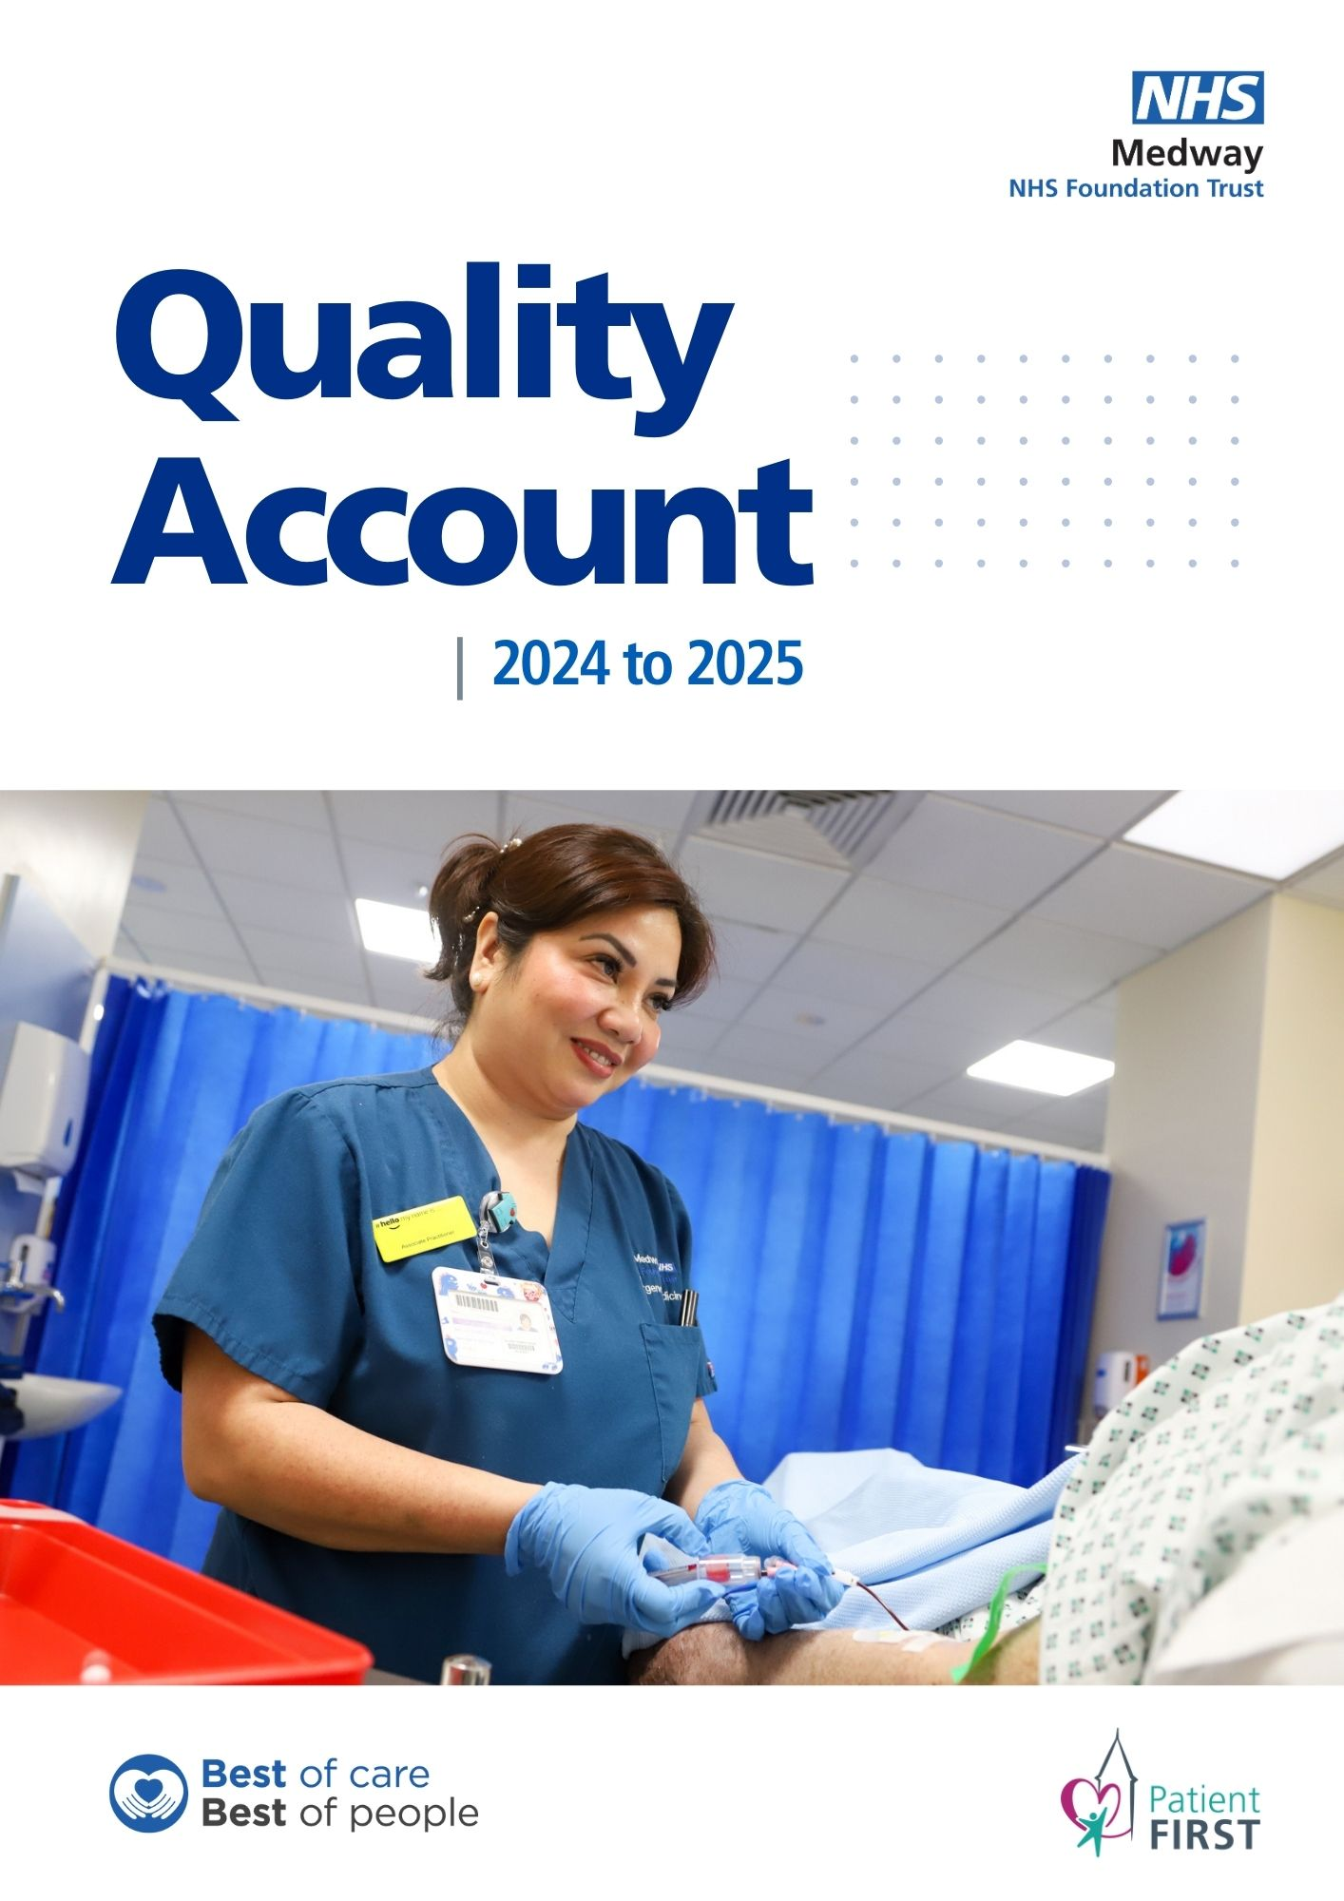

Table of Contents

Part 1: Chief Executive’s Foreword 2
Performance Overview: Introduction to the Quality Account 2024/25 3
Part 2: Priorities for Improvement and Statements of Assurance from the Board 4
2.1 Priorities for Improvement 2024/25 4
2.2 Quality Priorities 2024/25 5
2.3 Progress against our 2023/24 Quality Account Priorities 12
2.4 Statements of Assurance 2024/25 34
2.5 Reporting Against Core Indicators 56
2.6 Other Quality Information 72
Annex 1: Statements from Commissioners, Local Healthwatch Organisations and Overview and Scrutiny Committees 80
Annex 2: Statement of Directors Responsible for the Quality Report 89
Annex 3: National and Local Clinical Audit Participation 94
Glossary 101

Part 1: Chief Executive’s Foreword
As a provider of healthcare services to the local community, the Trust is committed to delivering safe, effective, and compassionate care to all patients. This Quality Account provides an opportunity to reflect on our achievements over the past year and to set out our priorities for the coming year. We have worked hard to engage with our patients, staff, and stakeholders to ensure that we are delivering high quality services that meet the needs of our local population.
Our focus on quality improvement is at the heart of everything we do, and we are constantly striving to improve the care we provide. Since our last Quality Account was produced, the Trust, and the NHS as a whole, has seen continued system pressures with high demands for our services, and the ongoing challenge of discharging medically fit patients continuing to have an impact. Our staff have worked hard to manage those challenges and ensure that safe care is consistently provided.
Using our Patient First improvement programme as the driver, we continue to see improvements in the care we provide, and I am pleased to say that, despite the pressures, we have seen some excellent performance against statutory targets.
We continue to expand the rollout of Patient First across the organisation, with more and more colleagues getting involved. As a Trust we are proud of our participation in national clinical audits and research, ensuring that we continue to be at the forefront of innovation across healthcare and implementing evidence-based treatments and models of care which improve outcomes for patients. We are one of the leading Trusts in Kent, Surrey and Sussex for patients participating in research studies and have been recognised both nationally and internationally. By taking part in research, we have the ability to offer our patients pioneering treatments.
Making care more accessible for our patients remains a key focus for the Trust and this year we were proud that we have continued rolling out initiatives which provide care closer to home for our patients. We have also introduced a number of new projects to improve the patient experience, including virtual wards and prison healthcare.
We continue to learn from the experiences of our staff and we receive feedback in a number of ways including monthly surveys and the annual national staff survey. Following the last staff survey we have introduced a range of initiatives including new staff networks, opportunities to share improvement ideas and staff wellbeing checks. While we have seen progress towards our Quality Priorities, we recognise that there is still much to do to ensure we are delivering the best of care every day.
This Quality Account sets out our ambitious plans for the future as we continue in our aim to deliver compassionate, high quality and effective services which meet the needs of our community.

Jonathan Wade
Interim Chief Executive

Performance Overview: Introduction to the Quality Account 2024/25
NHS organisations are required under the Health Act 2009 and subsequent Health and Social Care Act 2012, and the National Health Service (Quality Account) Regulations 2010 to produce an annual document detailing information in relation to the quality of services provided to local communities, any achievements and/or improvements made and any areas where further improvements may be required for each financial year. The Quality Account is therefore a key mechanism to enhance the Trust’s accountability to the public and its commissioners, providing demonstrable evidence of measures undertaken in improving the quality of the Trust’s services, and what further improvement is required. Quality accounts are therefore both retrospective and forward looking.
As part of the development of the Quality Account, all Foundation Trusts are required to identify measurable priorities that are mapped against the three Darzi headings of Safety, Effectiveness and Patient Experience. The purpose of the account is to:

- promote quality improvement across the NHS
- increase public accountability
- allow the Trust to review the quality of care provided through its services
- demonstrate what improvements are planned
- respond and involve external stakeholders to gain their feedback including patients and the public.

Operational performance at Medway NHS Foundation Trust is measured against its existing strategic objectives and improvement plans, which set out the key quality areas where focus on quality care delivery will be made.

The Trust’s overall vision is to continually improve our services and provide the ‘Best of Care through the Best of People.’ We have made a commitment that by 2028, our ambition is to deliver outstanding care outcomes through exceptional people and be a leading partner within the integrated health and social care system, providing patient experience without boundaries. At Medway, the delivery of high-quality care has always been placed at the centre of decisions taken by the Board. Our Quality Priorities are also a call to action for everyone to make a difference and be part of the Medway quality improvement journey. Our priorities have been mapped against the Trust’s Patient First Strategy to ensure alignment with patient safety, clinical effectiveness and patient experience as well as initiatives at national and regional level; this forms an important part of its implementation. It is both ambitious and aspirational by design.

For the completion of this Quality Account, NHS England has confirmed that NHS providers are no longer expected to obtain assurance from their external auditors in the preparation of their Quality Account, however the Trust has undertaken its own internal review to provide assurance that the required elements have been met (See Annex 2).

Part 2: Priorities for Improvement and Statements of Assurance from the Board

2.1 Priorities for Improvement 2025/26
The quality of the care that we provide and the safety of our patients are the top priorities for the Trust. Our vision to deliver our true north of ‘Patient First’ gives us the direction to achieve an organisational culture that empowers our staff to take the initiative and make lasting changes that benefit patients accessing our services and the community at large.
Aligned to our ambitious Patient First strategy is our 2025/26 Quality Priorities that are a building block to a longer-term approach to transform the way we deliver our services for the better. Patient First is a process of continuous improvement that gives frontline staff the freedom to identify opportunities for positive, sustainable change and the skills to make it happen. Patient First is also a programme based on standardisation, system redesign and ongoing development of care pathways, built on a philosophy of incremental and continuous improvement led by front-line staff empowered to initiate and lead positive change.
The Medway NHS Foundation Trust Board recognises that the foundation of excellent care delivery lies in the skill, enthusiasm and innovation our staff bring to their individual roles and their teams. Through our staff we have set out to achieve four Quality Priorities over the next 12 months that are strongly aligned with the Trust’s Quality Strategy and mission statement to provide the best of care by the best of people, providing excellent care every time.
Our 2025/26 Quality Priorities have been developed in collaboration with our patients and our staff and represent the highest priority areas for the population that we serve for the year ahead and outlines our breakthrough objectives (‘breakthrough objectives’ are a set of goals, derived from evidence-based analysis, that warrant most in-year improvement focus; they are typically achieved within 12 months, are delivered by frontline teams and supported by senior management).
Our Quality Priorities 2025/26 have also been endorsed by both our external and internal stakeholders including the Kent and Medway Integrated Care Board and Governors. As part of our development of the Trust’s 2025/26 Quality Priorities, a members’ event was held on 25 February 2025 to inform our governors, staff and patient group representatives of the progress made against last year’s (2024/25) Quality Priorities and to discuss and help shape the priority areas for quality improvement for the coming year. This successful event enabled our stakeholders to pose questions and gain an understanding of our Patient First Programme and the areas of focus for 2025/26. Themes shared on the day were used to support the development of, and reach agreement on, the priority areas for the year ahead, as highlighted on the next page.

2.2 Quality Priorities 2025/26

No patient will come to harm due to a missed finding on imaging or being ‘lost to follow up’ following a diagnostic test.

Domain: Patient Safety
To ensure patients do not come to any unintended or unexpected harm.
Breakthrough Objective
Reducing harm and creating a culture of safety
Measurement for success
Using the Trust incident data (DATIX) no patient will come to harm due to a missed finding on imaging (X-ray, CT or MRI) or a failure to follow a patient up after a diagnostic test requiring further review or treatment.
Rationale for Priority
A failure to identify a clinically significant finding on imaging or an omission leading to a delay in receiving a follow up scan or diagnosis or prompt commencement of treatment has been identified as an important priority for the Trust to improve over 2025/26. Omissions in radiological imaging or patients being lost to follow-up can lead to significant harm and the Trust will focus on ensuring the processes in place are robust to prevent any patient coming to harm because of a missed finding or being lost to follow up.
How we will achieve this priority:
We will achieve this by:
- A peer review process for Radiologists, Sonographers and Radiographers that takes place quarterly. The aim is to review five per cent of their work for errors and discrepancies
- A robust process for reviewing issues in the form of monthly REALM (Radiology Errors and Learning Meetings). This is a safe environment to discuss missed opportunities and highlight learning.
- Ensuring reporting errors highlighted during the peer review or from clinicians reviewing the patient, are discussed and reviewed and learning shared widely.
- Reporting urgent or unexpected findings via an alert system that is activated and the finding is emailed to the referring consultant and a generic inbox where appropriate.
- A process for ensuring alert emails are acknowledged.
- Undertaking a review of all alert notification systems across the Trust to ensure there is a failsafe process in place for all services.
- Enhanced oversight of patient tracker lists (PTLs) and training for pathway coordinators to manage such lists.

Improve the experience of patients receiving care in the Emergency Department (ED) by 10 per cent.

Domain: Patient Experience
Improving the quality of experience that patients receive

Breakthrough Objective
Providing outstanding, compassionate care for our patients and their families every time.

Measurement for success
Positive feedback from patients visiting the ED via the nationally recognised Friends and Family Test (FFT) will show an increase of 10 per cent - increasing from 72 per cent in 2024/25 to 82 per cent in 2025/26.
Rationale for Priority
Ensuring patients receive a good experience of care while in the ED is an area of improvement the Trust has been working hard to achieve over 2024/25. The department has seen a 10 per cent increase in positive feedback over the last 12 months taking the average recommendation rate from 62 per cent to 72 per cent. The Trust recognises that while improvements in patient experience have been made, there is still more work to do to achieve the Trust target of 85per cent and that is why patient experience in ED is a priority for 2025/26.

How we will achieve this priority:
We will achieve this by
- Undertaking a weekly lookback at the detail of all feedback given by patients and relatives and develop an action plan based on themes received.
- Understanding the common themes and having clear actions for improvement of; long waits in the department, lack of updates and general poor communication and customer care, lack of privacy and dignity, lack of refreshments and delays with medication.
- ED Leaders will meet every week to drive the improvement actions.
- Weekly deep dives will be undertaken into both positive and negative feedback themes pulling in key stakeholders to unblock any barriers to improving patient experience
- Greater collaborative working with acute colleagues and communication between teams.

Reduce delayed admissions to the Critical Care Unit from 17 per cent to 11.4 per cent.

Domain: Clinical Effectiveness
Evidence based and best practice

Breakthrough Objective
Reducing harm to patients by ensuring patients are admitted to critical care within four hours from the time of the decision to admit to critical care for level 2 or 3 care.

Measurement for success
Using Intensive Care National Audit and Research Centre (ICNARC) data from the Case Mix Programme (CMP), the Trust will move from being a national outlier for delayed admissions to the Critical Care Unit to within the 95 per cent predicted range for units with a similar admission profile.
Rationale for Priority
The Trust has been identified as a national outlier for timely admissions to the critical care unit and recognises the impact this can have on patients receiving prompt access to level 2 and 3 care.
Studies from the UK CMP of the ICNARC confirm the prognostic importance of timely admission to intensive care and initiation of definitive treatment for deteriorating illness. Minimising delays to definitive treatment is associated with better outcomes, and reduces mortality risk, length of stay, ventilator days and psychological effects of a critical care admission.
Because of the risks associated with delayed access to critical care, the Trust considers this a key patient safety and clinical effectiveness priority for the year ahead whereby we will ensure that patients who require the highest levels of supportive care can receive it within nationally benchmarked timeframes.

How we will achieve this priority:
We will achieve this by
  - Critical care prioritisation to transfer patients identified as ready for ward based/level 1 care, out of critical care, within four hours of a decision being made.
  - Ensuring critical care senior nurse representation seven days a week
  - Keeping one 'red bed' available at all times in High Dependency Unit (HDU) and Intensive Care Unit (ICU) to aid capacity to admit.
  - Utilising EHDU (Elective HDU) as an escalation/holding space to transfer patients, who are identified as ready for level 1 ward care, when no beds on wards are available, to ensure emergency admissions to level 2 and 3 care can occur within the gold standard four hours of being accepted to critical care.
  - Educating and upskilling the critical care nurses in charge to empower the team to take ownership to ensure patients are admitted within four hours.
  - Critical Care team to ensure patients are prepared to transfer within one hour of decision to stepdown. Including removal of equipment/lines and completion of discharge/handover paperwork
  - Focusing on a proactive responsive discharge from critical care once patient made ready for discharge, rather than reactive once a new admission is accepted, ensuring a 'red bed' is available at all time for timely admissions.
  - Continued development of the discharge Quality Improvement Plan (QIP)
  - Ensuring a timely review by the senior sister/matron of the receiving ward, within 30 mins of referral.

Getting It Right First Time (GIRFT) improvement programmes referenced within the Clinical Strategy will benchmark within the top 25 per cent nationally.
Domain: Clinical Effectiveness
To provide evidence based and best practice care
Breakthrough Objective
Excellent outcomes, ensuring no patient comes to harm and no patients dies who should not have.
Measurement for success
Using the model health system dataset, all nine GIRFT improvement programmes referenced within the Trust’s Clinical Strategy will benchmark within the top 25 per cent nationally for at least one key performance indicator.
Rationale for Priority
GIRFT is a national programme designed to improve the treatment and care of patients through an in-depth review of services, benchmarking, and presenting a data-driven evidence base to support change. The programme undertakes clinically-led reviews of specialties, combining wide-ranging data analysis with the input and professional knowledge of senior clinicians to examine how things are currently being done and how they could be improved.
The Trust strives to be one of the best performing Trusts in the country and by benchmarking in the top 25 per cent using GIRFT improvement data we can be confident that our outcomes for patients are among the best nationally. The Trust did not achieve this Quality Priority in 2024-25 but due to the importance placed on achieving the best patient outcomes the priority is going to be carried over into 2025/26.

How we will achieve this priority:
We will achieve this by
- The Trust Clinical Strategy 2024-27 references nine clinical specialties where GIRFT reviews have produced best practice recommendations. These specialties are: Paediatrics, Urology, Rheumatology, Emergency and Acute Medicine, Cardiology, Diabetes, Neonatology, Respiratory and Trauma and Orthopaedics.
- Each specialty identified Key Performance Indicators (KPIs) which have been carried across in to Quality Priority 4 for 2025/26

Trauma and Orthopaedics
- Length of stay in primary hip replacements
- Length of stay in primary knee replacements

Diabetes and Endocrinology
- Emergency readmissions (with greater than zero day stay) within 30 days following an emergency admission with Hypoglycaemia as the primary diagnosis on admission
- Mean length of stay for emergency admissions with Hypoglycaemia as the primary diagnosis on admission (patients aged 17 to 50 years) (12 months to quarter end)
- Percentage of patients with an emergency Diabetic Ketoacidosis (DKA) admission within 30 days following a previous emergency DKA admission, DKA as the primary diagnosis (note: patients not admissions, so a person with nine admissions is counted as one) (12months to quarter end)

Rheumatology
- Missed outpatients’ appointments (DNAs) rate in Rheumatology
- Patient Initiated Follow Up utilisation rate for Rheumatology
- Selected high cost drug expenditure in Rheumatology where main use of drug is inflammatory arthritis per 100 Trust rheumatology patients with a follow-up appointment (outpatient)

Acute and Emergency medicine
- Emergency readmissions without an overnight stay within 30 days of discharge for admissions with headache into Acute or General Medicine
- Emergency readmissions without an overnight stay within 30 days of discharge for admissions with chest pain into Acute or General Medicine

Cardiology
- Missed outpatients’ appointments (DNAs) in cardiology
- Emergency percutaneous coronary intervention (PCI) for acute Non -ST Segment Elevation Myocardial Infarction
- Electronic Position: Pacemaker insertion and maintenance

Respiratory
- Average length of stay with pneumothorax
- Percentage of admissions with Pleural Effusion achieving Best Practice Tariff (12 months to quarter end)
- Emergency readmission (within 30 days) rate following asthma admission

Paediatrics Ratio of follow up:
- first appointment in paediatrics

Neonatology
- Indicator to be confirmed

Urology
- Patients receiving stent insertion for urinary stone during the original emergency admission (12 months to quarter end)
- Day case rate for TURBT (12 months to quarter end)
- Day case rate for ureteroscopy (12 months to quarter end)
- Improvements are being seen in Respiratory with the asthma re-admission rate in the top 25 per cent nationally. An asthma nurse led clinic to review asthma discharges from ED and Acute Medicine within 28 days as per National Institute for Health and Care Excellence (NICE) guideline to start in June.
- Diabetes and Endocrinology have established care plans for recurrent ED attenders with DKA. The Endocrinology department are trying to expand their in-reach service which would enable more specialty time which would help to reduce both length of stay and reduce re-admission rates.
- Trauma and Orthopaedics have started a combined length of stay and reducing failed day cases project as they both involve similar patient pathways, to look at where improvements can be made. They process mapped the entire patient journey from the patients first appointment, through pre-assessment, admission, surgery and discharge. They have now started to see a downward trend in the length of stay for both hip and knee replacements.
- There has been a significant improvement reported in missed outpatient appointments (DNAs) in Rheumatology
- Solutions to improve the length of stay for headache admissions have been identified and the service propose to develop neurology champions in acute medicine, to liaise with King’s College Hospital Neurology for training opportunities, establish anaesthetic-led lumbar puncture clinics for training and timely procedures, advocate for faster Cerebrospinal Fluid result turnaround, potentially in-house, and explore specialist headache clinics to offload acute admissions.
- Where recommendations of best practice have been made, the Trust will undertake an analysis of whether it is achieving the recommendation, and if not, we will seek to undertake a series of actions to be able to achieve and embed the GIRFT recommendation.
- By benchmarking 50 per cent of all GIRFT recommendations within the top 25 per cent nationally (for the nine relevant clinical specialties), we will be able to demonstrate that we are an organisation that provides care and treatment in line with nationally recognised best practice standards.

2.3 Progress against our 2024/25 Quality Account Priorities

 | Metric | Achieved
Priority 1 | 10 per cent reduction in the total number of unwitnessed inpatient falls (including the Emergency Department). |  | Not achieved
Priority 2 | Reducing complaints and PALS relating to staff attitude |  | Achieved
Priority 3 | Earlier recognition of the dying person and commencement on an end of life care individualised care plan. |  | Improvement achieved but target not met
Priority 4 | 50 per cent of all GIRFT improvement programmes referenced within the Clinical Strategy to benchmark within the top 25 per cent nationally (using the model health system data set) |  | Not achieved
Priority 5 | Improve from 26 per cent to 95 per cent of applicable National Clinical Audit (NCA) reports having an established delivery and improvement action plan within 90 days. |  | Improvement achieved but target not met

10 per cent reduction in the total number of unwitnessed inpatient falls (including the Emergency Department).
In 2024/25, despite the improvement actions introduced throughout the year, there were more falls recorded (115 falls) compared to the year before. Throughout the year there were some logistical challenges in trying to meet this priority, in particular, unpredicted staff absences within the specialist Falls Team, which prevented some aspects of improvement work taking place.
How we measured success
We were aiming for no more than 621 unwitnessed patient falls in hospital in 2024/25. This would have been a 10 per cent reduction compared to 2023/24.
In order to achieve a 10 per cent reduction in the number of unwitnessed falls the Trust was aiming for an average of less than 52 falls per month.
The steps taken to achieve this quality priority in 2024-25 included:
- Throne project
- Data shows many patients fall in toilets. All toilets and bathrooms were audited for their risk to patients falling with a set of recommendations being developed for action. The Falls Team also requested emergency access keys for toilets so that should a patient fall in the toilet, staff can promptly open the door and provide assistance.
- Therapeutic Practitioner Pilot
  - Using the Patient First methodology, the team has reduced the number of falls at night, which is has been linked to better quality of sleep as a result of being more active and stimulated during the day.
  - Therapeutic Practitioner Pilot was rolled out on three wards (Milton, Byron and Tennyson) to provide evidence-based interventions for patients who require level 4 care. This pilot has also introduced a trolley of activities to help keep patients stimulated and engaged on the wards. One practitioner interacts with 100 patients per week on average.
- Decaffeinated drinks project.
  - A continence nurse completed research after recognising that as caffeine is a stimulant, irritant and mild diuretic, it can result in increased frequency and urgency of urination and therefore may increase patients’ risk of falling.
  - Decaffeinated drinks were offered as standard during hydration rounds, with caffeinated drinks being available on request
- Equipment.
  - Funding for falls prevention equipment has been secured for the next five years.
  - Falls sensors are within all of the new mattresses being deployed by the Tissue Viability Team.
  - The Falls Team are now working with OSKA Falls Alarm Mattress System and the Estates Team have linked the alarms to the call bell system.
  - The six wards that currently do not have Courtney Thorne (wireless nurse call systems and call bell solutions) equipment will now have flashing lights outside of the bays to alert staff to a patient at risk of falling.
  - Low level trauma trollies have now been located in the ED reducing the risk of falling from a height.
- Patient observation.
  - Patients are cohorted, wherever possible, to ensure that those at greatest risk of falling have the highest levels of supervision by ensuring a member of staff is always present within the bay.
  - Falls Team attend ward meetings and improvement huddles to drive improvement.
  - More support workers have been recruited, supporting the process of bay tagging, and constant sight of the patient.
- Training, Support and Audits
  - Falls Link Nurse study days to enhance falls education
  - Wards which are underachieving 90 per cent are being supported by the Falls Team at their quality improvement huddles.
  - Training sessions have been delivered across the divisions including; different types of falls, how to reduce falls and how to closely monitor their individual dashboards.
  - Falls Awareness Week pledges

At the end of 2024/25 the Trust reported 793 unwitnessed falls and therefore did not meet Quality Priority 1.
Table 1
Tar | Apr-24 | May-24 | Jun-24 | Jul-24 | Aug-24 | Sep-24 | Oct-24 | Nov-24 | Dec-24 | Jan-25 | Feb-25 | Mar-25 | Year to date
621 | 55 | 64 | 85 | 79 | 57 | 71 | 73 | 57 | 57 | 79 | 67 | 49 | 793
April 24 – Mar 25 This data takes into account those patients who have capacity and may take risks, for example not taking clinical advice or wearing inappropriate footwear.

Total falls in the last 36 months
Chart 1
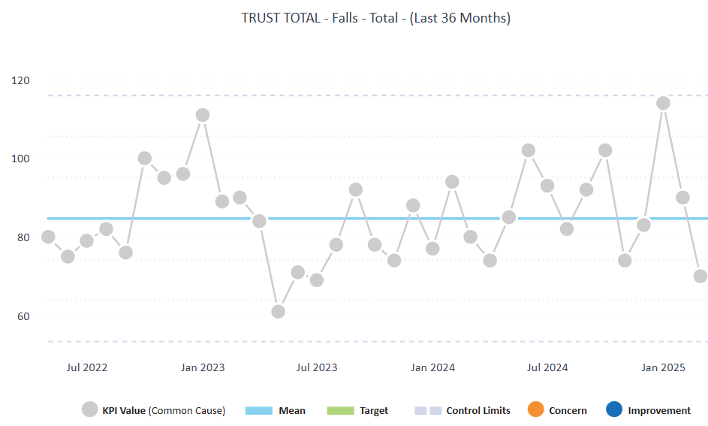

Table 1 and Chart 1 shows that there was a higher number of falls than average in June, July, September and October 2024, and January and February 2025.
The majority of falls are unwitnessed and tend to occur at night. However following education and creating awareness with staff, the number of falls has started to show a decrease from January.

Chart 2
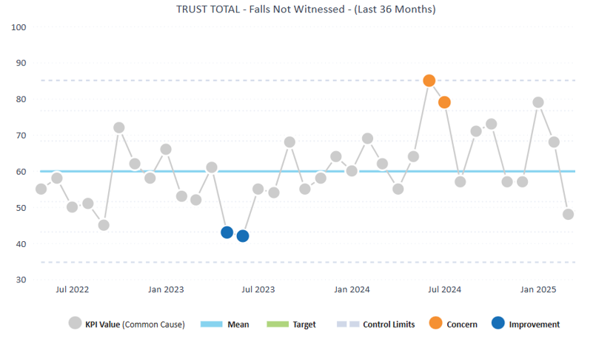

Unwitnessed falls in the last 36 months
Chart 2 shows that over the last 36 months, the number of unwitnessed falls has remained fairly consistent with the average sitting at around 60 unwitnessed falls per month.

Chart 3

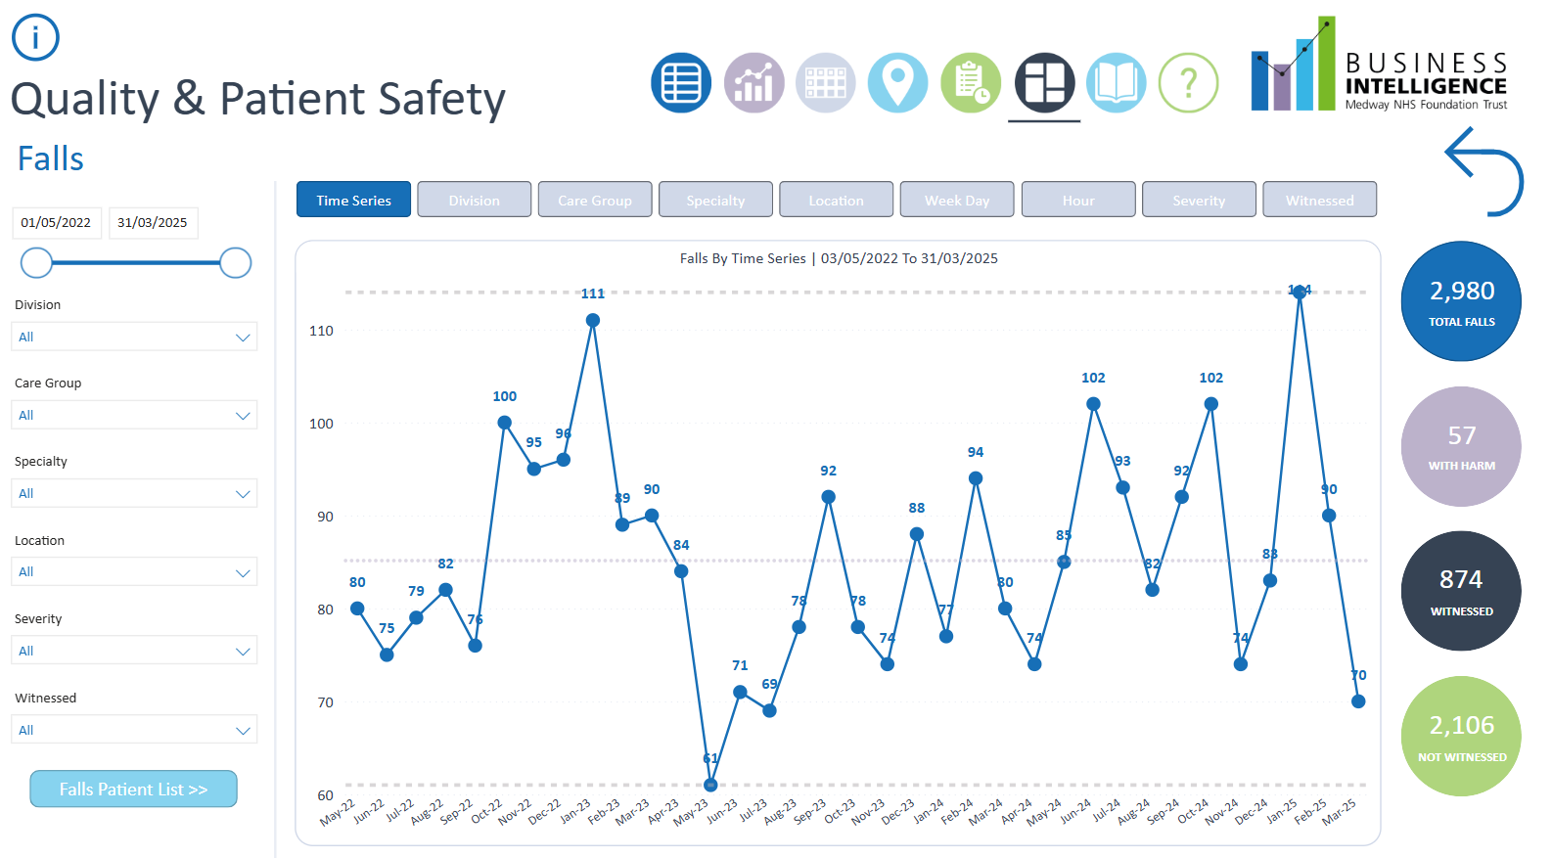

Fall by Time Series 1/5/22 to 31/3/25
Chart 3 shows the total number of falls recorded monthly from 1 May 2022 to 31 March 2025. The figures are the total number of falls per month across the hospital. The falls includes both witnessed and unwitnessed fall. Data shows that 16 months out of the 35 months recorded falls greater than 85. January 2023 and January 2025 recorded the highest number of falls.

Chart 4
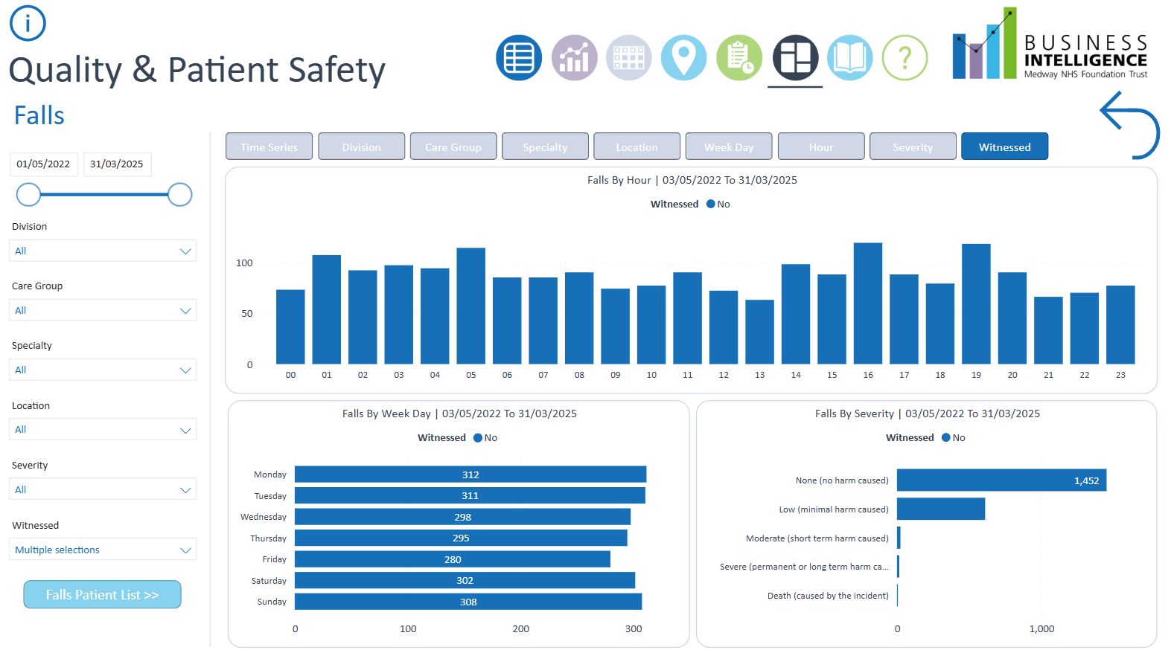

Falls by Hour 1/5/22 to 31/3/25
Chart 4 is showing falls by hour; the time of the day the unwitnessed fall took place, falls by week day; the days the fall happened, and the severity and harm sustained by the patient.
From the chart, it is showing that more unwitnessed falls happened at 4pm and 7pm, and also at 1am and 5am.

Reducing complaints and PALS relating to staff attitude
How we measured success
Reduction in the proportion of complaints and PALS cases where staff attitude is a theme, as a percentage of all complaints and PALS, compared to last year.
In order to achieve a reduction in the proportion of complaints and PALS cases where staff attitude has been referenced, the Trust was aiming for less than 30 complaints and 216 PALS cases over 2024/25.
At the end of 24/25 the Trust reported 208 PALS cases, and five complaints, both below the trajectory set achieving Quality Priority 2
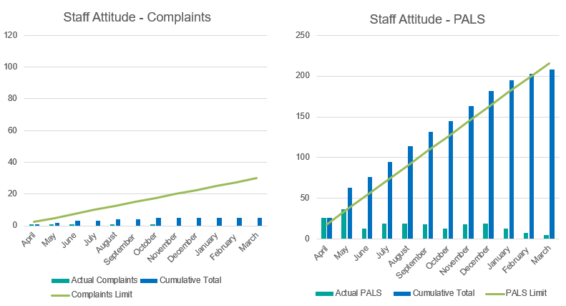
The steps taken to achieve this quality goal in 2024-25 were:
- A breakdown of the data was presented monthly to the Patient Experience Group detailing the specialty, staff type and the location.
- Each division is completing specific programmes of work to address staff attitude.
- The promotion of incivilities work across the organisation, including at induction, appraisal and monthly one to one meetings.
- Using a new informal conversation document, which is part of the disciplinary policy, to have a documented conversation about witnessed or reported poor behaviours and attitude.
- Recognition and promotion of positive behaviours across the Trust.
- Understanding the reasons why poor behaviours and choices surface for staff and reviewing data alongside compliments and patient feedback to promote positive behaviours.
- A focus on customer care during bespoke training sessions by the PALS and complaints team.

Earlier recognition of the dying person and commencement on an end of life care individualised care plan.
How we will measure success
- Improvement in the National Audit of Care at the End of Life (NACEL) summary scores from 4.9 (families’ and others’ experience of care) and 4.3 (needs of families and others) to 6.3 and 5.5 respectively (Round 4; 2022/23 England and Wales summary scores).
- Improved completion of bereavement survey to 25 per cent
- Where clinically appropriate, increase in the percentage of patients made End of Life (EoL) between 6am and 6pm from 50 per cent (2022/23 NACEL data) to 60 per cent.
- It is important to highlight that the ratified NACEL 2024 data is covering the time period of January 2024 to December 2024.

- NACEL Audit Summary Scores for Famillies’ and Others experience of care and Needs of the famillies and others.

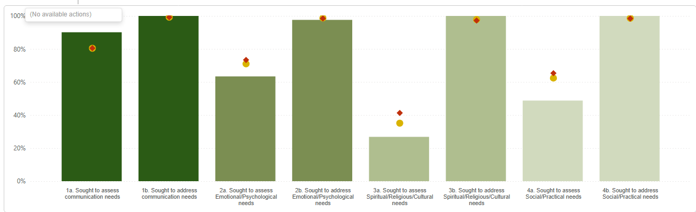
(Bar chart – Red diamond- Average for Acute site types; Amber circle- average for acute site types in South east)

The graph above depicts the cases reviewed and submitted to NACEL. All bars relate to the Trust as an acute site in the South East. However, Bars 3a and 4a are areas identified as requiring improvement work.

The chart highlights that those areas important to the dying person’s needs were assessed and actioned. The green bars highlight the scoring gained by Medway NHS Foundation Trust and the red diamond depicts all acute sites participating in the NACEL audit, the amber circle depicts the average for all acute hospital sites within the South East region.

Though it is hard to compare the data set to the previous NACEL audit (2022-23) due to changes in what information has been sought, it is evident from the data collected that there have been improvements in staff assessing and addressing the needs of those important to the person.

Communication in EoLC is pivotal in planning and delivering exceptional care and the Trust has undertaken a large programme of improvement work to improve this element of care - with breaking bad news, setting the scene for communication and delivering Grand Rounds on the importance of communication at EOL.

From the cases reviewed and submitted to NACEL, Medway NHS Foundation Trust achieved 80 per cent in seeking to assess the communication needs of those important to the dying person (The rationale for this question is that those important to the dying person need to be able to communicate to be part of the conversation about their care. 'Reason recorded why not' may include attempts to contact the nominated person(s) which were unsuccessful, no nominated person(s), patient had not consented for these discussions to take place with the nominated person(s), Independent Mental Capacity Adviser (IMCA) per cent addressed). There was documented evidence that there were incidences where there was no nominated Next of Kin (NOK), inability to contact the listed nominated individual and inability to gain consent from the dying person to have these said conversations surrounding their care.

With the cases reviewed and submitted to NACEL for ratification data shows that Medway NHS Foundation Trust is above the sample average and peer group average in assessing and addressing communication needs of those important to the dying person, as well as addressing spiritual/religious/cultural needs and addressing the social and practical needs of those important to the person. However, the cases reviewed has demonstrated three aspects of care in which we have not fully met needs important to the dying person, this being in seeking to assess the following needs; Emotional and Psychological needs, Spiritual and Religious needs and finally Social and Practical needs.
Due to achieving the ‘addressing’ of these aspects would lead the author to conclude that this aspect- assessing is undertaken informally and not documented.

- Improve completion of the trust Bereavement Survey

The Medway NHS Foundation Trust’s Bereavement Survey was postponed in 2024 due to the NACEL ‘Bereaved Relatives Feedback survey’ being utilised instead to avoid duplication and maximise the potential for completion of the NACEL survey.

However, NACEL had requested input from Medway into how our Trust had established a better response rate than other local/national and asked us to share our practice.

The NACEL bereavement survey results outlined the following:

- 85 per cent of bereaved people agreed that the hospital staff explained to them that their loved one was likely to die in next few days
- 81.5 per cent of bereaved people (N-82.6 per cent) strongly agreed/agreed that the communication was undertaken sensitively
- 70.4 per cent of bereaved people rated the overall care and support given to them and others by hospital staff as excellent/good (N-71.7per cent)
- 90.5 per cent of bereaved people stated that their loved ones had an individualised plan of care that addressed their needs at EoL.

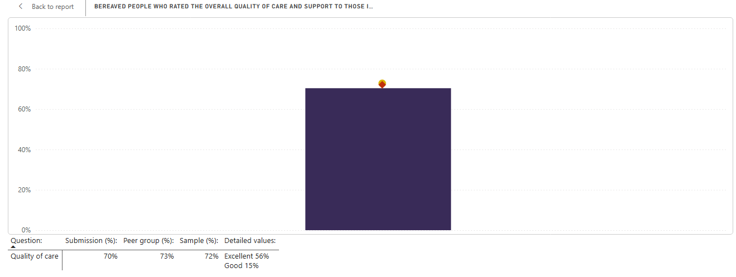
The Red diamond depicts all acute site participating in the NACEL audit, with the Amber circle depicts the average for all acute hospital sites within the South East region

The above graph is an indication of the feedback from bereaved people on their thoughts of the overall quality of care and support in which they received at their loved one/ important person’s end of life.

71 per cent of the bereaved people thought that this aspect of EoL care was either excellent (56 per cent) or good (15 per cent).

Improve the recognition of the dying person and commence EoLC individualised care plan between the hours of 6am and 6pm.

As the data collected during NACEL 2024 differs from NACEL 2022-23, a comparative comparison to ascertain any improvement or sustaining of this is not achievable. However, this will be achievable with the 2025 NACEL data collect set.

- The mean average time between admission to the Trust and dying is 14.9 days (357.6 hours).
- The mean average time from admission to recognition of dying is 10.23 days (245.5 hours)
- The mean average of recognition of dying to death is 5.1 days (122 hours)

For data purposes the Palliative and End of life Care referral system was reviewed to ascertain the timings of when the referral was made for EoL care input. Of note, this data accounts for when the referral was submitted, however this may differ slightly from when the decision was actually made.

Audit data for March 2025 shows that there were 89 referrals received requesting EoLC support for individuals that were entering the EoLC phase. During this time there were 65 deaths under the care of the EoLC team.

Of the 65 deaths that occurred during March, 2025:
- 48 EoL care decisions were implemented during the hours of 6am and 6pm
- 17 End of Life Care decisions were made outside of these hours

The one-month audit data shows that 65 per cent of EoLC decisions were made between the hours of 6am and 6pm rather than having to be made out of hours by on-call teams who are less familiar with the patients and their end of life care requests, making for a better experience for both our patients and our staff.

The audit does however highlight the need for a deeper dive into practices within the Critical Care Department as the EoLC service to not receive referrals for input.

From the data collected from local reviews there does appear to be some slight improvement in the commencement of EoLC decisions implementation phase during the hours of 6am to 6pm. The data also tells us that the time from the EoLC decision being made to the time of death of the patient remains short, with predominately death happening within 24-48 hours after a decision has been made.

Further improvement work for early recognition of EoLC will take place in 2025/26.

The steps taken to achieve this quality goal in 2024-25 were:

- The EoLC individualised plan re-designed and ratified via Patient Experience Group and will be placed onto Electronic Patient Records (EPR) for accuracy of commencement timing- Live date May/June
- Deep dive into delay with EoLC decisions (out of hours decision, poorly completed Treatment Escalation Plans)
- Education currently being re-devised to improve conversations with patients and families – support with visiting, Cedar Room access, welfare packs, parking, Namaste care/support
- EoLC team working with critical care areas to understand more about how they can support with patients receiving EoLC and no referral.
- A new audit tool has been developed and will be on Gather (data collection system), to allow for quicker inputting of this critical data and will be readily available
- Working in collaboration with Hospital Palliative Care Team, disease specific Clinical Nurses, South East Coast Ambulance Service (SECAmb) and streamline processes of earlier recognition in clinic settings- advance care planning
- Building and strengthening relationships with our community partners
- Developing and launching a trigger system for alert appropriate teams of attendance to ED and allowing the opportunity to undertake hospital admission avoidance
- Launching and embedding a prognostic tool for easier recognition of transition patients

50 per cent of all GIRFT improvement programmes referenced within the Clinical Strategy to benchmark within the top 25 per cent nationally (using the model health system data set)
Of the 23 Key Performance Indicators identified below, only four were benchmarked within the top 25 per cent nationally. The Trust did not meet this Quality Priority for 2024-25 and therefore is being taken forward as a priority for 2025-26.
How we measured success
Using the model health system dataset, all nine GIRFT improvement programmes referenced within the Trust’s Clinical Strategy were benchmarked within the top 25 per cent nationally for at least one key performance indicator.
The steps taken to achieve this quality goal in 2024-25 included:
The key performance indicators were identified.

Trauma and Orthopaedics
Key Performance Indicator | Top 25 per cent
Length of stay in primary hip replacements | No
Length of stay in primary knee replacements | No

Diabetes and Endocrinology
Key Performance Indicator | Top 25 per cent
Emergency readmissions (with greater that zero day stay) within 30 days following an emergency admission with Hypoglycaemia as the primary diagnosis on admission | No
Mean length of stay for emergency admissions with Hypoglycaemia as the primary diagnosis on admission (patients aged 17 to 50 years) (12 months to quarter end) | No
Percentage of patients with an emergency DKA admission within 30 days following a previous emergency DKA admission, DKA as the primary diagnosis (note: patients not admissions (12months to quarter end) | No

Rheumatology
Key Performance Indicator | Top 25 per cent
Missed outpatient appointments (DNAs) rate in Rheumatology | No
Patient Initiated Follow Up utilisation rate for Rheumatology | Yes
Selected high cost drug expenditure in Rheumatology where main use of drug is inflammatory arthritis per 100 Trust rheumatology patients with a follow-up appointment (outpatient) | Yes

Acute and Emergency medicine
Key Performance Indicator | Top 25 per cent
Emergency readmissions without an overnight stay within 30 days of discharge for admissions with headache into Acute or General Medicine | No
Emergency readmissions without an overnight stay within 30 days of discharge for admissions with chest pain into Acute or General Medicine | No

Cardiology
Key Performance Indicator | Top 25 per cent
Missed outpatient appointments (DNAs) in cardiology | No
Emergency PCI for acute Non -ST Segment Elevation Myocardial Infarction | No
EP: Pacemaker insertion and maintenance | No

Respiratory
Key Performance Indicator | Top 25 per cent
Average length of stay with pneumothorax | No
Percentage of admissions with Pleural Effusion achieving Best Practice Tariff (12 months to quarter end) | No
Emergency readmission (within 30 days) rate following asthma admission | No

Paediatrics
Key Performance Indicator | Top 25 per cent
Ratio of follow up: first appointment in paediatrics | No

Neonatology
Key Performance Indicator | Top 25 per cent
Indicator to be confirmed

Urology
Key Performance Indicator | Top 25 per cent
Patients receiving stent insertion for urinary stone during the original emergency admission (12 months to quarter end) | No
Day case rate for TURBT (12 months to quarter end) | Yes
Day case rate for ureteroscopy (12months to quarter end) | Yes

Improve from 26 per cent to 95 per cent of applicable National Clinical Audit (NCA) reports having an established delivery and improvement action plan within 90 days.
Although we have not been able to achieve 95 per cent of applicable National Clinical Audit reports having an established delivery and improvement action plan within 90 days we have made significant improvements with the 90-day standard which we continue to maintain.
How we measured success
An increase in compliance with NCA reports being reviewed and actioned within 90 days where an action plan is required.

The steps taken to achieve this quality goal in 2024-25 were:
- NCA reviews were an agenda item at Divisional and Care Group meetings with Quality Assurance and Compliance Team members presenting findings.
- Clinical Outcomes and Effectiveness Group meeting providing oversight of NCA audit compliance.
- Clinical Effectiveness Improvement Plan put in place to monitor non-compliance with 90-day target, now completed.
- Presentation to Ground Round to raise awareness.
- A3 session (Learning and Root Cause Analysis) using Patient First improvement methodology to identify issues with an action plan put in place.
- Review of the process and updated policy and procedures.
- Two drop-in sessions arranged for clinicians to go through the process changes.
- Annual Audit Plan for National Reports disseminated across the divisions.

In order to achieve Quality Priority 5, 95 per cent of all published national clinical audits are reviewed and where required, an action plan developed to address any national recommendations where we are not compliant. In 24/25, 79 per cent of NCAs were reviewed and actioned within 90 days; an increase of 150 per cent from the previous year (26 per cent to 79 per cent).
- 62 NCA reports were received in 24/25
55 reviews were undertaken
  - 13 were not received within 90 days
  - 42 were received within 90 days
  - Seven are still requiring review

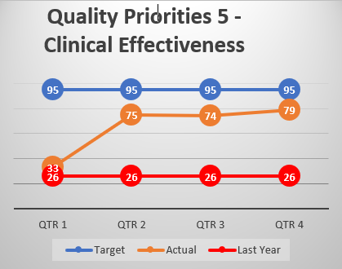

Patient Safety Incident Response Framework (PSIRF)
In addition to the Trust’s Quality Priorities, Medway NHS Foundation Trust has committed to fully implementing PSIRF (Patient Safety Incident Response Framework) which launched in February 2024. This framework determines how the organisation responds to patient safety incidents and sets out the NHS approach to developing effective systems and processes for responding to patient safety incidents, with a focus on truly understanding how incidents happen and identifying meaningful learning and improvement.
The aims of PSIRF are:
- Compassionate engagement and involvement of those affected by patient safety incidents
- Application of a range of system-based approaches to learning from patient safety incidents
- Considered and proportionate responses to patient safety incidents
- Supportive oversight focused on strengthening responses by focusing on system improvements and system learning.
PSIRF is ultimately a cultural change that continues to be role modelled and embedded. We have shifted the focus from “blame and retrain” and a single root cause, and we now look at how systems have allowed incidents to occur and, as humans are fallible, how we can minimise the human factors involved. Engagement and involvement of those affected by patient safety incidents is a high priority for the Patient Safety and Improvement Team (PSIT) and we are engaging with patients and families when an incident investigation has occurred. The majority of patients and their families have been thankful for including them throughout the investigation and learning process.
The Trust has successfully recruited and welcomed two Patient Safety Partners who provide a ‘patient voice’ in the patient safety process. Their roles include:
- membership of safety and quality committees whose responsibilities include the review and analysis of safety data
- involvement in patient safety improvement projects
- working with organisation boards to consider how to improve safety
- involvement in staff patient safety training
- participation in investigation oversight groups.

Rather than a prescriptive list of incident types that must be investigated, there are a reduced number of national reporting requirements and the Trust has created a PSIRF plan, based on data analysis from previous years, to focus our learning response efforts to where we can make the biggest difference to patients, their families and staff. This plan is designed to evolve and change as needed, for example, if we start to see that a current priority is making a measurable difference, and a different theme is emerging, the plan can be realigned. This flexibility allows the Trust to really focus on learning and improvement instead of outcomes and levels of harm. This means we are no longer focusing solely on the most serious incidents; we are now looking at near misses, no harm and low harm incidents as well. As PSIRF has been live for over 12 months, our data analysis will refresh our PSIRF plan. The analysis will be presented to key stakeholders for their views and to help to identify new local priorities to focus on which will have the most impact.
The Patient Safety and Improvement team have become experienced and confident in leading and supporting SWARM huddles, After Action Reviews (AARs) and Patient Safety Incident Investigations (PSIIs). As the principles of PSIRF have been embedded into our incident/investigation review groups and patient safety groups, the members have become more confident in not declaring a learning response for every incident that is reviewed, particularly if there is assurance of ongoing improvement work or if there is a recent learning response that already has identified actions to address the issues. The team continues to collate all improvement work within the Trust into a centralised log for oversight and monitoring. Additionally, quarterly reviews for any Trust-wide Quality Improvement Plans (QIPs) take place.
Patient Safety Syllabus training level 1 has been mandatory for all staff to complete and compliance is reported on a monthly basis. The Trust is currently considering making level 2 mandatory for identified staff groups. Identified staff have been encouraged to undertake HSSIB (Health Service Safety Investigations Body) training courses. The Trust originally secured accredited training for 15 Patient Safety Learning response leads which was delivered in June 2024. The Patient Safety and Improvement team provides further training to staff where required, and have also offered monthly drop in sessions over the last six months.
PSIRF has provided the opportunity to create better relationships, both internally and externally and this has widened knowledge within the team. The systems thinking approach enables the team to see gaps quickly and more easily, which then makes it simpler to identify recommendations. PSIRF has allowed incidents to be viewed more holistically with the option to undertake more proportionate learning responses to identify learning more quickly, and with mitigations being put in place to prevent the recurrence of an incident. PSIRF also enables us to share information and learning more effectively, with greater opportunities to recognise good care, which can also improve learning.

Learning from Patient Safety Events (LFPSE)
LFPSE is the new national system for recording patient safety events which replaced the NRLS (National Reporting and Learning System).
All healthcare staff in England, including those working in primary care, are encouraged to use the system to record any events where:
- A patient was harmed, or could have been harmed
- There has been a poor outcome but it is not yet clear whether an incident contributed or not
- Risks to patient safety in the future have been identified
- Good care has been delivered that could be learned from to improve patient safety
LFPSE was implemented in the Trust on 11 December 2023. Consequently, the Trust’s incident reporting system has been revised to provide earlier opportunities for staff to report incidents and to investigate and learn from what has happened.
LFPSE adds a number of new incident reporting questions which focus the reporter and investigator on the impact of the incident and the opportunities for learning.
As part of the transition to LFPSE the Patient Safety and Improvement Team provided training sessions to staff and procedural guidance has been created and shared as an aide memoir.
The information uploaded to LFPSE is aiding learning and supporting with the identification of national patient safety priorities.

Achievements in Quality

- NJR Data Quality Provider
In August 2024, the Trust was awarded the National Joint Registry (NJR) Quality Data Provider for the fourth consecutive year.
The NJR Quality Data Provider scheme has been devised to offer hospitals public recognition for achieving excellence in supporting patient safety standards through compliance with the mandatory NJR data submission quality audit process.
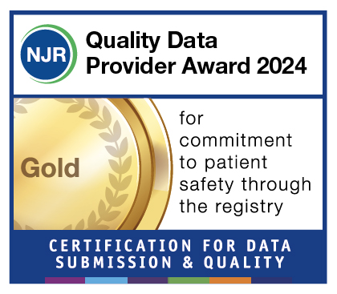

- Enhanced Care Service recognised for excellence
Congratulations to Iain Tredway-Murray, Clinical Nurse Lead for Enhanced Care, and colleagues from the Enhanced Care Service who won a prize at the prestigious Kent Healthwatch Recognition Awards.

This was in recognition of their excellent work to improve patient experience and support patients with dementia, delirium and mental health who need enhanced care, and enabling them to monitor standards and be involved in making improvements.

- Maternity achieves safety actions for fifth year
Maternity Services Team has achieved all 10 safety actions for year five of the Clinical Negligence Scheme for Trusts Maternity Incentive Scheme.
The scheme aims to improve the quality and safety of maternity services and provides financial incentives for trusts that can demonstrate they have implemented 10 key safety actions. These include training, governance, staffing, and measures to prevent hypoxic ischemic encephalopathy, a major cause of brain injury in newborns.


- Health Service Journal (HSJ) Safety Awards
Surgery and Anaesthetics Division receive a high commendation at the HSJ Safety Awards for their fantastic work in reducing waiting times and improving outcomes for patients needing emergency surgery.

- Healthy workplace recognised with Platinum award

The Healthy Workplace programme supports businesses of all sizes and sectors to meet the health needs of their workplace.
Achieving the Platinum award demonstrates continuous improvement alongside dedication to the Wellbeing of the wider community.

- National prize winner praises Medway support
Andreas Conte won the British Orthopaedic Association annual Medical Student Prize for a quality improvement project he led while training with us.
The project helped to improve the pathway for patients with suspected cauda equina syndrome, a rare and serious nerve disorder that requires urgent investigation and treatment.

- National Clinical Impact Award
Dr Aung Soe, Consultant Neonatologist, received a National Clinical Impact Award from the Department of Health and Social Care (DHSC).
The National N2 Award is a public acknowledgement of their sustained commitment and dedication to the NHS and a recognition of the national impact of their efforts over and above their contractual requirements and is awarded following intense scrutiny by committees made up of medical and dental professionals, NHS employers and lay members.

Patient First

Patient First is our improvement programme to help us improve the care and services we provide to the people of Medway and Swale.
Patient First is:
- A recognised and proven system for delivering significant long-term change within the NHS
- Identifies key areas for improvements and the root cause of problems
- Provides tools, techniques and a standard approach to identifying and tracking improvement needed
- Gives staff clarity about what they need to do, every day, and empowers them to make change happen in any areas of the Trust where they work
- Sets outs very clear and specific targets about what needs to be achieved in a fixed timescale

Improvements in paediatric day surgery
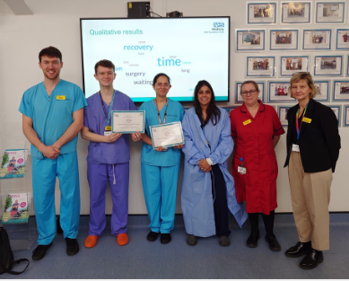

We have been focusing on improving our Paediatric Day Case Surgery using the principles set out by GIRFT in our main theatres and in Sunderland Day Case Centre.

Neonatal doctors create national toolkit to help clinicians diagnose jaundice in babies with darker skin tones.

Consultant Neonatologist Dr Helen Gbinigie and Dr Oghenetega Edokpolor from the Oliver Fisher Neonatal Unit, worked with the NHS Race and Health Observatory to develop a toolkit to improve screening for jaundice, raise awareness, and reduce healthcare disparities. This followed a national review which highlighted the urgent need for resources to help healthcare professionals identify jaundice in Black, Asian, and Minority Ethnic (BAME) newborns.

Digitisation of Treatment Escalation Plans and 2222 forms
We identified that top contributors were lacking in live data for 2222 calls, as well as visibility in Treatment Escalation Plan decisions (forms). Medway is one of the first trusts to report this data live, via Electronic Patient Records (EPR) and also to have a working dashboard. This means all clinicians and nurses can see any patients across the Trust that have triggered a high NEWS score. This oversight means there is raised awareness of these patients at risk which can be reviewed, if this has not yet been actioned. We have also digitised the 2222 documentation on EPR again, this produces a flag on the tracking boards so clinicians and service users can see at a glance that the patient has had an emergency call during their stay. Also means the teams can see what has been done and how they were managed.
Feedback from doctors has been overwhelmingly positive. Many have expressed just how much better the system now is; particularly the ability to access all patient details in one place. Orders are also now pre-populated.

Quality Week in ED
As part of the ongoing improvement work, colleagues come together from many areas of the hospital to facilitate a dedicated ‘Quality Week’ ED in May 2025.
Following the introduction of a Patient First improvement board, teams gathered at 9am every day to huddle (pictured) – to discuss issues, brainstorm ideas and celebrate successes, as part of an effort to make sure we provide the best possible care to every patient.
Some of the quick wins identified from the huddles included:
- improved cleaning regime
- better access to pillows for patients
- replacement of broken equipment
- replacement of seating for staff
- reducing noise in Majors.
Specialist teams spent time delivering bespoke teaching and offering support, which included Infection and Prevention Control, Tissue Viability, Falls, Patient Experience, Estates and Facilities, as well as other colleagues and senior leaders.


2.4 Statements of Assurance 2024/25

Review of our services
During 2024/25, the Trust provided (and/or sub-contracted) 46 relevant health services to the people of Medway and Swale.
Activity 2024/25 | Q1 | Q2 | Q3 | Q4 | TOTAL
Outpatient appointments | 94,452 | 93,964 | 93,079 | 93,419 | 374,914
Total Discharges - elective and non-elective | 13,354 | 11,222 | 10,854 | 10,679 | 46,109
Total Discharges – Day case and Regular Day Attenders | 9,172 | 9,374 | 10,396 | 9,903 | 38,845
Total Deliveries (confinements) | 1,102 | 1,203 | 1,048 | 1,063 | 4,416
Babies born (includes multiple births) | 1,111 | 1,230 | 1,068 | 1,083 | 4,492
Home Births | 26 | 25 | 18 | 25 | 94
Emergency Attendances - Type 1 | 27,970 | 27,490 | 27,778 | 25,936 | 109,174
Emergency Attendances - Type 3 | 24,424 | 22,945 | 23,329 | 23,636 | 94,334
Emergency Admissions | 3,957 | 4,216 | 4,251 | 4,283 | 16,707
Ambulance arrivals | 8,496 | 8,567 | 9,271 | 8,802 | 35,136
Occupied Bed Days (GandA) | 47,162 | 47,920 | 48,598 | 48,718 | 192,398
Beds open (GandA) | 51,150 | 50,968 | 50,526 | 50,479 | 203,123
Bed Occupancy per cent (GandA) | 92.2per cent | 94.0per cent | 96.2per cent | 96.5per cent | 94.7per cent
Beds Occupancy per cent (Critical Care) | 50.0per cent | 57.1per cent | 58.4per cent | 58.7per cent | 56.2per cent

Board Structure as of 2024/2025

Participation in National Clinical Audits (NCA) and National Confidential Enquiries into Patient Outcome and Death (NCEPOD)
The Trust’s participation in National Clinical Audits and National Confidential Enquiries into Patient Outcome and Death enables us to benchmark the quality of the services that we provide against other NHS Trusts. It also highlights best practice in providing high quality patient care and drives continuous improvement across our services.
During 2024/25 there were 59 mandatory national clinical audit programmes on NHS England’s Quality Account List, of those listed, 20 were not applicable to Medway. Of the remaining 39 programmes, the Trust participated in 38 (97per cent) of eligible audits.
There was one eligible audit that we did not participate in, as follows:
- Emergency Medicine QIPs
When a new audit lead came it to post it was identified that, although the RCEM subscription fee was paid for 2024/25 to participate in the Emergency Medicine QIPs, no cases had been submitted. There appears to have been a lapse in the divisional governance process at the time and therefore there was no escalation opportunity to allow communication with our commissioners. To ensure this does not happen again the Quality Assurance and Compliance Team now have access to the RCEM portal and will be reporting quarterly updates through care group and divisional governance board on the number of cases submitted. Where it is found that there are no cases this will be escalated appropriately to allow time to rectify the data submission and ensure compliance.
The list of national clinical audits and number or registered cases submitted for each audit are detailed in Annex 3 (page 52). Some areas have been marked as ‘in progress’ which means that the data is still being collated for the 2024/25 reporting period. Annex 3 also contains a summary of some of the key audit achievements and planned actions for improvement.

Local Audits
Clinical audit drives improvement through a cycle of service reviews against recognised standards and then provides a baseline for implementing change as required. We also use audit to benchmark our care against local and national guidelines so we can put resources into areas requiring improvement; this is part of our commitment to ensuring best treatment and care for our patients.
Local clinical audits are selected on the basis of various priorities and requirements including annual audit cycles, commissioning requirements, emerging incident themes, risks or complaints, trust priorities and many others.
100 per cent of registered local Clinical Audits/QI projects align to a Patient First breakthrough objective or a Trust Quality Priority under the following domains:
- People
- Quality
- Systems and Partnerships
- Sustainability
The data below shows that in 2024/25 the number of registered local audits decreased. To ensure local clinical audits registered on the Local Audit database will be completed they are monitored through Divisional and Care Group and any issues escalated to the Clinical Effectiveness and Outcomes Group. A yearly review of the audit status is completed and audit leads contacted to ensure the information is update to date.
- In the year 2023/24 there were 249 projects with 156 projects being completed, 21 abandoned, one rejected and 71 are still in progress.

- In the year 2024/25 there were 343 projects with 114 projects being completed, seven abandoned, three rejected and 219 are still in progress

Surgical and Anaesthetics (SA) and Women, Children’s and Young People (WCYP) Divisions
There is currently a combined total of 168 registered Local Audits in the Surgical and Anaesthetics (SA) and Women, Children’s and Young People (WCYP) Divisions. Out of these, 60 projects have been completed, with 44 in SA and 16 in WCYP.
At present, 105 projects are in various stages of completion, with a majority of 67 in the SA and 38 in the WCYP. One audit was rejected in SA.
This data emphasises a strong emphasis on ongoing efforts, with the majority of projects actively being worked on, and a substantial number already completed.

Medicine and Emergency Care (EC) and Cancer and Core Clinical Services (CCCS) Divisions
There is currently a combined total of 175 registered Local Audits in the Cancer and Core Clinical Services (CCCS) and Medicine and Emergency Care (MEC) Divisions. Out of these, 54 projects have been completed, with 21 in CCCS and 33 in MEC.
At present, 114 projects are in various stages of completion, with a significant majority of 81 in the MEC and 33 in the CCCS. Two projects, one duplication and one research based, were rejected in MEC.

Patient Led Assessment in the Care Environment (PLACE)
The PLACE assessments were carried out in October 2024, the assessment team consisted of patient assessors, Trust Governors and Trust staff who looked at the elements of the PLACE criteria including Cleanliness, Condition and Appearance, Dementia, Disability and Access, Privacy, Dignity and Wellbeing and Food. Each element was scored either as a pass, fail or qualified pass, the results are then submitted to the Health and Social Care Information Centre (HSCIC) a result is then calculated and published nationally. The submitted results to the HSCIC have been analysed and shown comparatively with our previous years and the results show a slight improvement on the previous year however there are still improvements that need to be made. There are actions plans being worked through as part of the PLACE action group in order to increase engagement Trust wide. ‘PLACE Lite’ is being organised in order to address any concerns ahead of annual PLACE audit.
Areas of improvement are:
Combined Food | + 3.12 per cent
Dementia | + 1.82 per cent
Disability | + 2.81 per cent

Results compared to other trusts.
Medway Foundation Trust compared Locally
Domain | Medway 2024 | East Kent (William Harvey) 2024 | Dartford  2024 | Maidstone and Tonbridge Wells 2024
Cleanliness | 94.42 | 98.41 | 98.85 | 98.49
Combined Food | 82.34 | 86.48 | 89.97 | 86.86
Organisational Food | 89.93 | 92.71 | 99.48 | 93.75
Ward Food | 80.38 | 89.93 | 86.81 | 84.25
Privacy, Dignity and Well being | 90.77 | 81.44 | 89.15 | 89.49
Condition Appearance and Maintenance | 91.03 | 99.80 | 96.16 | 98.85
Dementia | 84.55 | 80.85 | 82.85 | 85.37
Disability | 87.37 | 79.24 | 83.52 | 88.57

Results compared from 2023.
Domain | 2022% | 2023  % | 2024  % | Difference %
Cleanliness | 92.93 | 95.71 | 94.42 | - 1.29
Combined Food | 86.24 | 90.37 | 82.34 | - 3.89
Organisational Food | 80.05 | 86.81 | 89.93 | + 3.12
Ward Food | 87.25 | 91.27 | 80.38 | - 10.44
Privacy, Dignity and Well being | 69 | 90.84 | 90.77 | - 0.07
Condition Appearance and Maintenance | 84.24 | 94.84 | 91.03 | - 3.81
Dementia | 63.79 | 82.73 | 84.55 | + 1.82
Disability | 69.08 | 84.56 | 87.37 | + 2.81
Next steps:
- Robustly implement PLACE Lite and PLACE Action Group – clinical attendance is a concern however steps are being taken to improve it.
- Cleaning Services to demonstrate improvement by implementing an action plan to improve workforce capacity, equipment availability, training of staff and morale within the team.
- The Housekeeping Team to review the National Standards of Cleanliness especially for deep cleaning of the site for cleanliness and estates.
- Disability and Dementia compliance works to be taken by the Estates Teams.
- A cleaning Action Group being set up with stakeholders with progress report at the Cleaning and Decontamination Group.
- Implementation of the electronic food ordering system to improve ward food experience.
- The Catering and Patient Food Action Group to review the PLACE scores and plan improvements.

Participation in Clinical Research
The Trust has committed to undertaking research as a driver for improving the quality of care and patient experience and is actively involved in research supported by the National Institute for Health and Care Research (NIHR). Furthermore, our Research and Innovation (RandI) strategy is heavily linked to specialty priorities agreed by the Department of Health (DoH) and NIHR. During 2024/25 the capacity of clinical services to support research delivery has remained challenged due to national workforce and workload issues as services continue to recover from the various challenges the past year has shown. This however has not discouraged services engaging in research activity and has led to a year end position of 4,162 participants recruited, exceeding our recruitment target of 2,869.
The comparative data below shows the NIHR requirement target and the actual recruitment figures for Medway and shows that the Trust continues to exceed its recruitment targets.

Chart1. the annual recruitment target and the actual number of patients recruited into the NIHR adopted studies between 1 April 2014 and 31 March 2025.

In 2024/25 Medway Foundation Trust was the sixth highest performing organisation in terms of participant recruitment to clinical trials in the Kent, Surrey and Sussex region. This was due to other organisations taking part in a large-scale study which Medway NHS Foundation Trust did not participate in.

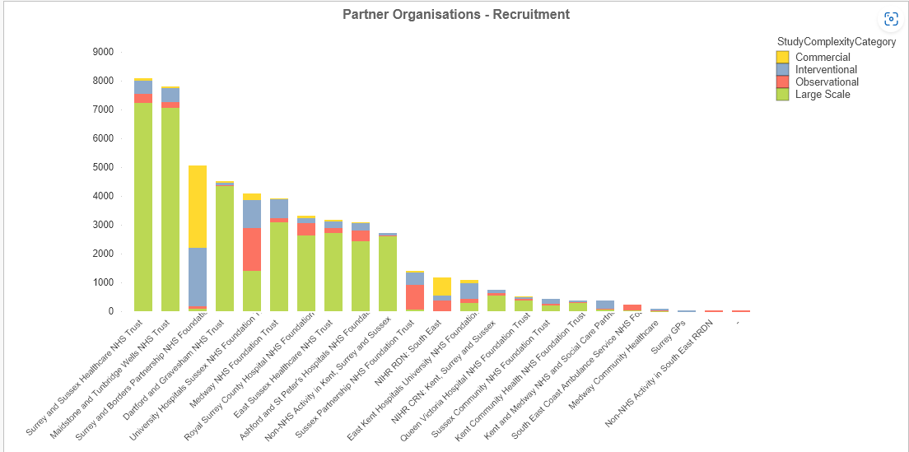

Chart.2. Medway NHS Foundation Trust performance compared to other Trust across Kent Surrey and Sussex Local Clinical Research Network

Trust staff are able to keep abreast of the latest treatment possibilities through active participation in many different types of research, which has led to successful patient outcomes.
For the period 2024/25, there were a total of 113 research studies conducted at the Trust, including staff undertaking MSc final year dissertations. For the same period, the Trust took part in 100 NIHR supported studies, including 29 cancer specialty studies.

Chart.3. the number of studies that Medway NHS Foundation Trust participated in between 1 April 2014 and 31 March 2025.
Conducting research requires commitment from staff and this commitment is evidenced by the number of clinical staff participating in research across various fields. There were approximately 182 clinical staff participating in research approved by the Health Research Authority at the Trust between 1 April 2020 and 31 March 2025 resulting in over 90 publications in peer reviewed journals.
Staff participating in research cover 17 disease specialties, including studies looking into urgent public health research.

Chart 4 Number of Studies Conducted Per Disease Speciality at Medway NHS Foundation Trust during 1 April 2024-31 March 2025.
*Studies outside of clinical speciality for example educational studies or research into overall patient experience.
Since the COVID-19 pandemic which itself brought new challenges, there has been a keen interest shown by staff to participate in the majority of leading global trials. Being able to offer up-to-date, novel treatments to the patient is at the forefront of the Trust agenda.
With the ambition of becoming a ‘University Trust’, Medway has established a portfolio of its own research (so-called ‘home grown’) in collaboration with local universities. In the last year we have registered nearly 90 ongoing ‘home grown’ studies.
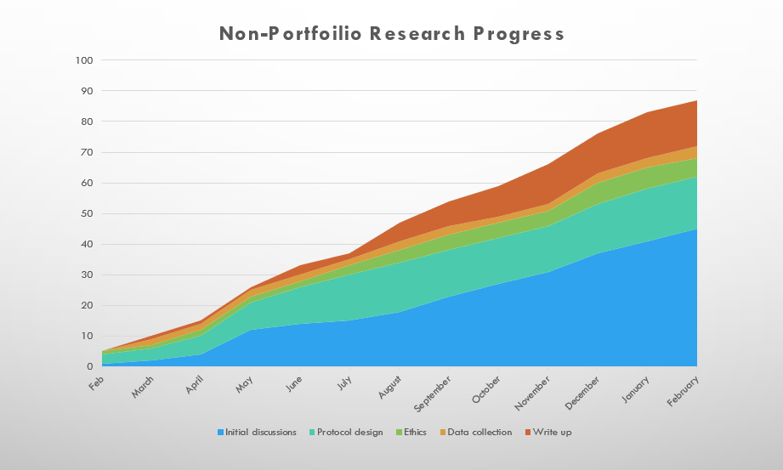
Chart 5. Number of Home grown since February 2024.
The following are examples of research undertaken in 2024/25.

Optimisation before Crohn’s surgery using Exclusive Enteral Nutrition (OCEaN):
Some studies suggest that a special liquid-only diet, called exclusive enteral nutrition (EEN) might help people recover better after surgery. This diet has already been shown to reduce symptoms, decrease inflammation, and heal the gut more effectively than steroids for active Crohn’s disease. However, EEN is not commonly used before surgery because there is not enough research to prove its benefits.
This study aims to find out if following a six-week EEN diet before surgery can help patients recover faster and reduce complications compared to a normal diet before surgery. All patients in the study will have surgery and will be monitored for a year to track their symptoms, medication use, quality of life and healthcare needs. If the liquid diet is proven to help, it could become a standard pre-surgery treatment for Crohn’s disease.
The aim is to include 618 patients from across the UK and interview patients and healthcare professionals to understand their experiences with the trial. Medway NHS Foundation Trust currently has five participants on this pathway.

HoT Trial – Hemithyroidectomy or Total-Thyroidectomy in ‘low-risk’ cancers:

The number of cases of well-differentiated thyroid cancer (DTC) is rising faster than any other type of cancer. The standard treatment for low-risk DTC has been a total thyroidectomy (TT), where the entire thyroid is removed, followed by radioiodine treatment. However, recent research suggests that a hemithyroidectomy (HT) – removing only the affected half of the thyroid – might be just as effective while offering important benefits.

Patients who have HT may avoid life-long thyroid hormone replacement therapy, calcium and vitamin D supplements, and radioiodine treatment. However, previous studies on HT have had mixed results and doctors do not fully agree on which surgery is best. This has led to different hospitals using different approaches.

The HoT trial is the first study to directly compare TT and HT to see which is better in terms of cancer recurrence, quality of life, surgery-related side effects, the need for hormone replacement therapy and cost to the NHS.

The study will include two groups of patients;
- Patients who already had HT at diagnosis – they will either be monitored closely or have a second surgery to remove the rest of the thyroid.
- Patients who have not had surgery yet – they will be randomly assigned to have either HT or TT in a single operation.

A total of 456 patients across UK hospitals will be recruited over four years, and they will be followed for up to 6.5 years after surgery. The results will help determine whether HT is as effective as TT. If it is, HT could become the recommended treatment for low-risk DTC, allowing patients to have less invasive surgery with fewer side effects. If TT is proven to be more effective, guidelines will recommend TT for most cases. This will help patient make better treatment decision.

Medway NHS Foundation Trust currently has 17 participants taking part in this study.

Quality in clinical decision-making in ADHD:
Attention Deficit/Hyperactivity Disorder (ADHD) affects about three to five per cent of children and young people. It can cause trouble with focus, impulsivity and hyperactivity. Early treatment is key to managing symptoms and preventing long-term challenges. Once treatment starts, doctors should regularly check if the medication is working, but research shows this doesn’t always happen. As a result, some people might not be on the best medication or dose for them.
It is not fully understood how this impacts children, families or what doctors think should be improved. To find out, young people with ADHD will be interviewed along with their parents/carers and healthcare professionals. Their experiences with medication will be explored and checks carried out to see if current guidelines are being followed.
Based on the interviews, it will be possible to identify if digital technology can help with the process. To ensure a broad perspective, five clinics over two or three regions will take part and over 10 months, insights will be gathered from patients, families and clinicians to develop recommendations on how technology can improve ADHD medication monitoring.
Findings will be shared with doctors, service managers and policymakers to help better shape services. This will also be communicated with young people with ADHD, and their families to ensure their voices are heard.

UnCorKED (Understanding Corridor Care in UK Emergency Departments)
Crowding in Emergency Departments is a recognised public health challenge. Crowding leads to patient care being delivered in areas not originally designed for this use, known as ‘escalation areas.’ Although a formal definition of an escalation area does not exist, examples include ambulance waiting areas, repurposed clinical areas outside the usual ED footprint and on-clinical areas such as hospital corridors. There is a lack of data about how many patients receive care in such environments, and what impact this has on their care and outcomes. In this study, these questions will be addressed by:
- Estimating the number of patients cared for in escalation areas
- Describing which patients experience escalation area care
- Defining emergency department escalation areas.

Patient recruitment will be conducted over 14 consecutive days with patients present in emergency departments at five predetermined snapshot time points.
The results will provide much-needed data on escalation area use, which will inform discussions on how best to address this problem and future research related to escalation area care and its impact on patient outcomes.

Care Quality Commission (CQC) inspection: Urgent and Emergency Care
On the 21 February 2024, the CQC conducted a site assessment of our Urgent and Emergency Care. The CQC team spoke with staff, patients and other health representatives such as ambulance staff, reviewed patient documents and observed the environment, equipment and patient flow. As part of this assessment process, they also carried out assessment activities off site. The findings of the inspection of our urgent and emergency care services was published on 5 March 2025.
Inspectors rated the services Good for being Caring, Requires Improvement for Safe, Effective, Responsive and Well Led. The service was rated Requires Improvement overall, previously Good.
The issues identified in the report were things that the Trust were already working hard to address – such as reducing treatment delays and providing consistently safe, compassionate and dignified care – and which colleagues have since made significant progress on, underpinned by Patient First.
The CQC's report also recognised that many patients ‘had a good experience of the department with staff being compassionate and receiving care and treatment in a timely manner’.
Inspectors also praised a ‘supportive culture at local level’ and recognised that ‘staff were committed to providing care in challenging circumstances. Staff and leaders were proud that partnership working had reduced ambulance off-load times’.
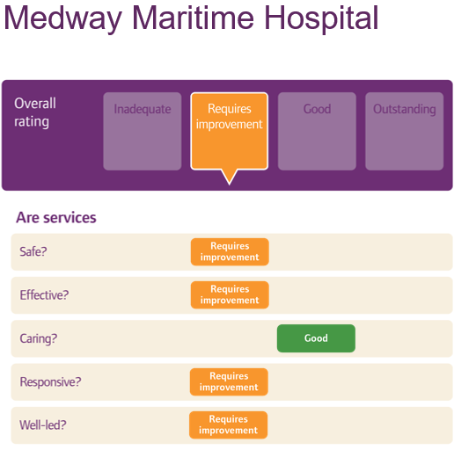
The trust aims to achieve a Good rating across all services and in all domains by:
- Strengthening its internal assurance by relaunching a Ward Accreditation programme focused on identifying and improving all areas assessed as requiring improvement. The approach aims to identify and improve all aspects of patient experience and care for patients, and is based on the continuous improvement principle of standardisation, recognition, sharing and consistently applying best practice in the interest of patient care.
- Improving access to data by further rolling out the data collection system ‘‘Gather’ which will enable staff to access real time data on the Trust’s performance against important indicators thus supporting the Trust’s mission to provide excellent care every time.
- Embedding the findings from external governance reviews to strengthen the Trust’s assurance and accountability framework.
- Transforming the way we deliver joined up patient care by continuing to introduce Electronic Patient Records (EPR) throughout the hospital as we move to a fully digitised organisation.

Ward Accreditation Programme
Ward accreditation is a way for us to ensure that we deliver consistently high-quality care and good patient experience, improving collaboration between teams to champion their strengths and achievements and to make improvements.
The scheme looks at a range of important indicators around patient care and ward practice – such as good infection control practice, patient nutrition and minimising the occurrence of pressure ulcers – along with a number of other measures.
The accreditation category each ward can achieve ranges from Gold to Silver, Bronze and White and is aligned to the CQC’s standards of Outstanding, Good, Requires Improvement or Inadequate.
Since the relaunch of the programme in July 2024 a total of 18 wards have been accredited achieving one Gold, nine Silver and eight Bronze.


Reporting to Secondary Users Service (SUS)
The Secondary Uses Service is designed to provide anonymous patient-based data for purposes other than direct clinical care such as healthcare planning, commissioning, public health, clinical audit and governance, benchmarking, performance improvement, medical research and national policy development.
The Trust submitted records during 2024/25 to the Secondary Uses Service for inclusion in the Hospital Episode Statistics and these have been included in the latest published data.
The percentage of records in the published data, which included the patient’s valid NHS number, was:
- 100 per cent for admitted patient care
- 100 per cent for outpatient care
- 99 per cent for accident and Emergency Care
The percentage of records in the published data, which included the patient’s valid General Medical Practice code, was:
- 99 per cent for admitted patient care
- 99 per cent for outpatient care
- 99 per cent for accident and emergency care

Data Security and Protection Toolkit (DSPT)
The newly Cyber Assessment Framework (CAF)-aligned Data Security and Protection Toolkit (DSPT) enables us and NHS England to measure the Trust’s performance against security standards aligned to the National Cyber Security Centre (NCSC) Cyber Assessment Framework (CAF).
An independent audit report is generated for the DSPT each year, and audit of our progress on the current 2024-2025 DSPT is due to take place in March-April 2025.
Last year, for the 2023-2024 DPST, our audit report rated us as Amber/Green, with ‘significant assurance with minor improvement opportunities’, acknowledging that the Trust had been able demonstrate significantly more robust evidence in comparison with previous years. We achieved ‘Standards Met’ in our full response, an improvement from the 2022-2023 submission level of ‘Approaching Standards’.
This year, for the current 2024-2025 DSPT, our audit report maintained our rating as Amber/Green, with ‘significant assurance with minor improvement opportunities’, acknowledging good practice with regards to the governance structure for the submission of the DSPT. The report gave a high confidence level in the veracity of our DSP Toolkit self-assessment.
Our full response for the 2024-2025 DSPT has yet to be submitted.

Clinical Coding
The Trust undertakes an annual clinical coding data quality audit to determine how accurately our coded clinical data reflects documented diagnoses and procedures in the patient’s record.
 | 2024/25 | Previous year (2023/24)
Primary diagnosis | 90.43 per cent | 90.00 per cent
Secondary diagnosis | 85.36 per cent | 84.25 per cent
Primary procedure | 96.85 per cent | 90.12 per cent
Secondary procedure | 89.23 per cent | 93.37 per cent

- The figures for primary diagnosis meet the standard 90 per cent attainment level outlined in Data Security and Protection Toolkit section E4.b Clinical Coding of Principle E4 Records Management.
- The figures for secondary diagnoses meet the standard 80 per cent attainment level outlined in Data Security and Protection Toolkit section E4.b Clinical Coding of Principle E4 Records Management.
- The figures for primary procedure exceed the standard 90 per cent attainment level and meets the upper 95 per cent attainment level outlined in Data Security and Protection Toolkit section E4.b Clinical Coding of Principle E4 Records Management.
- The figures for secondary procedures meet the 80 per cent attainment level outlined in Data Security and Protection Toolkit section E4.b Clinical Coding of Principle E4 Records Management.
In 2024/25, the results show that Clinical Coding met three and exceeded one of the four attainment level metrics.

Data Quality
High quality information leads to improved decision making, which in turn results in better patient care, wellbeing and safety. We continued to focus on improving the quality of our performance data, and the Trust is taking the following actions to improve data quality:
- Ensuring automated data flows become essential
- Investigating the implementation of two-way PTS (Patient Tracking Solution) within our PAS/EPR System
- Raising awareness of poor data quality and focusing attention on areas which need support, with embedded Data Quality Champions in each area, and drive on delivering against the Data Quality Policy
- Continuation and improvement of a Data Quality Steering Group with key lines of investigation and escalation.

Learning from Deaths
Medway NHS Foundation Trust is committed to identifying, reporting and learning from deaths, which occur in our care, or following interventions undertaken in our care and to enhancing the national learning in this field through engagement with carers and families and with our clinicians. Over the year of 2024/2025, embarked on a Learning from Deaths improvement journey. The process of learning from deaths underwent a full review from the mortality review process, the learning from deaths process and the governance of learning from deaths. A significant area of focus was to rebuild the Structured Judgement Review (SJR) process, ensuring that the Trust identifies where suboptimal care has occurred and to ensure these are investigated appropriately, learning is shared and actions are taken to drive improvement. Learning from deaths was previously far removed within the governance process. Today, learning from deaths is reported monthly to the Quality Assurance Committee and quarterly to the Trust Board.
The new SJR process follows national best practice with a stage 1 single review and a stage 2 multidisciplinary panel for cases requiring a second review. Training was delivered to the Trust and to the Trust Board on the Learning from deaths and the SJR process. The SJR reviewers now consist of both medical and nursing clinicians to give a more multidisciplinary view of care. Deaths selected for SJR come from a variety of sources including but not limited to, the Medical Examiner Office, Bereavement Office, complaints and specialty teams where potential learning is identified or where there have been concerns with care. Robust processes are in place to ensure any cases that are judged as potentially avoidable are escalated to the Patient Safety Team and investigated under the Patient Safety Incident Response Framework (PSIRF). All SJRs that identify learning are shared with the appropriate speciality teams to review at their Mortality and Morbidity Meetings (MandM) and shared with relevant clinical services to ensure that the learning is shared and actions are put in place to prevent suboptimal care re-occurring.

Deaths which occurred in 2024/2025
During 2024/25, 1,493 adult patients died at Medway NHS Foundation Trust. This comprised the following number of deaths which occurred in each quarter of the reporting period. This compared with 1,533 adult deaths reported in 2023/24.

 | Qrt.1 | Qrt.2 | Qrt.3 | Qrt4. | Total 2024/25
Total number of deaths (adult) | 354 | 299 | 385 | 455 | 1493

Between April 2024 and March 2025, 166 Structured Judgement Reviews (SJRs) were completed. This is an increase from 134 SJRs which were completed in 2023/2024.

 | Qrt.1 | Qrt.2 | Qrt.3 | Qrt4. | Total 2024/25
Number of structured judgement reviews carried out | 31 | 40 | 48 | 41 | 166

Reviews completed showed examples of excellent care during patients last admission with excellent multidisciplinary team working for complex patients, supportive and caring communication with families in the end of life care phases and prompt assessments when patients were in the Emergency Department.
The SJR reviewers are for their opinion as to whether a death is potentially avoidable. The Hogan score of preventability is used to determine if a death was potentially avoidable.
- Definitely not avoidable
- Slight evidence of preventability
- Possibly preventable (less than 50per cent)
- Possibly preventable (greater than 50per cent)
- Strong evidence of preventability
- Definitely avoidable
- Unable to grade

 | Qrt.1 | Qrt.2 | Qrt.3 | Qrt4. | Total 2024/25
Definitely not avoidable | 27 | 39 | 40 | 28 | 134
Slight evidence of preventability | 2 | 1 | 3 | 4 | 10
Possibly preventable (less than 50 per cent) | 1 | 0 | 4 | 3 | 8
Possibly preventable (more than 50 per cent) | 0 | 0 | 1 | 1 | 2
Strong evidence of preventability | 1 | 0 | 0 | 2 | 3
Unable to grade | 0 | 0 | 1 | 3 | 4

During quarter three, the new SJR process was implemented and processes are in place for cases identified as being potentially avoidable. For any cases that are judged as ‘poor’ or ‘very poor’ for overall care or cases that are judged as having any degree of avoidability and agreed at the stage 2 panel, are forwarded to the Patient Safety Team for further investigation under PSIRF.
Some of the key themes and learning and actions from SJR reviews of 2024/2025 are:
- Problems with communication between clinical teams- evidence of communication breakdowns between teams, especially for patients who require multiple speciality review. The Medical Directors have initiated a move from ‘it’s not my patient’ to ‘this is our Medway patient’. Cases where there are issues with communication between specific teams will hold joint mortality and Morbidity meetings as multidisciplinary team meeting to share learning and actions.
- Failure to initiate or complete sepsis 6 pathway. This issue was highlighted to the Emergency Department and to the wider Trust. The Trust is implementing a sepsis working group, bringing together key stakeholders to ascertain key focus areas and countermeasures using the A3 Patient First methodology. Sepsis audits and being completed and sepsis champions are being developed in all clinical areas to support with education and training which will be disseminated in all clinical areas.
- Poor documentation – Use of copy and paste on the Electronic Patient Record (ePR) for working diagnosis. Multiple entries copy and pasted through admission making it challenging to read the patient story. Educational presentations are delivered to specialities by coding and Learning from Deaths on the importance on clinical documentation and the impact this has on clinical coding, mortality and finances. Reminders to not use copy and paste on ePR and regularly relayed at speciality mortality and morbidity meetings and regularly via the Trust internal communications system.
- Long stays in ED and patients treated in inappropriate areas. A ban on corridor treatment was put in place to avoid patients being treated in ED corridors when the department is at full capacity. The flow of inpatient hospital admission and discharge forms part of the ongoing Mortality A3 Patient First project.
- Lack of observations/ lack of escalation or deteriorating patient/ incorrect NEWS score calculations. Deteriorating patients is a Trust priority under the Patient Safety Incident Framework (PSIRF) and there is a quality improvement plan in place for deteriorating patients. A deteriorating patient dashboard was created to provide real time data on observations and deterioration so that these can be monitored more closely.
- Communication with families and next of kin. Families and patients need to be updated in relation to deterioration. Conversations around end of life care need to happen early on so that this prepares the families for death. End of life and palliative care processes forms part of the Mortality True North (True North describes what we should all be continually striving towards and is the Trust's long-term aspiration) quality domain. Education around ‘breaking bad news’, building confidence with clinicians to have difficult conversations and decision making along with education around facilitating Recommended Summary Plan for Emergency Care and Treatment (RESPECT) forms.

Health and Safety Executive Incidents

One health and safety incident investigated by the Health and Safety Executive (HSE) during 2024/25.
This incident involves notification of the Health and Safety Executive by a member of the public or staff who reported that staff was seen standing on chair to change curtain (unsafe work at height). No further query from HSE following our response.

RIDDOR reportable incidents
There were 16 notifiable incidents under the Reporting of Injuries, Diseases and Dangerous Occurrences Regulations (RIDDOR) in 2024/25, a significant 50 per cent decrease from 32 in 2023/24. One of the recorded 16 notifiable incidents related to a patient.
This significant decrease in RIDDOR incidents can be associated to the work committed to investigating past RIDDOR incidents and sharing lessons learnt from incidents to prevent recurrence.
A reportable incident is one that is work related and results in a death, a specific type of injury or results in a staff member being incapacitated for over seven consecutive days. The Trust must also report certain specified injuries to members of the public on Trust grounds.

The RIDDOR incidents by type reported in 2024/25 were:
Type of RIDDOR incident | 2024 | 2023
Slips, trips and falls | 5 | 3
Physical Assault | 4 | 7
Moving and handling | 2 | 12
Struck by | 0 | 3
Sharps | 0 | 2
Exposure to hazardous substances | 3 | 2
Other | 2 | 3
Total | 16 | 32

Key Health and Safety Trends / Themes
This year the overall Health and Safety Incidents recorded is 254. This is a decrease from the previous year of 293 incidents.
All key incidents areas have seen a decrease in reported numbers apart from Violence and Aggression which recorded over 1,600 incidents across the Trust in the year.
It is difficult to pinpoint the decrease in incidents across key areas to one singular factor, but can be associated with an increase in visible engagement, awareness and education by the Health and Safety Team.

Violence and Aggression
Violence and aggression continues to be an issue, particularly within our Medicine and Emergency Care division which has seen an increase since last year, with 285 physical assault incidents notified this year, compared to 237 incidents notified last year, an increase of 17 per cent. However, there is a slight decrease in the numbers of incidents meeting RIDDOR criteria, with four incidents this year as opposed to seven meeting RIDDOR criteria last year.
Learning point: The Trust is providing prevention and management of violence and aggression (PMVA) training to staff, however the training spaces are limited and significant numbers of staff fail to turn up to training due to clinical commitments.
The Security Team monitors all violence and aggression incidents at the Trust and collaborates with other departments for actions to reduce incidents. The Security Team is continually encouraging incidents to be reported by departments onto DATIX following a Violence and Aggression incident. A Yellow and Red card system is implemented for repeat offenders with 65 yellow cards and 13 red cards being issued to service users between April 2024 and February 2025. Body worn cameras have been trialled since November 2023 and user survey data is currently being compiled by the Security Team.
The Security Team will benefit immensely from the support of a dedicated clinically trained mental health practitioner as there has been a steady increase in the number of patients with underlying mental health issues involved in violence and aggression incidents.

Moving and Handling
Moving and handling injuries are a high-risk area within health care.
Moving and handling continues to be an issue with a steady record similar to last year - 18 in 24/25 and 19 in 23/24. However, two incidents met RIDDOR criteria this year in comparison to 12 incidents meeting RIDDOR criteria last year.
Although there is a significant decrease in the numbers of RIDDOR moving and handling incidents, 18 recorded incidents from moving and handling is a concern and there is a need to recruit a subject matter expert to drive staff education following this post becoming vacant. However, currently the Trust has a freeze on recruitment until September 2025.
Learning point: The Trust continues to work to reduce moving and handling incidents, ensuring that risk assessments are suitable and sufficient, and that training is tailored to staff groups. There is more work to be done to ensure the Trust complies with legislative responsibilities in moving and handling patients and practice of safe handling by staff.

Staff Slips, Trips and Falls
Staff slips, trips and falls notifications have seen a decrease since last year, with 29 incidents notified this year compared to 37 incidents last year, a decrease of 22 per cent. However, five incidents met RIDDOR criteria this year as opposed to three meeting RIDDOR criteria last year.
Learning point: Key areas to focus on in the working environment are good housekeeping to ensure trip hazards are removed from corridors and work areas, damage to flooring is reported and repairs implemented quickly, chair castor selection to ensure they are correct for the type of flooring they are used on.

Sharps Injuries
There were 86 sharp incidents notified this year. This is a significant decrease from 105 notified last year. Also, none of the sharp incidents reported this year met RIDDOR criteria.
Learning point: A Sharps Group reporting into the Health Safety and Security Group was set up in March 2024 to review and report on the management of sharps, however, the group stopped meeting later in the year. In order to drive continuous improvement going forwards, the group has been instructed to resume this meeting.

2.5 Reporting Against Core Indicators

Summary Hospital Level Mortality Indicator (SHMI)
The Summary Hospital-level Mortality Indicator (SHMI) is the ratio between the actual number of patients who die following hospitalisation at the Trust and the number that would be expected to die on the basis of average England figures, given the characteristics of the patients treated there. It covers all deaths reported of patients who were admitted to non-specialist acute trusts in England and either die while in hospital or within 30 days of discharge.
The expected number of deaths is calculated from statistical models derived to estimate the risk of mortality based on the characteristics of the patients (including the condition the patient is in hospital for, other underlying conditions the patient suffers from, age, gender and method of admission to hospital).
The SHMI has been ‘higher than expected’ banding for the duration of 2024/2025. The 10 diagnosis groups included in the SHMI are the diagnosis groups most indicative of Trust performance. The nature of these groups is such that they are often higher risk with higher patient activity. The Trust is within the ‘as expected’ band for seven of the 10 diagnosis groups but remains ‘higher than expected’ for the acute bronchitis diagnosis, pneumonia and urinary tract infections (UTIs) group.
In-hospital mortality continues to account for more than 70 per cent of all deaths reported by the SHMI methodology; and in-hospital crude rate remains high. Recommendations for the Trust continue to be (i) validation of respiratory deaths; and (ii) understanding the trends around long lengths of stay for the elderly, and particularly, palliative patients, e.g. by reviewing levels of advanced care planning. It would make sense to target respiratory patients in this analysis in line with the persistent outlying diagnosis groups for respiratory.
Reporting period | SHMI | Observed | Expected | Banding | Observed deaths (in hospital) per cent | Observed deaths (out of hospital) per cent
November 2023 to October 2024 | 1.20 | 1850 | 1540 | Higher than Expected | 71.0 per cent | 69.0 per cent
© NHS Digital. All rights are reserved. No further copying, reproduction or publication of this information is permitted without consent from NHS Digital.

Hospital Standardised Mortality Ratio (HSMR+)
The Hospital Standardised Mortality Ratio (HSMR) is a calculation used to monitor death rates in a Trust. The indicator is produced and published monthly, three months in arrears. The data is published nationally by Telstra Health UK. It is the ratio of the observed number of in hospital deaths to the expected number of in hospital deaths (multiplied by 100) for 56 diagnosis groups (which give rise to 80 per cent of in hospital deaths).

In December 2024, Telstra Health announced the introduction of the HSMR+ and introduced changes to the methodology. HSMR+ replaced the previous HSMR model. The changed HSMR+ introduced were:

- 41 diagnosis groups (previously 56) - reflects mortality data more accurately from reducing to 41 groups, adding in the viral infections group which includes COVID.
- Covid-19 inclusion - a new Covid-19 sub group has been added within the viral infections diagnosis group, ensuring more specific risk adjustments for the pandemic’s impact.
- Exclusion of stillbirths.
- Deprivation metric update - deeper understanding of socio-economic factors.
- Comorbidity index enhancement - moving from Charlson Comorbidity Index to Elixhauser Bottle Comorbidity Index - a superior predictor of mortality, improving accuracy and considering a broader range of comorbidities.
- Global frailty addition - accounts for frailty in the model by looking across seven groups of frailty syndrome. This is a significant predictor of mortality and adds depth to patients’ risk profiles.
- Removal of palliative care addressing inconsistencies and potential biases.

The introduction of the global frailty score as a risk adjustment within the HSMR+ model has had a positive impact for the Trust. Medway are seen to report above the the national average for patients over 75 with a frailty condition. The new model calculates frailty similarly to the way comorbidites are scored as a risk adjustment. This adds another dynamic in understanding Medway’s improved performace.
The introduction of deeper analysis on socio-economic factors and how deprivation impacts the risk of mortality revealed that the average patient at Medway is within the fourth most deprived deciles (with the 1st being most deprived and the 10th being least deprived).
The introduction of Elixhauser Bottle Comorbidity Index, includes a broader range of comorbidites when compared to the previously used Charlson Comorbidiy Index. Medway perform higher than the national average for 15 of the 31 comorbidities listed and is a contributing factor to the improved expected rate of mortality and overall HSMR+ value.

Reporting period | HSMR+ | Crude rate per cent | Expected rate per cent | Banding
December 2023 to November 2024 | 99.6 | 5.3 per cent | 5.3 per cent | Within expected
© Telstra Health UK. All rights are reserved. No further copying, reproduction or publication of this information is permitted without consent from Telstra Health UK.

Mortality and Learning from Deaths is a Trust priority under the Trust’s Quality domain to reduce avoidable harms and deaths to patients on the emergency pathway. The Trust has adopted an A3 thinking Patient First approach to ascertain key focus areas and countermeasures to address challenges. Some of the areas of focus for this are:
- Care continuity and speciality review for patients on the emergency admission pathway.
- Recording of episodes of care, ensuring the data is accurate. Part of this will include the death validation process whereby coding is reviewed by Consultants to confirm the correct primary diagnosis and clinical documentation is submitted.
- The Learning from Death process inclusive of the structured judgement review and mortality and morbidity processes.
- The End of Life and Palliative Care processes.
- The Medical Examiner processes.

Patient Reported Outcome Measures (PROMS) (EQ-5D Index Score)
PROMs use a standardised tool as a measure of health outcomes. It is applicable to a wide range of health conditions and treatments and provides a simple descriptive profile and a single index value for health status.

Type of surgery | Sample timeframe | Per cent improved | Trust adjusted health gain | National average health gain |  | National highest | National lowest
Groin hernia* | Not applicable
Varicose veins* | Not applicable
Hip replacement (primary) | Apr 2019 to Mar 2020 | 92.7 per cent | 0.527 | 0.468 | 0.536 |  | 0.330
Hip replacement (primary) | Apr 2020 to Mar 2021 | 83.3 per cent | 0.44 | - | 0.54 |  | 0.40
Knee replacement (primary) | Apr 2019 to Mar 2020 | 82.5 per cent | 0.322 | 0.342 | 0.421 |  | 0.243
Knee replacement (primary) | Apr 2020 to Mar 2021 | 58.3 per cent | 0.27 | - | 0.39 |  | 0.20
* Oct 2017 - NHS England has taken the decision to discontinue the mandatory varicose vein surgery and groin-hernia surgery national PROM collections.
A higher score indicates better health and/or greater improvement in function following an operation. We consider any data received as described because it is extracted directly from NHS Digital, which is an established and recognised source of data nationally.
The Trust has taken the following actions to improve this indicator, and so the quality of its services, by:
- Ensuring that there is a robust, consistent and sustainable process in place for making sure that all patients are provided with the opportunity to complete the initial survey pre-procedure.
- Ensuring that compliance with the above process is monitored within the appropriate directorates and areas for improvement are identified, acted upon and tested.
- Continuing to make timely PROMS data submission.

28-Day Readmissions
28-day Readmissions | 2022-23 (Sept 22 to Aug 23) |  |  | 2023-24 (Nov 23 to Oct 24)
 | 0 to 15 | 16 and over | Total | 0 to 15 | 16 and over | Total
Discharge | 11,730 | 65,805 | 77,535 | 10,393 | 64,489 | 74,882
28-day readmissions | 1,230 | 5,465 | 6,695 | 1,002 | 5,273 | 6,275
28-day readmission rate | 10.5 per cent | 8.3 per cent | 8.6 per cent | 9.7 per cent | 8.2 per cent | 8.4 per cent

Reducing 28-day readmissions to hospital is an important national indicator across the NHS. Improved discharge processes are key to ensuring patients are discharged to the right place and at the appropriate time in order to prevent the costly effects of re-admitting patients.
The Trust has taken the following actions to improve this indicator, and so the quality of its services, by:
- Ensuring that the Operational Teams validate all readmission data internally.
- Ensuring that the data is monitored on a monthly basis at Treatment Function, Care Group, Divisional and Trust level.

The Friends and Family Test (Responsiveness)
The Friends and Family Test (FFT) is a nationally recognised tool to seek patient and family feedback in regards to their recent experiences of care. This facilitates patient voice and opinion, and allows the organisation to change practice based on recommendations that are provided to them.
Hearing from patients, carers and family members through the FFT has helped shape quality improvements across all clinical areas at Medway NHS Foundation Trust over the last 12-months. The patient voice has offered key insights into areas of the organisation that are performing well; reinforcing, sharing and promoting good practice promotes positive experiences of care. This has been a key area of focus alongside developing actions that address themes and trends in areas of concern.

Service | 2020/2021 | 2021/2022 | 2022/2023 | 2023/2024 | 2024/2025
Emergency care | 84.9 per cent | 76.1 per cent | 67.2 per cent | 73.1 per cent | 74.3 per cent
Inpatients | 83.3 per cent | 78.4 per cent | 80.3 per cent | 92.3 per cent | 94.4 per cent
Maternity | 99.9 per cent | 99.8 per cent | 97.6 per cent | 88.8 per cent | 95.6 per cent
Outpatients | 89.1 per cent | 88.9 per cent | 88.4 per cent | 91.8 per cent | 92.7 per cent
Grand total | 87.3 per cent | 84.2 per cent | 82.0 per cent | 89.0 per cent | 91.3 per cent
* Data as of March 2024

The Trust has taken the following actions to improve this indicator by:
- Focused weekly meetings with each division to highlight specific areas of good practice and celebrations.
- Clinical staff drilling down into the detail to understand the issues that patients are telling us to address right way, the first time.
- Regularly reviewing the themes and trends from feedback to ensure we are addressing the appropriate concerns as we hear them.

Responsiveness to the personal needs of our patients
This data is collated from the national Friends and Family Test (FFT) data set survey on FFT feedback.
The Trust has seen an improvement in performance figures from 2019 to date:
Medway Performance 2019/20 84 per cent
Medway Performance 2020/21 89 per cent
Medway Performance 2022/23 82 per cent
Medway Performance 2023/24 89 per cent

Volunteers
Medway Maritime Hospital is proud to celebrate the wonderful service our volunteers provide to our patients, carers and staff. Volunteers provide invaluable care and support to all people at Medway Maritime Hospital, improving the experiences of staff and patients in all areas of the trust.
More than 100 Volunteers give 500 plus hours a week of their time to support patients and staff in the following areas;
- Hospital Wards including the Sheppey Frailty Unit
- Meet and greet and wayfinding
- Chaplaincy
- Assisting with patient mealtimes and beverages
- Gardening
- Pets as Therapy
- Pharmacy
- Therapies
- Maternity
- Emergency Department.
Medway Hospital also boasts 10 therapy dogs as volunteers. Supported by their owners, the dogs provide a service that can have a positive impact on a patient’s journey, often while they are an inpatient but equally to assist them with tests and treatment.
Recruitment for new volunteers continues. Recently we were pleased to appoint a voluntary services assistant to support our ongoing improvements within the team. We will be welcoming almost 40 new volunteers over the coming months with the vision to double our volunteer workforce by 2026.
All of our volunteers have Enhanced DBS checks, occupational health assessment/clearance and references are taken up prior to commencing their role with us, supported by core mandatory training.
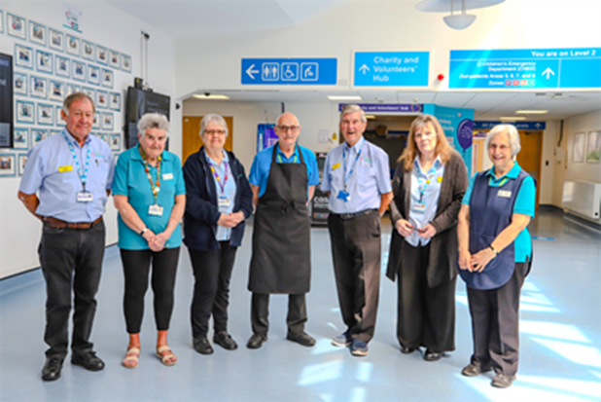

Venous Thromboembolism
The Trust considers the data presented is as described because it has been extracted directly from NHS Digital, which is an established and recognised source of data nationally, and all data is subjected to internal validation.
The Trust has taken the following actions, to improve this indicator, and so the quality of its services, by:
- Supporting colleagues through transition from paper to electronic prescribing and risk assessments.
- Supporting ward clerks to maintain logging of Venous Thromboembolism (VTE) risk assessment data.
- Regularly reporting VTE data at governance level so that awareness across the Trust is consistent.
- Using Patient First A3 methodology to improve VTE risk assessment compliance and data logging.
- Developed Quality Improvement Plans based on the lessons learned from investigations of hospital-acquired thrombosis (HAT)
VTE assessments | 2022-23 | 2023-24 (Feb-24) | 2024-2025
Our Trust | 80. 6per cent | 98.2 per cent | 98.8 per cent
National target | ≥95 per cent | ≥95 per cent | ≥95 per cent
National average | - | - | -
Best performing trust | - | - | -
Worst performing trust | - | - | -

2020/21 to date, data not available as national submission has been suspended *

Clostridioides difficile (C.diff)
In 2024/25 the trust reported a total of 64 cases of C.difficile infection breaching its threshold by 11 cases against a trajectory of 53. This equates to a rate of 33.2 cases per 100,000 occupied bed days. A post infection review PSIRF CDI Swarm is undertaken for all Trust apportioned C.difficile infections which identified that only one case was avoidable.
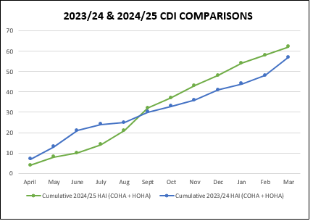

In order to reduce the number of Clostridioides difficile cases the Trust has taken the following actions:
- Work to ensure antimicrobial stewardship (AMS) remains a top priority for the Trust.
- Continue to hold C.difficile PSIRF CDI Swarms as a panel to ensure any learning from any lapses of care is identified and disseminated across the organisation to prevent reoccurrence.
- Monthly data driven discussions.
- Antimicrobial ward round with consultant microbiologists.
- The continued acquisition of new easier clean commodes.
- Continued roll-out of commode cleaning competencies for all staff
- Revised and updated Trust policy and guidelines.
- Updated the patient information leaflet for Clostridioides difficile.
- Trust-wide commode audits and sluice environmental auditing.
- Revised and updated the diarrhoeal assessment tool for ease of use.
- Revised condensed audit programme across wards and departments.
- Revised Infection Prevention Control (IPC) training, including a revised element for commode cleanliness.
- Link practitioners provide training to their respective clinical areas on using and completing the stool chart, assessment and associated documentation undertaken.

Patient safety incidents resulting in severe harm or death as reported to the Learning from Patient Safety Events service
The Trust encourages all healthcare professionals to report incidents as soon as they occur to ensure timely investigation and outcomes, which are shared to support learning that is reflective of a positive safety culture.
The Trust historically used nationally reported and verified data from the National Reporting and Learning System (NRLS) to benchmark its reporting culture against other like performing NHS Trusts. In 2023 the Trust transitioned from reporting incidents to the NRLS to the Learning from Patient Safety Events (LFPSE) platform. There is currently no nationally reported data available from LFPSE but NHS England have advised this will become available through the data access app which is now in testing and should be online soon (no date provided).
Medway NHS Foundation Trust considers that this data is as described in that:
The Trust uses an electronic reporting system DATIX which is used to report nationally and verified data to the LFPSE.
The Trust has a fortnightly Patient Safety Investigation Review Group (PSIRG) and weekly Incident Review Group (IRG), chaired by the Director for Patient Safety and Quality and Medical Director for Patient Safety and Quality, which explores in detail those incidents that fall within the scope of the terms of reference of the panel.
NHS England have currently paused the annual publishing of the number of reported patient safety incidents (PSI) while they consider future publications in line with the introduction of LFPSE.
We hold the following data internally:

Contract year | Patient safety incidents | Occupied bed days | Rate Per 1,000 bed days
2022/2023 | 5,486 | 178,141 | 30.8
2023/2024 | 7,027 | 187,067 | 37.6
2024/2025 | 5,282 | 192,398 | 27.5

The table below presents a summary update of the total number of PSIs which resulted in severe harm or death that were reported across the Trust from April 2018 to March 2023. Number of PSIs resulting in severe harm or death.

Patient safety incidents | April 18 to Sep 18 | Oct 18 to Mar 19 | April 19 to Sep 20 | Oct 19 to Mar 20 | April 20 to Mar 21 | April 21 to Mar 22 | April 22 to Mar 23
Incidents causing severe  harm or death | 20 | 42 | 26 | 19 | 56 | 41 | 43
per cent incidents causing severe  harm or death | 0.90 per cent | 1.80 per cent | 1.20 per cent | 1.50 per cent | 1.70 per cent | 0.9 per cent | 0.9 per cent
National average  (acute non-specialist) | 0.30 per cent | 0.40 per cent | 0.30 per cent | 0.30 per cent | 0.40 per cent | 0.40 per cent | On hold
Highest reporting rate | 1.20 per cent | 1.80 per cent | 1.60 per cent | 1.50 per cent | 2.80 per cent | 1.7 per cent | On hold
Lowest reporting rate | 0.00 per cent | 0.00 per cent | 0.00 per cent | 0.00 per cent | 0.00 per cent | 0.00 per cent | On hold

NHS England have currently paused the annual publishing of this data while they consider future publications in line with the introduction of LFPSE.
We hold the following data internally:
Contract year | Severe harm or death | Occupied bed days | Rate per 1000 bed days
2022/2023 | 41 | 178,141 | 0.2
2023/2024 | 43 | 187,067 | 0.2
2024/2025 | 34 | 192,398 | 0.2

The Trust intends to take the following actions to improve this data, and so the quality of its service by:
- Ongoing scrutiny of quality of learning responses within Patient Safety Investigation Review Group.
- Revision of the Trust’s Patient Safety Incident Response Framework (PSIRF) plan.
- Continue to educate staff on the importance of improving the reporting of incidents and near misses to support a positive safety culture for our patients.
- Revision of the incident management system to provide improved feedback to reporters of incidents and an easier to use system to encourage reporting.

Duty of Candour
The Trust is committed to being open and honest with our patients when something has gone wrong. Undertaking Duty of Candour is a legal requirement for all safety incidents recorded as causing moderate harm, severe harm or death and includes providing a formal apology to the patient and/or the family involved and undertaking an investigation into this aspect of their care.
The findings are fed-back in writing and detail any actions taken to prevent similar incidents from happening again. In 2024/25 formal Duty of Candour was applied to 98 of our reported incidents. This is a decrease from the previous year which was 103.

Serious Incidents
The Trust investigates all patient safety incidents, reported on our incident reporting system, DATIX. The Serious Incident Framework was replaced by Patient Safety Incident Response Framework (PSIRF). When PSIRF went live, all open serious incidents (SIs) continued to be progressed under the SI framework until complete. The Trust was running two frameworks concurrently until the remaining SIs were closed by the end of July 2024.

Learning Responses

Under PSIRF, the Trust has many more options for investigating compared to the SI framework. Patient Safety Incident Investigations (PSIIs) are the most in depth, followed by After Action Reviews (AARs) and SWARM huddles. Maternity and Newborn Safety Investigations (MNSI) are undertaken externally.
Learning response | Number declared
PSIIs | 8
AARs | 47
SWARMs | 52
MSNI | 7

Of the PSIIs declared, the PSIRF priorities were:
Delay in Treatment – 3
Deaths thought more likely than not due to problems in care – 3*
Never Events – 2
*Of the 3 deaths, 1 has been found not to be attributable to the Trust. The other 2 PSIIs are ongoing.

Never Events
The Trust reported twp never events between April 2024 and March 2025, both resulting in no harm to the patient. The first related to a nerve block administered incorrectly. The second related to wrong implant/prothesis, which was noted and immediately rectified.

2.6 Other Quality Information

Emergency Department (ED) performance
Over the past 12 months, the Emergency Department has experienced significant growth and improvement across multiple key performance areas, despite a substantial increase in patient volume. From April 2024 to March 2025, the department managed 204,000 patient attendances, representing a 40.69 per cent increase compared to the previous year’s total of 145,000 and 10 per cent inflation of patient attendances.
The rise in demand highlights the growing reliance on our emergency services and the importance of continued performance optimization. The department exceeded the national four-hour target in nine out of 12 months, marking a consistent and sustained improvement in patient flow and timeliness of care; this maintained improvement is the longest to date.
There was a notable increase in the initial assessment target, ensuring that patients were assessed more rapidly on arrival, contributing to overall better clinical outcomes and patient experience.
We consistently achieved one of the best ambulance handover performances in the region, minimising delays and enhancing operational efficiency. This directly supported reduced waiting times and improved ambulance turnaround. A significant number of patients were streamlined to alternative providers, alleviating pressure on the emergency department and ensuring appropriate care pathways. Despite increased attendances, there was a decrease in the number of patients admitted into the hospital base from September 2024 to Feb 2025, reflecting improved care at the front door and better utilisation of community and outpatient resources.
ED is extremely good at directing patients that do not require acute emergency care to the right care pathways. We validate this by the large numbers of streamed patients to Same Day Emergency Care (SDEC) and Medway on Call Care (MedOCC). SDEC saw 5,158 patients and MedOCC 44,773 patients from April 2024 to March 2025 – an increase on last year and a credit to the work of the team.
Despite extreme winter pressures we have sustained a high standard of ambulance handover times and continue to advocate a zero tolerance for delays to our crews. The Trust remains one of the best performers in the region and has been recognised for such standards by other hospitals who have come to observe our trends and actions to help improve their numbers. Further, we continue to have the highest intake of ambulances compared to other Trusts, but still perform as one of the best. To retain this standard of care with incoming ambulances – despite significant winter pressures – is a fantastic achievement for the department and commendable work.
As a department we recognised areas of where patients were waiting longer than they should have, including in Area 3. We now base a senior clinician in the area at all times, which has had a positive impact on staff from a supportive point of view and increased movement through Area 3. Last year we introduced the new Acute Medical Model; we have seen an increase in discharges from this model following the new phase (The Unidirectional Flow Model).
The leadership team continue to work closely on the shop floor with staff to drive performance through use of pathways to other care providers, streaming to Same Day Emergency Care, Frailty Same Day Emergency Care, Medway on Call Care (MedOCC) and speciality appropriateness. As a department we always strive for continuous improvement for patients and staff. Work continues around ED breaches and live validations; the operational team are working hard to improve and sustain higher levels of this.

Maximum time of 18 weeks from point of referral to treatment (RTT) in aggregate – patients on an incomplete pathway

RTT Incomplete Pathway per cent | 2022-23 | 2023-24 | 2024-25
Our Trust | 60.3 per cent | 50.8 per cent | 51.1 per cent
National average | 64.5 per cent | 57.2 per cent | 58.2 per cent
Best performing trust | 100 per cent | 100 per cent | 100 per cent
Worst performing trust | 31.9 per cent | 36.2 per cent | 34.08 per cent

The Trust considers that this data is as described for the following reasons.
- Data is taken direct from the internal source clinical system(s). Validation will occur by the appropriate service (in addition to the Central Data Assurance Team, where relevant) and once complete, is signed off and submitted nationally together with reported internally through dashboards and the Integrated Quality and Performance Report (IQPR).
Although we started to see a reduction in numbers of patients waiting greater than 65 weeks, the number increased again in the first half of the year.
The Trust has taken the following actions, to reduce the waiting times for our long waiting patients and so the quality of its services, by:
- Increasing the utilisation of current systems
- Increasing operating theatre efficiency and capacity
- Improving the management of GP referrals through advice and guidance and triage
- Creating additional virtual outpatient capacity by introducing a virtual hub
- Working with system partners and using the independent sector for insourcing and outsourcing capacity
- Reduction of outpatient DNA rates
- Implementation of automation within Patient Service Centre to support with patients queries, cancelling and rebooking of appointments and redirection of calls.

Maximum six-week wait for diagnostic procedures
The Trust considers that this data is as described for the following reasons:
- Data is taken direct from the internal source clinical system(s). Validation will occur by the appropriate service (in addition to the central Data Assurance team, where relevant) and once done, is signed off and submitted nationally together with reported internally through dashboards and the IQPR.
The Trust has taken the following actions, to improve this indicator and so the quality of its services, by:
- Using the independent sector to support insourcing and outsourcing capacity for a number of diagnostic modalities
- Additional imaging capacity is now being provided at Sheppey and Medway Communication Diagnostic Centres (CDCs) with further capacity coming online in 2025/26
six-Week Diagnostic Wait | 2022/23 | 2023/24 | 2024/25
Our Trust | 74.1 per cent | 66.7 per cent | 72.9 per cent
National average | 79.1 per cent | 78.2 per cent | 80.1 per cent
Best performing trust | 99.4 per cent | 100 per cent | 100 per cent
Worst performing trust | 21.6 per cent | 7.00 per cent | 19.70 per cent

National NHS Staff Survey
The NHS staff survey is an annual, validated survey that provides a robust measure of employee experience. It enables reliable benchmark group comparisons and provides a trend view of longer-term cultural change requirements for organisations’ strategic priorities.
The survey forms part of the national employee listening offering alongside the National Quarterly Pulse Survey together with local listening activities which together forms a rounded view of employee experience throughout the year.
The survey is aligned with the seven People Promise elements and in itself is critical to the promise that we each have a voice that counts. The employee voice is a fundamental enabler for employee engagement, and alignment of the survey with the People Promise elements began in 2021 – therefore the 2024 results offer a four-year trend. The Trust was benchmarked nationally against 122 Acute and Acute and Community Trusts.
Again for 2024, eligibility was extended to active, in-house, bank only workers last year (staff who do not have a substantive or fixed-term contract with the organisation.
The 2024 survey achieved a 46 per cent response rate (2,504 completed questionnaires) which is an increase of eight per cent from 2023. The national average response rate was 49 per cent. Bank only staff completed the survey which achieved an 18.3 per cent response rate (140 completed questionnaires). In total, 2,644 individual surveys were completed. The survey ran between 16 September and 29 November 2024.
Overall, the Trust has made improvements across six of the seven People Promise elements and has achieved improved scores for both staff morale and staff engagement.
The seven People Promises:

Our target as a Trust (our True North objective) is to move our staff engagement score to the upper quartile of national results by 2025, which is a score of 6.9. The Staff Engagement score was 6.74 for 2024, this has increased by 0.09 since 2023 and moves the Trust into the next quartile.
For 2024, the survey recorded answers for the question ‘I would recommend the Trust as a place to work’. This received a score of 55.81 per cent (positive) – an increase of 2.23 per cent from 2023, which remains below the national average of 60.90 per cent.
For question ‘if a friend or relative needed treatment I would be happy with the standard of care provided by this organisation’, a score of 54.32 per cent (positive) was recorded. This was an increase of 5.28 per cent from 2023 but remains below the national average of 61.54 per cent.
We have a combination of Trust-wide plans which will contribute to improving the recommendation as a place to work and receive treatment (below) and individual team/departments have or are in the process of developing their actions plans with delivery monitored through Strategy Deployment Reviews:
- Deliver outcomes recommendations of commissioned cultural transformation programme led by Absolute Diversity, action plan will follow the diagnostic and engagement stage
- Deliver outcome recommendations identified by the Incivilities and Behaviours Breakthrough Objective
- Our Leadership Way to be implemented and our Staff Compact to be updated and published including behaviours we do not want to see
- Implement a Staff Experience Council
- Review of the Flexible Working Policy to check its validity and reliability.
The theme indicator scores are based on a score out of 10 for certain questions with the indicator score being the average of those. Scores for each indicator together with that of the survey benchmarking group (acute) are presented below.

People Promise | 2023 score | 2023 respondents | 2024 score | 2024 respondents
We are compassionate and inclusive | 7.0 | 1934 | 7.05 | 2495
We are recognised and rewarded | 5.7 | 1939 | 5.74 | 2490
We each have a voice that counts | 6.5 | 1910 | 6.54 | 2456
We are safe and healthy | 5.84 | 1,909 | 5.96 | 2464
We are always learning | 5.6 | 1858 | 5.75 | 2405
We work flexibly | 6.1 | 1922 | 6.22 | 2472
We are a team | 6.6 | 1930 | 6.72 | 2486
ThemeS
Staff Engagement | 6.6 | 1933 | 6.74 | 2487
Morale | 5.6 | 1938 | 5.81 | 2493

Complaints and Compliments
The Trust welcomes and actively seeks patient and visitor feedback about experiences of care, which can include concerns, complaints, compliments and suggestions for improvement.
The Trust recognises that all patients may not have a positive experience of care, or may wish to give feedback about their encounter. Patients are supported to give feedback that is accepted with the mindset of continuous improvement for the services and customer care we provide.
Likewise, many patients and visitors wish to share positive feedback about their experience. Compliments are also welcomed and are shared with the staff or team who have provided the positive experience of care.
Between 1 April 2024 and 31 March 2025, 311 compliments were registered by the PALS team, which is just one of the services that captures positive feedback. The number of compliments captured and shared this year by the PALS team represents a 48 per cent increase on last year.
In accordance with the Local Authority Social Services and National Health Service Complaints (England) Regulations 2009, this part of the report sets out analysis of the nature and number of complaints received during 2024/25.
Between 1 April 2024 and 31 March 2025, the Trust registered 333 complaints, averaging around 27 per month, this is a reduction of the average of just three complaints in comparison with the same reporting period in the preceding year. The information below details themes of complaints for this reporting period.
We recognise that there will be times when things may not go to plan and the care and services fall below the high standard we expect. In these situations, we have measures in place to support the people who use our services, their families and carers to raise a concern or complaint or provide comments and suggestions so that we can understand what has caused care and services to fall below expectations. We signpost to advocacy services and offer a single point of contact. In doing this, we promise that this will not negatively affect their ongoing or future care and treatment or impact on the experience they receive.
The Trust strives to work in partnership with patients, their families and carers, colleagues and key stakeholders to seek opportunities to use feedback and experiences of care to achieve the excellent standard of care for patients and services that we strive to provide.
Concerns and complaints are triaged to identify the most appropriate and effective method of handling. It is the Trust’s ambition to resolve concerns as swiftly as possible by either a formal or informal method of resolution.
While handling concerns and providing resolution, there is a focused approach to identifying learning from themes from the feedback we receive which provides opportunity for short term and long-term improvements in relation to patient care and services across the organisation.
We use the feedback we receive to identify any barriers or challenges people face and to strengthen and improve our systems and processes whilst fully embracing the ethos of the Trust’s Patient First programme, which puts patients at the heart of everything we do.

Patient Advice and Liaison Service (PALS)
The Patient Advice and Liaison Service (PALS) offers confidential advice, support and information on health-related matters to patients and their families and provides a ‘much needed point of contact for patients, their families and their carers’ (NHS.UK 2018). Healthwatch UK recognises that people may want an opportunity to provide feedback about their experiences of care who may not necessarily want to make a formal complaint (‘A pain to complain’ January 2025). The Patient Advice and Liaison Service offers this opportunity with a focus on early remedy and resolution.
The Trust recognises that early and proactive resolution is key to de-escalating issues and providing remedy for patients and their families which can result in a more positive outcome. This approach reflects the Parliamentary and Health Service guidelines which promotes welcoming complaints and concerns in a positive way and recognising them as valuable insight for organisations, supporting patients and families with a thorough and fair approach that accurately reflects the experiences of everyone involved and promotes a learning culture by supporting organisations to see complaints as opportunities to improve services.
Patients and their families can contact PALS by telephone, email or visit in person. Additionally, contact can be made via a ‘Have Your Say’ form on the Trust website. This year has seen the launch of the ‘PALS hub’ which is situated within the hospital main entrance and is more accessible and visible to patients and visitors arriving and leaving the hospital.
The Patient Advice and Liaison Service (PALS) registered 5,464 enquiries in 2024/25. This is and increase on the 4,939 enquiries registered in the previous year and demonstrates the continued ambition to provide a responsive approach to handling concerns and feedback swiftly which provides remedy and resolution at the earliest opportunity.
The PALS team works collaboratively with teams, wards, departments and individual staff to highlight and help resolve concerns and enquiries as swiftly as possible. It requires a well informed and pro-active PALS team along with a responsive approach from staff to address concerns swiftly and effectively. The information below details themes of PALS concerns for this reporting period.

PALS themes by subject: | 2024/25 | In comparison with 2023/24 data
Admission, discharge and transfer arrangements | 257 | ↑
Aids and appliances, equipment, premises, access | 55 | ↑
All aspects of clinical treatment | 673 | ↓
Appointments, delay/cancellation (including outpatients and ED) | 1467 | ↑
Appointments, delay/cancellation (inpatient) | 59 | ↓
Attitude of staff | 258 | ↓
Communication/information to patients | 1388 | ↑
Compliment | 311 | ↑
Hotel services | 42 | ↓
Information relating to other organisations | 79 | ↑
Mortuary and post mortem arrangements | 2 | ↔
Other | 78 | ↓
Patients' privacy and dignity | 14 | ↑
Patients' property and expenses | 84 | ↑
Patients' status, discrimination | 6 | ↑
Personal records (inc. medical and/or complaints) | 184 ↑ | ↑
Results | 504 | ↑
Transport (ambulances and other) | 3 | ↓
Total | 5464 | ↑

Every complaint is assessed and managed individually, although issues raised may be similar to others; we recognise the circumstances and experiences are often different for the individual concerned. It is important to remember that not all formal complaints are as a result the Trust failing to provide a good quality service. For example, a complainant may not be happy with the service provided because they consider their needs are different to what the Trust has assessed them as needing or can offer.

Complaints themes by subject: | 2024/25 | In comparison with 2023/24 data
Admission, discharge and transfer arrangements | 22 | ↑
All aspects of clinical treatment | 236 | ↔
Appointments, delay/cancellation (including outpatients and ED) | 22 | ↑
Appointments, delay/cancellation (inpatient) | 4 | ↑
Attitude of staff | 8 | ↓
Communication/information to patients | 27 | ↑
Consent | 3 | ↑
Failure to follow agreed procedure | 2 | ↑
Patients' privacy and dignity | 1 | ↔
Patients' property and expenses | 1 | ↑
Patients' status, discrimination | 1 | ↔
Personal records (inc medical and/or complaints) | 4 | ↑
Results | 2 | ↔
Total | 333 | ↓

Performance
The Trust’s key performance indicators for complaints and PALS in 2024/25 includes:
Key Performance Indicator | End of Year position
95 per cent of complaints acknowledged within three working days. | 100 per cent of all complaints were acknowledged within three working days. | Achieved
95 per cent of amber complaints to be responded to within set timeframe of 40 working days. | In relation to the Trust’s key performance indicator for responding to complaints, on average over the year, 23 per cent of complaints breached (ranging from zero to 59.3 per cent breaches).  At the end of March 2024, the Trust had 65 complaints open and 21.5 per cent (14) of which had breached the Trust’s target response time. | Partly Achieved
Ensuring early resolution opportunities are exhausted so that no more than 80 complaints are open at any one time | 65 complaints open at year end | Achieved
20 per cent reduction in complaints and PALS that reference poor staff attitude (incivility) | To achieve a 20 per cent reduction in PALS referencing incivility, no more than 216 could be registered. The closing position was 208.  To achieve a 20 per cent reduction in complaints referencing incivility no more than 30 could be registered. The closing position was five. | Achieved  Achieved

Actions taken to reduce incivility across the year include:
- Incivility/poor staff attitude is an agenda item at the monthly Patient Experience Group meetings
- Each division has undertaken targeted work to address incivility and promote civility
- Trust-wide work includes; discussion at induction sessions and during appraisal
- Utilising a new informal conversation document which forms part of the disciplinary policy and includes having an informal and documented conversation about witnessed poor behaviour or attitude and promotion and recognition of positive behaviours.

Learning from complaints
In response to complaints received about clinical care and treatment the following improvement measures have been introduced:
- Mobility therapy boards are currently displayed above each patient bed. These are a quick reference point that provide quick, clear instructions to staff on how to transfer and mobilise a patient safely between therapy visits
- Cases involving the death of a patient are discussed at the specialty team Mortality and Morbidity meetings
- Cases discussed at clinical audit meetings for reflection and learning
- The Bereavement Team and the Medical Examiner’s office will forward any concerns raised by patients about care issues to the PALS and Complaints Team.
- Annual refresher training on the care and use of central lines is now mandatory
- Additional auditing has been introduced when necessary for example medication rounds, handwashing, Malnutrition Universal Screening Tool (MUST), hydration rounds, National Early Warning Score (NEWS2) to determine clinical deterioration).
- Revitalisation of ‘I care to call’ – a communication tool to improve communication with families.
- Improved visibility of ‘Call for Concern’ to inform families and patients of the option for a second opinion.
- A Therapy Practitioner pilot has been introduced on the frailty wards to improve engagement with patients.
- A review of Rehabilitation/Reminiscence and Interactive Therapy Activities (RITA) equipment has been completed to ensure they are readily available for patients who would like to use one whilst in hospital.
- Sharing key messages from patients experience of care with staff in the ‘Big Four’ communication tool, where we identify four key communications that we want to share with the team and this is communicated daily and updated weekly.
- A trial of pressure relieving mattress toppers within the ED.
- Promotion of civilities and Trust values and behaviours
- Customer Care promotion during discussions with teams
- The care pathway for first trimester pregnancy loss has been reviewed against the National Bereavement Pathway recommendations.
- Promotion of ‘pyjama paralysis’ messaging to encourage patients to get up and dressed.
- Support for patients to prepare for mealtimes
- Oral hygiene champions identified in some inpatient areas
- Improved visibility of posters advertising access to translation / interpreter services
- Paediatric Team have committed to;
- All children who are discharged home from the Paediatric Assessment Unit (PAU) must have vital signs taken with 30 minutes before discharge.
- A National Paediatric Early Warning System (PEWS) chart to be commenced at triage on all children attending PAU.
- Vital signs will be recorded every two hours for children attending PAU.

Parliamentary and Health Ombudsman Complaints
Between 1 April 2024 and 31 March 2025, seven new cases were requested by the Parliamentary and Health Service Ombudsman (PHSO) for assessment and/or investigation. This compares with eight cases in 2023/24.
During this period 10 cases were closed with the following outcomes:
- Six complaints were closed with no investigation necessary by the Ombudsman
- One complaint was investigated and upheld with recommendations to ensure that another healthcare professional referral and clinical views are taken into consideration when the patient presents to the Urgent Treatment Centre. The Trust apologised to the patient and provide assurance and evidence of a newly introduced streaming assessment chart adhering to NHS England’s standardising acuity clinical guide and initial assessment guidance.
- Three complaints were partly upheld with action plans to provide assurance of change in regard to clinical practice. One complaint included a payment of £900 in recognition of the impact on the family.
Learning and improvements actions include:
- When a patient has been assessed as not having the mental capacity to make a care decision a best interests meeting will be held. The team have committed to sharing this learning and it has been discussed during Mortality and Morbidity meetings.
- To involve family members in discussions prior to a clinical decision being made or discharging the patient, particularly in circumstances such as EoL Care or a lack of mental capacity.
- The Trial Without Catheter Guideline (TWOC) is being adapted to include; patients without capacity should be considered for admission to hospital for a trial without a catheter rather than removing the urinary catheter and discharging to their care provider.

Annex 1: Statements from commissioners, Local Healthwatch organisations and Overview and Scrutiny Committees

Statement from the Lead Governor on the Quality Account
Quality describes a commitment to making and ensuring continuous improvement in all that we do. The delivery of high quality care remains the responsibility of each and every member of the Trust, and that’s why quality is one of the key areas of focus in our Patient First improvement programme.
Our Quality Priorities for 2025/2026 were set following engagement with staff, patients and the public. The priorities agreed at our Quality Priorities event in February 2025, and then by our Council of Governors, were:
- Patient Safety: Reducing harm and creating a culture of safety.
- Patient Experience: Improving the quality of experience that patients receive.
- Clinical Effectiveness: Evidence based and best practice to reduce delayed admissions to the Critical Care Unit.
- Clinical Effectiveness: Evidence based and best practice, associated with GIRFT (Getting It Right First Time).

The Quality Assurance Committee, chaired by Non-Executive Director Paulette Lewis, meets on a regular basis, to receive and discuss quality matters. The papers and reports presented cover a wide range of subjects and have included Infection Prevention and Control Strategy, Maternity and Neonatal Services, Patient First and Safeguarding, as well as the Risk Register to name but a few. A heartfelt patient and or a staff story will, from time to time also be included in the agenda.
Patient First continues to give colleagues the opportunity to make suggestions for improvement, however small, through regular improvement huddles which take place across the hospital within teams.
It is also noted that there is a commitment by the Trust to continue to encourage participation in Clinical Research.
The CQC site assessment covering Urgent and Emergency care was conducted in February 2024 and rated Requires Improvement. Action plans to achieve a Good rating have been drawn up and work across the Trust continues to improve areas highlighted in the assessment.
Quality data continues to be shared with the Council of Governors on a regular basis and has demonstrated the drive for continuous improvement across the Trust. Reports are discussed at its regular meetings and feedback given as appropriate.
Public, Partner and Staff Governors continue to be active in all areas of the Trust, acting in an advisory capacity and by doing so, contributing to the strategic direction of the Trust. In addition, Governors act as ambassadors and as a link between the Trust and the communities we serve, by being represented on committees and groups including:
- Finance Committee
- Quality Assurance Committee
- Organ Donation Committee
- Charitable Funds Committee
- Governor Nominations and Remuneration Committee
- Patient Experience Group

The Council of Governors receives regular updates on the progress being made throughout the Trust and contributes to the ongoing work of all concerned throughout the organisation. Frequent ward and departmental visits continue to be undertaken.
Governors, working with Trust staff are regularly involved with showcasing the hospital to members of the public, which leads to increased membership across Medway and Swale.
A warm Medway welcome is extended to John Goulston, no stranger to the NHS and associated disciplines on being appointed Trust Chair. Having completed his term in office as a Non-Executive Director, Mark Spragg became the Interim Trust Chair and then retired. Our thanks and good wishes to Mark for his continued support over many years.
We were sorry to learn of the departure of Jayne Black, Chief Executive. Jonathan Wade, Chief Executive for Dartford and Gravesham NHS was appointed Interim Chief Executive, serving both Trusts. We wish both Jayne and Jon well in their new roles.


Cllr. David Brake - Lead Governor
20 May 2025

Statement from Kent and Medway Integrated Care Board (ICB)

We welcome the Quality Account for Medway NHS Foundation Trust. Kent and Medway Integrated Care Board (ICB) confirm that this Quality Account has been produced in line with the national requirements and includes all the required areas for reporting.
The annual account demonstrates an overview of quality of care in your focus areas, looking at improving the safety, and effectiveness of your services, as well as improving patient experience. The report has a clear flow that would be easy to follow for members of the public.
We were pleased to see your progress with your Quality Priorities from 2024/2025, particularly the achievement around the priority of reducing complaints and PALS relating to staff attitude. Progress was made against earlier recognition of the dying person and commencement on an End of Life care individualised care plan. Also, with improving rate of applicable National Clinical Audit (NCA) reports having an established delivery and improvement action plan within 90 days. We commend your embedding of Patient First, your improvement programme.
We commend your choice of Quality Priorities for 2025/2026. We were delighted to see that you completed comprehensive consultation of your 2025/26 Quality Priorities which have been developed in collaboration with your patients and staff. We welcome your focus to improve the outcomes on improving the experience of patients receiving care in the Emergency Department. We welcome the priority for no patients coming to harm due to a missed finding on imaging or being ‘lost to follow up’ following a diagnostic test.
You have set clear priorities for the coming year, aligned to the aims of the organisation’s strategy, objectives and values as an organisation. We invite you to update us on your progress with your Quality Priorities in the Provider Quality Meetings in 2025/2026.
We would also like to thank you for your ongoing engagement at the Provider Quality Meetings and the System Quality Group, continuing our collaborative partnership for the population of Kent and Medway. We are appreciative and praise your effort for the work you have completed on your Emergency Department improvement via the Emergency Department oversight group the ICB has chaired.


Paul Lumsdon
Chief Nursing Officer
NHS Kent and Medway ICB

Statement from Medway Healthwatch
Healthwatch Kent response to the Medway NHS Foundation Trust Quality Account 2024/2025
Healthwatch Medway and Healthwatch Kent are independent champions for health and social care in Kent and Medway. Our aim is to improve services by ensuring local voices are heard – we want to hear about health and social care experiences so to influence positive change for communities across the Kent and Medway area.
For several years now, local Healthwatch across the country have been asked to read, digest and comment on the Quality Accounts which are produced by every NHS provider (excluding primary care and Continuing Healthcare providers).
We are proud to celebrate our collaborative work with Medway NHS Foundation Trust throughout 2024/2025, highlighting the following key projects:
- Falls Prevention Project – Patient engagement was conducted in clinical settings at Medway NHS Foundation Trust, with valuable support from the Trust’s clinicians and managers.
- Self-Harm in 10–25-year-olds – The Trust’s Safeguarding team played a crucial role in this initiative by sharing insights into challenges within acute care settings, promoting a professionals’ survey, and contributing anonymous case studies to enhance learning and understanding across the system.
- Patient and Parent/Carer Engagement at Medway Maritime Hospital – Following successful partnership efforts and open discussions at the Patient Experience Group, Healthwatch Medway launched monthly engagement sessions at Medway Maritime Hospital in May 2025.
- Spotlight Report on the Deaf Community in Medway – Medway NHS Foundation Trust demonstrated strong responsiveness to the report’s recommendations, implementing immediate actions to improve experiences and outcomes for deaf individuals.
This collaborative work evidences the commitment to improving healthcare accessibility, engagement, and support for diverse communities.
We would like to encourage Medway NHS Foundation Trust to continue on improving services through lived experience gathered both internally and through external partnerships.
We have read the Quality Account with interest. Generally, the report is clear concise and engaging.

Healthwatch Medway June 2025


Statement from Medway Council’s Health and Adult Social Care Overview and Scrutiny Committee (HASC)

Medway Health and Adult Social Care Overview and Scrutiny Committee (HASC) thanks Medway NHS Foundation Trust for providing its Quality Account for 2024/25.

Considering the priorities for 2024/25, HASC notes that the Trust didn’t deliver all priorities, but made progress on several of them. Regarding the priority to reduce unwitnessed falls, HASC commends the Trust for the work done to try to reduce falls and acknowledges that staff absences were a major reason why this priority was not achieved. Staff health and wellbeing is an issue that HASC and Medway’s Health and Wellbeing Board take seriously and HASC recognises that the Trust is a platinum award holder for Medway Council’s Workplace Health programme and that the Trust has been engaging with our Public Health physical activity team, NHS health checks workshops and is working with our A Better Medway teams on a wellbeing event for new staff. HASC hopes that this work will continue, especially as the Kent and Medway system develops further work around work and health. HASC would be keen to see a follow-up report on falls prevention in the coming year.

The proposed priorities for 2025/26 are all important areas of focus. One area that might have been helpful to include is a priority on reducing mortality. The issue of high mortality rates in the Trust was brought to a HASC meeting in October 2024 and rates continue to remain high – the latest Summary Hospital-level Mortality Indicator (SHMI) figure, covering January 2024 to December 2024, is the fourth highest in the country. The Quality Report notes that mortality rates are high and describes work that has been done so far to try to reduce mortality rates, but it seems to be a persistent issue for the Trust.

Under Domain 2 (patient experience) it’s not clear how the Trust will ensure the voice of the child/children will be heard and how they plan to make reasonable service changes on the back of this feedback. It would be helpful to consider this over the coming year and include reference to it in the Quality Account for 2025/26.

Teri Reynolds
Principal Democratic Services Officer
Medway Council

Statement of adjustment following receipt of written statements required by section 5 (1) (D) of the National Health Service (Quality Account) Regulations 2010

In response to Medway Council’s Health and Adult Social Care Overview and Scrutiny Committee’s statement, amendments were made to;
- Outline the number of staff that would recommend the Trust as a place to work (quality indicator 21), and actions taken to improve.
- Provide rationale as to why the Trust did not participate in the Emergency Medicine QIPs.
- From the regulations; outline the percentage of staff employed by, or under contract to, the Trust during the reporting period who would recommend the Trust as a provider of care to their family or friends.

Annex 2: Statement of Directors Responsible for the Quality Report
The directors are required under the Health Act 2009 and the National Health Service (Quality Accounts) Regulations to prepare Quality Accounts for each financial year.
NHS England has issued guidance to NHS foundation trust boards on the form and content of annual quality reports (which incorporate the above legal requirements) and on the arrangements that NHS foundation trust boards should put in place to support the data quality for the preparation of the quality report.
In preparing the Quality Report, directors are required to take steps to satisfy themselves that:
- the content of the Quality Report meets the requirements set out in the NHS foundation trust annual reporting manual 2024/25 and supporting guidance detailed requirements for quality reports 2024/25
- the content of the Quality Report is not inconsistent with internal and external sources of information including:
  - board minutes and papers for the period April 2024 to March 2025
  - papers relating to quality reported to the board over the period April 2024 to March 2025
  - feedback from commissioners dated 16June 2025
  - feedback from councillors 20 May 2025
  - the Trust’s 2024-25 complaints report for the period April 2024 to March 2025 published under Regulation 18 of the Local Authority Social Services and NHS Complaints Regulations 2009
  - the 2024/25 national patient survey results
  - the 2024/25 national staff survey
- the Quality Report presents a balanced picture of the NHS foundation trust’s performance over the period covered
- the performance information reported in the quality report is reliable and accurate
- there are proper internal controls over the collection and reporting of the measures of performance included in the quality report, and these controls are subject to review to confirm that they are working effectively in practice
- the data underpinning the measures of performance reported in the quality report is robust and reliable, conforms to specified data quality standards and prescribed definitions, is subject to appropriate scrutiny and review
- the Quality Report has been prepared in accordance with NHS Improvement’s annual reporting manual and supporting guidance (which incorporates the quality accounts regulations) as well as the standards to support data quality for the preparation of the quality report.
The directors confirm to the best of their knowledge and belief they have complied with the above requirements in preparing the Quality Report.

By order of the board:
 Dated: 2025
John Goulston
Chair of Medway NHS Foundation Trust

Independent Auditor’s Report to the Council of Governors of Medway NHS Foundation Trust on the Quality Report
There is no requirement for a foundation trust to commission external assurance on its Quality Report for 2023/24, however the Trust has undertaken its own internal review to provide assurance that the required elements have been met.

Description | Areas applicable to Medway NHS Foundation Trust | National Average | Outcome/ Performance | Supporting commentary explaining variation | Referenced page on report
(a) The value and banding of the summary hospital-level mortality indicator (‘SHMI’) for the Trust for the reporting period; and  (b) The percentage of patient deaths with palliative care coded at either diagnosis or specialty level for the Trust for the reporting period. | Summary Hospital-level Mortality Indicator (SHMI) | Expected 1540  No data available | Observed  1850  No data available | The Trust has been ‘higher than expected’ band for seven of the 10 diagnosis groups | Page 60
The Trust’s patient reported outcome measures scores for:  (i) groin hernia surgery  (ii) varicose vein surgery  (iii) hip replacement surgery and  (iv) knee replacement surgery  during the reporting period. | Not applicable  Not applicable | Not applicable  NA  0.54  0.39 | Not applicable  N/A  0.44  0.27 | Not applicable  N/A  The Trust is reliant on feedback from patients in relation to the results of their surgery. | Page 62
The percentage of patients aged:  (i) 0 to 15 and  (ii) 16 or over  readmitted to a hospital which forms part of the Trust within 28 days of being discharged from a hospital during the reporting period. | 28 Day Readmissions | No data available | 9.7 per cent  8.2 per cent |  | Page 63
The Trust’s responsiveness to the personal needs of its patients during the reporting period. | Friends and Family Test | No data available | 91.3 per cent |  | Page 64
Friends and Family Test – Patient. The data made available by National Health Service Trust or NHS Foundation Trust by NHS Digital for all acute providers of adult NHS funded care, covering services for inpatients and patients discharged from Accident and Emergency (types 1 and 2) | Friends and Family Test | Not available | Recommended ED 74.3 per cent |  | Page 64
The percentage of patients who were admitted to hospital and who were risk assessed for venous thromboembolism during the reporting period. |  | Not known | 98.8 per cent | 2022/23 to date, data not available as national submission has been suspended *Data up to and including February 2024 | Page 66
The rate per 100,000 bed days of cases of C.difficile infection reported within the trust amongst patients aged two or over during the reporting period. | Aged two and above | No data available | 33.2 cases per 100,000 occupied bed days |  | Page 66
The number and, where available, rate of patient safety incidents reported within the Trust during the reporting period, and the number and percentage of such patient safety incidents that resulted in severe harm or death. | All areas | 57.5 incidents per 1000 bed days | 27.5 incidents per 1000 bed days  0.2 severe harm/death per 1000 bed days |  | Page 68

Annex 3: National and Local Clinical Audit Participation

Example of actions to improve quality of healthcare – National Audits

National Audit of Cardiac Rhythm Management:
National audit of pacemaker / defibrillator implants, as well as cardiac ablation and is the longest running audit in the world of cardiac devices.
Currently above national averages in data collection for metrics shown below:
Quality Metric | Standard (per cent) | Medway (per cent) | National average (90 per cent)
dual chamber pacing for sick sinus syndrome | 90 | 88 | 81
dual chamber pacing for AV block | 90 | 87 | 83
compliant with NICE ICD primary prevention | 80 | 100 | <50
compliant with NICE ICD secondary prevention | 80 | 59 | 47

Patient Reported Outcome Measures (PROMs):
Patients undergoing elective inpatient surgery for hip and knee replacement, funded by the NHS are asked to complete questionnaires before and after their operations to assess improvement in health as perceived by the patients themselves.
- 97 per cent of respondents reported an improvement for hip replacements
- 95 per cent of respondents reported an improvement for knee replacements
- At least 90 per cent of respondents felt better after their operation – 95 per cent of hip replacement patients and 90 per cent of knee replacement patients felt better after the operation.
- The majority of patients thought the results of their operation were excellent, very good or good. This occurred for 93 per cent of hip replacement patients and 87 per cent of knee replacement patients.

National Paediatric Diabetes Audit (NPDA):
Benchmarked against South East and national – consistently achieved above the national average. Every child is offered four clinics per year, we have achieved 98.6 per cent.

National Heart Failure Audit (NHFA):
This is a national audit in which heart failure outcomes are assessed. This enables the Heart Failure CNS team to accurately assess whether patients admitted to Medway NHS Foundation Trust receive safe, appropriate, evidence-based care. This drives up the quality of diagnosis, treatment and management of heart failure in the acute hospital setting.
Targets are being met and the service has increased since it was set up in 2013.
Data shows we are hitting and exceeding national targets for all areas except patients admitted to cardiac ward, 19 per cent compared to 60 per cent. At Medway we have limited cardiac beds and many patients do not need to be on a cardiac ward, they will be seen by the team even if they are on a medical or frailty ward. We review them and ensure they are on the right medication. Care is not impacted and we ensure the patients that do need to be on a cardiac ward go there.
We are meeting and often exceeding meeting key pharmacological interventions.

National Quality Account Audits Participation

Title | Workstream | Current Status | Cases submitted
BAUS Data and Audit Programme | a) BAUS Penile Fracture Audit | Completed | 2
BAUS Data and Audit Programme | b) BAUS I-DUNC (Impact of Diagnostic Ureteroscopy on Radical Nephroureterectomy and Compliance with Standard of Care Practices) | No data submitted
BAUS Data and Audit Programme | c) Environmental Lessons Learned and Applied to the bladder cancer care pathway audit (ELLA) | No data submitted
Breast and Cosmetic Implant Registry NHSE | Breast and Cosmetic Implant Registry NHSE | Participating | 25
British Hernia Society Registry | British Hernia Society Registry | Participating
Case Mix Programme (CMP) | Case Mix Programme (CMP) | Participating
Cleft Registry and Audit NEtwork (CRANE) Database | Cleft Registry and Audit Network (CRANE) Database | Not participating
Emergency Medicine QIPs: | a) Adolescent Mental Health | Paused
Emergency Medicine QIPs: | b) Care of Older People | No data submitted
Emergency Medicine QIPs: | c) Time Critical Medications | No data submitted
Epilepsy12: National Clinical Audit of Seizures and Epilepsies for Children and Young People | Epilepsy12: National Clinical Audit of Seizures and Epilepsies for Children and Young People1 | Completed | 35
Falls and Fragility Fracture Audit Programme (FFFAP) | a) Fracture Liaison Service Database (FLS-DB) | Participating | 1264
Falls and Fragility Fracture Audit Programme (FFFAP) | b) National Audit of Inpatient Falls (NAIF) | Participating | 2
Falls and Fragility Fracture Audit Programme (FFFAP) | c) National Hip Fracture Database (NHFD) | Participating | 356
Learning from lives and deaths – People with a learning disability and autistic people (LeDeR) | "Learning from lives and deaths – People with a learning disability and autistic people | Participating | 12
Maternal, Newborn and Infant Clinical Outcome Review Programme MBRRACEUK | Maternal, Newborn and Infant Clinical Outcome Review Programme MBRRACEUK1 | Participating | Ongoing
Mental Health Clinical Outcome Review Programme NCISH | Mental Health Clinical Outcome Review Programme NCISH1 | Not participating
National Adult Diabetes Audit (NDA) | a) National Diabetes Core Audit | Participating | Ongoing
National Adult Diabetes Audit (NDA) | b) Diabetes Prevention Programme (DPP) Audit | Not participating
National Adult Diabetes Audit (NDA) | c) National Diabetes Footcare Audit (NDFA) | Not participating
National Adult Diabetes Audit (NDA) | d) National Diabetes Inpatient Safety Audit (NDISA) | Participating | Ongoing
National Adult Diabetes Audit (NDA | e) National Pregnancy in Diabetes Audit (NPID) | Completed | 87
National Adult Diabetes Audit (NDA) | f) Transition (Adolescents and Young Adults) and Young Type 2 Audit | Participating | Automatic data collection
National Adult Diabetes Audit (NDA) | g) Gestational Diabetes Audit | Participating | Automatic data collection
National Audit of Cardiac Rehabilitation | National Audit of Cardiac Rehabilitation | Not participating
National Audit of Cardiovascular Disease Prevention in Primary Care (CVDPrevent)1 | National Audit of Cardiovascular Disease Prevention in Primary Care (CVDPrevent)1 | Not participating
National Audit of Care at the End of Life (NACEL) | National Audit of Care at the End of Life (NACEL)1 | Participating | Ongoing
National Audit of Dementia (NAD) | National Audit of Dementia (NAD)1 | Paused
National Bariatric Surgery Registry | National Bariatric Surgery Registry | Not participating
National Cancer Audit Collaborating Centre (NATCAN): RCS | National Audit of Metastatic Breast Cancer (NAoMe) | Participating | Automatic data collection
National Cancer Audit Collaborating Centre (NATCAN): RCS | National Audit of Primary Breast Cancer (NAoPri) | Participating | Automatic data collection
National Cancer Audit Collaborating Centre (NATCAN): RCS | National Bowel Cancer Audit (NBOCA) | Participating | Automatic data collection
National Cancer Audit Collaborating Centre (NATCAN): RCS | National Kidney Cancer Audit (NKCA) | Participating | Automatic data collection
National Cancer Audit Collaborating Centre (NATCAN): RCS | National Lung Cancer Audit (NLCA) | Participating | Automatic data collection
National Cancer Audit Collaborating Centre (NATCAN): RCS | National Non-Hodgkin Lymphoma Audit (NNHLA) | Participating | Automatic data collection
National Cancer Audit Collaborating Centre (NATCAN): RCS | National Oesophago-Gastric Cancer Audit (NOGCA) | Participating | Automatic data collection
National Cancer Audit Collaborating Centre (NATCAN): RCS | National Ovarian Cancer Audit (NOCA) | Participating | Automatic data collection
National Cancer Audit Collaborating Centre (NATCAN): RCS | National Pancreatic Cancer Audit (NPaCA) | Participating | Automatic data collection
National Cancer Audit Collaborating Centre (NATCAN): RCS | National Prostate Cancer Audit (NPCA) | Participating | Automatic data collection
National Cardiac Arrest Audit (NCAA) ICNARC | National Cardiac Arrest Audit (NCAA) ICNARC | Participating | 143
National Cardiac Audit Programme (NCAP): NICOR | a) National Adult Cardiac Surgery Audit (NACSA) | Not participating
National Cardiac Audit Programme (NCAP): NICOR | b) National Congenital Heart Disease Audit (NCHDA) | Participating | Automatic data collection
National Cardiac Audit Programme (NCAP): NICOR | c) National Heart Failure Audit (NHFA) | Participating | 298
National Cardiac Audit Programme (NCAP): NICOR | d) National Audit of Cardiac Rhythm Management (CRM) | Participating | 490
National Cardiac Audit Programme (NCAP): NICOR | e) Myocardial Ischaemia National Audit Project (MINAP) | Participating | 489
National Cardiac Audit Programme (NCAP): NICOR | f) National Audit of Percutaneous Coronary Intervention (NAPCI) | Participating | 312
National Cardiac Audit Programme (NCAP): NICOR | g) National Audit of Mitral Valve Leaflet Repairs (MVLR) | Not participating
National Cardiac Audit Programme (NCAP): NICOR | "h) UK Transcatheter Aortic Valve Implantation (TAVI) Registry" | Not participating
National Cardiac Audit Programme (NCAP): NICOR | i) Left Atrial Appendage Occlusion (LAAO) Registry | Not participating
National Cardiac Audit Programme (NCAP): NICOR | j) Patent Foramen Ovale Closure (PFOC) Registry | Not participating
National Cardiac Audit Programme (NCAP): NICOR | "k) Transcatheter Mitral and Tricuspid Valve (TMTV) Registry" | Not participating
National Child Mortality Database (NCMD)1 | National Child Mortality Database (NCMD)1 | Participating | Automatic data collection
National Clinical Audit of Psychosis (NCAP) RCP1 | National Clinical Audit of Psychosis (NCAP) RCP1 | Not participating
National Comparative Audit of Blood Transfusion: | a) National Comparative Audit of NICE Quality Standard QS138 | Completed | 40
National Comparative Audit of Blood Transfusion: | b) National Comparative Audit of Bedside Transfusion Practice | Participating | 20
National Early Inflammatory Arthritis Audit (NEIAA) BSR1" | "National Early Inflammatory Arthritis Audit | Participating | 3
National Emergency Laparotomy Audit (NELA)RCA1 | National Emergency Laparotomy Audit (NELA)RCA1 | Participating | Ongoing
National Joint Registry HQIP National Major Trauma Registry | National Joint Registry HQIP | Participating | 928
(Note: Previously TARN. To commence data collection in 2024) NHSE | National Major Trauma Registry | Participating | 507
National Maternity and Perinatal Audit (NMPA)1 | National Maternity and Perinatal Audit (NMPA)1 | Paused
National Neonatal Audit Programme (NNAP) 1 | National Neonatal Audit Programme (NNAP) 1 | Participating | Automatic data collection
National Obesity Audit (NOA)1 | National Obesity Audit (NOA)1 | Not participating
National Ophthalmology Database (NOD): | a) Age-related Macular Degeneration Audit | Not participating
National Ophthalmology Database (NOD): | b) Cataract Audit | Not participating
National Paediatric Diabetes Audit (NPDA)1 | National Paediatric Diabetes Audit (NPDA)1 | Participating | >300
National Perinatal Mortality Review Tool MBBRACE | National Perinatal Mortality Review Tool MBBRACE | Participating | 3
National Pulmonary Hypertension Audit | National Pulmonary Hypertension Audit | Not participating
National Respiratory Audit Programme (NRAP) | a) COPD Secondary Care | Participating | 533
National Respiratory Audit Programme (NRAP) | b) Pulmonary Rehabilitation | Not participating
National Respiratory Audit Programme (NRAP) | c) Adult Asthma Secondary Care | Participating | 130
National Respiratory Audit Programme (NRAP) | d) Children and Young People’s Asthma Secondary Care | Participating | 48
National Vascular Registry (NVR) RCS1 | National Vascular Registry (NVR) RCS1 | Not participating
Out-of-Hospital Cardiac Arrest Outcomes (OHCAO) | Out-of-Hospital Cardiac Arrest Outcomes (OHCAO) | Not participating
Paediatric Intensive Care Audit Network (PICANet)1 | Paediatric Intensive Care Audit Network (PICANet)1 | Not participating
Perioperative Quality Improvement Programme RCA | Perioperative Quality Improvement Programme RCA | Participating | Ongoing
Prescribing Observatory for Mental Health (POMH): | a) Rapid tranquillisation in the context of the pharmacological management of acutely disturbed behaviour | Not participating
Prescribing Observatory for Mental Health (POMH): | b) The use of melatonin | Not participating
Prescribing Observatory for Mental Health (POMH): | c) The use of opioids in mental health services | Not participating
Quality and Outcomes in Oral and Maxillofacial Surgery (QOMS): BAOMS | a) Oncology and Reconstruction | Not participating
Quality and Outcomes in Oral and Maxillofacial Surgery (QOMS): BAOMS | b) Trauma | Not participating
Quality and Outcomes in Oral and Maxillofacial Surgery (QOMS): BAOMS | c) Orthognathic Surgery | Participating | Ongoing
Quality and Outcomes in Oral and Maxillofacial Surgery (QOMS): BAOMS | d) Non-melanoma skin cancers | Not participating
Quality and Outcomes in Oral and Maxillofacial Surgery (QOMS): BAOMS | e) Oral and Dentoalveolar Surgery | Not participating
Sentinel Stroke National Audit Programme (SSNAP) 1 | Sentinel Stroke National Audit Programme (SSNAP) 1 | Not participating
Serious Hazards of Transfusion (SHOT): UK National Haemovigilance Scheme | Serious Hazards of Transfusion (SHOT): UK National Haemovigilance Scheme | Participating | 1
Society for Acute Medicine Benchmarking Audit (SAMBA) | Society for Acute Medicine Benchmarking Audit (SAMBA) | Completed | 73
UK Cystic Fibrosis Registry | UK Cystic Fibrosis Registry | Not participating
UK Renal Registry Chronic Kidney Disease Audit | UK Renal Registry Chronic Kidney Disease Audit | Not participating
UK Renal Registry National Acute Kidney Injury Audit | UK Renal Registry National Acute Kidney Injury Audit | Not participating

National Confidential Enquiry into Patient Outcome and Death (NCEPOD)
Programme | Title | Workstream | Current Status | Cases submitted
National Confidential Enquiry into Patient Outcome and Death (NCEPOD) | Child Health Clinical Outcome Review Programme | Emergency paediatric surgery | Completed | 13
National Confidential Enquiry into Patient Outcome and Death (NCEPOD) | Medical and Surgical Clinical Outcome Review Programme NCEPOD1 | Blood Sodium | Completed | 9

Example of actions to improve quality of healthcare – Local Audits

Implementing an Identification Tool for Non-Ambulatory Fragility Fractures (NAFF)
The project aim was to enhance patient care in recognition and treatment of NAFFs, a category of fragility fractures that significantly impairs patient mobility and is associated with increased morbidity and mortality. NAFFs, defined by their impact on a patient’s ability to ambulate, often fall through the cracks in standard diagnostic pathways.
Recognising this gap, the team embarked on a two-cycle audit. The first cycle involved a retrospective audit of NAFF identification and found NAFFs were under-recognised. The team developed and implemented a bespoke NAFF Identification Tool within the E-trauma system during Plan, Do Study, Ac (PDSA) Cycle Two.
The second audit cycle assessed the effectiveness of the tool and results showed improved recognition, and feedback was used to refine the tool and identify opportunities for additional staff training.
This Quality Improvement Project has spotlighted a critical area of unmet need in orthopaedic care. By introducing a systematic approach to NAFF identification, the team at Medway NHS Foundation Trust has not only improved recognition but also laid the groundwork for more consistent, guideline-driven management of these vulnerable patients. This work exemplifies the power of structured improvement methodology and collaborative teamwork in driving meaningful clinical change.

Improving Osteoporosis Secondary Prevention Compliance Post-Hip Fracture
Fragility fractures are a major public health issue associated with high morbidity and re-fracture risk. The National Hip Fracture Database (NHFD) KPI 7 monitors compliance with osteoporosis treatment 120 days post-discharge. At Medway NHS Foundation Trust, the initial audit in January 2024 revealed:
- 0 per cent documented compliance checks at 120 days
- Only 50 per cent success in post-discharge patient follow-up (all after 120 days)
- Key barriers: cognitive impairment, poor tolerance of oral bisphosphonates (due to fasting requirements and GI side effects) and extremely difficult to get osteoporosis outpatient appointment (usual waiting time is 12 months).
Second Cycle (August 2024):
- Implementation of inpatient IV Zoledronate led to significant improvements in compliance
- Multi Disciplinary Team engagement enhanced discharge planning
- Improved documentation and handover to primary care
- Preliminary data suggested progress toward meeting NHFD KPI 7
- 80 per cent reduction in osteoporosis clinic referral.
Patients discharged after fragility hip fractures had poor adherence to osteoporosis secondary prevention, undermining NHFD KPI 7 performances. By introducing inpatient IV Zoledronate administration and improving follow-up processes, compliance and long-term bone health outcomes can be significantly improved.

Radiological investigation of suspected physical abuse in children (fourth cycle)
Compliance for reporting within 72 hrs is 100 per cent. Compliance for reporting within 1 days has increased to 90p er cent. Compliance for double reporting has increased to 100 per cent. Compliance for follow-up survey being done has increased to 100 per cent.

Peri-Operative Management of Antiplatelet and Anticoagulant Therapy for Patients Undergoing Non-Elective Orthopaedic Procedures
High adherence (100 per cent) to surgical timing guidance in patient taking anticoagulant/antiplatelet. Identification of trend toward reduced complications when compliant to guideline. - Improved clinicians' awareness of peri-operative bleeding/thrombosis balance. - Reinforcing safe prescribing practices.

Improving the Quality of Follow Up for Discharged Babies with Outstanding Investigations at Oliver Fisher Neonatal Unit
The implementation of VBC significantly reduced the waiting time for biologic treatment prescription in Inflammatory Arthritis patients. The distribution of data indicates a notable improvement in service provision by reduction of waiting times by approximately 40 per cent (going by clustered data) post-VBC, with faster turnaround times and a broader distribution of waiting periods.

RCR emergency imaging
National Suspected Cauda equina Syndrome Pathway guidelines (2023), recommend patients to get MR imaging done within four hrs of MRI request, our average time is 228 minutes (3.8 hrs) which is well within the acceptable standards.

To improve the efficiency of Same Day Emergency Care Clinic
The waiting time has decreased by 40 per cent, demonstrating the effectiveness of the slot system.

Day Case Hysterectomy Quality Improvement Project
Overall safe and acceptable pathway for doing a hysterectomy. 92 per cent success rate. No readmissions within 72 hours, which shows comparable to patients who stay in overnight.

Medical history recording in paediatrics department at Medway Maritime Hospital
100 per cent notes contained correct patient identification, presenting complaints which corresponds with previous audit. While 10 per cent case notes did not have past illness and medications along with five per cent case notes for allergy history in previous audit, re-audit showed 100 per cent compliance. No anthropometric measurements plotting noted in clerking paper in both audit and re-audit. 100 per cent case notes had clinical examination, treatment plan and differential diagnosis in both audits. All notes (100 per cent) in re-audit had documentation regarding clerking doctor.

Collaborative Effort for Patient Outcome Development – CEPOD Theatre
Medway Maritime Hospital sought to identify specific inefficiencies within the process, which ensures emergency surgery patients are taken to theatre promptly and safely and aimed to implement targeted improvements to optimise the utilisation of theatre time.
The project was conducted in three phases and improvements made using existing resources with no extra funding. There was a marked improvement from phase 1 to 2 with the waiting time decreasing from seven hours to one hour. In phase 3 the breaches per category had improved by 13 per cent and time gaps (cumulative median of one hour 28 minutes). Efficiency and patient preparation has dropped slightly compared to the second cycle but that gave us a good insight into where re enforcements are required and to introduce more clarity by means of Standard Operating Procedures where required. Ongoing audits are required to not only to keep the standards but to identify and introduce new strategies to further improve patient care.

Glossary
Acronym Meaning
ASSKING Assess Risk, Skin assessment and skin care, Surface selection and use, Keep patients moving, Incontinence assessment and care, Nutrition and hydration assessment/support, Giving information
CCG Clinical Commissioning Group
C-DIFF Clostridium difficile
CNST Clinical Negligence Scheme for Trusts
CO Carbon monoxide
CQC Care Quality Commission
CQUIN Commissioning for Quality and Innovation
CRASH CRASH Bundle C= call bell, R= Review medication, A= Appropriate equipment, S = shoes (appropriate footwear), H= Hypotension (postural)
DATIX National Risk Management and reporting system
DQ Data Quality
E. coli Escherichia coli
ED Emergency Department
EoLC End of Life Care
FFT Friends and Family Test
FGR Fetal growth restriction
GRAM Gram-negative bloodstream infections
HSMR Hospital Standardised Mortality Ratio
IPC Infection Prevention and Control
KPI Key Performance Indicator
LeDER Learning Disabilities Mortality Review Programme
MRSA Methicillin-Resistant Staphylococcus Aureus
NCAA National Cardiac Arrest Audit
NELA National Emergency Laparotomy Audit
NHS National Health Service
NHSI National Health Service Improvement
NIHR National Institute for Health Research
NRLS National Reporting and Learning System
PALS Patient Advice and Liaison Service
PAS Patient Administration System
PHSO Parliamentary and Health Service Ombudsman
PPE Personal Protective Equipment
PROM Patient Reported Outcome Measures
PST Patient Safety Team
QIP Quality improvement project
RADG Resuscitation and Acute Deterioration Group
RTT Referred to Treatment
SATOD Smoking at time of delivery
SHMI Summary Hospital Level Mortality Indicator
SJR Structured Judgement Review
StEIS Strategic Executive Information System
SUS Secondary Uses service
UTI Urinary tract infection
VTE Venous Thromboembolism
Medway NHS Foundation Trust
Medway Maritime Hospital
Windmill Road
Gillingham
Kent
ME7 5NY
Tel: 01634 830000
www.medway.nhs.uk


