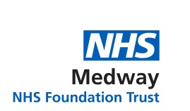

Green Plan

Author: | Carbon Zero Delivery Manager  Inspired PLC
Document Owner: | Chief Operating Officer  Director of Estates and Facilities
Revision Number: | V1.15
Approved By: | Trust Board November 2025
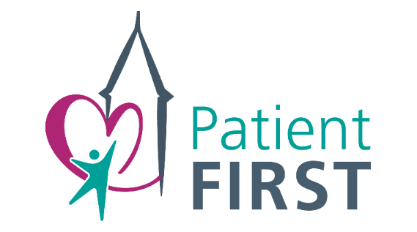
Document Control / History

Revision Number | Reason for change
V1.01 – V1.15 | Plan Refresh

Consultation

Green Sustainability Operational Group 04.08.2025
Trust Leadership Team (TLT) 24.06.25
Finance, Planning, Performance Committee (FPPC) 29.10.2025
© Medway NHS Foundation Trust [2025]

TO BE READ IN CONJUNCTION WITH ANY POLICIES LISTED IN TRUST ASSOCIATED DOCUMENTS

Contents

1. Foreword 3
2. Introduction 3
3. Drivers for Change 4
4. Metrics and Targets 6
5. Implementation Plan 11
6. Green Plan Governance 26
7. Conclusion 27
8. Glossary 28
9. References 29

Foreword


At Medway, we recognise that our environmental impact must underpin the long-term efficiency, resilience and quality of the services we provide. Our Green Plan represents a significant step forward in our commitment to delivering sustainable healthcare for our patients, staff and the community.

We are fully committed to embedding sustainability into every aspect of our work. We have already begun making meaningful changes. Thanks to £25.9 million of funding through the Public Sector Decarbonisation Scheme (PSDS), we have been able to start investing in a greener future by installing solar panels, replacing aging boilers with modern heat pumps, and installing energy efficient Light Emitting Diode (LED) lights and double glazing.

This will help us in our aim to achieve our full net-zero target in 2040, and we will continue to build on this progress. From reducing our carbon footprint, to improving energy efficiency and promoting greener practices, our efforts are ongoing and evolving. Together we can create a healthier environment and a more sustainable future for generations to come.

Neil McElduff – Director of Estates and Facilities

Introduction

Climate change presents an immediate and growing threat to health. The UK is already experiencing more frequent and severe floods and heatwaves, as well as worsening air pollution. Contributing around 4 per cent of the country’s carbon emissions and over 7 per cent of the economy, the NHS has an essential role in meeting the net-zero targets set under the Climate Change Act. ​

The impact of climate change will be expensive for society, including the NHS. However, action to tackle climate change will bring direct benefits for public health, health equity and taxpayers.

In 2020, the NHS became the world’s first health system to commit to reaching net-zero emissions. The “Delivering a Net-Zero National Health Service” report set out the scale of ambition. The Health and Care Act 2022 reinforced this commitment, placing new duties on Integrated Care Boards (ICBs), NHS trusts and NHS foundation trusts (referred to collectively in the guidance as ‘trusts’) to consider statutory emissions and environmental targets in their decisions.

Trusts and ICBs are expected to meet these duties through the delivery of board-approved green plans. These should outline the key actions that the Trust will take to deliver emission reductions and support resilience to climate impacts over the next three years.

Medway NHS Foundation Trust (MFT) is a single-site hospital Trust based in Gillingham, Kent, serving more than 427,000 people across Medway and Swale and is part of the wider Kent and Medway Integrated Care System (ICS).

To achieve net-zero, MFT has developed a Green Plan aligned with the ICS, the Greener NHS Strategy, and national sustainability goals that will be integrated into the regional ICS Green Plan.

It addresses near and long-term greenhouse-gas emissions with the financial year 2024 set as the baseline. The Green Plan emphasises environmental and social dimensions in healthcare, recognising the climate crisis as a public health issue.

Through this plan, and the underpinning implementation plan, MFT intends to collaborate with staff, patients, and partners to prioritise patient welfare and climate action whilst providing high-quality care for our patients and community.

The Trust secured PSDS funding of £25.9 million to support the decommissioning of the site phase 1, reinforcing its commitment to sustainable development and responsible estate management. A further £11 million was successfully secured to deliver phase 2. This funding enables MFT to retire legacy infrastructure in a way that aligns with national sustainability objectives.

As part of its long-term strategic direction, MFT will continue to pursue government funding to support future initiatives aimed at achieving net-zero.

Where external funding is not available, individual services within MFT will be required to develop comprehensive business cases to support proposed sustainability projects. This ensures that all initiatives are financially justified, strategically aligned, and contribute meaningfully to our net-zero ambitions.

The Government has made available up to £230m for projects for financial year 2024/25 with additional budget for financial year 2025/26. MFT expects to supplement these grants with a maximum of £5 million pounds a year.

Drivers for Change

Sustainability at a Local and Regional Level

We are committed to working closely with our partners across Kent and Medway to improve sustainability and achieve our net-zero carbon targets. Our efforts are aligned with the goals of local authorities and NHS partners: The Kent and Medway ICB commissions NHS services across the region and is aligned with the national NHS net-zero targets for direct emissions by 2040 and for indirect emissions by 2045.

Medway Council aims to achieve net-zero emissions across Medway by 2050, with an interim target of a 68 per cent reduction by 2030. These goals are supported by the Kent and Medway Energy and Low Emissions Strategy, which outlines a coordinated approach to tackling climate change across the county.

Sustainability in the NHS

The NHS contributes around 4–5 per cent of the UK’s carbon emissions, making it a key player in achieving national net-zero targets. In response, it became the first health system globally to commit to net-zero, as outlined in the “Delivering a Net-Zero National Health Service” report. The targets are:

- Net-zero by 2040 for direct emissions (“NHS Carbon Footprint”)
- Net-zero by 2045 for indirect emissions (“NHS Carbon Footprint Plus”)

Achieving these goals requires collaboration across all NHS Trusts, staff, and partners. Trusts are expected to align their local Green Plans with national guidance and regularly review updates from the NHS Net-Zero Expert Panel. In 2025, NHS England released updated Green Plan Guidance, setting out further priorities to embed sustainability in patient care and planning to improve efficiency and investment, ensuring alignment with net-zero targets. In order to assure alignment, there are supporting documents that must be considered, including but not limited to the NHS Long Term Plan, Net-Zero Building Standard, Net-Zero Supplier Roadmap, and Travel and Transport Strategy.

Sustainability at a National Level

Climate change is widely recognised as the greatest environmental threat to global health in the 21st century by leading organisations such as the World Health Organization (WHO), the British Medical Association (BMA), the Royal College of Physicians (RCP), and the Royal College of Nursing (RCN).

To support the ambition to meet net-zero targets by 2040 and 2045, the Greener NHS programme was launched, working with NHS staff, hospitals, and partners to reduce environmental impact while improving health outcomes. Key national initiatives include:

- Green Plans: All NHS trusts and ICBs are required to develop and implement board-approved Green Plans, which outline local strategies for reducing emissions and improving sustainability. These plans are being refreshed for the 2025–2028 cycle in line with updated statutory guidance.
- Sustainable procurement: NHS suppliers must now disclose their carbon emissions and publish carbon reduction plans, aligning with the “NHS Net-Zero Supplier Roadmap”.
- Decarbonising clinical care: Amongst other planned initiatives, the NHS has phased out desflurane - a high-emission anaesthetic gas - and is reducing nitrous oxide waste. It is also promoting lower-carbon respiratory care, including the use of more sustainable inhalers.
- Energy efficiency: Over £1billion has been secured through the PSDS, contributing to NHS trusts reducing energy costs and emissions.
- Clean energy investment: In 2025, the NHS received £100million from Great British Energy to install solar panels and battery storage systems across NHS sites.

These efforts align with broader UK climate policy. Under the Climate Change Act 2008, the UK committed to achieving net-zero carbon emissions by 2050. This has been supported by a series of strategic frameworks:

- The Ten Point Plan (2020) launched the UK Green Industrial Revolution, aiming to create 250,000 green jobs.
- The Net-Zero Strategy: Build Back Greener (2021–2022) expanded on this, setting a roadmap for decarbonisation.
- The Powering Up Britain policy paper (2023) updated targets and committed to £100billion in private investment and 480,000 new green jobs by 2030.

Most recently, the new Labour Government introduced its Environmental Manifesto, aiming to make the UK a “clean energy superpower.” Key pledges include:

- Achieving a zero-carbon electricity system by 2030.
- Investing £6.6 billion to improve energy efficiency in 5 million homes.
- Creating 650,000 clean energy jobs.
- Ending new oil and gas licences and banning fracking.

Together, these national and NHS-specific initiatives represent a comprehensive and coordinated response to the health and environmental challenges posed by climate change.

Metrics and Targets

Carbon Footprint

Greenhouse gas emissions are conventionally classified into one of three ‘Scopes’, depending on the emission source and the level of control an organisation has over the emission source. They are reported in ‘tonnes of carbon dioxide equivalent’ (tCO2e). The definitions were published by the Greenhouse Gas (GHG) Protocol, a widely recognised international standard for measuring and managing greenhouse gas emissions.

Scope 1: Direct Emissions

These are emissions from sources that a company owns or controls directly. Examples include:

- Fuel combustion in company-owned vehicles
- Emissions from boilers, furnaces, or manufacturing processes on-site

Scope 2: Indirect Emissions from Energy

These are emissions resulting from the generation of purchased energy — electricity, steam, heating, or cooling — that the company uses. Although the emissions occur off-site, the company is responsible for them because it consumes the energy.

Scope 3: Indirect Emissions Across the Value Chain

These are all other indirect emissions that occur outside the company’s direct operations, both upstream and downstream. Examples include:

- Emissions from suppliers producing raw materials
- Transportation and distribution
- Use of sold products by customers
- Disposal of products after use

Medway NHS Foundation Trust has measured its full Scope 1, 2 and 3 emissions for the first time in FY 2024, showing commitment to emission reductions and providing a baseline for future improvements.

Data is provided to our third-party Environmental, Social and Governance (ESG) reporting advisors for calculation following the GHG Protocol, however no formal assurance is provided.

Trust emissions are reported on a consolidation, operational control approach, as per the GHG Protocol. All emissions have been calculated following the GHG Protocol's Corporate Accounting and Reporting Standard. All seven greenhouse gases defined by the Kyoto Protocol have been accounted for and reported on a tonnes of carbon dioxide equivalent (tCO2e) basis.

All conversion factors are sourced from UK Government (Department for Energy Security and Net Zero) GHG Conversion Factors for Company Reporting 2024 v1.1 and include Scope 3 Well to Tank and Transmission and Distribution (T and D) losses.

The Greenhouse Gas Protocol Value Chain methodology is followed in all cases.

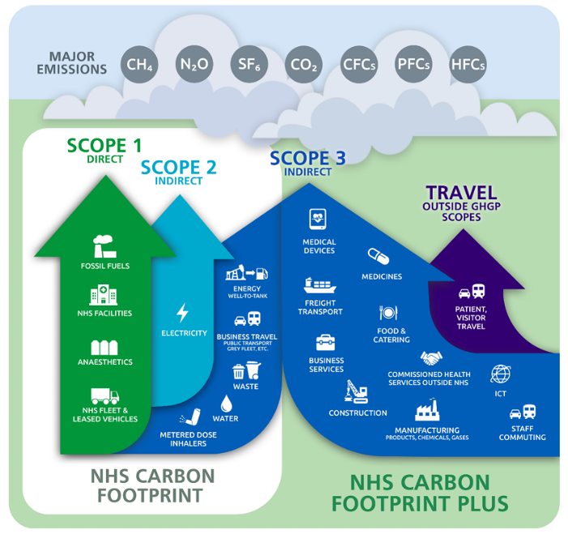
Figure 1 Overview of GHG Protocol scopes and emissions across the value chain

Figure 2: Medway NHS Foundation Trust GHG emissions summary
Emissions Scope | Baseline (FY2024) GHG emission tCO₂e
Scope 1 | 9,031
Scope 2 (Location-based) | 2,038
Scope 2 (Market-based) | 0
Scope 3 | 18,095
Total GHG emissions (Location-based) | 29,164
Total GHG emissions (Market-based) | 27,126

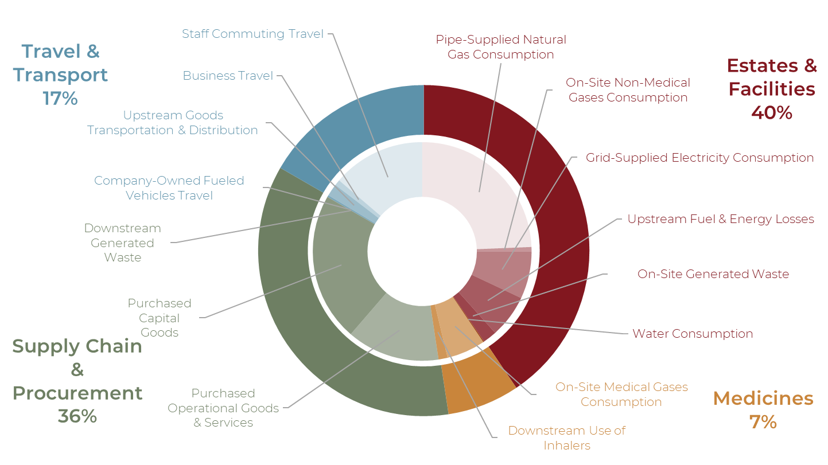
Figure 3 Trust Emissions Categorised by Source

Greenhouse Gas Emissions Inventory

The Greenhouse Gas Emissions Inventory – an annual report tracking the UK’s GHG emissions - follows the GHG protocol guidance and accounts for all operational and value chain associated with a company. The Scope 3 inventory is divided into the 15 categories established by the Greenhouse Gas Protocol Corporate Value Chain (Scope 3) Accounting and Reporting Standard). Not all categories are applicable to every business. All applicable categories have been quantified. Each applicable category has been mapped to either the NHS Carbon Footprint or NHS Carbon Footprint Plus categorisation.

Figure 4 Medway NHS Foundation Trust’s GHG emissions inventory
Emissions Scope | FY2024  tCO2e | % | NHS Target
Scope 1 | 9,031 | 31%
Natural Gas | 7,100 | 24% | Carbon Footprint
Transport (internal combustion vehicles) | 74 | 0.3% | Carbon Footprint
Other fuels | N/A | N/A | Carbon Footprint
Fugitives - air-con losses | 195 | 1% | Carbon Footprint
Fugitives - medical gases | 1,662 | 6% | Carbon Footprint
Scope 2 (Location-based) | 2,038 | 7%
Grid-Supplied Electricity | 2,038 | 7% | Carbon Footprint
Transportation (electric vehicles) | N/A | N/A | Carbon Footprint
Scope 2 (Market-based) | 0 | 0%
Scope 3 | 18,095 | 62%
1. Purchased Goods and Services | 4,044 | 14%
Water consumption | 42 | 0.1% | Carbon Footprint
Other purchased goods and services | 4,002 | 14% | Carbon Footprint Plus
2. Capital Goods | 6,407 | 22% | Carbon Footprint Plus
3. Fuel- and Energy-related Activities | 1,858 | 6% | Carbon Footprint
4. Upstream Transportation and Distribution | 531 | 2% | Carbon Footprint Plus
5. Waste Generated in Operations | 597 | 2% | Carbon Footprint
6. Business Travel | 252 | 1% | Carbon Footprint
7. Employee Commuting | 4,005 | 14% | Carbon Footprint Plus
8. Upstream Leased Assets | N/A | N/A | Carbon Footprint Plus
9. Downstream Transportation and Distribution | N/A | N/A | Carbon Footprint Plus
10. Processing of Sold Products | N/A | N/A | Carbon Footprint Plus
11. Use of Sold Products | 392 | 1% | Carbon Footprint
12. End-of-life Treatment of Sold Products | 10 | 0.04% | Carbon Footprint Plus
13. Downstream Leased Assets | N/A | N/A | Carbon Footprint Plus
14. Franchises | N/A | N/A | Carbon Footprint Plus
15. Investments | N/A | N/A | Carbon Footprint Plus
Out of Scope (Patient and Visitor Travel) | Not Available | N/A | Carbon Footprint Plus
Total Emissions (Location-based) | 29,164 | 100%
Total Emissions (Market-based) | 27,126 | 93%

Targets

NHS England has set ambitious yet realistic net-zero targets to encourage immediate action and ongoing monitoring and innovation. These targets are based on an analysis of current and planned NHS activities, national and international best practices, and assumptions about future innovations and the pace of change from the government and other sectors.

All NHS trusts are required to align Green Plans with NHS England’s net-zero ambitions:

- NHS Carbon Footprint emissions: net-zero by 2040 (with an ambition for an 80 per cent reduction (compared with a 1990 baseline) by 2028 to 2032)
- NHS Carbon Footprint Plus emissions: net-zero by 2045 (with an ambition for an 80 per cent reduction (compared with a 1990 baseline) by 2036 to 2039)

Figure 5: Medway NHS Foundation Trust's target summary and status
Target | Baseline FY2024 Value | Status and Risk Mitigation
Achieve net-zero on ‘Carbon Footprint’ emissions by 2040 | 14,133 tCO2e | A 6.3% annual reduction is required to meet the target
Achieve net-zero on ‘Carbon Footprint Plus’ emissions by 2045 | 14,955 tCO2e | A 4.7% annual reduction is required to meet the target.

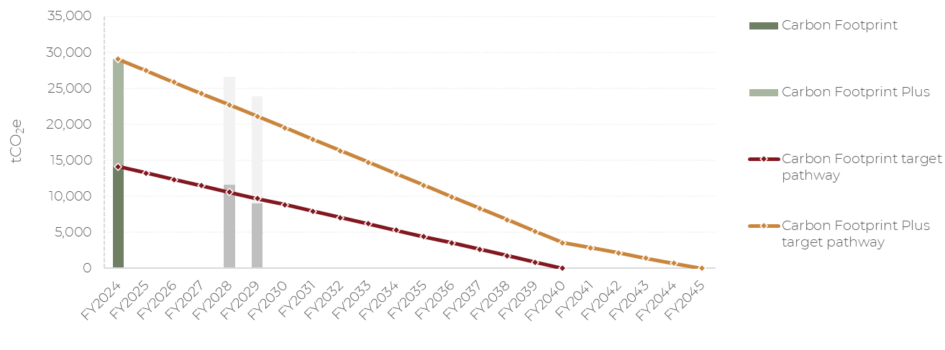
Figure 6 Medway NHS Foundation Trust’s net-zero pathways, including estimated ‘Carbon Footprint’ emission reductions related to the implementation of the Trust’s heat decarbonisation scheme in FY2028 and FY2029

Implementation Plan

Medway NHS Foundation Trust’s implementation plan is broken down into the nine focus areas as per NHSE’s recommendations:
Across our nine areas of focus, the Trust has already begun implementing initiatives. Emissions reductions from these actions however will not reflect in our reported progress towards net zero because they pre-date when our baseline was set.

Figure 7 The Nine Areas of Focus as per the NHSE Green Plan
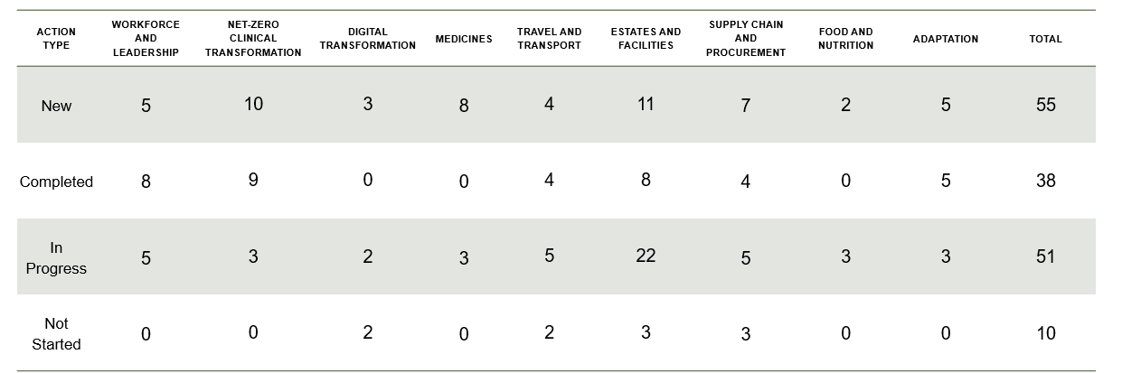

Workforce and Leadership

“The transition to a net zero NHS will be driven by its people. There is already strong support for a greener future; 9 in 10 staff support the NHS net zero ambition.”

Medway NHS Foundation Trust recognises that achieving our sustainability ambitions requires the active participation of all staff. As such, we are embedding environmental responsibility by incorporating sustainability commitments into job descriptions, induction programmes, and professional development frameworks. We will also develop and implement employee training, and ensure Executive sponsorship of all proposed ambitions within the implementation plan.

Initiatives such as the integration of sustainability into corporate inductions, the promotion of low and zero-emission vehicle schemes, and policies encouraging sustainable travel and flexible working, all contribute to creating a workplace culture that align with our Green Plan goals.

To further empower staff, we are enhancing awareness through programmes such as the Green Champions initiative, which offers staff the tools and confidence to collaborate and lead on embedding positive change.

Sustainability is becoming a regular feature within team meetings, appraisals, and internal communications. This ensures it remains a live and visible agenda item.

Our progress will be measured by increased participation in sustainability events, uptake of green initiatives, and staff-led innovation.

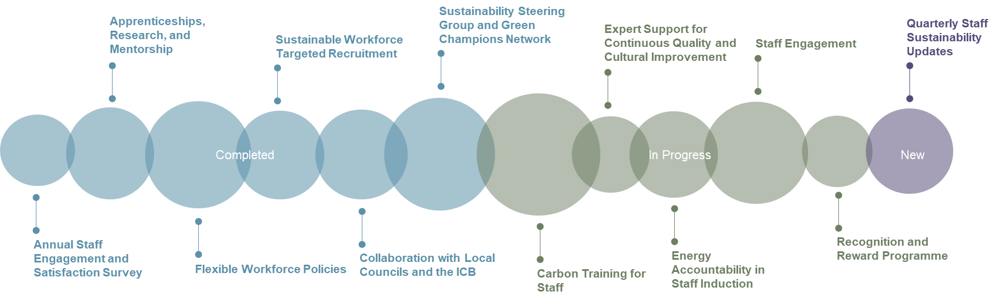
Figure 7 Overview of proposed sustainability initiatives
Figure 8 Workforce and Leadership – New Actions and SMART Targets from within the Implementation Plan
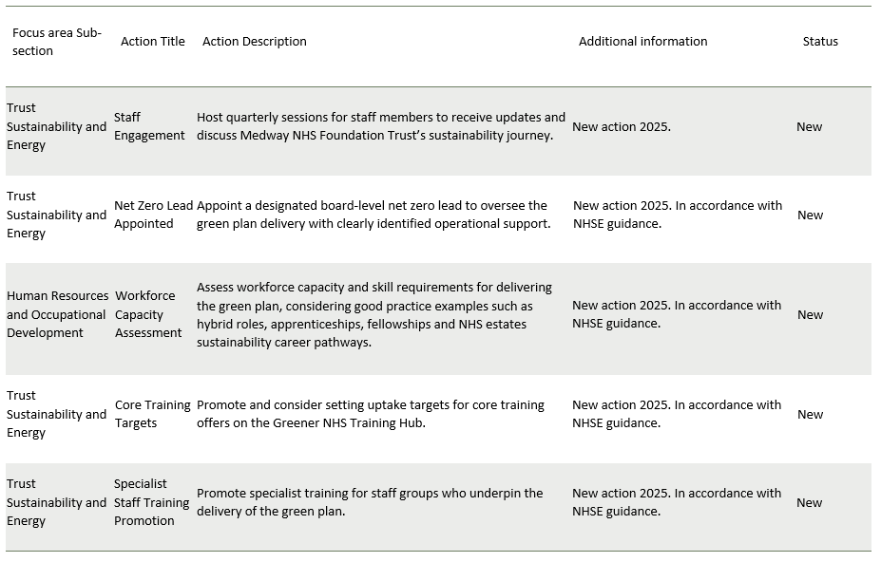

Net-Zero Clinical Transformation

“The NHS is committed to moving to out-of-hospital and digitally-enabled care where clinically appropriate, improving prevention of ill health and reducing health inequalities. These changes also underpin our commitment to net zero." ¹

Net-zero clinical transformation aims to ensure high-quality, preventive, low-carbon care for patients across the Trust. The Trust has been successful in securing funding to support innovative projects across key Green Plan priority areas. By 2026, the Trust will have initiated and completed three pilot projects designed to test new technologies, processes, or care practices that directly reduce carbon emissions and operational waste, with each initiative delivering quantifiable environmental benefits. This proactive approach ensures the Trust is not only decarbonising care pathways but also embedding sustainability into clinical innovation and service redesign.

MFT uses Patient First data-driven tools, evidence-based decision-making and workforce engagement to drive our culture of environmentally sustainable healthcare. The Trust will utilise national repositories for sustainable healthcare research and ensure staff routinely engage with the Kent and Medway SHARe Network via the NHS Futures platform to share best practices. The Trust also collaborates with the ICB on events that emphasise celebrating and expanding sustainability research.

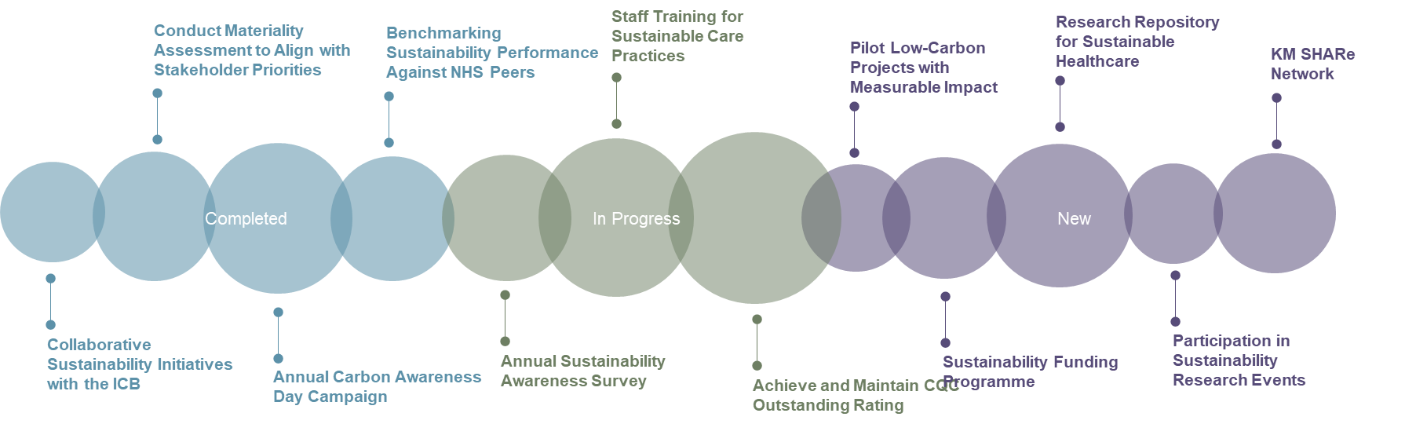

Figure 9 Overview of proposed sustainability initiatives

Figure 10 Net-Zero Clinical Transformation – New Actions
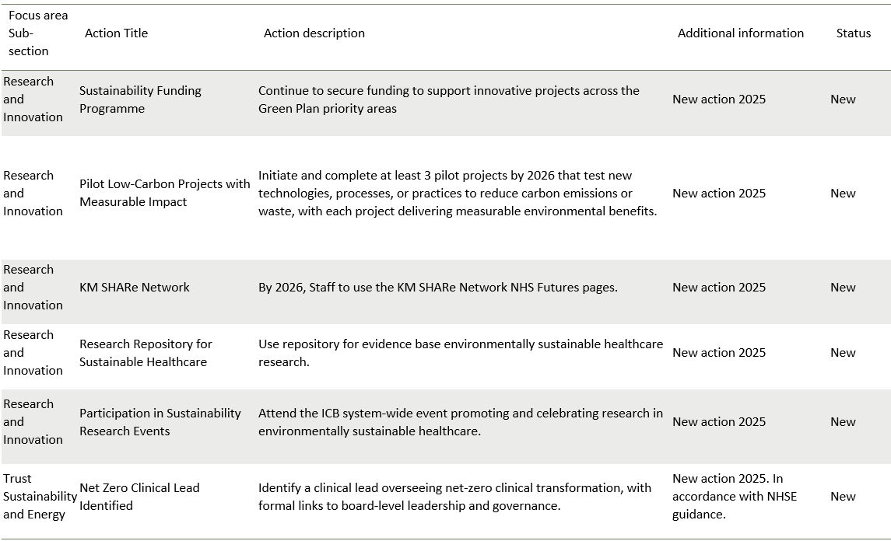

Digital Transformation

“Strong digital foundations are essential for transforming care by improving access, quality, productivity and reducing emissions.”¹

MFT is committed to embedding digital innovation across its operations and clinical services as a core enabler of sustainability, patient-centred care, and operational efficiency.

A significant focus has been placed on digitisation initiatives to reduce paper usage and optimise information flow. Implementing systems such as Sunrise Electronic Patient Records (EPR) and Patients Know Best (PKB) will significantly reduce a reliance on printed materials and physical storage. These efforts are part of a wider digital strategy to eliminate redundant paper processes and streamline administrative workflows, supporting the NHS’s ambition for paperless operations leading to financial savings, estimated at £700,000 annually.

Moreover, this shift is anticipated to yield medium-level carbon reductions by reducing resource consumption, print infrastructure energy use, and logistics associated with postal services.

In parallel, the Trust is advancing work to minimise the energy footprint of its digital estate. Initiatives underway include the development of power-down policies for IT equipment, planned upgrades to ageing infrastructure, and rationalisation of data centre operations.

By targeting high-consumption legacy systems and enhancing energy efficiency across devices and cooling systems, the Trust expects to achieve high-level carbon savings alongside moderate cost reductions. We will further explore the use of digital technologies to optimise care delivery, enhance data-driven decision-making, and reduce the need for patient and staff travel.
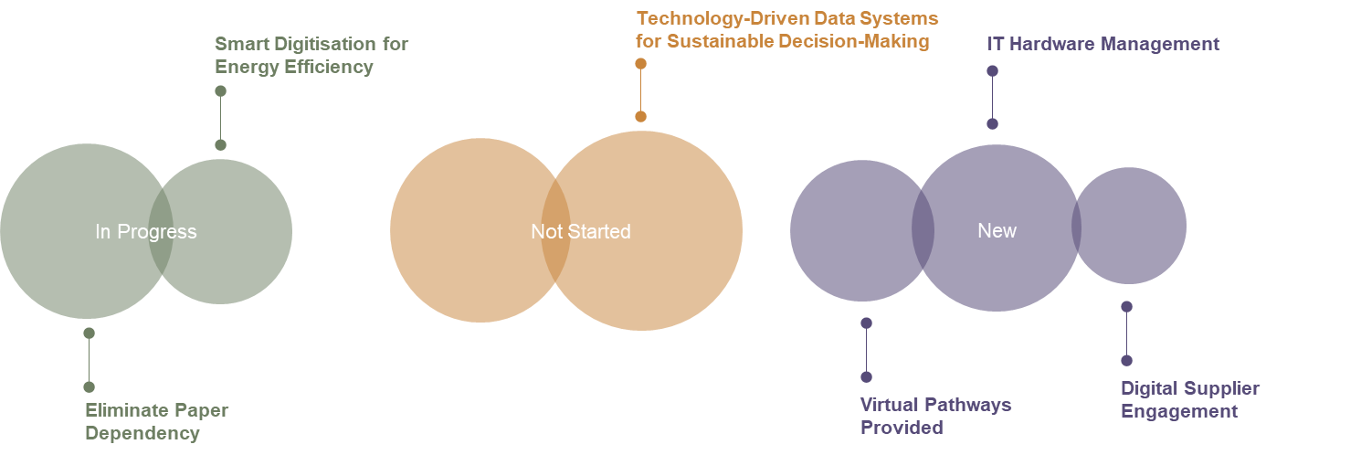

Figure 11 Overview of proposed sustainability initiatives
Figure 12 Digital Transformation – New Actions and SMART Targets Noted on the Implementation Plan
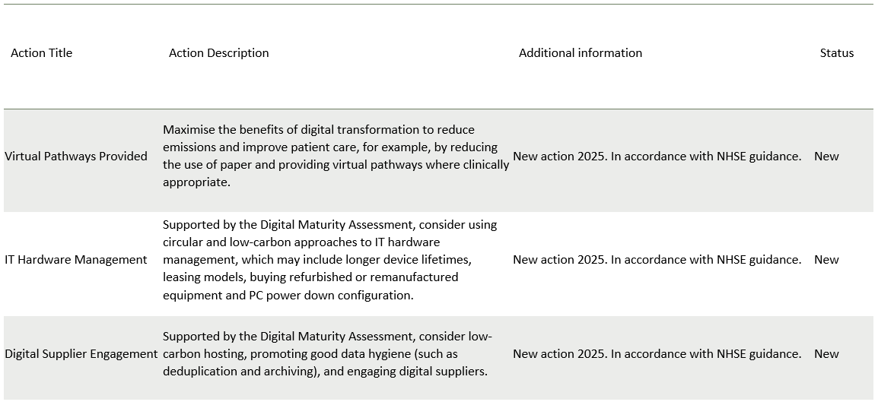

Medicines

“A few medicines account for a large portion of the NHS medicine related emissions, for example, anaesthetic gases (2 per cent of NHS emissions) and inhalers (3 per cent).”¹

The Trust is committed to reducing the carbon footprint of inhalers by shifting from Metered Dose Inhalers (MDI’s) to Dry Powder Inhalers (DPI’s). This transition aligns with the NHSE target of reducing MDI usage to less than 25 per cent of all prescribed inhalers by 2026. In the last reporting year, 8,450 MDI inhalers were dispensed, accounting for a 99.7 per cent share of the Trust’s total 392 tCO₂e of downstream inhaler emissions. In contrast, 827 DPI units were dispensed, generating one tonne of CO2e.

MFT have audited nitrous oxide usage, improved procurement and decommissioned the pipeline. Based on these audits, a sustainable anaesthesia programme has eliminated desflurane, a volatile anaesthetic with a Global Warming Potential (GWP) Index over 2,500 times that of CO₂, in 2024. MFT is also evaluating piped Entonox gas systems with funding and decommissioning areas where wastage can be found. In the last reporting year, on-site medical gas consumption added 1,662 tCO₂e to the Trust total emission. This emphasises the need for optimised delivery systems and more efficient clinical practices.

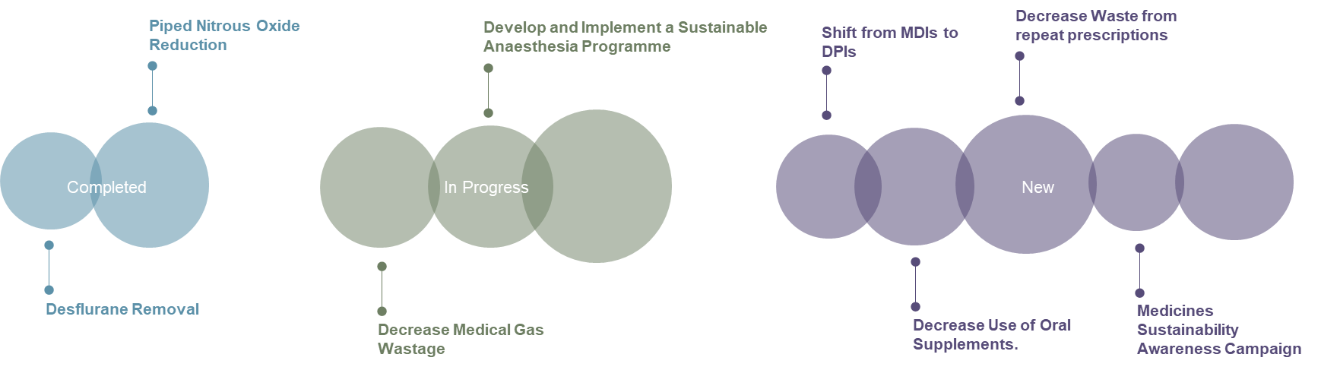

Figure 13 Overview of proposed sustainability initiatives

Figure 14 Medicines – New Actions and SMART targets as noted on the implementation plan
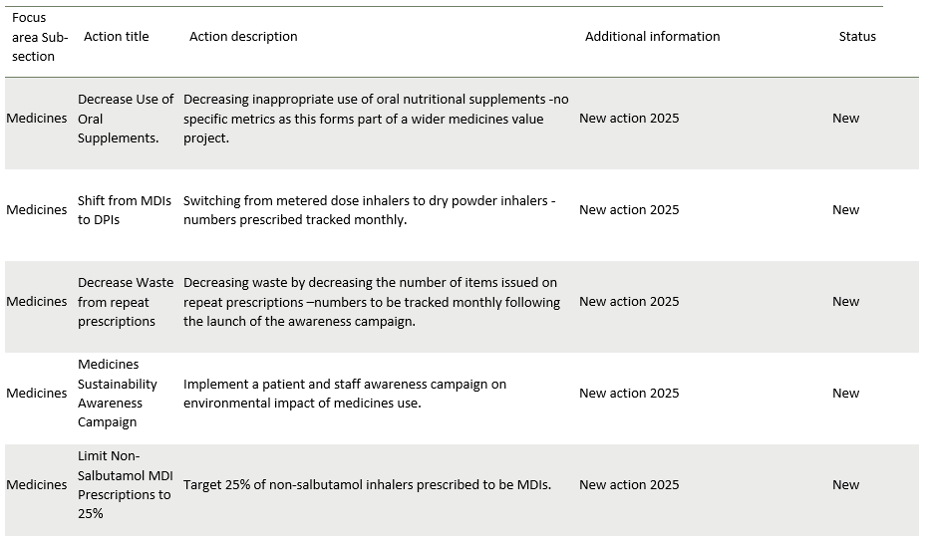
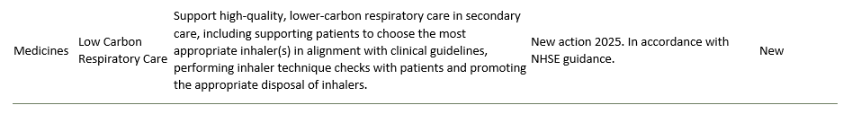

Travel and Transport

“The NHS fleet is the second largest in the country, consisting of over 20,000 vehicles. It directly contributes to harmful air pollution.”

As part of its commitment to reducing emissions from the Trust’s estate and operations, Medway NHS Foundation Trust is actively investing in a transition to an all-Electric Vehicle (EV) infrastructure of its owned and leased fleet to zero-emission alternatives by 2028. This will exclude ambulances.

Key actions include the annual installation of at least two EV charging points across the Trust, underpinned by an assessment of grid-capacity in collaboration with local network operators and authorities.

This infrastructure rollout is designed to future-proof fleet operations and support wider system decarbonisation efforts. By prioritising the use of EV transport, Medway NHS Foundation Trust is reducing its reliance on fossil fuels, improving local air quality, and aligning with NHS England’s Delivering a Net Zero National Health Service framework.

Figure 15 Overview of proposed sustainability initiatives
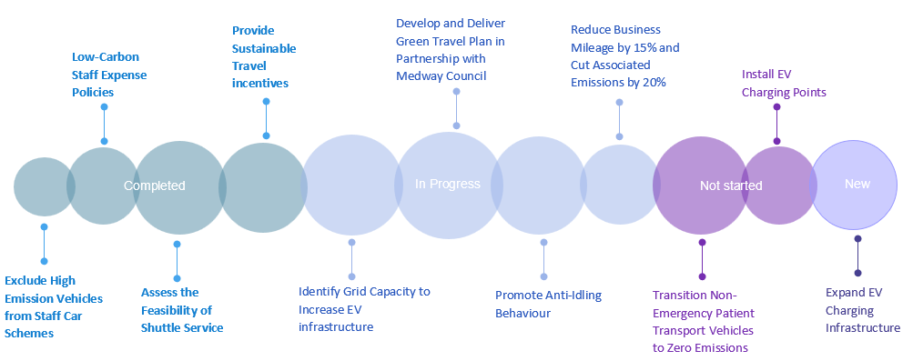

Figure 16 Travel and Transport – New Actions and SMART Targets as noted on the Implementation Plan
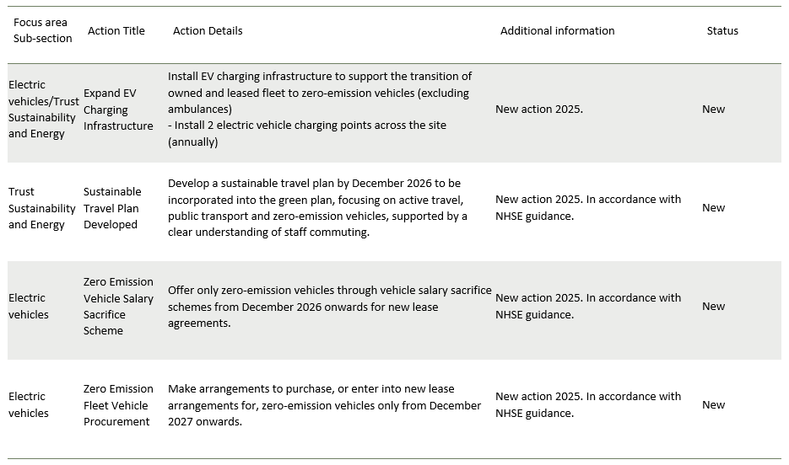

Estates and Facilities

“There are significant opportunities across the NHS estate to reduce emissions and lower costs, while improving energy resilience and patient care.”

Our estates are being developed year on year to accommodate our growing services and patient numbers. As we provide critical services 24 hours a day, our energy and resource consumptions are substantial.

The Trust is transitioning away from fossil fuels by implementing energy decarbonisation plans, adopting renewable energy tariffs, and phasing out coal and oil-based heating systems.

The Trust aims to meet electricity consumption targets of under 70 kWh/m² and achieve water use efficiency of 1.66m³/m² by deploying smart metering, leak detection systems, and innovations in water conservation. Further investments in LED lighting, heat pump solutions, and on-site renewables are being pursued to ensure that at least 80 per cent of the estate’s energy use is derived from zero-carbon sources.

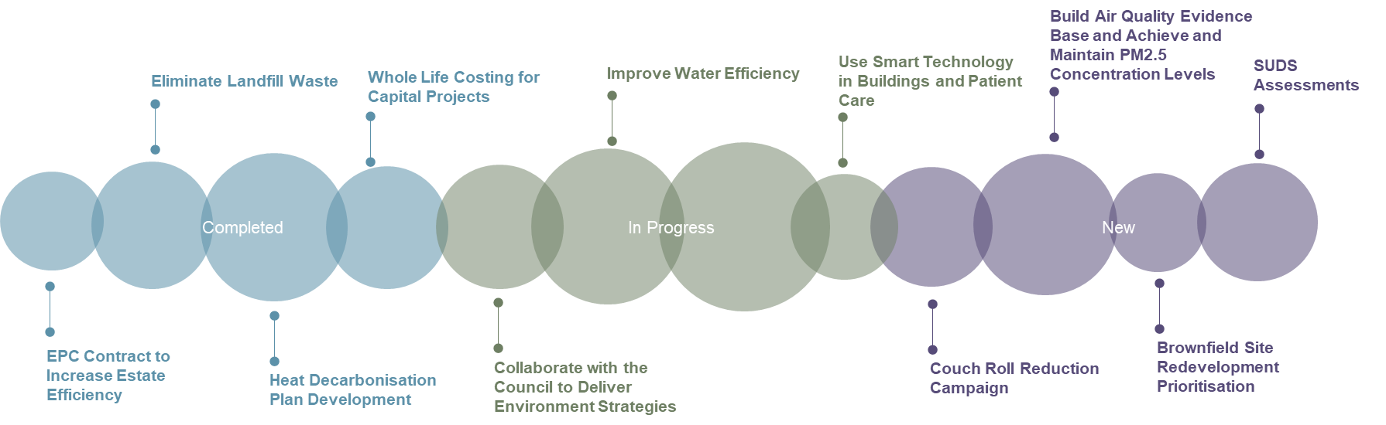

Figure 17 Overview of proposed sustainability initiatives

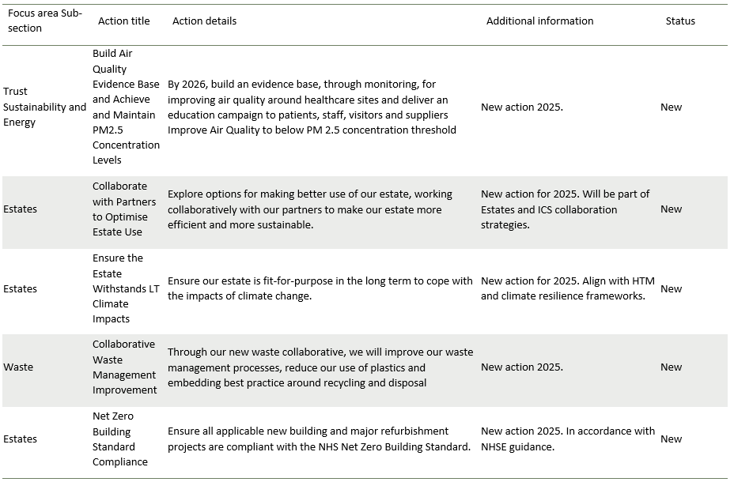
Figure 18 New Actions and SMART Targets as noted on the Implementation Plan

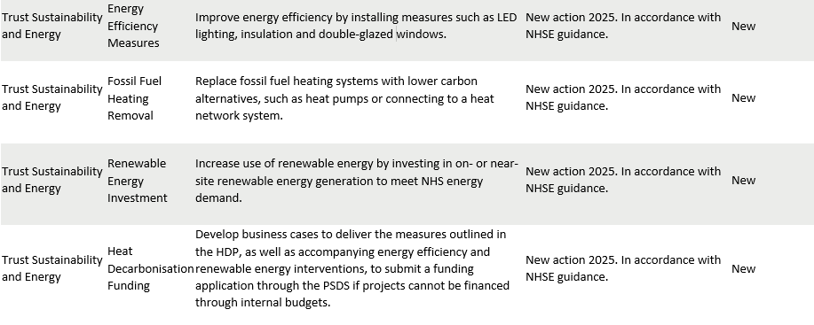

Supply Chain and Procurement

“The NHS net zero supplier roadmap outlines steps suppliers must follow to align with the NHS net zero ambition between now and 2030.”

We commit to integrating environmental sustainability at every stage of the procurement lifecycle, aligning with NHS priorities and the ICB strategy. Our structured approach aims to reduce the carbon footprint of purchased goods and services while fostering a resilient, ethical, and circular supply chain.

MFT is putting into place, a strategic way forward within Procurement, to support integrating sustainability and social value into tendering, supplier engagement, and contract management. We will apply a minimum 10 per cent social value weighting in all tenders and align supplier requirements with the NHS Net Zero Supplier Roadmap. This will include mandatory Carbon Reduction Plans for contracts over £5 million annually and using tools like the Evergreen supplier assessment.

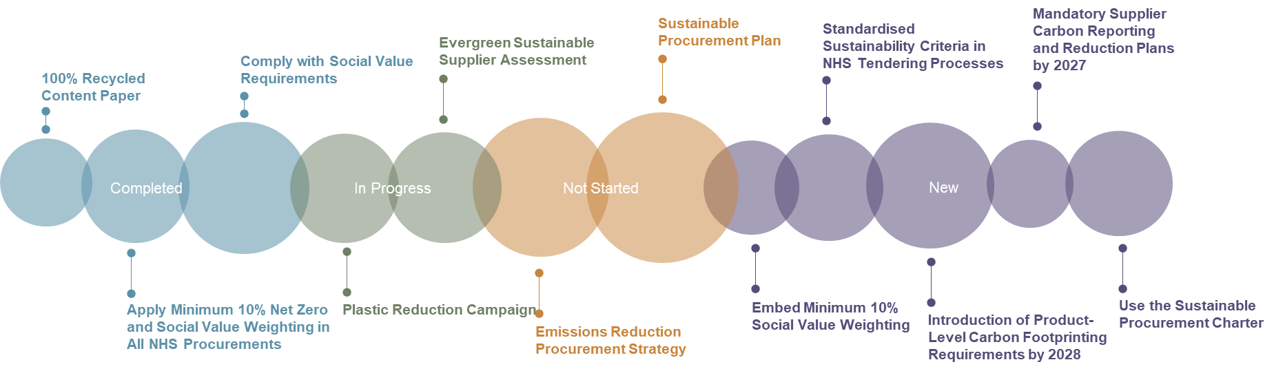

Figure 19 Overview of proposed sustainability initiatives

Figure 20 New Actions and SMART Targets as noted on the Implementation Plan
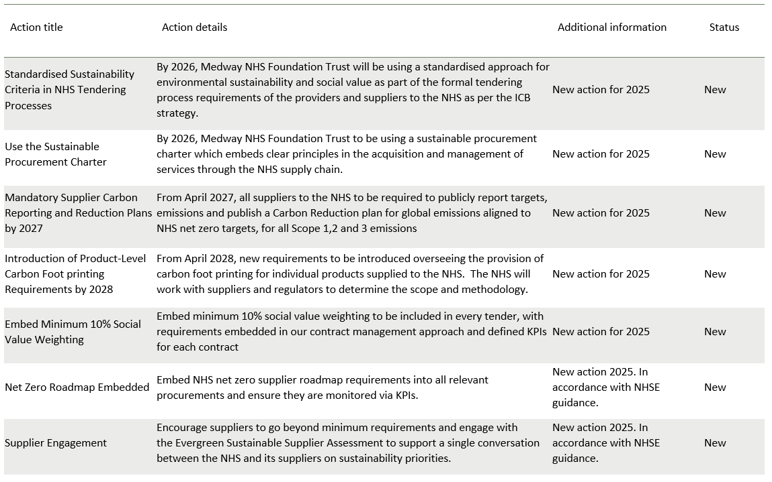

Food and Nutrition

“Organisations should continue implementing the National standards for healthcare food and drink, requiring NHS organisations to deliver high-quality, healthy and sustainable food and minimise waste.”

The Trust is advancing its commitment to sustainable food systems through targeted interventions to reduce food waste and improve environmental performance in catering services.

A key focus has been measuring and minimising food waste, including kitchen spoilage, preparation waste, unserved meals, and plate waste, with unserved food from patient and restaurant services already being recycled. In alignment with NHS England’s national food waste reduction priorities, MFT participated in the NHS Food Waste Trial in April 2023.

Data from this initiative is monitored via the Estates Returns Information Collection (ERIC) platform, although the electronic food monitoring system currently remains unfunded as a capital scheme. Further work is required to assess waste generated in wards and staff areas. Complementing these measures, the Trust conducts weekly separate food waste collections and composts biodegradable material, thereby supporting circular waste practices.

MFT already integrates sustainability into its food and nutrition improvement plans, by engaging staff through discussion groups and the Green Champions network to reduce their carbon footprint. Products are sourced locally, and comply with the Hospital Food Standards Panel Review.

Plans are underway to implement a digital patient meal ordering system by 2026, pending approval of the Capital Project Initiation Document (PID). If funded, this system will improve data availability for food waste monitoring and support evidence-based decision-making. These actions place MFT on a progressive path toward sustainable services that align with NHS Greener principles and national food policy objectives.

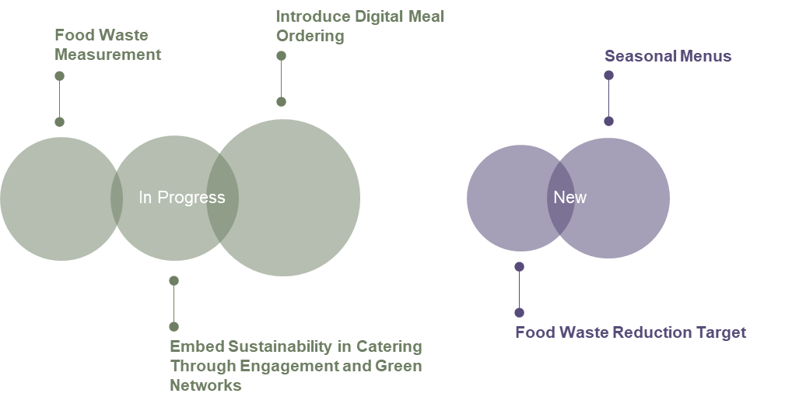

Figure 21 Overview of proposed sustainability initiatives

Figure 22 New Actions and SMART Targets as noted on the Implementation Plan
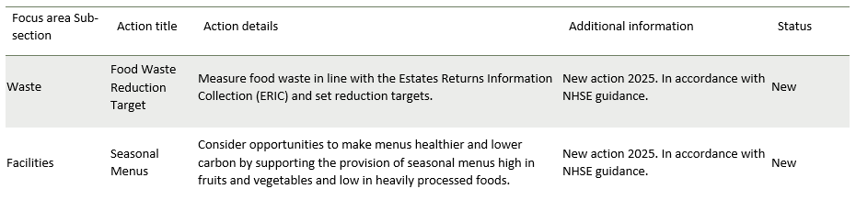

Adaptation

“Resilience and adaptation should be built into business continuity and longer-term planning to avoid climate-related service disruptions.”

MFT recognises the increasing threats that climate change presents to healthcare services, patient safety, and the resilience of infrastructure. Consequently, the Trust has published an Adverse Weather and Impacts of Climate Change Plan.

Integrating a robust adaptation framework into its operational planning will ensure that MFT is ready for the growing frequency and intensity of climate-related threats like extreme heat, cold spells, and flooding.

Key elements could address heatwave response, cold weather resilience, and local flood management. These plans would be underpinned by dynamic risk monitoring systems and integrated into Business Continuity Plans, Primary Care Network (PCN) estate strategies, and core estate planning.

The Trust plans to integrate adaptation and sustainability risks into its main risk register and perform structured impact assessments to analyse how climate-related choices influence patient health and local communities, particularly those vulnerable populations. Awareness campaigns targeting staff and service users will enhance understanding of climate impacts and the operational risks involved.

By anticipating and mitigating threats from environmental disruptions in a structured and transparent way, the Trust will safeguard health care continuity, and ensure the estate remains safe, and functional, under changing climatic conditions.

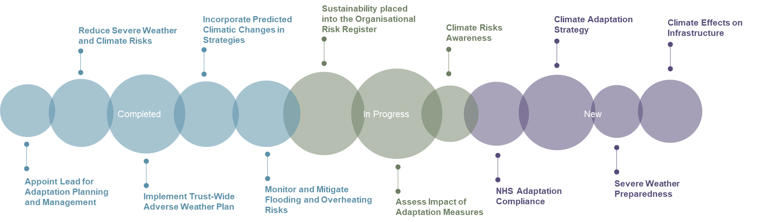
Figure 23 Overview of proposed sustainability initiatives

Figure 24 New Actions and SMART Targets as noted on the Implementation Plan
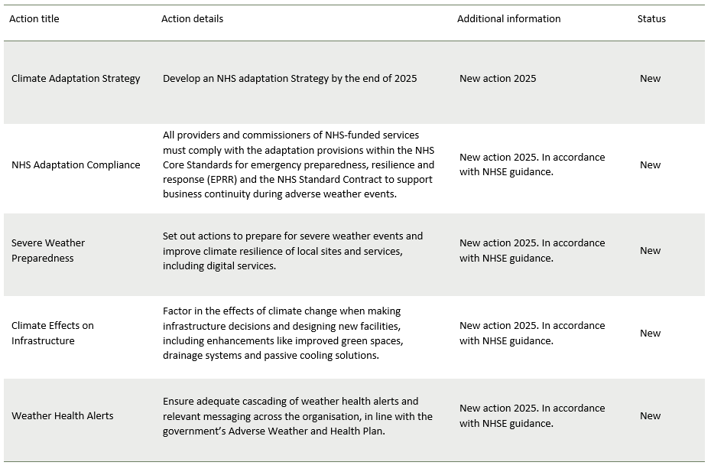

Green Plan Governance

MFT’s Green Plan outlines the requirements of the Trust to enhance our sustainability. The underpinning implementation plan highlights the specific actions the Trust will undertake to achieve this over the next three years. To be successful and accountable, employees have been assigned to each focus area and action item. ​

Oversight of the Implementation Plan progress is as follows:

Conclusion

This Green Plan Strategy aligns with our organisational vision and values, and reinforces our commitment to the broader ambitions set out in the NHS 10 Year Plan, which calls for integrated, preventative, and sustainable models of care to improve population health and reduce health inequalities.

In full alignment with the NHSE Green Plan, we are actively contributing to the national goal of achieving net-zero carbon emissions by 2040, and embedding sustainability into every facet of our operations—from energy and travel to procurement and clinical care. Our strategy also emphasises ongoing system collaboration recognising that climate action is a shared mission across health and social care partners. By working together, we can amplify our impact, build resilience, and deliver greener, healthier futures for the communities we serve.

This strategy is a foundation for us to build upon from our baseline. Through innovation, accountability, and collective action, MFT will continue to evolve, ensuring that sustainability becomes and remains central to our identity and our service. Together, we are not only reducing our environmental footprint—we are redefining what it means to deliver compassionate, future-ready healthcare.

Glossary

- GHG Protocol: The Greenhouse Gas Protocol is the most widely used standard for calculating Greenhouse Gas (GHG) emissions.

- Kyoto Protocol: The Kyoto Protocol operationalises the UN Framework Convention on Climate Change by committing industrialised countries and economies in transition to limit and reduce greenhouse gas (GHG) emissions following agreed individual targets. There are seven GHGs that are required to be reported on under the Kyoto Protocol: Carbon dioxide (CO2), Methane (CH4), Nitrous oxide (N2O), Hydrofluorocarbons (HFCs), Perfluorocarbons (PFCs), Sulphur hexafluoride (SF6) and Nitrogen trifluoride (NF3).

- Location-based emissions: Methodology to calculate scope 2 emissions using a region’s average grid emissions factor.

- Market-based emissions: Methodology to calculate scope 2 emissions using emissions factors specific to the contractual instruments in place.

- Net-zero: Net-zero requires a concerted effort over time to eliminate GHG emissions, with compensatory measures as a final step for any emissions that can’t be reduced. The Science Based Targets Initiative (SBTi) net-zero standard requires a 90 per cent reduction in emissions prior to any residual offsets, up to 10 per cent of the baseline, being offset using carbon removal offsets.

- Scope 1: Emissions from gas usage and transportation fuels (under the company’s control).

- Scope 2: Emissions associated with the consumption of purchased electricity. They are presented on both a location-based (using country average electricity emission factors) and market-based (considering any purchased renewable-generated electricity) approach.

- Scope 3: Company’s value chain emissions, divided into 15 categories, as established by the Greenhouse Gas Protocol Corporate Value Chain (Scope 3) Accounting and Reporting Standard.

- tCO2: Tonnes of carbon dioxide gas released into the atmosphere. This metric is often used when reporting electricity emissions factors.

- tCO2e: Greenhouse gases have different global warming potentials and are converted to a carbon dioxide equivalent for ease of comparison and reporting.

References

Trust Associated Documents
Patient First Strategy
Clinical Strategy
Estates and Facilities Strategy

External Documents
INSPIRED PLC Inspired PLC - Commercial energy and sustainability advisor
KMICB Green Strategy
Delivering a Net Zero NHS Greener NHS » Delivering a net zero NHS
NHS Net Zero Building Standard NHS England » NHS Net Zero Building Standard
NHS Zero Travel and Transport Strategy NHS England » Net Zero travel and transport strategy
NHS Climate Change Risk Assessment Tool NHS England » Climate adaptation resources
Green Plan guidance NHS England NHS England » Green plan guidance
Future NHS Futures - Futures
The Health and Care Act 2022 Health and Care Act 2022 - GOV.UK
Climate Change Act Climate Change Act 2008
Greener NHS Strategy Greener NHS
NHS Long Term Plan 10 Year Health Plan for England: fit for the future - GOV.UK
Net Zero Supplier Roadmap NHS-Net-Zero-Supplier-Roadmap-2024.pdf
Kent and Medway Energy and Low Emissions Strategy Kent and Medway Energy and Low Emissions Strategy - Kent County Council
Green Plan updated guidance (2025) NHS England » Green plan guidance
Great British Energy Great British Energy

END OF DOCUMENT

NHS Green Plan Guidance NHS England » Green plan guidance
Delivering a Greener NHS: Five Years on NHS England » Progress report – delivering a greener NHS: five years on
Five Years of a Greener NHS: Progress and Forward Look item-9i-five-years-of-a-greener-nhs.pdf
NHS Net Zero Supplier Roadmap - https://www.england.nhs.uk/greenernhs/
Five Years of a Greener NHS: Progress and Forward Look item-9i-five-years-of-a-greener-nhs.pdf
Progress report – delivering a greener NHS: Five years on - NHS England » Progress report – delivering a greener NHS: five years on

