
Therapy Department
Location: Level 2 Blue Zone

Enhanced Recovery Programme
Integrated Care Pathway

Total Hip Replacement Passport

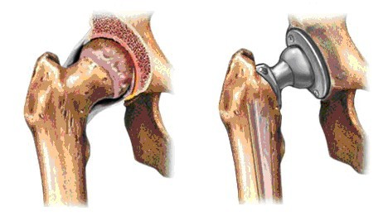

www.medway.nhs.uk

Aim of your passport
This document contains important and useful information to guide you through your Hip Replacement Surgery from pre-admission to Discharge.
Please read carefully and if you have any questions regarding your hip replacement, please contact the Surgical Medical Acute Recovery Team (SMART).

Contact numbers can be found on page 14.

Section 1 - Anatomy of the hip joint and what a hip replacement involves
Section 2 – Preparing for admission
Section 3 - Physiotherapy and Occupational Therapy advice
Section 4 - Your hospital stay
Section 5 - Possible complications of Surgery
Section 6 – Discharge home

Section One
- Hip joint anatomy
- Arthritis of the hip
- What does a hip replacement involve?

The Normal Hip

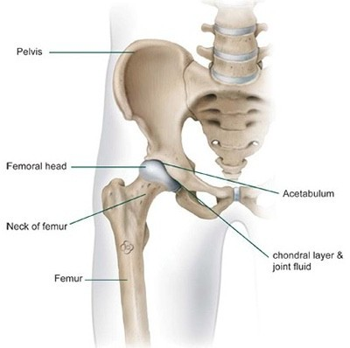
- The hip joint is classed as a ball and socket joint- formed by the upper end of the thigh bone known as the femoral head and socket (acetabulum) of the pelvis.
- The bone ends are covered by a smooth substance called “articular cartilage” to allow for a smooth and painless movement.
- The hip joint is surrounded by a capsule which secretes a special fluid called synovial fluid that lubricates the articular cartilage.
- Cartilage lines the socket to act as a “shock absorber” between the two bones.
- The hip joint is supported by strong ligaments and muscles.

What happens in arthritis?
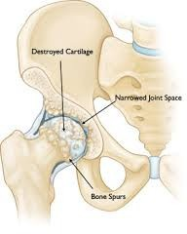
- The cartilage is damaged and worn away due to “wear and tear”.
- The joint space (gap between the ball and socket) becomes narrowed.
- This causes the bone ends to rub against each other causing pain, swelling and inflammation - you may have heard the term “bone on bone”.
- Bone spurs are formed (extra pieces of bone which cause the bone ends to become rough.
- You may experience a shorten leg length on the affected side.

What does a total hip replacement involve?
An incision is made down the outside of the affected hip. The surgeon will dislocate the hip to allow them to access the two bone ends. They will cut away the damaged ball compartment of your hip and reshape the socket. The stem of the ball section of the hip prosthesis is placed down the bone marrow canal of the thigh bone; and the new socket cap is cemented into place. The skin is then closed with clips or steri-strips and glue.

Before After
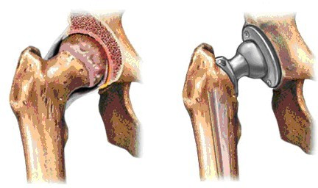

The total hip prosthesis consists of three parts:
- A cup (usually plastic but can be ceramic) which replaces your hip socket.
- A metal or ceramic ball that replaces the head of femur.
- A metal stem which is attached to the ball to add stability to the prosthesis.

Section Two

Preparing for your admission
Please ensure you maintain a healthy lifestyle prior to surgery; as the fitter you are the better the outcome. This can be achieved by:

- Eating a healthy and balanced diet while you are waiting for your surgery and after to help you heal well and regain your strength.
- Regular exercise.
- Ensuring a healthy weight.
- Good personal hygiene- daily showers.
- Good dental hygiene- please visit your dentist if required.
- Ensure any existing medical conditions are controlled, please visit your GP if required.
- If you suffer from anaemia, please contact your GP prior to pre-assessment for a blood test.

You will be contacted before your operation to attend a pre-assessment clinic to ensure that you are safe and fit enough to have your proposed surgery.

You will be asked questions about your health and past illnesses as well as any operations you have had before. You will also be asked about your current medications and repeat prescription. It is important that you bring all your medication in with you for review.

The pre-assessment nurse will request for investigations, which may include a blood test, ECG (tracing of your heart) and urine sample.

Section Three

Occupational Therapy

Home environment
Prior to your joint replacement consider the layout of your home environment. You will be unable to squat or kneel down initially after surgery due to your hip precautions; therefore, you may wish to move items from low cupboards and drawers to higher surfaces.

Hip Precautions
Please follow these to minimise your risk of dislocation for the first 6 Weeks after surgery.

- No crossing: Do not cross your legs or ankles when sitting, standing or lying.
- No bending the hip past 90 degrees: When sitting, keep your knees below the level of your hips. Avoid bending over at the waist. Use aids such as long- handled shoehorns to put shoes on, or use the “helpful hand” to pick things up off the floor and avoid low chairs.
- No twisting: Make sure that you step your foot around when changing directions. Avoid twisting or turning to reach behind you.

Sleeping Position: When lying in bed try to lie on your back with knees slightly apart – use a pillow to keep your knees apart. If you prefer to sleep on your side, lie on the operated hip, using a pillow between your knees.
Bed Transfer: When getting into bed place your back to the bed and place your bottom as far into the middle as possible, then swing your legs around on to the bed.
Bathing: Do not use the bath for 6 weeks, as getting in involves you having to lift the knee above your hip height. Strip wash only or shower if not over the bath.
Driving & Car Travel: You can usually drive a car after about six weeks, subject to advice from your surgeon. It can be tricky getting in and out of your car at first. To get into the car:
- Push the passenger seat back and slightly recline it.
- Step down on to the road before getting into the passenger seat.
- Turn so your back is to the seat.
- Place your bottom as far into the middle of the seat as possible, and swing your legs into the car.
- Reverse this procedure to exit the care.
It is recommended that you get up to stretch or walk at least once an hour when taking long trips. This is important to help prevent blood clots.

Fatigue management
What is fatigue management?
Although fatigue cannot be cured there are techniques that can be used by people of all ages to make the best of the energy you have. The most important thing is to listen to your body and ask yourself:

- Is this activity really necessary?
- Am I the right person to do it?
- Is this the best way to do it?
- Is this the best time to do it?

Fatigue management promotes using energy in an efficient way and having the best level of energy available to use.

For example:
Taking frequent breaks
Prioritising activities
Planning ahead
Organising tools and work area
Good posture
Healthy lifestyle

Tips for saving energy:
- Learn to eliminate unnecessary tasks.
- Use labour saving and adaptive equipment.
- Arrange items so they are within easy reach.
- Choose the correct work surface height (the most efficient area is between your stomach and your chest).
- Sit rather than stand.
- Accept offers of help with heavy tasks (eg laundry).
- Avoid bending to complete a task.
- Take breaks throughout the day.
- Pace activities – distribute heavy and light jobs evenly throughout the day/week/month.
- Balance rest and activity.
- If you work- tell your employer about flexible hours, ex- tended lunch breaks, rests, using a trolley, sitting down and delegating tasks.
- Get a good night’s sleep.
- Avoid caffeinated drinks before bedtime.

Physiotherapy
A successful joint replacement relies on you participating in your physiotherapy programme which aims to:
- Strengthen the bottom and leg muscles.
- Improve range of movement.
- Improving your walking pattern.
- Increase your mobility

On the next two pages you will find exercises that have been specifically designed for patients undergoing a hip replacement. We encourage you to start your exercises before surgery to help strengthen muscles in the correct way. Aim to complete your exercises 2 to 3 times a day.

When you leave hospital your Physiotherapy will not stop. You should continue your exercises as instructed and the ward physiotherapist will refer you on to the Outpatient Physiotherapy service as you may require up to 3 to 6 months’ of physiotherapy to achieve the best from your new joint.

The most important thing to remember is:

Your recovery depends on YOU!

Exercise Programme
Repeat 2 to 3 times a day.

In lying:
1. Squeeze your buttocks together and hold for a slow count of 5, then relax Repeat 10 times. | 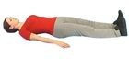
2. With your leg straight- push the back of your knee down onto the bed. Hold for 5 seconds.
Repeat 5-10 times with both legs.
3. Keeping your affected leg straight try to slide it out to the side and back again but without crossing, (even if the leg doesn’t move it is still working the muscles.) Repeat 5-10 times. | 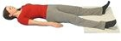

In sitting:

1. Slide your affected leg slowly out in front of you to straighten the knee, then slide your foot back to the starting posi- tion. You should feel your thigh muscles working.  Repeat 10 times. | 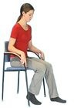
2. In sitting with your back straight place your hand against the side of your knee and push out against it. Hold for a slow count of 3 seconds then relax. Repeat  5-10 times.  Once this becomes easier try to slide your  affected leg out to the side. | 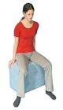

Exercise Progression
(Full weight bearing only)

In standing: hold on to a secure support (i.e. kitchen counter) when completing exercises.

1. Take your affected leg out to the side, leading from your ankle and not your foot. You should feel your hip muscles working. Repeat 10 times. | 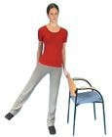
2. Take 5 side steps to the left then 5 side steps  to the right. Repeat 10 times. | 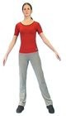
3. Bend your knees slightly so that you feel the muscles in your thigh working. If you look down at your feet with your knees bent, your knees should cover your toes. Repeat 10 times. | 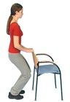
4. Keeping your legs straight, stand on tip toes  and squeeze your buttocks together. Hold for a slow count of 3 seconds and relax. Repeat 10 times. | 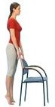
5. Aim to gradually increase your walking distance with your appropriate walking aid to your pre-operative level.

Bruising and Swelling
Bruising and swelling around the hip joint, and down to the thigh and calf will develop 3 to 5 days after surgery. This will cause your whole leg to feel stiff and potentially reduce movement.

Swelling can be reduced by elevating the affected leg on a foot stool or on the bed, ensure pillows are placed long ways to support the whole leg rather than just under then knee joint. Make sure you follow your hip precautions when elevating. You may need to do this 2 or 3 times daily for 1 hour in the first 2 weeks.

ICE Therapy
The use of ice therapy in combination with elevation is effective in the treatment of swelling and has painkilling benefits.
Don’t use ICE THERPAY if you have:
- Tumours
- Infection
- Thrombosis (blood clot)
- Raynaud’s disease/Neuropathy or other conditions affecting your sensation and circulation.

How to use ICE THERAPY
- A bag of peas or ice cubes in a slightly damp towel or pillowcase.
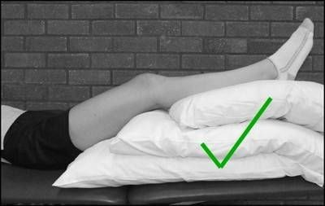
- Elevate your leg on a bed, stool or chair.

- Apply the ice to the area of swelling or pain for a maximum of 20 minutes.
- After 5-10 minutes check your skin under the ice therapy to ensure normal and no reaction has occurred.
- Ice Therapy can be repeated every 2-4 hours.

Section Four
What will my hospital stay involve?

What to bring in?

You will be admitted to POCU (Pre-Operative Care Unit) or Ocelot ward on the morning for your surgery.

POCU can be found on Level 3, Green Zone. Ocelot ward can be found on level 2, Green Zone.
Items you will require on Elective Orthopaedic ward:
- Loose fitting clothing, e.g. shorts/trousers for men is ideal or skirts/loose fitting trousers for woman.
- Sensible shoes- i.e. slippers with a back or trainers, please avoid flip-flops.
- Toiletries.
- Magazines/books etc.
- Walking aids you currently use– Therapists on the ward can give them a MOT (change the rubber at the bottom if worn etc).
- Your Hip Replacement Passport.

Preparing for Theatre
Before the day of your surgery, you will receive a letter informing you of what time to stop eating and drinking from. (Nil By Mouth)

You may be given a Pre-Load drink in the pre-assessment clinic to be taken before your surgery to help keep your energy levels up (please follow the instructions given).

The nursing staff will help prepare you safely for your operation.

You will be asked to:
- Remove all jewellery (except wedding ring).
- Put on a hospital gown.
- Put a TED stocking on the leg that is not being operation on. The affected leg will have a flowtron applied in theatre to help minimise the risk of blood clots.
- Remove false teeth.
- Remove nail vanish.

You will be seen by the operating team including the anaesthetist. At this point:
- Your consent form will be reviewed with you.
- The leg you are having the operation on will be marked.
- A check list will be carried out and you will go to theatre.

Types of Anaesthesia
Before your surgery the Anaesthetist will meet with you to discuss the best type of anaesthesia available for you. This will be based on any previous surgery you have had and your current health conditions. There are two types of anaesthesia used at Medway.

Spinal and General Anaesthesia

What is Spinal Anaesthesia?
This involves an injection into your back causing numbness below your tummy. It is usually combined with a light sedation to allow you to sleep. Due to spinal anaesthesia causing numbness below the tummy, a bladder catheter may be inserted during surgery or after if you are unable to pass urine. Numbness lasts for around 3 to 12 hours.

What is General Anaesthesia?
Sleep medication is given through a cannula. A tube is then inserted in to the windpipe to allow the anaesthetist to ventilate your lungs. A general anaesthetic can be combined with nerve blocks for postoperative pain relief. Common side effects can be nausea and sickness.

After your operation
- Following your surgery, you will be taken to the recovery ward, before being transferred to Elective Orthopaedic ward.
- You may have drains from your wound to collect any extra fluid; this is usually taken out the day after surgery.
- You may have a drip in your arm to replace any fluid loss.
- You may be given oxygen through a mask to help improve your oxygen intake whilst recovering from anaesthesia.
- You will wake up with flowtrons on your calves to help your circulation. These work by applying a gentle pressure to your legs to push the blood back to your heart. These are worn while you are in bed and can be removed when you start walking.
- You may have a pillow between your legs to prevent you crossing them.
- EARLY MOBILISATION is very important to help move the joint and prevent stiffness. We recommend you start mobilising as soon as you can feel your operated leg and the nurses are happy with your blood pressure. You should be getting out of the bed the same day as your operation. You can start your bed exercises and sit or stand as soon as you wake up from surgery - even in the Recovery Ward!

Pain control
It is important that your pain is controlled. You should expect to feel some pain after surgery but be comfortable to enable mobilisation.

You will be given regular pain medication normally at 8am and 8pm but you can ask for extra pain medication if necessary. Remember that at rest pain will be minimal but when asking for pain relief consider the pain you experience on movement.

On discharge home, you will be given pain medication to ensure you remain comfortable. Take them regularly as advised. If you experience uncontrolled pain please contact your GP for a review. Repeat prescriptions should be obtained from your GP.

Sickness
Sometimes after an operation, a person may feel sick or be sick. This is usually caused by the anaesthetic agents or drugs we use. You will be given medication during surgery to reduce this, but if you feel sick following surgery, tell the staff who can provide other medications. It is important to relieve sickness in order to allow you to feel better so that you can eat and drink normally which will aid your recovery.

Section Five

Possible complications of surgery

Most people do well after joint replacement but complications can occur in a small number of patients.

Early Complications
- Deep Vein Thrombosis (DVT) - blood clot in your leg
- Pulmonary Embolism (PE) - blood clot in your lungs
- Wound Infection (discharging and angry wound)
- Dislocation (Hip out of socket)
- Leg length discrepancy (Difference in leg length)
- Foot drop due to nerve damage
- Swelling and stiffness
- Excess bleeding
- Pain

Late Complications
- Loosening
- Pain

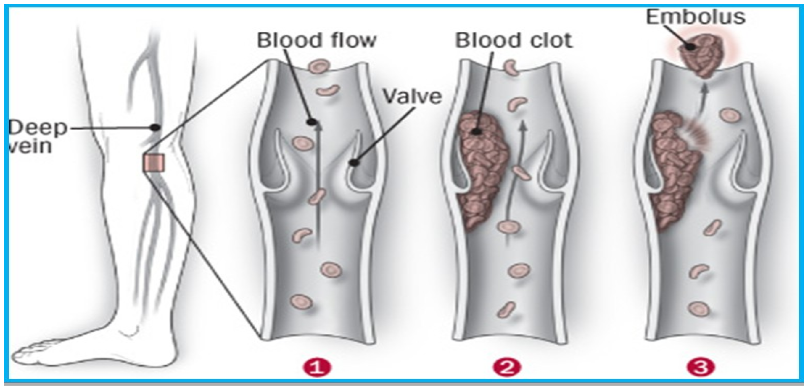
Deep Vein Thrombosis

Possible Signs of DVT
- Pain, swelling and tenderness in one of your legs (usually your calf).
- A heavy ache in the affected area.
- Warm skin in the area of the clot.
- Redness of your skin, particularly at the back of your leg, below the knee.
- The pain may be made worse by bending your foot up- ward towards your knee.

If you experience any of these symptoms, please call 111, they will follow the community DVT pathway.

Possible Signs of PE
- Sudden onset of chest pain - worse when breathing in.
- Shortness of Breath - can be sudden or develop gradually.
- Coughing (Usually dry).
- Sweating.
- Feeling light-headed or dizzy.
- Passing out.

*If you experience any of these symptoms please call 999*

Infection
To reduce the risk of Infection please ensure:
- Good personal hygiene at all times- hip dressings are not waterproof please do not get them wet.
- Please ensure your wound always has a dressing in place whilst the clips/steristrips are still in.
- Ensure good dental hygiene.
- Please do not get into the shower until your nurse tells you that your wound is healed.

Possible Signs of Infection
- Increased pain.
- Discharge/pus from wound.
- Increased redness around wound.

If you have any signs of infection or concerns regarding your wound healing at any stage please contact SMART.

Section Six

Being discharged from hospital

What happens when I’m discharged after surgery?

If you live in the Medway or Swale area, SMART will follow you up on discharge to your own home, if you don’t require a package of care.

SMART is a team of dedicated nurses and physiotherapists based at Medway Hospital. The team strives to promote the patient’s privacy and dignity at all times, whilst demonstrating consideration for the needs of the patient and family within the home environment.

The team will provide you with advice and immediate care to enhance your recovery the 1st two weeks after your surgery.

If you live outside of Medway or Swale you will be referred to your local District Nurse and Physiotherapy service. But if you have any worries or concerns please contact SMART

Hospital based SMART Clinical Sister: 07500126262. Office Number: 01634 833804.

What happens if I’m not under the SMART team?
If you are not being followed up on discharge by the Smart team (i.e. if you have a care package or live out of area) then you will be referred to the District nurses to look after your wound and teach you how to administer your fragmin (if required).
Before discharge the ward Physiotherapists will discuss your options for continued physiotherapy in the community.

YOU ARE STILL ALLOWED TO CONTACT SMART WHEN
YOU ARE CONCERNED (We have direct contact to your surgeon, and can support you with our specialist knowledge).

Useful Numbers
Therapy Office: 01634 833860 / 01634 833848
Medway District Nurses: 0300 1233444
Swale District Nurses: 0300 2470400

Getting Home after your Hip Replacement
It’s safe after a hip replacement to get into a car. If you are unsure how is best to get in and how to abide by your hip precautions, please speak with one of the therapy team who can advise.

We encourage you to make arrangements regarding getting home from hospital prior to your admission, rather than leaving it till the day of discharge. If your family/friends are unable to collect you till late afternoon or evening you may be transferred to the Discharge and Admission Lounge (ADL).

Medication and Discharge Letter
On discharge you will be given your medication and a paper copy of your discharge letter which outlines the operation you have had and the current medication you are taking. An electronic copy of your discharge letter will be sent to your GP on discharge.

Please be aware that it can take a few hours for your letter and medication to be prepared. It may be possible for you to go home and a member of your family to come back later to the ward to collect your medication- please speak to the nurse looking after you regarding this.

Sexual Activity after Joint Replacement
You’ve had joint replacement surgery and may be wondering what positions are safe for sex. The positions on this sheet should be safe after a hip replacement. Try to avoid putting too much pressure on your new joint. Also, take the same care getting out of a position as you did getting into it.

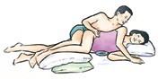
Side-Lying Position
This position works for woman with a hip replacement. She lies on her side, with the new joint on the bottom. Use pillows to support.
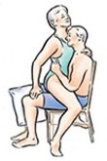

Sitting in a Chair
This position works after a hip re- placement. It is a safe position for a man or a woman with a new joint. The man sits on a straight chair. His feet are supported or are flat on the floor. The woman sits on the man’s lap.

Man Propped on Elbows
This position is for a man with a new hip joint. He lies on top of his partner with his legs stretched out behind, with a pillow between his knees. He supports his weight on his elbows.

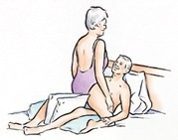
Face-to-Face
This position works after a hip replacement. Being on the bottom is safe for a man or a woman with a new joint. The partner on the bottom keeps his/her legs apart and turnout slightly.

Use pillows to support the legs on the outside and pillows between the knees to prevent crossing. Depending on comfort, the person on the bottom can recline propped up on pillows or lie flat.

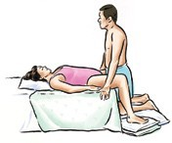
Woman lying and man kneeling

This position works for a woman with a new hip joint. The woman lies on the bed on her back, buttocks near the edge of the bed. Both feet should be supported or flat on the floor. The man kneels in front of the woman, on pillows placed on the floor. His hands are placed on either side of her body.

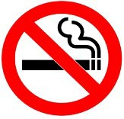
Medway NHS Foundation Trust is a smoke free organisation.
As a healthcare provider, we believe it is important to provide the best possible environment for our patients, visitors and staff.
Therapy Department
Medway NHS Foundation Trust Windmill Road, Gillingham, Kent, ME7 5NY. Tel: 01634 830000
Document reference: COPS-SMA-INF-17
Date of Issue: November 2025 Review Date: November 2027 Version: 03

