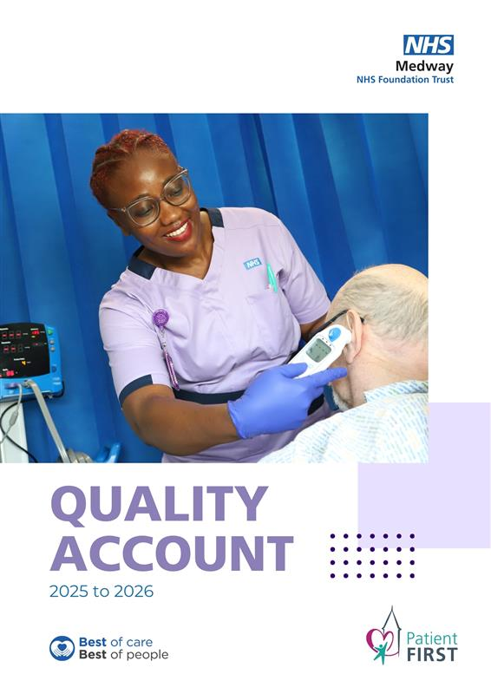
r

Table of contents

Part 1: Statement on Quality 2
Part 1.1: Statement from our Chief Executive 2
Part 1.2: Introduction to the Quality Account 2025/26 4
Part 1.3: Understanding Quality at Medway NHS Foundation Trust 5
Part 1.4: Care Quality Commission (CQC) 7
Part 1.5: Summary of successes 11
Part 2: Priorities for Improvement and Statements of Assurance 21
Part 2.1: Performance Progress against our 2025/26 Quality Account Priorities 58
Part 2.2: Looking Forward 64
Part 3: Other Key Dimensions of Quality 70
Annex 1: Statements from commissioners, Local Healthwatch organisations and Overview and Scrutiny Committees 77
Annex 2: Statement of Directors Responsible for the Quality Report 83
Annex 3: GIRFT Benchmarking and Specialty Overview 87
Annex 4: National and Local Clinical Audit Participation 90
Glossary 103

Part 1: Statement on Quality

Part 1.1: Statement from our Chief Executive
Welcome to the Medway NHS Foundation Trust 2025/26 Quality Account.
This report provides an overview of our progress over the past year, the challenges we've encountered, and the actions we're implementing to continue improving the care and services we provide to our patients, families, carers, and local communities. It also outlines our priorities for the coming year and highlights our ongoing commitment to delivering safe, effective, compassionate and inclusive care to everyone who uses our services.
The past year has presented significant challenges across the NHS, including ongoing pressure on urgent and emergency care, rising patient demand, workforce shortages, financial constraints, and broader system pressures. Despite these difficulties, I remain immensely proud of the dedication, professionalism, and compassion our staff, volunteers, and partners display daily. Their commitment to patient care, often under extremely tough circumstances, has been exceptional.
While we recognise that we do not always get everything right, we are committed to listening, learning, and improving. We know that high-quality care is not only about achieving targets and standards but also about ensuring patients feel safe, heard, respected, and cared for with dignity and compassion. Learning from feedback, incidents, concerns, and patient experiences remains central to improving outcomes and strengthening our services for the future.
Over the past year, we have continued to implement our Stabilisation Plan, which has now developed into our Improvement Plan, placing quality and patient safety at the heart of our organisational recovery and transformation journey. During this period, we have made progress across several of our quality priorities and key improvement programmes.
One of our most significant achievements has been the ongoing expansion of services closer to patients’ homes. Our Community Diagnostic Centres in Sheppey and Rochester have improved access to diagnostic testing, reducing waiting times and enabling patients to receive care more quickly and conveniently. Our Virtual Hospital has also continued to expand, allowing more patients to safely receive monitoring, treatment, and recovery support at home, reducing unnecessary hospital stays and enhancing patient experience.
During the year, we strengthened various patient safety improvement programmes, such as incident management, learning from patient safety events, deteriorating patient processes, harm prevention, safeguarding oversight, and governance systems. We have continued to review, update, and embed the Patient Safety Incident Response Framework to promote a more compassionate, systems-based, and learning-focused approach to patient safety investigations and improvements.
We have also concentrated on better identifying and responding to deteriorating patients, strengthening our escalation procedures and enhancing oversight to enable timely intervention and safer care. Alongside this, we have improved our quality governance arrangements to provide clearer ward to board visibility of risks, concerns, and improvement actions, ensuring stronger accountability and more effective organisational learning.
Safe staffing remains a key organisational risk and priority. Ongoing national workforce pressures continue to affect the NHS, and we recognise the direct link between workforce capacity, staff wellbeing, patient experience, and patient safety. Throughout the year, we have focused on workforce planning, safer staffing oversight, recruitment, retention, professional development, and staff support arrangements to help ensure we can continue
delivering safe, high-quality care for patients.
Importantly, this year has also marked the beginning of a wider programme of cultural and workforce transformation across the Trust. We recognise that creating a safe, inclusive, compassionate, and respectful culture is essential to delivering outstanding patient care and enhancing staff experience. We understand there is still more work to do, and we remain dedicated to addressing behaviours and inequalities that negatively affect our staff and patients.
We have continued to strengthen our work around equality, diversity, inclusion, and anti-racism, recognising that discrimination and inequity can significantly affect the experiences and outcomes for both staff and patients. We are dedicated to fostering an environment where all staff feel psychologically safe, valued, respected, and empowered to speak up. We understand that an inclusive culture, where staff feel supported and heard, directly leads to safer care and improved patient outcomes.
Listening to the voices of our patients, carers, and staff remains fundamental to our improvement journey. We actively seek feedback through patient experience programmes, staff engagement, complaints, compliments, incident learning, and speaking-up processes, using these insights to shape service improvements and strengthen the quality of care we provide.
Looking ahead, our Quality Priorities for the upcoming year concentrate on what matters most to our patients and communities: enhancing access to timely care, strengthening patient safety, reducing harm, improving patient experience, supporting our workforce, and continuing to build a culture of openness, learning, inclusion, and ongoing improvement.
While we recognise the scale of the remaining challenges, I am confident in the dedication, resilience, and compassion of our staff and in our shared resolve to keep improving services for the people of Medway and Swale. We remain fully committed to providing safe, effective, responsive, and patient- and family-focused care.

Siobhan Callanan

Interim Chief Executive

Part 1.2: Introduction to the Quality Account 2025/26

What is a Quality Account?
A Quality Account is an annual report published by NHS organisations regarding the quality of the services they provide. It is a legal requirement under the Health Act 2009, the Health and Social Care Act 2012, and the National Health Service (Quality Account) Regulations 2010.
The purpose of a Quality Account is to enhance transparency, increase accountability to patients and the public, and promote ongoing quality improvement across the NHS. It offers organisations a chance to honestly reflect on the quality of care provided, celebrate successes, recognise challenges, and outline priorities for improvement in the year ahead.
The quality of care provided by the NHS is generally described using three nationally recognised dimensions of quality:
- Patient safety: Quality care involves delivering care that prevents avoidable harm, minimises risks to patients, and encourages safe care systems.
- Clinical effectiveness: Quality care is care that is delivered in accordance with the best available evidence, guidance, and standards to achieve the best possible outcomes for patients.
- Patient experience: Quality care is compassionate, person-centred, and respectful, ensuring people are treated with dignity, kindness, and understanding, while involving them in decisions about their care.
This Quality Account aims to:
- promote continuous quality improvement
- increase transparency and accountability
- demonstrate how quality is monitored and improved
- show where progress has been achieved
- identify areas where further improvement is needed
- set out priorities and actions for the year ahead
- involve and respond to patients, carers, staff and external stakeholders

Our Quality Account 2025/26
This Quality Account reflects on the progress we have made during 2025/26 to enhance the quality of services for patients, families, and carers across Medway and Swale. It also outlines our plans for the coming year, including the Quality Priorities for 2026/27 and how we aim to achieve further improvements.
Throughout this document, we refer to patients, families, and carers as all individuals who currently use, have previously used, or may in the future use our services.
This Quality Account should be read alongside the Trust’s Annual Report and Accounts 2025/26, which offers further information about the organisation’s operational performance, governance arrangements, workforce, financial position, and strategic objectives.
If you require any further information about this Quality Account, please contact our Patient Advice and Liaison Service (PALS): medwayft.pals@nhs.net

Part 1.3: Understanding Quality at the Trust
Quality is central to everything we do. We recognise that providing high-quality healthcare involves more than just meeting performance standards. It requires safe systems, compassionate care, effective clinical practice, strong leadership, listening to patients and staff, and fostering a culture of continuous learning and improvement.
To support this, we have introduced a single, integrated Clinical Quality Governance Framework that provides a clear and consistent approach to delivering, overseeing, and enhancing quality across the organisation.
Our framework brings together:
- patient safety
- clinical effectiveness
- patient experience
- workforce insight
- governance and assurance
- improvement and learning
- operational performance.
These elements form one integrated system, enabling risks, concerns, and opportunities for improvement to be identified early and managed consistently.
Our approach is based on a clearly defined ward to board operating model, ensuring that learning and intelligence from frontline care are converted into meaningful oversight, action, and assurance at every level of the organisation.
This means that:
- risks and concerns can be identified and escalated early.
- information is triangulated across quality, safety, workforce and operational performance.
- assurance provided to the Board is evidence-based and reduces the risk of false reassurance.
- improvement actions are clearly owned, measurable and monitored through to delivery.
- frontline teams, divisions, executives and the Board all have clear accountability for quality.
This approach helps ensure that governance stays rooted in frontline patient care while allowing the Board to retain a complete understanding of quality and risk across the Trust.

Delivering care in a challenging environment
During 2025/26, we continued to provide care amid ongoing system pressures, rising demand for services, increasing patient complexity, workforce shortages, and financial difficulties across the NHS.
Particular pressures persisted across urgent and emergency care, frailty pathways, patient flow, and discharge arrangements. Despite these challenges, we maintained a strong focus on patient safety, clinical effectiveness, and patient experience.
Recently, we began to strengthen governance and assurance frameworks, review and continue implementing the Patient Safety Incident Response Framework (PSIRF), strengthened oversight of patient safety and mortality review processes, and embedded improvement methodologies to promote sustainable change across services.
We have also continued to strengthen our culture of learning and improvement, shifting from a narrow focus on individual incidents to a broader understanding of system reliability, human factors, proactive risk management, and continuous improvement.

How we developed our Quality Priorities
Our Quality Priorities for 2025/26 were developed through engagement with patients, carers, staff, governors, commissioners, and partner organisations.
The priorities were informed by:
- patient and carer feedback
- complaints and compliments
- PALS feedback themes
- staff feedback and speaking up themes
- incident reporting and patient safety learning
- mortality reviews and clinical audit findings
- national benchmarking and performance data
- Care Quality Commission (CQC) intelligence
- NHS England priorities and system priorities
- learning from operational pressures and improvement programmes

Our Quality Operating Model - A ward to board approach
How the system works:
Frontline teams identify risks and opportunities for improvement.
⬇
Data, incidents, feedback, and outcomes are reviewed at the divisional level.
⬇
Risks and concerns are escalated through governance structures.
⬇
Executives and committees oversee improvement actions and assurance.
⬇
The Board receives triangulated intelligence to support decision-making.
⬇
Learning and improvement are fed back into frontline care.
This creates a continuous closed-loop system of learning, improvement, and assurance throughout the organisation.

Assurance and accuracy
In preparing this Quality Account, we have carried out an internal review to ensure that the information included is accurate, balanced, and reflects performance during 2025/26.
NHS England guidance confirmed that external audit assurance is no longer required for Quality Accounts. Details of the Trust’s internal review arrangements are included within Annex 2.

Part 1.4: Care Quality Commission (CQC)
The CQC continues to implement its new single assessment framework as part of its regulatory approach to assessing healthcare providers.

- The framework keeps the five main questions used to assess NHS organisations.
- Safe – are people safeguarded from avoidable harm?
- Effective – do services deliver good, evidence-based outcomes following best practices?
- Caring – do staff involve and treat people with compassion, kindness, dignity, and respect?
- Responsive – are services organised to address people’s needs?
- Well-led – does leadership support the delivery of high-quality, sustainable, and inclusive care?
Under this framework, the CQC assesses services based on a series of Quality Statements, which replace the previous Key Lines of Enquiry (KLOEs), prompts, and rating characteristics. Assessments may be either:
- Responsive assessments – undertaken following concerns, intelligence or risk
- Planned assessments – scheduled assessments aligned to the CQC’s regulatory programme

Our CQC position
We remain on a significant improvement journey. We continue to work closely with the CQC, NHS England and system partners to strengthen quality, governance, leadership and operational performance across the organisation.

Our current overall CQC rating remains Requires Improvement.
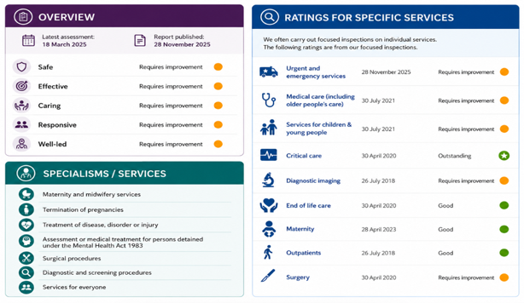
There have been improvements in several services and areas over recent years, especially in enhancing governance arrangements, leadership oversight, and quality assurance processes. However, we acknowledge that there are still areas needing further improvement to ensure consistently safe, responsive, and high-quality care across all services.

Improvement journey and recovery
We have faced ongoing operational, workforce, and system pressures in recent years, especially in urgent and emergency care pathways. The organisation has therefore continued to implement improvement activities despite high demand, increasing patient complexity, and broader NHS challenges.
Our improvement work is coordinated through the:
- Improvement Plan
- Recovery Programme
- Clinical Quality Governance Framework
- Patient Safety Improvement Programme
- Improvement workstreams
- NHS England undertakings and oversight requirements
These programmes aim to support sustainable organisational recovery and embed quality improvement at all levels of the organisation.
An Urgent and Emergency Care improvement programme forms part of the Trust’s wider Stabilisation, Improvement and Recovery Programme and is aligned with well-led improvement work, NHS England undertakings, and a strengthened Clinical Quality Governance Framework. While the latest CQC assessment demonstrates a positive trajectory of improvement, it also identified that further work is required to ensure consistent delivery of safe, compassionate and timely care during periods of sustained pressure.
The Trust remains in breach of Regulation 10 (Dignity and Respect), with challenges identified in maintaining privacy, dignity and responsiveness to patients’ basic needs, particularly within lodge bays and temporary escalation areas. In addition, the Trust remains in breach of Regulation 12 (Safe Care and Treatment), with concerns relating to the management and monitoring of patients experiencing long waits, including those with mental health needs, completion of risk assessments, and aspects of medicines management.
Improvement activities have also focused on strengthening patient safety governance by enhancing incident learning, reviewing and revising the implementation of the Patient Safety Incident Response Framework (PSIRF), reinforcing harm review processes, and improving oversight of deteriorating patients and patient flow risks.
The phased rollout of the Electronic Patient Record (EPR) will further promote safer and more coordinated care by enhancing real-time patient visibility, supporting clinical decision-making, strengthening documentation, and improving management of patient flow and escalation.
We recognise that sustainable improvement requires strong governance, effective leadership, a compassionate culture, workforce stability, robust operational management, and a consistent focus on patient safety and patient experience.

Strengthening governance and well-led arrangements
A significant area of focus that began in 2025/26 has been strengthening governance and assurance arrangements throughout the organisation in response to regulatory feedback, organisational learning, and NHS England undertakings.
We have continued to strengthen:
- Ward to board governance model
- quality oversight arrangements
- Divisional governance structures
- risk management processes
- Board assurance systems
- Quality governance reporting
- learning from patient safety incidents
- mortality and harm review processes
- improvement programme oversight
- Executive and Board visibility of operational risk.
We have also started to adopt a more intelligence-led and triangulated approach to assurance, integrating patient safety, workforce, operational, quality, and patient experience data into a single governance framework.
Significant work has also been made to strengthen well-led arrangements across urgent and emergency care, including clearer governance structures, strengthened escalation processes, enhanced executive oversight, improved divisional accountability, and more resilient ward to board assurance mechanisms.
This work enhances organisational oversight and reduces the risk of fragmented assurance being conveyed to leadership teams and the Board.

Well-led Improvement and organisational culture
We continue to progress a significant programme of well-led improvement initiatives focused on strengthening leadership capability, organisational culture, accountability, delivery of improvements, and staff engagement.
Recent CQC assessments of the Emergency Department (ED) highlighted positive progress in leadership structures and local team support, while also recognising areas where further improvement is needed in organisational culture, communication, and staff confidence in raising concerns.
In response, we have continued to:
- strengthen leadership visibility and accountability
- improve staff engagement and speaking-up culture
- embed compassionate and inclusive leadership behaviours
- develop stronger governance capability across divisions
- improve quality improvement methodology and delivery oversight
- strengthen programme management and assurance arrangements
- support cultural transformation and anti-racism initiatives
- improve communication and feedback mechanisms for staff.
We recognise that sustainable improvement requires more than short-term corrective action and we remain committed to embedding changes into daily operational practice through strengthened quality surveillance, ongoing monitoring, and regular assurance reviews.
Knowing the impact that long waits, overcrowding, and care in temporary escalation areas can have on patients, families, and staff, we remain committed to enhancing the experience, privacy, dignity, and safety of everyone who accesses our emergency services.
Alongside operational improvements, we continue to prioritise workforce wellbeing, compassionate leadership, psychological safety, and cultural transformation, recognising the vital link between staff experience, patient safety, and quality of care.
We recognise that a positive organisational culture and an engaged workforce are essential foundations for providing safe, high-quality, and sustainable patient care.

NHS England undertakings and regulatory improvement work
We continue to operate within the framework of NHS England undertakings and regulatory oversight arrangements aimed at supporting organisational recovery and improving governance.
This has included work to strengthen:
- governance systems and standards
- Board effectiveness and capability
- leadership oversight
- quality assurance processes
- improvement programme delivery
- risk management and escalation
- organisational accountability.
The undertakings programme has supported the development of measurable governance improvement plans, strengthened oversight arrangements, and provided clearer monitoring of improvement delivery and organisational risk.

Part 1.5: Summary of successes

Patient Led Assessment of the Care Environment
During 2025/26, we achieved significant improvements in our Patient Led Assessment of the Care Environment (PLACE) results, showing good progress in the quality, cleanliness, and overall experience of the environments where care is provided.
PLACE assessments are undertaken nationally with direct involvement from patients, service users, and members of the public, providing an independent evaluation of the hospital environment from the perspective of those who use our services. The assessments concentrate on several key areas that are essential to patient experience, safety, and dignity, including:
- cleanliness
- food and hydration
- privacy and dignity
- condition, appearance and maintenance
- dementia-friendly environments
- disability access and support.
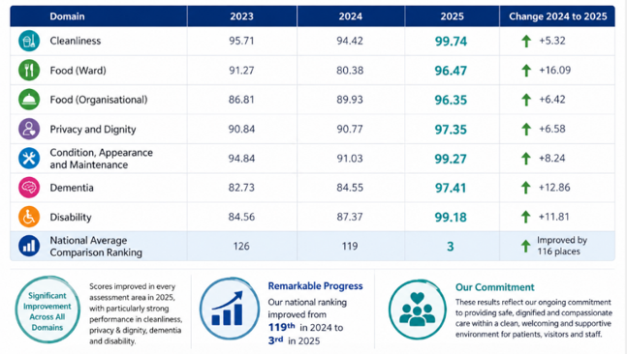
After experiencing declining PLACE performance and a lower-quartile national position in 2024, we launched a targeted PLACE Improvement Plan in 2025 as part of our quality improvement initiative to enhance patient experience and care environments.
The improvement programme concentrated on strengthening leadership and operational oversight in Estates and Facilities services, while empowering frontline teams to achieve consistent improvements. As a result, PLACE scores increased markedly across all domains in 2025, elevating our national performance ranking from one of the lowest in 2024 to one of the highest in 2025.

National Joint Registry Quality Data Provider
We were awarded Gold Quality Data Provider status by the National Joint Registry (NJR) for the second consecutive year, recognising our continued commitment to patient safety, clinical governance and high-quality data reporting within orthopaedic services.
The NJR Quality Data Provider scheme awards hospitals that meet high standards of data quality and compliance, supporting patient safety and national surveillance programmes. Organisations can achieve Gold, Silver, or Bronze status based on the accuracy and completeness of data submitted to the registry.
To achieve Gold status, organisations must demonstrate exceptionally high levels of compliance between the number of joint replacement procedures recorded on the Trust’s Patient Administration System (PAS) and the number submitted to the NJR. During 2025/26, we met the required compliance threshold of between 99 per cent and 100 per cent, reflecting the quality and reliability of local data capture and reporting processes.
Earning Gold status for a second year in a row shows:
- strong clinical governance within orthopaedic services
- robust patient safety and data assurance processes
- high quality clinical documentation and data accuracy
- effective multidisciplinary collaboration between clinical, administrative and information teams
- continued commitment to national quality standards and improvement programmes.
High quality registry data is essential in safeguarding patient safety, facilitating national benchmarking, enhancing surgical outcomes, and enabling early detection of potential implant or procedural issues. Accurate data submission also supports informed clinical decision-making, research, service improvement, and transparency for patients undergoing joint replacement surgery.
This achievement reflects the ongoing dedication and collaborative work of our orthopaedic clinicians, theatre teams, ward staff, information teams and administrative colleagues, who continue to support high standards of care, governance and patient safety across surgical services.


Recognition at the Kent and Medway Local Maternity and Neonatal System Awards
Colleagues were honoured at the Kent and Medway Local Maternity and Neonatal System (KMLMNS) Awards, recognising the exceptional work of those involved in maternity and neonatal services. These awards recognise individuals and teams who demonstrate excellence in patient care, leadership, education, innovation, and workforce development, while supporting improvements in safety, experience, and outcomes for women, babies, and families across Kent and Medway.
We are proud that members of our medical and midwifery team received recognition for their commitment, expertise, and dedication to improving care and supporting colleagues across our services.
Award winners
- Dr Gavin Guy was awarded Obstetrician of the Year award in recognition of his leadership, clinical expertise, and dedication to providing safe and compassionate care for women and families through our maternity services.
- Dr Helen Gbinigie received the award for Neonatologist of the Year, recognising her contribution to neonatal care, clinical leadership, and support for babies and families requiring specialist neonatal services.
- Meye Bevoro-Sami, Recruitment and Retention Preceptor Lead, Fiona Drayton, Student Practice Development Midwife, and Samantha Burton, Clinical Facilitator and Maternity Support Worker Lead, jointly received the award for Education and Development. This recognised their significant contributions to workforce development, staff education, professional support, and the strengthening of learning environments across maternity services.
These achievements showcase our ongoing commitment to supporting clinical excellence, compassionate leadership, education, and workforce development across maternity and neonatal services. They also highlight the vital role our staff play in enhancing patient experience, promoting safer care, and shaping the future workforce.
We recognise that high-quality maternity and neonatal care relies on skilled, well-supported, and engaged staff, and we remain dedicated to investing in education, professional development, and leadership opportunities across all professional groups.
We would like to congratulate all colleagues recognised through the awards and thank them for their continued dedication to women, babies, families and colleagues across Medway and Swale.



National recognition for clinical leadership and health equity
We were proud to see one of our senior clinical leaders receive national recognition for outstanding leadership, clinical excellence, and dedication to advancing equity in healthcare.
Dr Helen Gbinigie, Neonatal Consultant and Neonatal Clinical Lead, was named Clinician of the Year at the National BAME Health and Care Awards.
The award honours healthcare professionals who demonstrate outstanding leadership, innovation, and impact in enhancing care for patients and communities, while fostering inclusion, equality, and excellence across health and social care services.
Dr Gbinigie was recognised for her excellence in both clinical practice and leadership, as well as her dedication to tackling health inequalities and enhancing access to high-quality care for diverse communities.
This national recognition highlights our wider commitment to reducing inequalities, enhancing inclusion, and providing equitable, person-centred care for all patients and communities across Medway and Swale. It also emphasises the significant role of clinical leadership in enhancing quality, patient experience and outcomes, while fostering innovation, learning, and workforce development across healthcare services.

National recognition for gynaecology and obstetrics training excellence
Our Gynaecology and Obstetrics teams received national recognition from the Royal College of Obstetricians and Gynaecologists (RCOG) for the quality of training, supervision, and support provided to trainee doctors within maternity and gynaecology services.
Following feedback submitted directly by trainees through the RCOG Training Evaluation Form (TEF), we were highly praised in the national TEF Awards for our performance as a medium-sized training unit, based on annual birth numbers.
The TEF is a nationally recognised assessment tool used by the RCOG to evaluate the quality of training environments in maternity and gynaecology services. This process allows trainees to provide structured feedback on their learning experiences, helping organisations identify strengths and areas for improvement. The assessment focuses on several key areas, including:
- clinical supervision and support
- quality of training and educational opportunities
- professional development
- team culture and working environment
- staff wellbeing and support
- access to learning and development
- leadership and educational engagement.
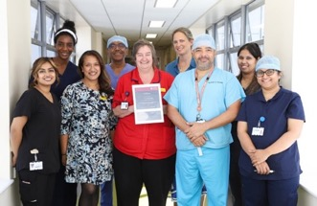
Receiving this recognition reflects the strong commitment of our maternity and gynaecology teams to creating a supportive, inclusive, and high-quality learning environment for future clinicians. It also demonstrates the important relationship between workforce development, staff experience, and the delivery of safe, effective, and compassionate patient care.
We recognise that quality education and training are essential for developing a skilled workforce and enhancing patient outcomes in NHS services. We are dedicated to investing in education, leadership, and professional growth for all professional groups. This success highlights the commitment of consultants, midwives, educators, and multidisciplinary teams in nurturing the next generation of healthcare professionals in Medway and Swale.

UNICEF Baby Friendly Accreditation for the Oliver Fisher Neonatal Unit
Our Oliver Fisher Neonatal Unit achieved Level 3 accreditation under the UNICEF Baby Friendly Initiative (BFI), recognising the high standards of care, support, and family-centred practice provided to babies and their families receiving neonatal care.
The UNICEF Baby Friendly Initiative is a nationally recognised programme that enhances care for babies, mothers, and families by promoting evidence-based infant feeding practices, parent–baby bonding, and compassionate, family-centred care. Accreditation is awarded only to services that consistently meet the high standards set by national criteria.
Achieving Level 3 accreditation reflects our neonatal team’s commitment to ensuring families are supported, informed, and involved throughout their baby’s care journey. As part of the assessment process, the unit demonstrated how it:
- supports families to understand the importance and benefits of breastfeeding
- enables parents to continue breastfeeding for as long as they choose
- provides families with evidence-based information to support informed feeding decisions
- supports safe and responsive infant feeding practices
- promotes close, loving and responsive relationships between parents and babies
- delivers compassionate, family-centred neonatal care
- improves the experience and quality of care for babies and families during neonatal admission.
The accreditation process also recognised the unit’s commitment to ensuring that families stay actively involved in caring for their baby throughout their neonatal stay, fostering bonding, attachment, and emotional wellbeing during what can often be a very stressful and emotional experience for parents and carers.
This achievement reflects the dedication, compassion, and professionalism of our neonatal nurses, midwives, medical staff, maternity colleagues, and wider multidisciplinary teams who collaborate to provide safe, personalised, and supportive care for babies and families across Medway and Swale.

Virtual Hospital
One of the most significant service developments in 2025/26 has been the ongoing expansion of our Virtual One of the most significant service developments in 2025/26 has been the ongoing expansion of our Virtual Hospital, led by the Surgical Medical and Acute Recovery Team (SMART). This is part of our broader strategy to enhance patient flow, reduce unnecessary hospital admissions, facilitate earlier discharges, and provide more personalised care closer to home. This initiative also supports the Trust’s Improvement Plan by helping to lessen pressure across urgent and emergency care pathways and inpatient capacity.
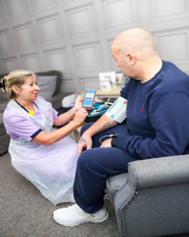
During the year, the first phase of the enhanced Virtual Hospital was rolled out, increasing virtual bed capacity and introducing 24-hour, seven-day nursing coverage for the first time. This development has significantly enhanced our ability to safely care for patients with more complex clinical needs within their own homes, including providing overnight clinical support and monitoring where appropriate.
The expansion of the service is already delivering positive benefits for both patients and the wider health system. By enabling earlier hospital discharges and preventing unnecessary admissions, the Virtual Hospital helps ease pressure on inpatient wards and ED while maintaining patient safety, clinical oversight, and continuity of care.
The Virtual Hospital allow patients to recover comfortably and with familiarity in their own homes while still being cared for and monitored by acute clinical teams. Increasing evidence indicates that many patients experience better recovery, greater independence, and an improved overall experience when treated at home, when clinically appropriate. Remote monitoring technology allows clinical teams to consistently oversee patients’ health and well-being by monitoring key physiological observations.

This allows clinicians to identify deterioration early, respond promptly to changes in condition and ensure patients continue to receive safe, responsive and effective care while remaining at home.
Feedback from both patients and staff has been very positive, with many patients emphasising the benefits of recovering in a familiar environment while still feeling reassured that specialist clinical support remains readily available if needed. One patient who benefited from the Virtual Ward service during the year was Elliot Hall from Gillingham.
Reflecting on his experience, Elliot said:
“I thought it was so much better for my recovery being in the comfort of my own home and I had security in the knowledge that the team were just on the other end of a phone should I need them. Just feeling more relaxed at home was a great help for my recovery and mental health. What a great service.”
This feedback emphasises the vital role that the Virtual Hospital can play not only in supporting physical recovery but also in boosting patient confidence, emotional wellbeing, and overall care experience.
Virtual care is a vital part of future healthcare delivery, and we remain committed to developing community-based, digitally enabled models of care that improve patient outcomes, enhance experience, and support sustainable healthcare across Medway and Swale. With national policy increasingly focused on shifting care closer to home, as outlined in the NHS 10-Year Health Plan, remote and virtual care services are set to expand rapidly. The Trust aims to build on its experience in this area, positioning its Virtual Hospital as a blueprint for delivering high-quality, technology-enabled acute care in community settings.

Improving Quality in Liver Services (IQILS) Programme
Our Hepatology Team achieved full accreditation through the Improving Quality in Liver Services (IQILS) programme, marking a notable achievement for both the service and the wider organisation. We became the first trust in Kent and one of only a few organisations nationwide to reach this highest level of accreditation.
The IQILS programme is a nationally recognised accreditation scheme that evaluates the quality, safety, and effectiveness of liver services against established best-practice standards. It assesses services across various areas, including clinical care, patient experience, leadership, governance, multidisciplinary working, and service improvement.



The external assessment identified several areas of good practice within our hepatology service and emphasised the strong focus on patient-centred care and ongoing improvement. Feedback from patients showed that individuals felt:
- well supported throughout their care
- listened to and treated with compassion and respect
- involved in decisions about their treatment and care plans
- able to access specialist advice and support when needed.
Assessors also confirmed that clinical pathways within the service adhered to national best practice guidance and that patient feedback was actively used to inform service development and improvement activities.
Throughout the year, the Hepatology Team continued to implement key service enhancements aimed at improving patient outcomes, reducing preventable hospital admissions, and enabling more proactive management of liver disease within community settings. These advancements included:
- expansion of specialist community clinics to improve access to expert advice closer to home
- development of virtual ward pathways to facilitate safe monitoring and treatment outside hospital environments
- enhanced support for patients with alcohol-related liver disease and day-of-care alcohol needs
- increased utilisation of day-case pathways and procedures, decreasing the need for inpatient admissions and extended hospital stays.
- improved coordination of care across acute, community and specialist services.
These developments have helped enhance patient experience, minimise disruption for patients and families, and support more timely and personalised care. They also contribute to broader organisational priorities such as reducing hospital admissions, improving patient flow, and delivering more care closer to home where clinically appropriate.
Achieving IQILS accreditation reflects the dedication, expertise, and collaborative effort of the hepatology multidisciplinary team and demonstrates our ongoing commitment to delivering high-quality, evidence-based, and compassionate care for patients living with liver disease across Medway and Swale.

Ward Accreditation Programme
We continued to strengthen our Ward Accreditation Programme as part of our wider commitment to improving patient safety, patient experience and the consistency of care delivered across inpatient services.
The Ward Accreditation Programme offers a structured framework to support high-quality, safe, and compassionate care at ward level, while encouraging continuous improvement, multidisciplinary collaboration, and greater local ownership of quality standards. The programme also bolsters our broader CQC readiness and ward to board governance approach by adding an extra mechanism for local assurance, monitoring improvement, and recognising both best practices and emerging risks. Accreditation assessments are undertaken against a range of standards and quality indicators aligned to the delivery of safe, effective and person-centred care.
During 2025/26, a total of 15 wards took part in the accreditation process, with outcomes as follows:
- two wards achieved Gold accreditation
- 12 wards achieved Silver accreditation
- one ward achieved Bronze accreditation.
The programme has helped support greater visibility of quality standards at ward level and has enabled teams to recognise good practices, share learning, and target improvement efforts where needed. Importantly, we understand that ward accreditation results must be viewed alongside broader real-time indicators of quality and safety, such as incidents, falls, patient feedback, staffing, harm data, and operational pressures. While accreditation offers valuable assurance regarding standards and processes, the organisation recognises that higher accreditation ratings do not always fully capture the dynamic pressures and risks faced within frontline clinical environments.
Therefore, a thorough review of the Ward Accreditation Programme is currently in progress as part of broader efforts to strengthen governance and enhance quality improvement. The review seeks to ensure that the programme offers meaningful, dependable, and intelligence-led assurance that better aligns with operational performance and patient safety outcomes. The outcomes of this review will guide the development of a revised Ward Accreditation Programme in 2026/27, aligned with our Clinical Quality Governance Framework, CQC quality statements, and broader organisational improvement priorities.

Part 2: Priorities for improvement and statements of assurance

During 2025/26, we provided or commissioned through subcontracted arrangements 46 relevant health services for the people of Medway and Swale. Throughout the year, we maintained delivery of care amid ongoing operational pressures, rising demand, and increasing patient complexity across acute, urgent, and maternity services. Despite these difficulties, our staff continued to provide essential services to hundreds of thousands of patients in hospitals, emergency units, maternity units, and outpatient clinics.
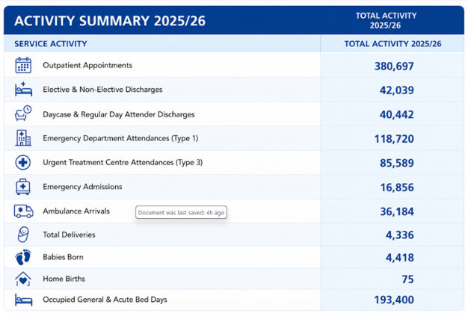
We continued to face substantial demand in urgent and emergency care services throughout the year, with over 118,000 ED attendances and more than 36,000 ambulance arrivals. Demand for inpatient services also stayed high, with average general and acute bed occupancy at 94.3 per cent over the year, indicating ongoing pressure on patient flow and hospital capacity.
Maternity services continued to support thousands of women and families across Medway and Swale, with over 4,300 deliveries occurring during the year, including support for families opting for home births where clinically suitable. Alongside operational delivery, we continued to prioritise improving quality, patient safety, and patient experience through stronger governance arrangements, service improvement programmes, workforce initiatives, and expanded models of care, including community diagnostic services and Virtual Hospital.
These activity figures highlight the scale and complexity of services provided, reflecting the ongoing dedication, compassion, and professionalism of our staff in caring for patients and communities across Medway and Swale.

Emergency Department performance
Our ED managed more than 236,000 patient attendances, reflecting continued high levels of demand across urgent and emergency care services.
Throughout the year, we continued to provide emergency care despite significant operational pressures, such as increasing patient acuity, more ambulance arrivals, workforce challenges, and ongoing pressure on inpatient capacity and patient flow. Despite these difficulties, there remained a strong organisational focus on enhancing patient safety, timeliness of care, patient flow, and overall patient experience.
Performance against the national four-hour emergency care standard remained fairly stable for much of the year, while ambulance handover performance continued to improve due to strong partnership working with system colleagues, including the South East Coast Ambulance Service (SECAmb).
A number of improvement initiatives were progressed during the year to support safer and more effective urgent and emergency care pathways, including:
- strengthening Same Day Emergency Care (SDEC) pathways to support admission avoidance and reduce unnecessary inpatient stays
- improving patient flow through earlier senior clinical review, decision-making and discharge planning
- enhancing access to alternative community and urgent care services to ensure patients receive care in the most appropriate setting
- strengthening escalation and operational oversight processes during periods of high demand
- continuing collaborative work with system partners to improve ambulance handover performance and reduce delays
- expanding the Virtual Hospital to support earlier discharge and reduce pressure on inpatient capacity
Alongside operational improvements, we also continued to focus on enhancing the experience of patients receiving urgent and emergency care, recognising the impact that long waits, crowding, and escalation pressures can have on patients, families, and staff.
We recognise that significant challenges remain across urgent and emergency care pathways, especially during periods of sustained demand, rising patient acuity, and increased pressure on inpatient capacity and patient flow. We acknowledge that caring for patients in non-designated clinical areas, is not appropriate and can pose risks to patient safety, privacy, dignity, and overall patient experience. However, during times of operational escalation and exceptional system pressure, temporary escalation areas may be used to help maintain patient flow and ensure continued access to urgent and emergency care services.
In response, we have initiated a whole-system approach aimed at reducing and eliminating use of non-designated clinical areas through enhanced operational management, better patient flow, and the development of alternative care pathways.

Referral to Treatment (RTT) – incomplete pathways
The NHS Constitution states that patients should begin consultant-led treatment within 18 weeks of referral for non-urgent conditions. Referral to Treatment (RTT) performance measures the proportion of patients on an incomplete pathway who are waiting less than 18 weeks for treatment.
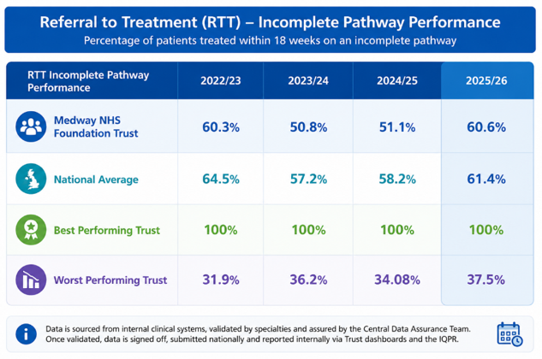
During 2025/26, we continued to face high demand for elective care services, along with operational and workforce pressures that affected capacity and patient flow. Despite these difficulties, ongoing recovery efforts have led to improvements in RTT performance and enhanced oversight of elective pathways across the organisation.
The percentage of patients treated within 18 weeks on an incomplete RTT pathway improved to 60.6 per cent, compared to 51.1per cent in 2024/25. While performance remained slightly below the national average of 61.4 per cent, we demonstrated sustained improvement during the latter part of the year following targeted recovery and improvement actions.
We also continued to focus on reducing the number of patients facing long waits for treatment. Although pressures during the first half of the year caused some decline in performance, recovery measures taken in the second half helped reduce long waits, including eliminating waits over 65 weeks. A number of improvements were introduced during 2025/26 to strengthen elective pathway management and improve patient access to timely care, including:
- introduction of a new Patient Tracking List (PTL) reporting system, improving visibility and oversight across all stages of patient pathways
- strengthened specialty-level oversight through regular PTL review meetings and escalation processes
- increased pathway validation activity and strengthened compliance with the Trust Access Policy
- effective use of NHS England elective recovery and sprint funding to increase clinical activity and reduce waiting times
- continued partnership working, insourcing and targeted capacity management to support timely access to treatment
- improved operational oversight and performance governance through divisional and Trust-wide recovery arrangements.
These actions have strengthened our ability to proactively manage patient pathways, identify delays earlier and support more timely access to treatment for patients waiting for elective care.
Improving access to planned care remains a key organisational priority within our Improvement Plan. We recognise the impact that prolonged waits can have on patients’ physical health, mental wellbeing and overall experience of care, and remain committed to continuing elective recovery work to improve access, reduce delays and deliver care in a timely, safe and compassionate way.

Maximum six-week wait for diagnostic procedures
Access to timely diagnostic tests is crucial for early diagnosis, reducing treatment delays, and enhancing patient outcomes and experience. In 2025/26, we notably improved diagnostic waiting times, with 92.1 per cent of patients receiving their tests within six weeks, a significant rise compared to previous years and above the national average.
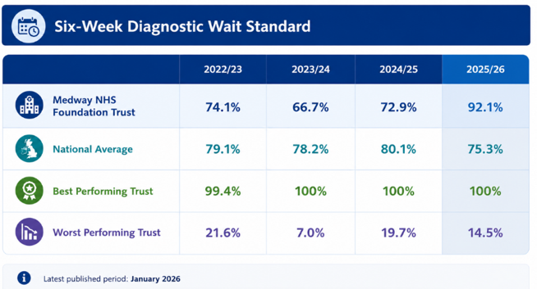

This improvement demonstrates ongoing efforts to enhance diagnostic services, expand capacity, and improve patient access to prompt investigations across various diagnostic pathways, including imaging and scanning services.
The significant progress achieved has been driven by a combination of service redesign, improved operational oversight, and expanded diagnostic capacity. Key improvements included:
- expansion of Community Diagnostic Centre (CDC) services in Sheppey and Rochester
- introduction of additional diagnostic modalities across CDC sites
- improved demand and waiting list management processes
- increased use of insourcing and outsourcing where clinically appropriate
- strengthened workforce planning and productivity initiatives
- enhanced pathway management and scheduling processes
- improved patient access to diagnostics closer to home
The expansion of CDCs has played an important role in improving patient experience and reducing barriers by providing more convenient local diagnostic services for patients and communities across Medway and Swale.
One patient who benefited from the new Sheppey CDC was Paul O’Connor, who attended the site for a CT scan while working from home. Reflecting on his experience, Paul said
“It was really easy to get here as I live just around the corner in Minster. I was even able to come for my CT scan on a short break while working from home, and I got a parking space straight away.
“It’s very different to coming into a busy, bigger hospital environment. The calming atmosphere is really noticeable – the murals on the wall, and the quietness, help you feel less anxious about the clinical setting. The radiographers were very friendly and caring – overall it was a really great experience and I felt at ease.”
Paul later attended as a guest of honour at the official opening of the site and assisted in cutting the ribbon during the ceremony.
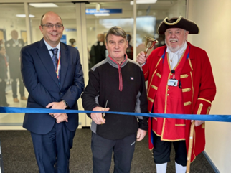
This feedback reflects the wider benefits of improving access to diagnostics nearer to patients’ homes, such as increased convenience, less travel, faster access to investigations, and an improved overall patient experience. Maintaining and upholding this improved level of performance remains a key priority. Continued focus will stay on enhancing resilience, productivity, workforce sustainability, and equitable access to timely diagnostic testing as part of the organisation’s wider Improvement Plan.

Patient safety
Patient safety remains our highest priority and is essential for delivering high quality, compassionate, and effective care. During 2025/26, we continued to strengthen our approach to patient safety by emphasising learning, improvement, early risk detection, and the implementation of safer care systems. Despite ongoing operational pressures across health and care services, significant efforts have been made to improve safety culture, strengthen governance and oversight arrangements, reduce avoidable harm, and improve outcomes and experiences for patients, families, and carers across Medway and Swale.

Patient Safety Incident Response Framework
During 2025/26, we continued to implement the Patient Safety Incident Response Framework (PSIRF), marking a significant shift in how patient safety incidents are reviewed, understood, and learned from across the organisation. PSIRF aims to move organisations away from a predominantly process-driven approach to investigations towards a more compassionate, systems-based, and improvement-focused model of learning.
Throughout the year, we continued to strengthen our PSIRF arrangements and governance structures; however, we recognise that implementation has not yet been fully embedded across the organisation and that additional work is needed to realise the framework's full benefits.
An independent assurance review conducted in December 2025 provided a thorough assessment of our progress and identified several key areas needing further development. The review confirmed that our overall PSIRF framework and governance arrangements are broadly in line with national guidance and acknowledged the strong commitment from both clinical and corporate teams to improving patient safety and learning.
However, the review also identified variation in operational implementation, in the consistency of engagement, and in the overall effectiveness of learning processes across the organisation. In particular, the review emphasised the need to strengthen clinical ownership, enhance confidence in alternative PSIRF learning approaches, and ensure that learning is more consistently translated into meaningful and measurable system-wide improvements.
We recognise that PSIRF has not yet been fully embedded as a consistently effective organisational learning system and understand that further work is needed to strengthen both culture and implementation. We also acknowledge that enhancing patient safety requires more than process redesign alone and must involve cultural change, increased clinical engagement, open learning environments, and robust quality improvement capabilities at all levels.
In response to the review findings, we have implemented a comprehensive PSIRF Improvement Programme to enhance the quality, consistency, and impact of patient safety learning across the organisation. Oversight of the PSIRF Improvement Programme is maintained through our governance structures, including the Patient Safety and Harm Prevention Subcommittee, Quality Assurance Committee, and Trust Board.
We remain committed to developing a compassionate, learning-focused, and improvement-driven patient safety culture that promotes openness, ongoing learning, and safer care for patients, families, and staff across Medway and Swale.

Patient safety incidents resulting in severe harm or death
We are committed to maintaining an open and transparent patient safety culture where staff are encouraged and supported to report patient safety incidents, concerns, and near misses promptly. Reporting and learning from incidents is an essential part of enhancing patient safety, reducing avoidable harm, and improving the quality of care provided to patients and families across Medway and Swale.

During 2025/26, we continued to report patient safety incidents via the national Learning from Patient Safety Events (LFPSE) service, following the transition from the previous National Reporting and Learning System (NRLS). Incident reporting is managed through our electronic incident reporting system (DATIX), with data submitted nationally in accordance with NHS England requirements.
We continue to strengthen oversight of patient safety incidents through established governance arrangements, including:
- a weekly Incident Review Group (IRG), chaired by the Chief Medical Officer
- a fortnightly Patient Safety Investigation Review Group (PSIRG), chaired by the Chief Nursing Officer
- oversight through the Patient Safety and Harm Prevention Subcommittee, Quality Assurance Committee, and Trust Board.
These forums support the review, triangulation, and oversight of incidents, learning responses, and improvement actions across the organisation.
NHS England has currently paused the routine national publication of patient safety incident reporting data while future reporting arrangements are developed following the implementation of LFPSE. We therefore continue to monitor and review local reporting data internally alongside wider patient safety intelligence.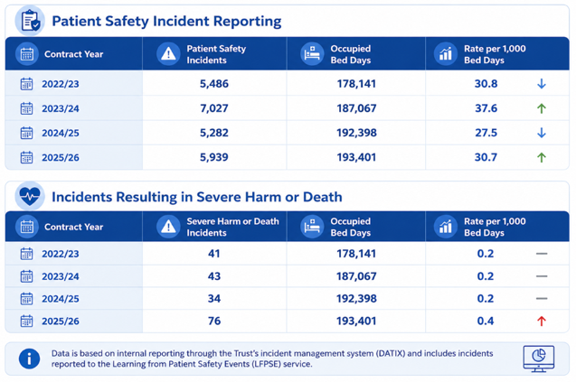
During 2025/26, we observed an increase in reported patient safety incidents compared to the previous year. While incident reporting rates can be affected by several factors, including operational pressures, reporting behaviours, and changes linked to PSIRF implementation, we understand the importance of fostering a strong reporting culture where staff feel safe and supported in raising concerns and reporting incidents.
We also monitor incidents resulting in severe harm or death as part of wider patient safety oversight and learning frameworks.
The rise in incidents classified as severe harm or death during 2025/26 has undergone a thorough review and reflects several contributing factors, including enhanced scrutiny and classification procedures, increased oversight through PSIRF governance arrangements, better identification and escalation of patient safety concerns, and changes in reporting practices following the implementation of LFPSE and PSIRF methodologies.
We acknowledge the importance of this increase and continues to focus on understanding key themes, identifying learning opportunities, and ensuring incidents are reviewed properly and transparently. Importantly, reporting incidents and recognising harm should be considered within the context of a learning organisational culture, patient complexity, operational pressures, and evolving national reporting frameworks.
We also recognise that the quality and impact of learning are more important than the number of investigations undertaken alone. Therefore, the focus remains on ensuring that patient safety learning leads to measurable improvements, reduces avoidable harm, and creates safer systems of care.

Learning responses
Under PSIRF, we now employ a variety of learning methods based on the nature, complexity, and potential learning from an incident or patient safety concern. These approaches aim to facilitate timely learning, multidisciplinary reflection, and more meaningful improvement, rather than relying solely on lengthy formal investigations.
Learning responses employed include:
- Patient Safety Incident Investigations (PSII) – the most detailed form of systems-based investigation, undertaken for incidents where there is potential for significant organisational learning or where required by national guidance
- After Action Reviews (AARs) – structured multidisciplinary discussions undertaken shortly after events to support rapid learning, reflection and improvement
- Patient safety huddles and debriefs – shorter learning reviews focused on immediate understanding, shared learning and local improvement
- Thematic reviews – reviews of recurring themes, trends or risks across multiple incidents or services
- Multidisciplinary learning reviews – collaborative reviews involving clinical teams and wider stakeholders to explore system factors and opportunities for improvement
- Maternity and Newborn Safety Investigations (MNSI) – independent investigations undertaken externally in line with national maternity safety requirements.
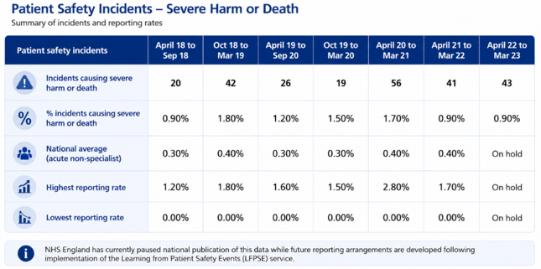
We recognise that effective learning is not solely determined by the depth or duration of an investigation, but by the quality of analysis, openness of discussion, and the degree to which learning leads to measurable improvements for patients and services.

During 2025/26, efforts continued to enhance understanding and confidence in the full range of PSIRF learning methodologies across the organisation. This involves supporting teams to adopt a more proactive, compassionate, and systems-focused approach to patient safety learning, while ensuring that patients, families, and staff remain appropriately involved throughout the process.
We recognise that more work is needed to reliably embed these approaches across all services and to ensure that learning responses produce sustainable improvement and reduce avoidable harm. Enhancing the impact and effectiveness of learning remains a key focus of our PSIRF Improvement Programme.

Never Events
During 2025/26, we reported two Never Events, both of which resulted in moderate patient harm. At the time of publication, one incident remains subject to final confirmation and review in accordance with national reporting requirements.
Never Events are serious patient safety incidents that are largely preventable when national safety guidance and recommendations designed to avoid such incidents are available and should be implemented by healthcare providers. Although rare, Never Events can significantly impact patients, families, and staff and are treated with the highest level of seriousness.
Following each incident, immediate actions were taken to safeguard patients, support patients and families, and commence appropriate review and learning processes. Investigations have been carried out in accordance with the PSIRF, focusing on understanding contributing system factors, identifying lessons, and preventing future incidents.
Learning identified through investigations is reviewed through our patient safety governance structures, including the Incident Review Group (IRG), Patient Safety Investigation Review Group (PSIRG), Patient Safety and Harm Prevention Subcommittee, and Quality Assurance Committee.

Duty of Candour
We are committed to being open, honest, and transparent with patients, families, and carers when something goes wrong in the delivery of care. Openness and transparency are essential for maintaining trust, supporting compassionate care, and fostering a positive culture of learning and safety. The statutory Duty of Candour is a legal obligation that applies when a patient safety incident results in moderate harm, severe harm, or death.
During 2025/26, formal Duty of Candour processes were applied to 203 patient safety incidents, compared to 98 incidents during 2024/25. The increase reflects a combination of strengthened oversight, improved identification and application of Duty of Candour requirements, increased scrutiny through patient safety governance processes, and broader implementation of the Patient Safety Incident Response Framework (PSIRF).
We recognise that Duty of Candour is not just a regulatory obligation but also a vital aspect of providing compassionate, person-centred care and fostering organisational learning. Consequently, efforts have continued throughout the year to enhance the consistency, timeliness, and quality of Duty of Candour procedures across all services.
Oversight of Duty of Candour compliance is managed through the patient safety and governance frameworks, including the PSIRG, the Patient Safety and Harm Prevention Subcommittee, and the Quality Assurance Committee.

Health and Safety Executive and RIDDOR incidents
We are committed to creating a safe environment for patients, staff, visitors, and contractors, recognising that health, safety, and wellbeing are vital to providing high quality care and fostering a positive working environment.
During 2025/26, there were no incidents that required formal investigation by the Health and Safety Executive (HSE). According to the Reporting of Injuries, Diseases and Dangerous Occurrences Regulations (RIDDOR), we reported a total of 23 incidents during the year, compared to 17 incidents in 2024/25. All reported incidents involved staff members rather than patients or visitors.
The increase in reportable incidents was primarily associated with:
- violence and aggression towards staff
- exposure to hazardous substances
- moving and handling incidents
- opportunities to strengthen organisational learning and prevention measures.

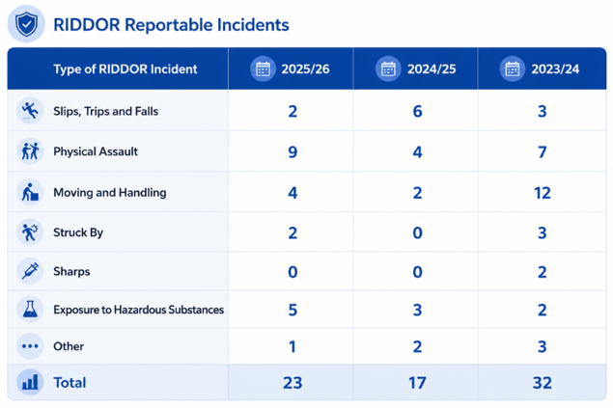

Although the overall number of reported incidents across the organisation decreased during the year, violence, abuse and aggression towards staff remain a serious and unacceptable concern. The Trust is clear that such behaviour is not tolerated and is committed to taking appropriate action in response. We recognise the significant impact that violence and aggression can have on staff wellbeing, morale, psychological safety and the delivery of safe, high-quality patient care. Reducing violence and improving staff safety therefore remain key organisational priorities, supported by continued focus on prevention, reporting and effective response.
We continued to strengthen our approach to health and safety through a focus on prevention, staff support, governance oversight and organisational learning. Key areas of improvement work included:
- reducing violence and aggression towards staff
- improving staff safety, wellbeing and support arrangements
- strengthening training, risk awareness and incident prevention
- improving safe handling and hazardous substance management practices
- strengthening reporting, review and learning processes
- enhancing multidisciplinary oversight of health and safety risks.

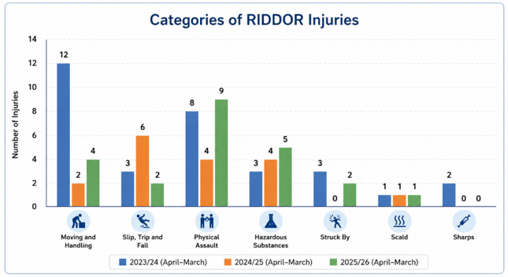Actions carried out during the year included enhanced staff training, strengthened incident review processes, improved governance oversight, and increased focus on prevention and early intervention measures.
Our governance arrangements, including the Health, Safety and Security Subcommittee and Quality Assurance Committee, oversee health and safety risks and incidents.
We recognise that establishing a safe working environment is vital for supporting both staff wellbeing and patient safety. Therefore, work will continue throughout 2026/27 to reduce incidents, enhance prevention measures, and improve safety for staff, patients, and visitors across all services.

Mortality and Summary Hospital-level Mortality Indicator
Reducing avoidable mortality and improving patient outcomes remain top priorities for us. In 2025/26, we continued to enhance our approach to mortality review, learning, and improvement, recognising the importance of understanding mortality within the wider context of patient complexity, frailty, operational pressures, and whole-system care pathways.
Our Summary Hospital-level Mortality Indicator (SHMI) remains higher than expected and continues to be a key focus for the organisation. SHMI evaluates the number of observed deaths against the expected number, cosidering factors such as age, diagnosis, and comorbidities. 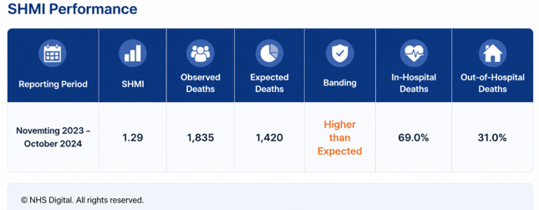

During 2025/26, we carried out further analysis and independent review work to better understand the factors contributing to higher-than-expected mortality. This work identified that mortality is affected by a combination of clinical, operational, and system-wide factors, including:
- increasing patient frailty and complexity
- delays in discharge and patient flow
- pressure across urgent and emergency care pathways
- deterioration management and escalation processes
- variability across end-of-life and palliative care pathways
- the impact of whole-pathway care across acute and community settings.
The review found that greater progress is most likely to come from targeted clinical and system-wide improvements rather than just focusing on data validation or coding processes. This has helped promote a more clinically orientated and improvement-driven approach to mortality oversight and learning.
Learning from deaths and mortality reviews continue to offer valuable insights into opportunities for improvement. Deaths identified as potentially preventable undergo detailed clinical review and are escalated where appropriate, ensuring that learning results in meaningful improvements and safer care.

Mortality intelligence is also triangulated alongside wider patient safety, operational, and quality information to support a broader understanding of risk and outcomes across the organisation.

Hospital Standardised Mortality Ratio Plus
Alongside SHMI, we also monitor the Hospital Standardised Mortality Ratio (HSMR+), which assesses in-hospital mortality by comparing observed deaths with expected deaths after adjusting for patient characteristics and clinical complexity. For the reporting period from December 2024 to November 2025, our HSMR+ was within the lower than expected band.
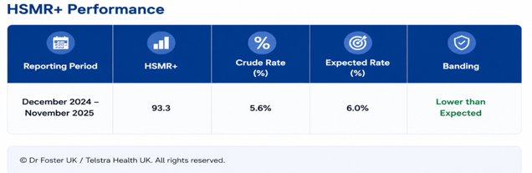

Understanding mortality indicators
We recognise the importance of carefully interpreting mortality indicators within the appropriate clinical context. SHMI and HSMR+ employ different methodologies and measure distinct aspects of mortality. A key difference is that HSMR+ accounts for frailty, while SHMI does not. Consequently, SHMI may be more sensitive to variations in patient complexity, frailty, and case mix.
These differences emphasise the importance of analysing mortality indicators together with clinical review, learning from deaths, patient safety intelligence, and broader operational factors, rather than depending on a single metric in isolation.

Forward focus
Reducing mortality and enhancing patient outcomes will continue to be a key priority during 2026/27. We acknowledge that further improvements are needed to ensure consistently safe, effective, and high-quality care across all pathways. Future work will continue to focus on:
- strengthening frailty pathways and integrated care models
- improving patient flow and reducing delays in discharge
- enhancing deterioration management and escalation processes
- strengthening palliative and end-of-life care
- improving mortality review within specific diagnosis groups and pathways
- increasing focus on whole-pathway and system-wide learning
- strengthening multidisciplinary clinical engagement in mortality improvement.
This work is part of our broader initiatives for quality improvement, patient safety, and recovery programmes, reinforcing the organisation’s ongoing commitment to improving outcomes, reducing preventable harm, and providing compassionate, person-centred care for patients and families.

Venous Thromboembolism risk assessment
Venous Thromboembolism (VTE), which includes deep vein thrombosis and pulmonary embolism, remains a significant and potentially preventable cause of patient harm within healthcare settings. Ensuring patients receive prompt and effective VTE risk assessment and preventative care therefore continues to be a key patient safety priority.
We consider the data presented to be accurate, as it is extracted directly from nationally recognised NHS Digital reporting systems and is subject to local validation and assurance processes. During 2025/26, we maintained a strong performance against the national VTE assessment standard, with 97.2 per cent of eligible adult inpatients receiving a VTE risk assessment, remaining above the national target of 95 per cent.

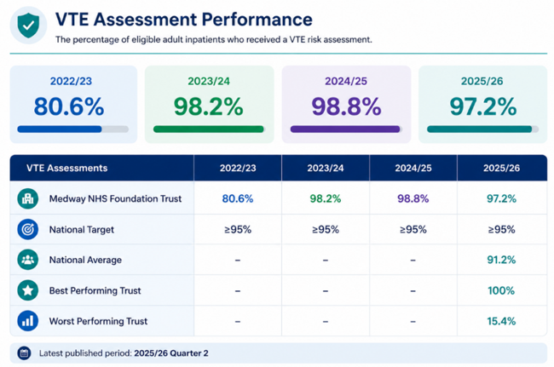

The improvement and ongoing performance over recent years demonstrate continued organisational efforts to enhance VTE prevention, risk assessment procedures, and clinical oversight across inpatient services. During 2025/26, we took several actions to enhance VTE assessment compliance and decrease the risk of Hospital Acquired Thrombosis (HAT), including:
- supporting clinical teams to improve timely and accurate documentation of VTE risk assessments
- working with the Business Intelligence Team to develop automated VTE data extraction from electronic patient records, reducing reliance on manual data collection processes
- providing ongoing support to ward teams during transition to improved electronic reporting arrangements
- strengthening governance oversight and review of VTE and Hospital Acquired Thrombosis (HAT) data through governance forums
- implementing mandatory VTE training for registered nursing, midwifery, medical and dental staff
- developing and implementing an updated VTE Quality Improvement Plan informed by learning from HAT investigations, audit findings and Electronic Prescribing and Medicines Administration (EPMA) analysis
- Learning from VTE incidents, audits, and thrombosis investigations continues to support improvement efforts across the organisation, with a focus on reducing avoidable harm, enhancing the reliability of assessment processes, and strengthening preventative care.
We recognise that ongoing vigilance is essential to uphold high standards of VTE prevention and remain dedicated to ongoing improvement efforts during 2026/27 to ensure patients receive safe, evidence-based, and timely preventative care throughout their hospital stay.

Clostridioides difficile
Preventing healthcare-associated infections (HCAIs) remains a key patient safety and an important part of delivering safe, effective, and high-quality care. During 2025/26, we continued to strengthen our Infection Prevention and Control (IPC) arrangements by focusing on surveillance, education, environmental standards, antimicrobial stewardship, and organisational learning.
During the reporting period, we recorded 39 cases of Clostridioides difficile (C. difficile) infection, well below the NHS England threshold of 53 cases. A post-infection review was conducted for all Trust-related cases, with only one identified as avoidable.
This performance reflects continued work across clinical, operational and support services to reduce HCAIs and strengthen infection prevention practices across the organisation.
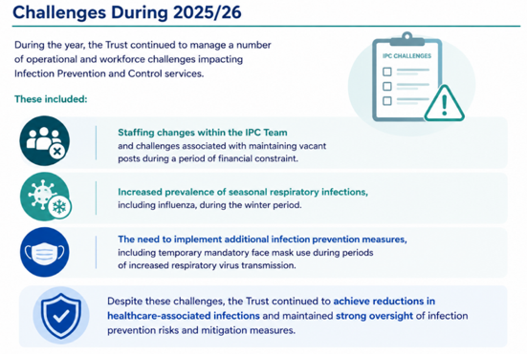
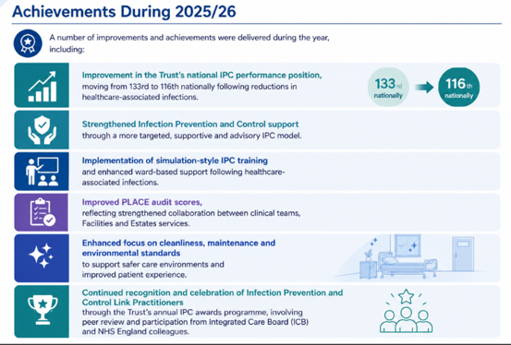

Supporting Reductions in Healthcare-Associated Infections (HCAIs)
During 2025/26, we continued a wide range of improvement measures to reduce the risk of C. difficile infection and support a wider reduction in HCAIs, including:
- maintaining a strong organisational focus on antimicrobial stewardship (AMS)
- continuing multidisciplinary C. difficile review huddles to identify learning and reduce recurrence
- monthly data-driven IPC review and improvement discussions
- antimicrobial stewardship ward rounds led by Consultant Microbiologists
- continued replacement and acquisition of easier-to-clean commodes
- ongoing roll-out of commode cleaning competency training for staff
- revision and update of IPC policies, guidelines and patient information leaflets
- Trust-wide commode and sluice environmental audits
- revision of diarrhoeal assessment tools to improve usability and compliance
- strengthened IPC audit programmes across wards and departments
- enhancement of IPC training programmes, including focus on commode cleanliness and environmental hygiene
- ongoing support from IPC Link Practitioners to provide local training and reinforce best practice within clinical areas.
Learning from infection prevention incidents, post-infection reviews, environmental audits, and surveillance data continues to inform improvement activities across the organisation. We remain committed to reducing preventable healthcare-associated infections and ensuring patients are cared for in clean, safe, and well-maintained environments. IPC will therefore continue to be a primary focus during 2026/27 as part of our broader patient safety, quality improvement, and recovery initiatives.

Methicillin Resistant Staphylococcus Aureus (MRSA)

In 2025/2026 the Trust had reported a total of 28 cases of MRSA colonisation found during routine screening shows a significant reduction in reported cases from 2024/2025. MRSA colonisation is monitored by the Trust as part of their HCAI reduction programme but does not have an NHS England threshold set against it. All patients found to be colonised with MRSA has provided MRSA decolonisation treatment and isolated in a side room until tested negative.

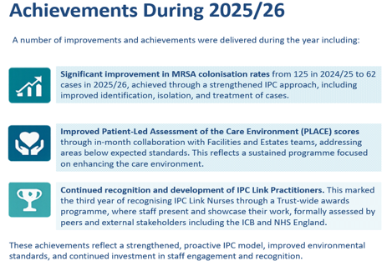

MRSA Bacteraemia
MRSA bacteraemia is the presence of the antibiotic-resistant Staphylococcus aureus (MRSA) bacteria in the bloodstream. It is viewed as a serious, life-threatening infection often originating from a primary source like a wound, device (e.g., IV catheter), or internal organ, which can rapidly spread bacteria to other parts of the body. The Trust takes these types of infection extremely seriously and investigates each case using the PSIRF methodology.
2025/26 saw a slight increase in MRSA bacteraemia’s for the Trust by one case totalling six for the year. The IPC Team worked closely with the areas that reported cases and all areas have gone through additional training and intensive support.

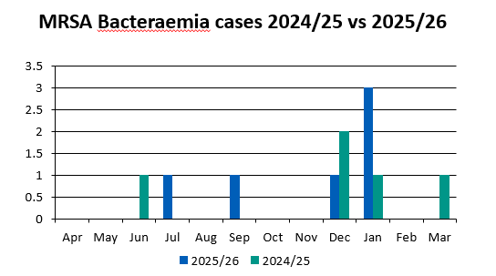

Supporting reductions in HCAIs
In order to reduce the number of MRSA Bacteraemia’s the Trust has:
- Work to ensure good compliance with vascular access devices and reviewing policy.
- Continue to hold MRSA Bacteraemia PSIRF meetings as a panel to ensure any learning from any lapses of care is identified and disseminated across the organisation to prevent reoccurrence.
- Monthly data driven discussions.
- Revised and updated Trust policy and guidelines.
- Updated the patient information leaflet for C-difficile.

Escherichia coli
In 2025/2026 the Trust had reported a total of 53 cases of Escherichia coli (E.coli) found during routine screening which shows a significant reduction in reported cases from 2024/2025. E.coli infection is monitored by the Trust as part of their HCAI reduction programme
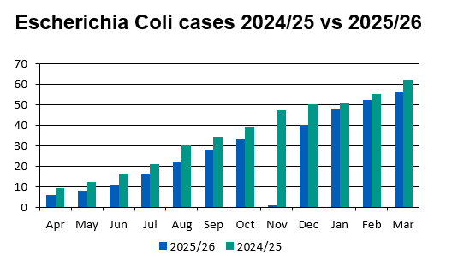

Achievements
- We have managed to improve the Trust’s overall reported cases of E.coli from 60 cases in 2024/25 to 53 cases in 2025/26 This is a great achievement and we also came well below the permitted NHS England threshold of 88 cases for two consecutive years.
- The Trust has achieved improvements in the Patient Assessment of the Care Environment (PLACE) audit scores from in 2024/25 to in 2025/26. This has been achieved by working closely with the Facilities and Estates teams to improve the patients experience through Bi-monthly joint inspections where a better overall picture of the Trust’s estate and immediately action areas that fall below the standards expected. This result is testament to the ongoing work programme to improve the look, feel and fabric for a better patient experience.
- The Trust’s fundamental standards of care group has done a lot of work to address hydration within the hospital. This work has raised the profile and pushed hydration as key priority.
- The Hydrate to feel great campaign has increased the amount of refreshments available to patients especially in the hot weather to reduce dehydration in the wards.

Safeguarding
Safeguarding remains a core element of our approach to patient safety, quality care, and compassionate practice. We are dedicated to protecting children, young people, and adults at risk from abuse, neglect, exploitation, and harm, ensuring safeguarding responsibilities are integrated into daily clinical care and organisational culture.
During 2025/26, we continued to handle a high volume of safeguarding activities, reflecting the increasing complexity among patients and families accessing healthcare services. Our Safeguarding Team maintained strong oversight of safeguarding arrangements, strengthened partnership working across agencies, and continued to deliver statutory safeguarding responsibilities.
We achieved compliance with all statutory Section 11 safeguarding standards, with assurance provided through external review by the Local Safeguarding Children Partnership.
To support early identification and protection of vulnerable children, all children attending the hospital are continuously checked against the national Child Protection Information System (CP-IS). This enables prompt information sharing and improves safeguarding decision-making across health and care settings.
Throughout the year, we also continued to see increasing numbers of children and young people presenting with mental health needs and vulnerabilities, placing additional demand on clinical and safeguarding services. In response, safeguarding and Mental Capacity Act (MCA) training remained a key organisational priority. During 2025/26:
- Mental Capacity Act (MCA) training exceeded the Trust target of 85 per cent
- Safeguarding adults and safeguarding children Level 3 training compliance remained between 81 to 85 per cent
- Learning disability nurses supported more than 1,000 patients requiring additional support and reasonable adjustments during their care.
We continued to enhance personalised care for patients with learning disabilities and autism through the use of the Reasonable Adjustment Flag, supporting earlier identification of patients who may require additional support, communication adjustments, or improved care planning.
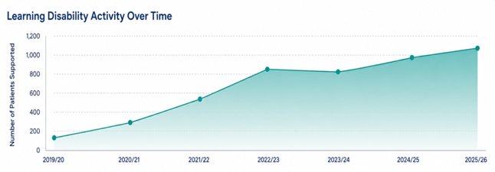

Learning and improvement
We continue to learn from safeguarding reviews, serious incidents and multi-agency investigations, including:
- Section 44 Safeguarding Adult Reviews
- Child Safeguarding Practice Reviews
- Domestic Abuse Related Death Reviews
- Multi-agency safeguarding learning events and partnership reviews.
Learning from these processes supports improvement in safeguarding practice, strengthens partnership working and helps identify opportunities to improve patient protection and outcomes across the wider health and care system. Improvement work undertaken during 2025/26 included:
- strengthening safer recruitment processes and Disclosure and Barring Service (DBS) compliance monitoring
- updating domestic abuse guidance and policies in line with legislative changes and best practice
- expanding safeguarding training and staff awareness programmes
- continued rollout of the Oliver McGowan Mandatory Training Programme on Learning Disability and Autism
- strengthening governance oversight and safeguarding assurance processes
- improving support for patients requiring reasonable adjustments and personalised care planning.
We recognise that further work is needed to improve uptake of some enhanced safeguarding and learning disability training elements, including Tier 2 Learning Disability training, and this remains an area of continued focus during 2026/27.

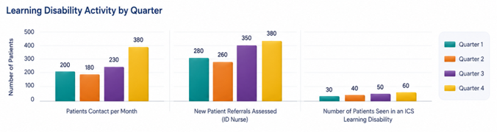
Safeguarding continues to be closely linked with our wider quality, patient safety and cultural improvement programmes. We remain committed to promoting a culture where safeguarding is everybody’s responsibility and where patients, families and carers feel safe, protected and supported throughout their care.

Clinical effectiveness

Clinical audit
Clinical audit remains a key component of our strategy to enhance quality, patient safety, and clinical effectiveness. It ensures care is provided according to evidence-based practice, national standards, and regulatory requirements, while helping services pinpoint opportunities to improve outcomes, reduce variation, and enhance patient experience.
During 2025/26, we continued to show strong engagement in clinical audit activities across a wide range of specialties and services, despite ongoing operational pressures. Most of the planned audit activity was either completed or actively progressing during the year, reflecting ongoing commitment from clinical teams to quality improvement and learning.

National clinical audit and NCEPOD participation
We engage in a wide range of national clinical audits and the National Confidential Enquiries into Patient Outcome and Death (NCEPOD). Participation in these programmes allows for benchmarking against national standards and helps identify areas where care pathways, clinical practices, and patient outcomes can be further enhanced.
These programmes provide valuable external assurance regarding the quality and effectiveness of care delivered throughout the organisation and support learning from both local and national findings.
Outcomes and recommendations from national audit and NCEPOD reviews are shared through governance structures and used to inform:
- clinical practice and pathway redesign
- patient safety and quality improvement activity
- compliance with national guidance and standards
- workforce education and training
- mortality improvement and learning from deaths
- service development and operational improvement
We recognise the important role national audit participation plays in strengthening transparency, benchmarking performance and supporting continuous improvement across clinical services.

Local clinical audit
Local clinical audit activity also remains an important part of our quality improvement and governance framework. These audits are aligned with organisational priorities, key risks, and areas with the greatest clinical impact, with particular emphasis on patient safety, clinical effectiveness, and experience.
During 2025/26, local audit activity supported improvement across a range of areas, including:
- deteriorating patient care and escalation
- infection prevention and control
- diagnostic safety and follow-up
- medicines management and prescribing
- documentation and consent
- End-of-life and palliative care
- frailty, discharge and patient flow pathways
- compliance with national guidance and best practice standards.
Learning from local audits is regularly reviewed through divisional and Trust governance structures to support organisational learning, improve compliance and strengthen assurance. Audit findings are triangulated alongside incidents, complaints, mortality review, patient feedback and wider quality intelligence to support a more comprehensive understanding of risk and performance.
We continue to strengthen the connection between clinical audit, quality improvement and governance to ensure that audit activity leads to measurable improvement in clinical practice and patient outcomes, rather than solely assurance of compliance.
Further detail regarding specialty-level clinical audit activity, participation and outcomes is provided within Annex 3 of this Quality Account.

Clinical research and innovation
We remain committed to clinical research and innovation as an important part of improving patient outcomes, patient experience and access to new and emerging treatments. During 2025/26, research activity continued to grow despite significant operational pressures, with:
- 3,930 participants recruited into research studies
- 78 active research studies delivered across multiple clinical specialities
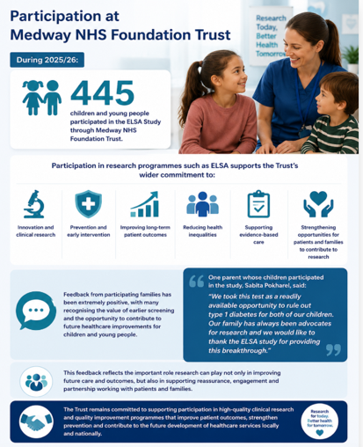
Research plays an important role in supporting earlier access to innovative treatments, improving clinical pathways and contributing to safer, more effective and evidence-based care for patients and communities across Medway and Swale.
We continue to strengthen our research capability through collaboration with academic institutions, regional partners and clinical teams, while supporting greater integration of research activity within everyday patient care.
Key areas of focus during the year included:
- expanding participation in national and locally developed research studies
- strengthening partnerships with academic and system organisations
- embedding research within clinical pathways and service improvement programmes
- increasing staff capability, engagement and leadership in research activity
- supporting patients and families to participate in research opportunities
We recognise that research and innovation are essential to improving future healthcare outcomes and remain committed to supporting high quality research that benefits patients locally and contributes to wider NHS learning and development.
The following is an example of research undertaken in 2025/26 involving patients at the Trust.

Early Surveillance for Autoimmune Diabetes Study
We continued to support participation in the Early Surveillance for Autoimmune Diabetes (ELSA) Study, a major UK-wide research and quality improvement programme focused on the early detection of children and young people at risk of developing Type 1 Diabetes (T1D).
The ELSA Study is among the largest population-based screening programmes of its kind in the UK and aims to recruit at least 70,000 children and young people aged 2 to 17 years from May 2022 to August 2029. The programme is designed to identify early autoimmune markers associated with Type 1 Diabetes before symptoms develop.
Earlier identification can support:
- earlier clinical intervention and monitoring
- reduction in emergency presentations and diabetic ketoacidosis (DKA)
- improved patient safety and outcomes
- increased access to research and prevention trials
- improved family awareness and support
- We are proud to contribute to this important national programme, supporting both research advancement and earlier, safer care for children and families within our local community.


Patient Reported Outcome Measures
Patient Reported Outcome Measures (PROMs) offer valuable insights into how patients perceive their health, well-being, and quality of life after treatment and care. Historically, PROMs data, including the EQ-5D Index Score, have supported understanding of patient outcomes across a variety of elective procedures and clinical pathways.
In recent years, national collection requirements for PROMs have changed considerably, with routine national collection now focused on a smaller number of elective procedures. As a result, PROMs and EQ-5D data are no longer routinely collected or reported nationally across many healthcare services, reflecting changes to national reporting arrangements rather than shifts in our commitment to understanding patient outcomes and experience.
Despite these changes, we remain dedicated to understanding the impact of care from the patient’s perspective and continues to use a wide range of alternative patient feedback, experience, and outcome measures to support quality improvement and service development. These include:
- Friends and Family Test (FFT) feedback
- patient experience surveys
- complaints, compliments and PALS themes
- national patient surveys
- local engagement and co-production activity
- clinical outcome measures and pathway-specific audit data
- patient stories and qualitative feedback
This information continues to offer valuable insight into patient outcomes, experience, and quality of care, helping us to identify opportunities for improvement and enhance person-centred care across services.
We acknowledge the importance of keeping patients’ voices at the heart of quality improvement and service planning. Therefore, work continues to enhance methods for capturing meaningful patient feedback and outcome data, ensuring that services stay responsive to the needs, experiences, and outcomes that are most important to patients, families, and carers.

PROMs: Hip and knee replacement
Despite changes to national PROMs collections, data continues to be available for selected elective procedures, including hip and knee replacement surgery. National collection of PROMs for groin hernia and varicose vein procedures has been discontinued following NHS England’s decision to reduce the scope of routine PROMs reporting.
For the Trust, EQ‑VAS (EuroQol Visual Analogue Scale) scores show:
- Hip replacement: 13.579 (2022), 13.267 (2023), 13.889 (2024)
- Knee replacement: 8.407 (2022), 8.159 (2023), 8.604 (2024)
These results indicate:
- stable outcomes for hip replacement, with improvement in 2024
- year-on-year improvement in knee replacement, now aligned with national benchmarks
- performance remains within the expected range, with no outlier status identified.
There is no PROMs data currently available for 2025/26.

28-day readmissions
Reducing avoidable hospital readmissions remains a key measure of quality, safety, and effectiveness across the NHS. Emergency readmissions within 28 days can be linked to various factors, including patient complexity, frailty, discharge arrangements, community support, and broader system pressures.
We recognise the importance of discharging patients safely, at the appropriate time and to the most suitable care setting, with effective follow-up and ongoing support where necessary. Reducing avoidable readmissions not only enhances patient experience and outcomes but also enables more efficient use of hospital capacity and alleviates pressure on urgent and emergency care services.
During 2025/26, we continued to see an overall improvement in 28-day readmission rates, with the rate decreasing to 6.8 per cent from 7.3 per cent during 2024/25. This reflects ongoing work across clinical and operational teams to strengthen discharge planning, improve patient flow, and support safer transitions of care. A number of actions have contributed to this improvement, including:
- strengthening discharge planning and multidisciplinary coordination
- improving patient flow and reducing delays in discharge
- expanding Virtual Hospital and community-based care pathways
- strengthening frailty pathways and admission avoidance initiatives
- improving communication and coordination with community and system partners
- enhancing speciality-level review of readmission trends and themes
- increasing operational oversight and validation of readmission data.
We also continue to ensure that readmission data undergoes regular internal validation and review processes. Performance is monitored monthly at specialty, Care Group, Divisional, and Trust-wide levels to support oversight, learning, and targeted improvement activities.

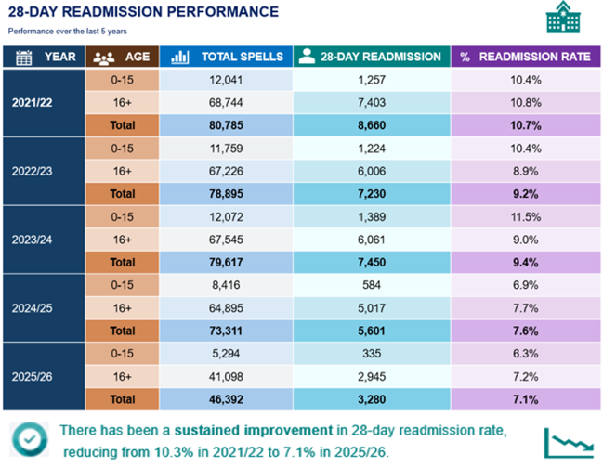

We recognise that some readmissions are clinically necessary and appropriate, especially considering increasing patient complexity, frailty, and long-term conditions across the population we serve. Readmission data is therefore reviewed alongside broader clinical, operational, and patient safety information to support a more complete understanding of patient outcomes and pathway effectiveness.

Enhancing discharge procedures, strengthening integrated care pathways, and reducing avoidable readmissions will continue to be key priorities in 2026/27 as part of our broader quality improvement, frailty, and patient flow programmes.

Patient Experience

Friends and Family Test
Listening to patients and responding to their feedback remains essential to our strategy for improving quality, experience, and compassionate care. The Friends and Family Test (FFT) continues to provide valuable insights into patient experiences across our services and helps identify opportunities for improvement at ward, service, and organisational levels.
During 2025/26, we continued to see sustained improvement in overall patient experience, with 91 per cent of patients recommending us as a place to receive care, compared to 84.2 per cent in 2021/22. This reflects the ongoing commitment of staff across the organisation to deliver compassionate, person-centred care despite continuing operational pressures and increasing demand.
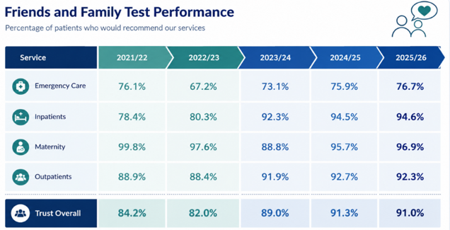
We have experienced particularly strong and sustained improvements in inpatient services, while maternity services showed notable recovery after a dip in performance during 2023/24. Although emergency care still faces greater variability due to ongoing operational pressures and high demand, performance has steadily improved throughout the year.
Patient feedback throughout 2025/26 continued to highlight positive experiences regarding the kindness, professionalism and compassion shown by staff, particularly during periods of significant service pressure.
The percentage of staff who would recommend the Trust as a provider of care to their family or friends was 46.38 per cent during 2025/26. This measure reflects staff confidence in the quality and safety of care provided and is an important indicator of organisational culture and patient experience.
The results indicate a decline in organisational confidence, with fewer than half of staff reporting that they would be satisfied with the standard of care provided.
These findings highlight an important area for improvement, as staff experience and engagement are recognised as key drivers of patient safety, quality of care, and workforce sustainability.

Improving patient experience
During the year, we continued to strengthen the use of FFT feedback to support local and organisational improvement. Themes from patient feedback are regularly reviewed within wards, departments and governance forums to support learning and targeted action.
Improvement activity during 2025/26 included:
- strengthening ward and service-level review of FFT feedback and patient themes
- expanding use of ’You Said We Did’ improvement boards across clinical areas
- improving communication with patients and families
- strengthening visible leadership and senior clinical presence within wards and departments
- supporting improvements in patient flow and waiting times, particularly within urgent and emergency care
- increasing staff engagement and listening events to better understand patient and staff experience
- supporting compassionate, inclusive and person-centred care through cultural improvement work.
We recognise that patient experience is influenced not only by clinical care, but also by communication, dignity, kindness, timeliness and the overall care environment. Improving responsiveness to patients’ individual needs therefore remains a key priority across all services.
We remain committed to ensuring that patient feedback directly informs service improvement and quality priorities. During 2026/27, continued focus will be placed on:
- improving patient experience within urgent and emergency care pathways
- strengthening communication and involvement of patients and families
- embedding learning from FFT, complaints, PALS and patient stories
- reducing variation in experience across services
- supporting compassionate leadership and positive staff culture
- ensuring care remains safe, responsive, respectful and person-centred.
We recognise that listening to patients and acting on their feedback are essential for providing high quality care and enhancing outcomes and experience for the communities we serve.

CQC Adult Inpatient Survey 2024
The Trust participated in the CQC Adult Inpatient Survey 2024, undertaken by Picker, which gathered feedback from patients discharged between November 2024 and January 2025. A total of 63 questions were included in the survey, with 45 questions contributing to scored results that enable comparison with previous years.
The response rate increased by 2 per cent compared to 2023, with the overall demographic profile of respondents remaining broadly consistent, although there was a slight increase in responses from men.

Performance and trends
- In 2023, the Trust had 24 questions scoring in the ’somewhat worse’ or ’worse‘ categories compared with other trusts.
- In 2024, there was a notable improvement, with:
  - 33 questions scoring ’about the same’ as other trusts, and
  - 1 question scoring ’somewhat better’.

Overall position
The results indicate a positive shift in patient experience, with performance moving away from below-average categories towards outcomes that are more closely aligned with national benchmarks. While most areas are now performing at a similar level to other trusts, there remain opportunities to achieve further improvement and move more areas into above-average performance.
The Trust’s score for responsiveness to patients’ personal needs in the CQC Adult Inpatient Survey was 6.9 out of 10, reflecting how well services are organised to meet individual patient needs, including dignity, comfort, and communication.
This measure is an important indicator of patient experience and organisational responsiveness, and is considered alongside other sources of patient feedback to inform quality improvement priorities.

PALS, complaints and patient feedback
Listening to patients, families, and carers remains central to our approach to enhancing quality, safety, and patient experience. Feedback received through PALS, formal complaints, compliments, and wider patient engagement offers valuable insights into what matters most to patients and where further improvement is needed.
During 2025/26, we received 5,611 PALS enquiries, 337 formal complaints, and 277 compliments. Feedback received throughout the year has continued to support learning, service improvement, and a greater understanding of patient experience across clinical pathways and services.
PALS offers an accessible and responsive route for patients, families, and carers to raise concerns, seek advice, and resolve issues swiftly whenever possible. The service plays a key role in supporting early resolution, reducing escalation, and identifying opportunities for improvement.

PALS themes and patient feedback
The most common themes identified through PALS during 2025/26 related to:
- appointment delays and access to services
- communication with patients and families
- clinical care and treatment
- test results and personal records
- coordination of care and discharge processes.
The largest category of PALS enquiries continued to relate to appointments, delays and cancellations, reflecting sustained operational pressures and increased demand across urgent, elective and outpatient services.
Despite these pressures, we continued to receive a significant number of compliments from patients and families recognising the kindness, professionalism and compassion shown by staff. Compliments are regularly shared with teams and services to recognise good practice and support staff wellbeing and morale.

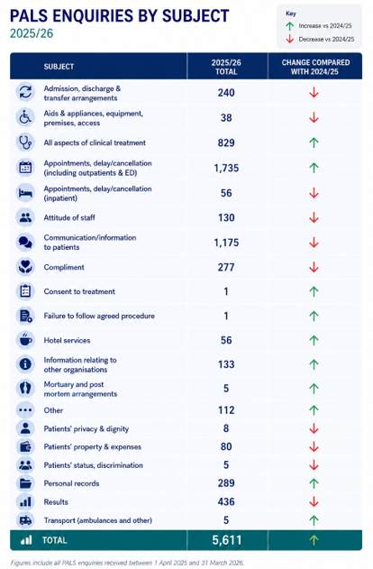

Complaints
During 2025/26, we received 337 formal complaints, compared to 333 complaints during 2024/25. Themes identified through complaints were consistent with PALS feedback and included:
- clinical care and treatment
- access to services and appointment delays
- communication with patients and families
- discharge planning and coordination
- dignity, comfort and patient experience.
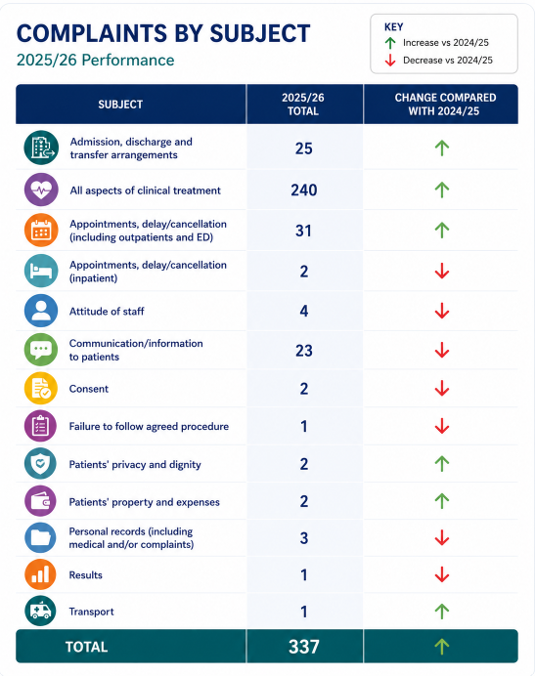

We recognise the importance of responding to concerns openly, compassionately, and promptly. Although complaints continued to be acknowledged within the required timescales, response times worsened over the year. At the yearend:
- All complaints (100 per cent) were acknowledged within three working days
- Response performance against the 40-working day target had declined during the year.
125 complaints remained open at year end, with approximately 50 per cent exceeding response timescales
This deterioration was associated with a combination of operational pressures, increasing complexity of complaints and changes to internal approval processes. We recognise the impact that delays in responding to complaints can have on patients, families and staff and acknowledge that further improvement is required in this area.

Improving patient experience and learning
We continue to review feedback from PALS, complaints, compliments, patient safety incidents, and mortality reviews collectively to identify themes and opportunities for improvement. This triangulated approach supports a broader understanding of patient experience and organisational learning.
Key areas of improvement identified during 2025/26 included:
- communication and engagement with patients and families
- discharge planning and coordination of care
- fundamental care, comfort and patient dignity
- End-of-life care and compassionate communication
- reducing incivility and improving staff behaviours and culture.
Improvement activity undertaken during the year included:
- strengthening communication with patients and families
- supporting more compassionate and person-centred care
- improving discharge planning and patient flow processes
- embedding “You Said, We Did” feedback and improvement approaches
- strengthening oversight and learning from complaints themes
- supporting behavioural and cultural improvement programmes to reduce incivility.
We also continued to make progress on our quality priority related to reducing incivility. During 2025/26, PALS concerns about staff attitude decreased for the second consecutive year. Although complaints about incivility remained above the stretch reduction target, we recognise the progress made and remain committed to continuing this work during 2026/27.
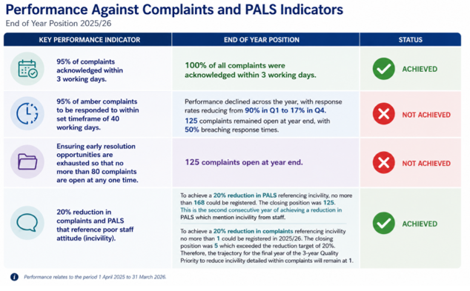

Parliamentary and Health Service Ombudsman (PHSO)
Between 1 April 2025 and 31 March 2026, the Parliamentary and Health Service Ombudsman (PHSO) referred 17 new cases for assessment. Of these, four progressed to formal investigation and remain ongoing at the time of reporting. During the year, six cases were closed with the following outcomes:
- four complaints were not upheld or required no further investigation
- one complaint was partly upheld
- one complaint was upheld
Sharing learning from PHSO cases across Care Groups and Divisions occurs through structured summaries and governance forums, including the Patient Experience Group, to enhance organisational learning and improvement.
Improving the timeliness and quality of complaint responses remains a key priority for 2026/27. Work is under way to strengthen complaints management processes, improve oversight and reduce delays, while ensuring patients and families receive compassionate, meaningful and transparent responses to concerns raised.

Volunteers
We are proud to recognise and celebrate the invaluable contribution of our volunteers, whose kindness, compassion, and dedication make a meaningful difference to patients, families, carers, and staff every day. Volunteers play a vital role in enhancing the patient experience, supporting wellbeing, and helping to create a welcoming and caring environment throughout the hospital.
During 2025/26, over 100 volunteers collectively dedicated more than 500 hours of support weekly across a diverse range of clinical and non-clinical services.
These include:
- wards and frailty services, including the Sheppey Frailty Unit
- meet-and-greet and wayfinding services
- chaplaincy and spiritual care support
- mealtime assistance and patient companionship
- maternity services
- emergency Department support
- pharmacy and therapy services
- gardening and wellbeing initiatives
- library trolley and patient engagement services.
We are also supported by 13 therapy dogs and their volunteer handlers, who offer comfort, reassurance and emotional support to patients attending hospital or receiving inpatient care. These visits continue to receive highly positive feedback from patients, families and staff, especially in helping to reduce anxiety and enhance wellbeing during periods of illness or treatment.



To ensure a safe and supportive environment for patients and staff, all volunteers undergo appropriate recruitment and onboarding processes, including enhanced DBS checks, occupational health clearance and satisfactory references before commencing their role.
Recruitment to the volunteer service remains ongoing, with continued focus on expanding opportunities for volunteers to support patient experience, wellbeing and community engagement across the organisation.

Part 2.1: Performance progress against our 2025/26 Quality Priorities

While some progress has been made across our 2025/26 Quality Priorities, we recognise that further improvement is required to ensure that changes are consistently embedded and translated into sustainable improvements in patient outcomes, safety and experience. We also recognise that some improvement programmes have progressed more slowly than planned due to ongoing operational pressures, workforce challenges and increasing patient complexity across the health and care system.

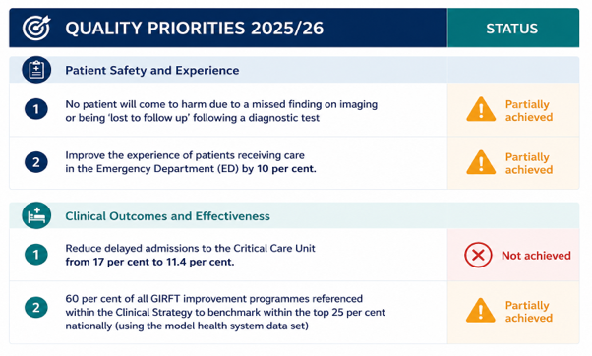

Priorities

No patient will come to harm due to a missed finding on imaging or being ‘lost to follow up following a diagnostic test.

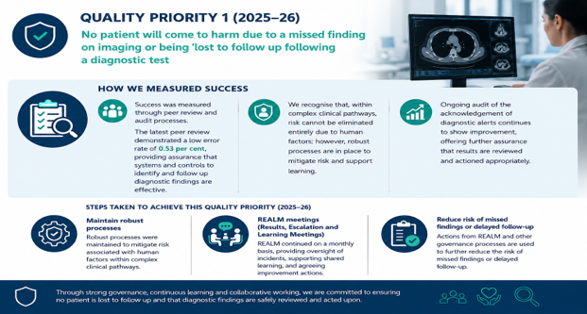

Improve the experience of patients receiving care by 10 percent.

Success was measured using the Friends and Family Test (FFT) recommend score for the Emergency Department, with a baseline of 72 per cent in 2024/25 and a target of 82 per cent in 2025/26. Performance was monitored through weekly and monthly FFT data. While the target was not achieved, some improvement was observed between January and April 2026 despite sustained operational pressures.

A range of targeted actions were implemented to improve patient experience. Communication and conflict resolution training was rolled out across ED and specialty teams to support more effective and compassionate interactions, with further embedding planned. Prolonged waiting times were identified as a key driver of dissatisfaction, and proposals were developed to improve real-time patient information, including digital display screens, subject to funding. Improvements to the care environment included increased seating capacity, reducing negative feedback, alongside visitor restrictions during peak periods to prioritise patient access. Work also continued to improve patient flow through optimisation of SDEC pathways, expansion of our Virtual Hospital and strengthened collaboration with system partners.

Despite these actions, performance remained below the planned trajectory, reflecting sustained demand, workforce and estate constraints, and ongoing challenges with patient flow and discharge delays. Patient feedback highlighted concerns around delays, communication about waiting times and expectations, and aspects of comfort and environment. However, incremental improvement towards the end of the year indicates early positive impact.

In response, actions continue to focus on improving communication and real-time updates, increasing leadership visibility, and strengthening patient flow to reduce waiting times and overcrowding. Delivery of this priority will continue into 2026/27 with a focus on measurable improvement, monitored through FFT, patient feedback, complaints and operational performance data.

Reduce delayed admissions to the Critical Care Unit from 17 per cent to 11.4 per cent.
Critical Care performance data shows that, historically, delays in admission to the unit exceeding four hours have been relatively rare; however, current performance indicates a sustained rise, with delayed admissions now occurring more frequently than expected when compared to similar units.

Conversely, delays in discharge from Critical Care exceeding four hours remain substantially higher, with persistent variation throughout the reporting period and a notable peak of over 60 per cent. This discrepancy underscores ongoing system-wide challenges in patient flow, especially regarding the availability of appropriate ward beds and timely transfer arrangements. Delayed discharges reduce Critical Care capacity to respond to acute demand and add to broader hospital pressures. Addressing this remains a key quality priority, demanding ongoing focus on whole-system flow, collaborative working with specialty teams, and enhanced escalation and discharge planning to ensure safe and timely transfers of care.
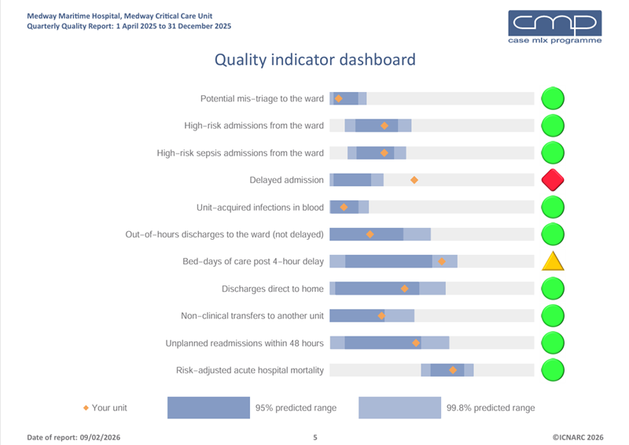
Figure 1

The quality indicator dashboard (Figure 1) shows how the Critical Care Unit is performing across a range of nationally benchmarked indicators compared with expected ranges. Most measures, including mis‑triage, high‑risk admissions, unit‑acquired infections, readmissions, and risk‑adjusted mortality, are within expected limits and rated green, indicating safe and effective care. However, delayed admissions are flagged red, demonstrating worse‑than‑expected performance, while bed‑days of care following a four‑hour delay are rated amber, highlighting ongoing patient flow pressures. Overall, the unit continues to deliver safe care, but access to and flow through Critical Care remain key areas for improvement.
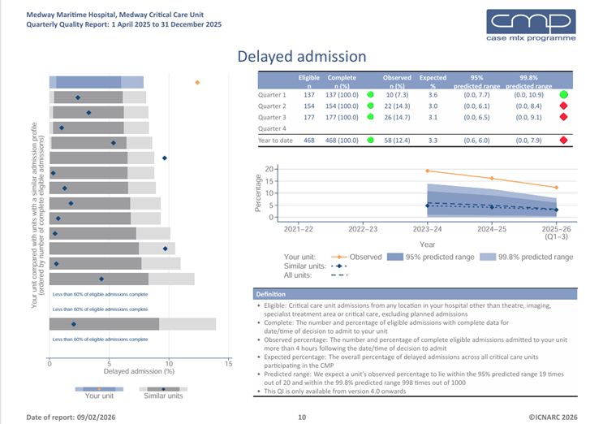
Figure 2

The delayed admissions analysis (Figure 2) shows that admissions to Critical Care delayed by more than four hours are occurring more frequently than expected when benchmarked against similar units. Year to date, 12.4 per cent of eligible admissions were delayed, compared with an expected rate of approximately 3.3 per cent, placing the unit outside both the 95 per cent and 99.8 per cent predicted ranges. While there is evidence of gradual improvement over time, performance remains worse than peer units, indicating persistent pressures related to Critical Care capacity and wider hospital flow rather than isolated or short‑term variation. Overall, these findings highlight the need for sustained improvement in patient flow and system capacity to reduce delays and associated risks to patient safety.
Quarter one demonstrated notable improvement; however, performance deteriorated in Quarters three and four in line with winter pressures. This correlates with increased delayed discharges, unjustified discharges home, and a rise in non‑clinical transfers to other Critical Care units, reflecting escalating hospital‑wide flow pressures.

50 per cent of all Get it Right First Time (GIRFT) improvement programmes referenced within the Clinical Strategy to benchmark within the top 25 per cent nationally (using the model health system data set)
During 2025/26, we have continued to progress our GIRFT improvement programme, focusing on reducing unwarranted variation and strengthening the quality, safety and efficiency of clinical pathways.
A more coordinated, organisation-wide approach has been adopted, recognising that improvement is best achieved through consistent pathway design and delivery across specialties.

Trust-wide improvement focus
Improvement activity has focused on:
- reducing length of stay to support safer patient flow
- increasing SDEC and day-case pathways
- improving access to diagnostics to enable timely decision-making
- strengthening pathway standardisation and redesign
- improving the balance between productivity and quality.

Impact and progress
- Increased use of ambulatory and same-day pathways
- Improvements in pathway design supporting reduced length of stay in some areas
- Expanded use of diagnostics and virtual care models.
However, variation remains, reflecting differences in pathway maturity, workforce capacity and operational pressures.

Ongoing challenges
Delivery continues to be influenced by:
- diagnostic capacity and turnaround times
- workforce constraints
- sustained operational pressures, particularly within urgent care.
These factors present ongoing challenges to the consistent delivery of high-quality care.

Approach going forward
We will continue to strengthen our organisation-wide approach, focusing on:
- consistent use of benchmarking data to reduce unwarranted variation
- alignment to Clinical Strategy, Quality Priorities and principal risks
- delivery of coordinated improvement across specialties.

Further information
Further detail on specialty-level benchmarking and improvement activity is provided in Annex 3.

Part 2.2: Looking forward

Delivering our Quality Priorities for 2026/27
We acknowledge that, although significant progress has been made during 2025/26, further improvements are necessary to ensure that changes are consistently embedded, measurable, and translated into lasting enhancements in patient safety, outcomes, and experience.
In 2026/27, we will enhance delivery through a more targeted, coordinated, and improvement-focused approach, ensuring that quality improvement activities are fully aligned with our Clinical Quality Governance Framework, Improvement Plan, and key risks outlined in the Board Assurance Framework (BAF).
This method will facilitate clearer prioritisation, stronger oversight, and improved organisational focus on the areas of greatest risk and potential for improvement, while ensuring that learning translates into meaningful and sustainable change for patients and staff.
The quality of care we deliver, as well as the safety and experience of our patients, continue to be our top priorities. We recognise that excellent care is achieved through the skill, compassion, innovation, and dedication of our staff, and we remain devoted to fostering an environment where colleagues feel valued, supported, and empowered to drive improvement.

Our Quality Priorities for 2026/27
Our Quality Priorities for 2026/27 build on the progress and learning from 2025/26 and form part of a long-term strategy to transform how care is delivered across the Trust. The priorities are aligned with our Improvement Plan and Clinical Quality Governance Framework, ensuring that improvement efforts are coordinated, measurable, and focused on delivering sustained enhancements.

Governance, accountability and assurance
Delivery of the 2026/27 Quality Priorities will be supported through strengthened executive and divisional accountability arrangements, enhanced audit and assurance processes, and improved use of triangulated data and intelligence to support decision-making and oversight.
We will continue to strengthen our ward to board governance model, ensuring that risks, concerns and learning identified at frontline level are translated into timely action, meaningful assurance and sustainable improvement across the organisation.
Each Quality Priority will therefore include:
- clearly defined improvement aims and measures
- outcome, process and balancing metrics
- named executive and divisional accountability
- embedded ward to board assurance arrangements
- oversight through established governance structures, including:
  - Divisional Quality and Safety Subcommittees
  - Patient Safety and Harm Prevention Subcommittee
  - Quality Assurance Committee
  - Trust Board.
Each priority will also be:
- data driven
- risk aligned
- outcome focused
- governance led
- clinically owned and operationally delivered.

Quality Priority 1
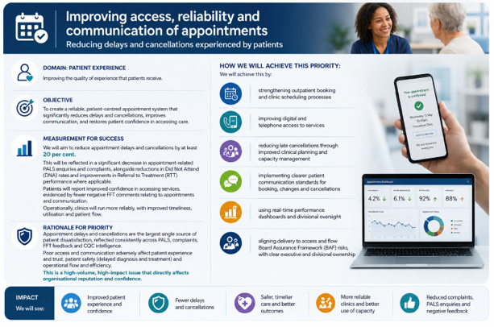

Quality Priority 2
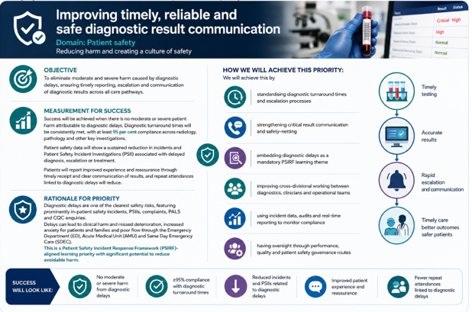

Quality Priority 3
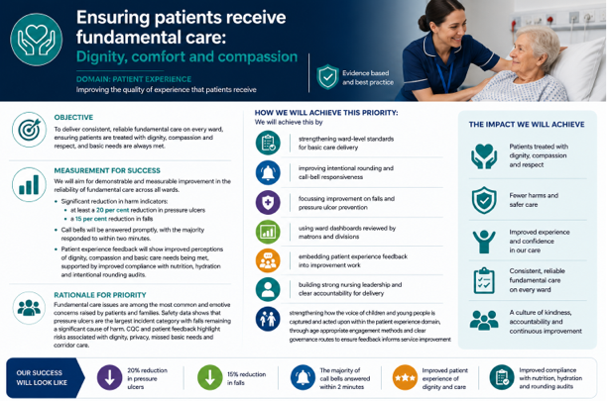

Quality Priority 4
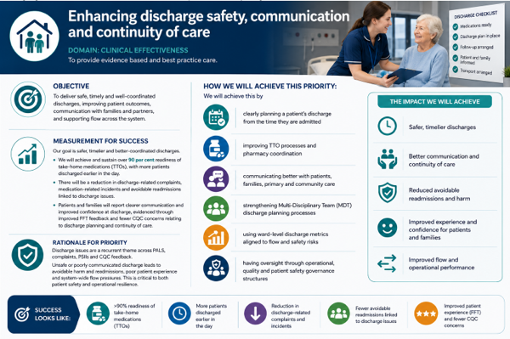

The priorities have been informed through a wide range of intelligence sources, including:
- staff feedback and engagement
- patient safety incidents and PSIRF learning
- complaints, PALS and FFT feedback
- mortality review and learning from deaths
- national benchmarking and GIRFT intelligence
- CQC findings and quality statements
- workforce, operational and patient flow intelligence
- wider system priorities across Kent and Medway.

The priorities are also aligned to our principal organisational risks, particularly those relating to:
- urgent and emergency care pressures
- patient flow and discharge delays
- patient safety and harm prevention
- workforce and culture
- clinical quality and governance
- system capacity and operational resilience.

This ensures that improvement activity is targeted towards the areas that present the greatest risk to patient outcomes, safety and experience.

Key areas of focus during 2026/27
During 2026/27, we will focus on a number of key improvement programmes and quality priorities, including:
- strengthening diagnostic safety and learning through further development of PSIRF
- embedding EM5 best practice standards to improve the care and experience of patients experiencing delays within urgent and emergency care pathways
- continuing work to reduce the use of non-designated clinical areas
- strengthening patient flow, frailty pathways and discharge coordination across acute and community services
- further developing Critical Care, deteriorating patient and escalation pathways
- strengthening mortality improvement, learning from deaths and clinically led improvement programmes
- refocusing GIRFT programmes on key priorities with measurable impact on quality, productivity and outcomes
- embedding compassionate leadership, cultural improvement and staff wellbeing initiatives
- strengthening the connection between learning, governance and improvement delivery.

Strengthening PSIRF and organisational learning
A major focus during 2026/27 will be on strengthening the implementation of the PSIRF. We recognise that PSIRF remains both a key organisational priority and a significant area of risk requiring sustained leadership attention and organisational focus.
During 2026/27, we will prioritise:
- embedding a clinically led, system-focused PSIRF model
- strengthening the connection between learning and measurable improvement delivery
- improving staff confidence, engagement and psychological safety
- increasing clinical ownership of patient safety learning
- ensuring learning is consistently translated into Trust-wide improvement actions
- strengthening transparency, multidisciplinary involvement and governance oversight
- building capability in systems-based learning, human factors and quality improvement methodologies.
Through this approach, we aim to move beyond implementation towards effective, high-impact delivery of PSIRF, ensuring that learning from patient safety incidents results in meaningful and sustained improvements in care.

Our commitment
We remain committed to ensuring that learning from 2025/26 is translated into measurable and sustained improvement during 2026/27. Through our 2026/2027 Quality Priorities, we will continue to focus on delivering care that is safe, effective, responsive, compassionate and person-centred for the communities we serve.
We recognise that sustainable improvement requires strong leadership, engaged staff, effective governance and a culture where learning, openness and continuous improvement are embedded at every level of the organisation. Through this approach, we aim to strengthen quality, improve patient outcomes and experience, and continue our journey towards delivering consistently high-quality care across Medway and Swale.

Part 3: Other key dimensions of quality

Reporting to Secondary Users Service
High quality data is essential to understanding the needs of our population, planning services, monitoring performance, and improving outcomes. The Secondary Uses Service (SUS) provides anonymised patient-level data for purposes beyond direct clinical care, including healthcare planning, commissioning, public health, clinical audit, research, and national policy development. Ensuring the accuracy and completeness of our submissions is therefore a critical part of our responsibility as a provider of NHS services.
Throughout 2025/26, we submitted activity records to SUS for inclusion in the national Hospital Episode Statistics (HES). These submissions have been incorporated into the latest published datasets, supporting national benchmarking and system-wide analysis.

Data Quality: NHS number completeness
The percentage of published records containing a valid NHS number was:
- Admitted patient care: 99.9 per cent
- Outpatient care: 100 per cent
- Accident and emergency care: 99.5 per cent
These results demonstrate consistently high levels of data completeness, ensuring that patient activity can be accurately linked across services and care pathways.

Data Quality: GP practice code completeness
The percentage of published records containing a valid General Medical Practice (GMP) code was:
- Admitted Patient Care: 99.4 per cent
- Outpatient Care: 99.4 per cent
- Accident and Emergency Care: 98.8 per cent
Accurate GMP coding supports effective communication with primary care, strengthens continuity of care, and enables more reliable population-level analysis.

Our Commitment to High-Quality Data
Maintaining strong data quality performance is essential to ensuring that the information used for planning, commissioning, and national reporting is robust and reliable. These results reflect the sustained efforts of clinical, administrative, and information teams across the Trust to ensure that patient records are complete, accurate, and submitted in line with national standards.
As we continue to strengthen our digital infrastructure and move towards a fully integrated EPR, we expect further improvements in data quality, consistency, and timeliness. This will support better clinical decision-making, enhance patient safety, and contribute to a more accurate understanding of healthcare needs across Medway and Swale.

Data Security and Protection Toolkit
Protecting the confidentiality, integrity, and availability of patient and staff information is fundamental to delivering safe, high quality care. The Data Security and Protection Toolkit (DSPT) provides the national framework through which NHS organisations demonstrate compliance with data security standards and assess their resilience against cyber threats. The updated toolkit is aligned to the National Cyber Security Centre’s Cyber Assessment Framework (CAF), ensuring that our approach reflects national best practice.
Each year, we undergo an independent audit of our DSPT submission, assessing performance against 12 auditable outcomes. The audit for the 2025/2026 cycle is currently under way (March to April 2026).
Last year, we achieved an Amber/Green rating, with auditors providing ’significant assurance with minor improvement opportunities’. This reflected a notable strengthening of our evidence base compared with previous years. We achieved ‘Standards Met’ in our full DSPT submission, maintaining the level achieved in 2023/2024 and improving on the 2022/2023 rating of ‘Approaching Standards’.
Our interim assessment, submitted in December 2025 and accompanied by the mapped essential functions scope, again achieved ‘Standards Met’. This demonstrates sustained progress in embedding robust data security practices across the organisation.
For the final submission, covering all 47 DSPT outcomes, we are working towards achieving a High Confidence audit rating, providing assurance that our evidence is comprehensive, reliable, and aligned with national expectations. The full submission is scheduled for 30 June 2026.
We continue to strengthen our cyber security position and information governance arrangements through:
- enhanced monitoring and assurance processes
- improved documentation and evidence capture
- strengthened collaboration between digital, clinical, and operational teams
- ongoing investment in staff training and awareness
- alignment with national cyber security guidance and Cyber Assessment Framework (CAF) requirements.
These improvements support our wider ambition to build a digitally mature, resilient organisation capable of protecting sensitive information while enabling safe, effective, and efficient care.

Confidentiality and information security
Protecting the confidentiality, integrity, and security of information relating to our patients, staff, and partners is fundamental to delivering safe, high-quality care. Our Information Governance (IG) Strategy and Framework set out the legal, regulatory, and policy requirements that underpin our approach, ensuring that information is handled responsibly, securely, and in line with national standards.
As the organisation continues to transition from paper-based systems to a more digitally enabled environment, we recognise that the volume and complexity of personal information held electronically is increasing. While this brings significant benefits for patient care and operational efficiency, it also requires robust safeguards to prevent data breaches and ensure that information is used appropriately.
Despite strong controls, data security incidents can occur in large and complex NHS organisations. When they do, we follow a rigorous process to investigate, assess, and learn from each incident. All incidents involving the loss, unauthorised disclosure, or potential compromise of personal data are investigated in line with our information governance breaches and incident management policies.
Incidents are assessed using the NHS Digital Guide to the Notification of Data Security and Protection Incidents, which considers both the severity of the breach and the likelihood of harm to individuals. Where an incident is assessed as high risk, it is reported to the Information Commissioner’s Office (ICO) and the Department of Health and Social Care (DHSC) via the Data Security and Protection Toolkit within 72 hours.
We actively encourage staff to report all suspected data protection or cyber incidents, including near-misses. This supports a culture of openness, early identification of risks, and continuous learning.
During 2025/26, we reported three incidents to the ICO, compared with two in the previous year. This increase reflects an improvement in reporting culture rather than a deterioration in data protection practices. All incidents were subsequently closed by the ICO with no further action required. In each case, we implemented appropriate mitigation measures and strengthened relevant policies or processes to prevent recurrence.
To further enhance our information governance arrangements and reduce the likelihood of future incidents, we have taken the following actions:
- Reviewing IG policies and procedures to ensure they reflect the needs of different departments and remain aligned with evolving legislation and national guidance.
- Delivering comprehensive quality assurance and spot checks across departments to ensure compliance with data protection requirements.
- Providing targeted training, including e-learning modules and bespoke sessions on data security, information asset management, confidentiality, and the National Data Opt-Out.
- Strengthening monitoring of departmental action plans, Data Protection Impact Assessments (DPIAs), and audit recommendations through the Information Governance Group (IGG).
- Enhancing the annual review of Information Assets and Flows Registers (IAFR) to ensure compliance with the UK General Data Protection Regulation (GDPR) Record of Processing Activity (ROPA) requirements.
- Running regular staff awareness campaigns, supported by the Communications and Engagement Team, to reinforce key messages and address areas of non-compliance.
We remain committed to maintaining the highest standards of confidentiality and information security. By strengthening our governance arrangements, investing in staff training, and fostering a culture of transparency and learning, we aim to ensure that personal information is handled safely, responsibly, and in a way that supports high-quality care.

Freedom of Information)
We remain committed to openness, transparency, and accountability in the way we manage and share information. Responding effectively to Freedom of Information (FOI) requests is an important part of this commitment, ensuring that members of the public, patients, staff, and partner organisations can access information about how we operate and how decisions are made.
The FOI Act is regulated and enforced by the ICO, which has the authority to issue penalties, including monetary fines, where organisations fail to comply with statutory requirements. Ensuring timely and accurate responses is therefore essential to maintaining public trust and meeting our legal obligations.
During 2025/26 we received 738 FOI requests, with 92 per cent responded to within the statutory 20-working-day timeframe. This represents a significant improvement compared with the previous year.
In 2024/25 we received 843 requests, with an annual compliance rate of 66 per cent, which was assessed as Unsatisfactory. The improvement to 92 per cent compliance in 2025/26 reflects strengthened internal processes, clearer escalation pathways, and enhanced oversight from senior management.
Despite ongoing operational pressures across the organisation, several targeted actions contributed to the improved performance:
- strengthened FOI processes and workflows, ensuring requests are logged, tracked, and responded to more efficiently
- awareness campaigns and policy updates, helping staff understand their responsibilities and the importance of timely responses
- improved escalation mechanisms, enabling earlier intervention where delays were identified
- enhanced oversight from senior leaders, ensuring FOI performance remains a visible organisational priority.
We remain committed to maintaining high standards of transparency and public accountability. We will continue to strengthen our FOI processes, support staff in meeting statutory requirements, and ensure that information is shared responsibly, accurately, and in a way that supports public confidence in our services.

Clinical coding
Accurate clinical coding is essential to ensuring that the care we provide is correctly reflected in national datasets, supports high quality reporting, and enables effective planning, benchmarking, and financial assurance. Each year, we undertake an external clinical coding audit to assess how reliably our coded data represents the diagnoses and procedures documented in patients’ records.
Measure | 2025/26 | 2024/25
Primary diagnosis | 90% | 90%
Secondary diagnosis | 89% | 85%
Primary procedure | 92% | 97%
Secondary procedure | 87% | 89%

The 2025/26 audit confirms that we have met all attainment level requirements set out in the Data Security and Protection Toolkit. This reflects sustained progress in coding accuracy and demonstrates the commitment of our clinical coding teams to maintaining high standards despite ongoing operational pressures.

Summary of the Clinical Coding Data Security and Protection Toolkit Audit Report 2025/26
The external audit found that we continue to meet national standards for coding accuracy across both diagnoses and procedures. While overall performance remains strong, the review highlighted two key risks that can affect coding reliability: workforce capacity and variation in the quality of clinical documentation. These factors can increase the likelihood of coding delays or errors.
To address this, we are strengthening documentation quality, expanding coding capacity, and enhancing internal audit and feedback processes. These actions will help ensure that the data used for patient care, safety monitoring, and statutory reporting remains accurate, reliable, and reflective of the care delivered.

Digital safety and clinical risk management
Digital systems are now central to how we deliver safe, effective, and coordinated care. As we progress with the implementation of the EPR and wider digital transformation, we recognise that digital innovation brings significant opportunities for improvement but also introduces new risks that must be carefully managed.

Why digital safety matters
Digital safety is directly linked to patient safety. If digital systems are not designed, implemented, or used safely, they can affect clinical decision-making, continuity of care, and the overall patient experience. Potential risks include:
- delays or errors in clinical decision-making due to system design or usability issues
- gaps in communication between clinical systems or partner organisations
- medication safety risks associated with electronic prescribing (EPMA)
- loss of access to essential information during system downtime or outages.
For this reason, digital safety is embedded within our wider clinical risk management and patient safety framework, rather than treated as a stand-alone technical function.

How we manage digital safety
We have established a Clinical Risk Management System (CRMS) for all digital programmes. This provides a structured, nationally aligned approach to identifying, assessing, and managing risks associated with healthcare IT systems. Through this framework, we ensure that digital systems are:
- designed and implemented safely
- subject to formal clinical risk assessment before deployment
- monitored and improved throughout their life cycle.

Governance and accountability
Digital safety is overseen through robust governance arrangements, including:
- the Digital Data and Technology (DDAT) Board, reporting to Executive leadership and the Trust Board
- the Clinical Safety Officer (CSO) framework, providing clinical leadership and assurance
- integration of digital safety oversight within patient safety and quality governance structures.

Clinical risk management approach
All digital systems follow a consistent risk management process, which includes:
- formal hazard identification workshops
- ongoing risk assessment, evaluation, and control
- use of hazard logs to track and manage risks
- development of clinical safety cases and safety case reports to support safe implementation and ongoing use.

Assurance and compliance
We ensure that digital systems meet national safety standards by:
- adhering to DCB0129 and DCB0160 clinical safety standards
- undertaking internal and supplier audits
- integrating digital risks within our Corporate Risk Management Framework.

Supporting safe digital care
As part of our digital transformation, we are strengthening several key areas:
- EPR safety: structured clinical engagement, rigorous testing, and formal safety sign-off
- EPMA safety: monitoring medication-related risks and improving prescribing and administration processes
- Inter-operability: improving safe, timely information sharing across systems and partners
- Downtime and resilience planning: ensuring clear processes to maintain safe care during outages
- Incident management: reporting and managing digital safety incidents through Datix, aligned with wider patient safety processes.

Workforce capability and learning
Safe digital care relies on a well-trained and confident workforce. Staff involved in digital systems:
- receive appropriate clinical safety training
- have clearly defined roles and responsibilities
- maintain competency through ongoing development and appraisal.

Continuous improvement
As a learning organisation, we are committed to using incident data, audits, and staff feedback to strengthen digital safety. We are also enhancing the connection between digital safety, clinical outcomes, and patient experience, ensuring that digital risk management is embedded within our broader quality improvement approach.

Our commitment
We remain committed to delivering digital transformation that is safe, reliable, and clinically effective. This means:
- identifying risks early and managing them consistently
- ensuring digital systems support safe, high quality care
- using learning from digital incidents to drive measurable improvement.
Digital safety is a critical component of our ambition to deliver outstanding care and to build a culture of continuous learning and improvement.

Annex 1: Statements from commissioners, Local Healthwatch organisations and Overview and Scrutiny Committees

Statement from the Lead Governor on the Quality Account
As Lead Governor, I am pleased to present this statement on behalf of the Council of Governors regarding the Trust’s Quality Account for the reporting year 2025/2026. Throughout the year, the Council of Governors (COG) has continued to uphold and develop its statutory duties by representing the interests of members, patients, and the wider public through attendance at various events both in person and via other communication channels. The Governors hold the Non-Executive Directors (NEDs) to account for the performance of the Board.
Governors receive regular reports on quality, patient safety, and organisational performance through formal COG meetings and committees that Governors regularly attend. Their engagement aims to understand the implications of policies and to ensure the voice of the community they represent is heard through policy development and any proposed changes.
The Quality Account demonstrates the Trust’s commitment to transparency and ongoing improvement, in line with the governance standards and regulatory expectations outlined in the Annual Report and Accounts, which are overseen by the Board. These standards highlight transparency, integrity, and openness.
Progress has been made towards our Quality Priorities, with a continuous focus on enhancing patient outcomes, experience, and safety through the introduction of improvements and changes.
The Quality Account highlights notable achievements. The Governors recognise areas of positive improvement but also acknowledge areas where further progress is needed. The Trust has faced challenges and changes during the year, including those in finance, staff leadership, government funding, and other areas. The Governors will continue to seek assurance from the Board and NEDs on the actions being taken to address these issues.
Governors wish to praise and thank all staff for their hard work in continually striving to improve the delivery of safe and compassionate care amid the current climate of significant challenge and change.
The COG endorses the publication of this Quality Account and remains committed to collaborating with all parties to continually improve services for those in need.

Martina Rowe
Lead Governor

Statement from Kent and Medway Integrated Care Board (ICB)

We welcome the Quality Account for Medway NHS Foundation Trust for 2025/2026. Kent and Medway Integrated Care Board (ICB) confirms that this Quality Account has been produced in line with national requirements and includes the key elements expected within a Quality Account, including a clear statement on quality, priorities for improvement, performance against core indicators, and supporting assurance.
The Quality Account provides a comprehensive and transparent overview of the quality of care delivered by the Trust over the reporting period. It demonstrates a strong organisational commitment to improving patient safety, clinical effectiveness, and patient experience, with a clear narrative describing both achievements and ongoing challenges. The report is well structured and evidences a mature approach to quality governance, with a clear ward to board framework and strengthened triangulation of quality intelligence.
We recognise the progress made against the Trust’s 2025/2026 quality priorities. In particular, we acknowledge improvements in diagnostic performance, including increased access and reduced waiting times, and continued development of community diagnostic services. We also note progress in strengthening urgent and emergency care pathways, improving patient flow, and expanding virtual ward provision to support care closer to home.
The Trust has also demonstrated progress in embedding a stronger patient safety culture through implementation of the PSIRF, alongside improvements in governance, incident learning, and oversight arrangements. In addition, improvements in patient experience measures, including sustained increases in FFT scores and reductions in concerns related to staff attitude, are welcomed.
However, we note that some priorities have been only partially achieved, with continued challenges in areas such as ED pressures, patient flow, and delays to critical care. We also recognise that variation in performance across clinical pathways remains, particularly in relation to national benchmarking and GIRFT metrics. The Trust has been transparent in acknowledging these areas and has demonstrated a clear understanding of the underlying causes.
We are encouraged by the Trust’s priorities for 2026/2027, which are appropriately aligned to these areas of risk and focus on strengthening diagnostic safety, improving urgent and emergency care experience, reducing harm, enhancing patient flow, and embedding organisational learning. The continued focus on PSIRF, mortality improvement, governance strengthening, and cultural transformation is particularly welcomed.
We also recognise and commend the Trust’s continued engagement with system partners through Provider Quality Meetings and system-wide improvement programmes, including urgent and emergency care oversight arrangements. This collaborative approach will be critical in delivering sustainable improvement.
The ICB will continue to work with the Trust through established governance and assurance mechanisms to monitor progress against these priorities during 2026/2027. We thank you and your staff for your continued dedication and commitment to improving the quality of care for patients across Medway and Swale, particularly in the context of ongoing operational and system pressures.
Yours sincerely

Ian Brandon
Associate Director of Quality and Safety
NHS Kent and Medway ICB
19 June 2026





Statement from Medway Healthwatch

Healthwatch Medway response to the
Medway NHS Foundation Trust Quality Account 2025/26

Healthwatch Medway is the independent champion for the views of patients and social care users in Medway. Supported by our host organisation EK360, our role is to help the public get the best out of their local Health and Social Care services.
For over 10 years now, local Healthwatch across the country have been asked to read, digest and comment on the Quality Accounts which are produced by every NHS Provider (excluding primary care and Continuing Healthcare providers).
We’d like to take this opportunity to recognise the positive working relationship we have developed with the Trust over the past year. We are grateful to the patient experience team for working with Healthwatch Medway to gather feedback from people using Medway NHS Foundation Trust services, insights from which are presented at the Patient Experience Group on a quarterly basis. This collaborative work evidences the commitment to improving healthcare accessibility, engagement and support for diverse communities.
We would like to encourage Medway NHS Foundation Trust to continue improving services through lived experience gathered both internally and through external partnerships.
Quality Account
- Healthwatch Medway recognises the key achievements made by the Trust this year but acknowledges some priorities from last year have not been achieved fully.
- Healthwatch Medway recognises the benefits of expanding the Trust’s Virtual Hospital service. The positive feedback included in the Quality Account reflects some of the themes we hear from local people. As the service continues to expand, we would welcome the opportunity to engage directly with people being cared for on the virtual ward to enable to Trust to develop the service to respond to the needs of local people.
- The Quality Account states that listening to and responding to patient feedback remains essential for the Trust. We would be happy to provide independent expertise to the Trust to help deliver on this.

Healthwatch Medway June 2026

Statement from Medway Council’s Health and Adult Social Care Overview and Scrutiny Committee

Medway Council welcomes the opportunity to comment on Medway NHS Foundation Trust’s Quality Account for 2025/2026.

Medway Council recognises the considerable pressures under which the Trust has been operating over the past year, including the sustained demand on urgent and emergency care, increasing patient complexity, workforce shortages and financial constraints. We would like to recognise the work undertaken by the Trust to improve patient care and service performance in this context.

Medway Council commends the considerable improvement in Patient-Led Assessments of the Care Environment (PLACE) results across all domains, noting that the Trust’s national ranking has improved by 116 places to 3rd since 2024. This improvement reflects significant progress in the quality of the environment in which care is provided and demonstrates the tangible impact of the Trust’s targeted PLACE improvement programme.

The Council also notes the positive progress made in diagnostic wait times, with a marked increase in the proportion of patients receiving diagnostic tests within six weeks compared to 2024/2025.

Notwithstanding this progress, Medway Council notes that the Trust received a Care Quality Commission (CQC) rating of ‘Requires Improvement’ across all domains in November 2025. Of particular concern is the deterioration in the ‘Caring’ domain from ‘Good’ since the previous inspection of ED. We would welcome further analysis of the factors contributing to this change, and a clearer explanation of the underlying issues, alongside defined and targeted actions that will lead to measurable improvement.

In reviewing the Trust’s performance against its quality priorities for 2025/2026, Medway Council acknowledges the work undertaken, while noting that none of the priorities have been fully achieved. The report would benefit from a clearer assessment of the barriers to delivery and, importantly, a more detailed articulation of how these priorities will be progressed into 2026/2027, including specific actions and intended outcomes. Specifically, there is limited detail provided regarding Quality Priority 2, which sets out to improve the experience of patients receiving care in the Emergency Department by 10%, as measured through the Friends and Family Test (FFT). While the Trust’s overall FFT performance has remained stable since 2024/2025, the target of 82% positive FFT feedback within the Emergency Department has not been met. At the time of review, the Quality Account does not provide a dedicated assessment of this shortfall. Medway Council would welcome greater transparency in this area, including the provision of more detailed FFT feedback from patients and families, and clarity around how feedback themes are being used to inform targeted improvements.

Medway Council recognises that the priorities identified for 2026/2027 reflect important areas of focus and looks forward to observing the Trust’s progress. One area that we would like to see improvement is communication to patients regarding what they can expect in terms of service levels – poor communication is a common cause of complaints and improving communication will lead to fewer complaints, a better experience for patients and reduction in time and money being wasted.

To strengthen future Quality Accounts, we would encourage the Trust to provide greater specificity regarding the delivery of these priorities, including clearer articulation of actions, milestones and measures of success.

In terms of leadership, Medway Council has been pleased with the engagement of the senior leadership in the Health and Wellbeing Board (HWB) and the Health and Adult Social Care Overview and Scrutiny Committee (HASC), as it is important that all parts of the system work well together to improve health and wellbeing. We hope that this will continue following the appointment of Mark Orchard as Chief Executive of the Trust. There has been some uncertainty regarding the longer-term model of leadership and Medway Council would welcome clarity on this.

Statement of adjustment following receipt of written statements required by section 5 (1) (D) of the National Health Service (Quality Account) Regulations 2010

In response to the feedback received from Medway Council’s HASC, the Trust welcomes the feedback received and remains committed to continuous improvement and strengthening both service delivery and future reporting.

The feedback has been fully considered and will inform:

the development of the 2026/27 Quality Account with a focus on enhanced analysis, transparency and alignment between feedback and improvement actions

ongoing improvement programmes, particularly in relation to patient experience, communication and urgent and emergency care

Annex 2: Statement of Directors responsible for the Quality Report

The Directors are required, under the Health Act 2009, the National Health Service (Quality Accounts) Regulations 2010, and subsequent amendments, to prepare a Quality Account for each financial year.
NHS England has provided guidance on the format and content of Quality Accounts, including the requirements outlined in the NHS Foundation Trust Annual Reporting Manual 2025/26 and related guidance for preparing Quality Reports. The Directors are accountable for ensuring that the Quality Report offers a fair, balanced, and precise account of the quality of services delivered by the Trust during the reporting period.
In preparing the Quality Report, the Directors must take all reasonable steps to ensure that they are satisfied that:
- The content of the Quality Report complies with the requirements outlined in the NHS Foundation Trust Annual Reporting Manual 2025/26 and the supporting guidance for Quality Reports 2025/26.
- The information contained within the Quality Report is consistent with other sources of information available to the Trust, including:
  - Board and Committee papers and minutes for the period April 2025 to March 2026
  - quality, safety and performance reports presented to the Board and its subcommittees during the year
  - feedback received from commissioners, regulators and external stakeholders
  - feedback from patients, carers, staff, governors and local authority scrutiny arrangements
  - the Trust’s complaints and PALS reports
  - national patient survey results
  - national NHS staff survey results
  - CQC inspection findings and regulatory feedback
- The Quality Report provides a balanced overview of the Trust’s performance, accurately highlighting areas of achievement, challenge, and ongoing improvement.
- The performance information included within the Quality Report is reliable, meaningful and properly validated.
- Appropriate internal controls and governance arrangements are in place to support the collection, monitoring, and reporting of quality performance information, and these arrangements are regularly reviewed to ensure they remain effective.
- The data underpinning quality indicators and performance measures is robust, subject to appropriate scrutiny and review, and prepared in accordance with recognised data quality standards and prescribed definitions
- The Quality Report has been prepared in accordance with the relevant statutory requirements, NHS England guidance, and the standards expected for the preparation of Quality Accounts and Quality Reports.

The Directors recognise the importance of transparency, openness, and accountability in reporting quality performance and are committed to ensuring that the Quality Report fosters learning, drives improvement, and boosts public confidence in the services provided by the Trust.

To the best of their knowledge and belief, the Directors confirm that they have complied with the above requirements in preparing this Quality Report and that the information contained within it is accurate, balanced and reflective of the Trust’s performance during 2025/26.

By order of the board:

John Goulston
Chair of Medway NHS Foundation Trust
Dated: June 2026

Annex 3: GIRFT benchmarking and specialty overview

Introduction
This annex provides a summary of specialty-level performance supporting Quality Priority 4: Reducing unwarranted variation through GIRFT benchmarking.
It complements the main report by providing additional context on how services are using benchmarking data to improve clinical pathways, reduce variation and improve patient outcomes, while maintaining a clear focus on Trust-wide themes, system improvement and overall impact.
Detailed specialty-level data is reviewed routinely through established governance structures and is available on request.

Overview of performance
During 2025/26, the Trust has continued to use GIRFT and Model Health System data to identify variation, improve pathway reliability and strengthen clinical outcomes.
Performance varies across specialties, reflecting differences in pathway maturity, workforce capacity and operational pressures. While progress has been made in a number of areas, further improvement is required to ensure consistent delivery of high‑quality care across all services.

Key themes across specialties
Analysis of specialty-level benchmarking highlights a number of consistent themes:
- Variation remains in areas such as length of stay, day-case rates and outpatient utilisation.
- Improvement has been achieved through pathway redesign, including increased use of Same Day Emergency Care (SDEC), patient-initiated follow-up (PIFU) and virtual care models.
- Diagnostic access and turnaround times are a key constraint across multiple pathways.
- Workforce capacity and operational pressures continue to influence performance and the pace of improvement.
- Clinical engagement and data quality are critical to ensuring benchmarking insights translate into measurable improvement.

Summary of improvement by specialty group

Urgent and emergency care
Improvement work has focused on reducing unnecessary admission and length of stay through pathway redesign and earlier clinical decision-making.
This includes the expansion of SDEC pathways, increased use of CDCs and wider use of virtual wards.
These actions have supported improved access to specialist assessment and reduced reliance on inpatient care. However, diagnostic delays and sustained demand remain key challenges, with implications for patient flow and timeliness of care.

Cardiology
Improvement activity has focused on reducing variation in outpatient pathways and improving clinic utilisation.
Key developments include increased use of PIFU, introduction of digital booking solutions, and an executive-led outpatient review.
While these actions have improved understanding of non-attendance and pathway variation, further work is required to improve day-case rates and reduce unwarranted variation across clinics.

Long-term conditions (including Diabetes, Respiratory and Rheumatology)
Across long-term condition pathways, improvement work has focused on reducing variation in readmissions, length of stay and outpatient management.
This has included improvements in clinical coding, benchmarking, ambulatory care pathways and discharge planning, alongside strengthened use of nurse-led services.
While progress has been made, variation in practice and workforce constraints continue to affect consistency, and further work is required to embed best practice across all services.

Paediatric surgery
Improvement activity has focused on the appropriate use of pathways such as PIFU and improving pathway consistency.
Strong adoption of PIFU has been achieved where clinically appropriate, supported by patient education and ongoing monitoring.
Performance continues to be influenced by clinical complexity and the limitations of certain models within surgical care, alongside data and coding challenges which are being addressed.

Surgical specialties (Orthopaedics and Urology)
Improvement programmes have focused on pathway redesign, increasing day-case rates and reducing length of stay.
This includes the implementation of structured improvement approaches, enhanced patient preparation and expanded use of day-case surgery.
These actions have contributed to measurable improvements in length of stay and efficiency, although performance continues to be influenced by wider system pressures and case complexity.

Key constraints and risks
Across specialties, a number of common factors continue to influence performance:
- diagnostic capacity and turnaround times
- workforce availability and specialist expertise
- operational pressures, particularly patient flow
- clinical complexity and case mix.
These factors represent ongoing constraints and pose a risk to consistent delivery of high‑quality, timely care if not addressed.

Next steps in 2026/27
During 2026/27, the Trust will continue to:
- embed and expand SDEC, PIFU and virtual hospital
- strengthen pathway standardisation to reduce unwarranted variation
- improve diagnostic access and turnaround times
- enhance clinical leadership and ownership of improvement
- use benchmarking data more consistently to drive measurable and sustained improvement.

Conclusion
Reducing unwarranted variation remains a key component of improving quality, safety and efficiency.
The Trust has established a structured, clinically led approach to improvement across specialties. Further work is required to ensure consistency and sustain progress, with continued focus on translating benchmarking data into meaningful improvements in patient care and outcomes.

Annex 4: National and local clinical audit participation

Example of actions to improve quality of healthcare – National clinical audits

The National Oesophago-Gastric Cancer Audit
The National Oesophago-Gastric Cancer Audit (NOGCA) shows the Trust is performing above the national average in key quality measures, including stage-at-diagnosis completeness, performance status recording, and provision of Clinical Nurse Specialist (CNS) support. The data highlights that although the Trust performs strongly, opportunities remain to further reduce emergency presentations and late-stage diagnoses, shorten the time from referral to first treatment especially the proportion waiting over 62 days and strengthen access to CNS support for all patients. Lessons learnt from the audit emphasise the importance of early detection, timely treatment pathways, optimising curative treatment outcomes, and improving completion rates and complication management for palliative chemotherapy, ensuring that care remains proactive, patient‑centred, and aligned with national improvement.

Epilepsy 12
The Epilepsy12 audit highlights ongoing national challenges in ensuring consistent quality of care for children and young people with epilepsy, with particular findings centred on variable participation across Trusts, gaps in community‑based provision, and delays in accessing specialist services. The audit findings emphasise the need for strengthened multidisciplinary engagement, protected time for epilepsy‑specific audit work, and more robust digital systems to support communication, transition, mental health screening and self‑management across home, school and healthcare settings. Lessons learnt point to the importance of improving timely access to paediatric epilepsy clinics, especially ensuring new seizure referrals are seen within two weeks, and enhancing mental health support and transition pathways through nurse‑led clinics. Increasing Paediatric Epilepsy Nursing and consultant capacity is identified as essential for delivering equitable and effective care, ensuring that services can meet demand and align with national recommendations.

National Falls and Fragility Fracture Audit Programme (FFFAP) – State of the Nation 2025
The NHFD findings demonstrate that the Trust is performing strongly in several key aspects of hip fracture care, achieving excellent compliance in early assessments such as 4AT screening, physiotherapy review, mobilisation by the next day, nutritional risk assessment and bone health evaluation—all consistently above 97 per cent, and in many cases exceeding national averages.
However, areas requiring improvement include low rates of admission to an orthopaedic ward within four hours and limited achievement of the Best Practice Tariff, with only 58.5 per cent compliance against a national target of 70 per cent, both of which contribute to increased patient risk and adversely affect outcomes. Lessons learnt highlight the need for strengthened fast‑track admission pathways, greater use of weekend physiotherapy to maintain rehabilitation continuity, continued optimisation of multi-disciplinary team escalation and anticoagulation processes, and adoption of national toolkits such as REDUCE to streamline therapy and minimise delays. These insights reinforce the importance of theatre capacity planning, multidisciplinary collaboration, and ongoing monitoring through neck of femur (NOF) meetings and board rounds to ensure safe flow, timely surgery and reduced length of stay.

National Audit of Care at the End of Life (NACEL)
The NACEL 2025 findings for the Trust highlight key themes in the quality of end‑of‑life care across hospital settings, drawing on case note reviews, staff‑reported measures and bereavement feedback. Although the dataset is provisional pending national ratification in April 2026, early insights indicate variation in personalised care planning, consistency of communication with families, and equitable access to specialist palliative care services across wards. Lessons learnt emphasise the need for strengthened oversight of improvement plans, enhanced training and support for frontline staff, and improved systems for documenting and delivering individualised care aligned with patient wishes. The audit also reinforces the importance of structured feedback mechanisms, particularly bereavement surveys, to better understand the experiences of relatives and to drive service development priorities for 2026 as part of the ongoing Quality Improvement Plan for End‑of‑Life Care.

National Kidney Cancer Audit (NKCA)
The NKCA findings highlight that while the Trust demonstrates strong clinical practice, such as near-universal MDT discussion and active clinical trial recruitment. These strengths are not fully reflected in the national dataset due to gaps in documentation and audit submission, emphasising the need for improved data-capture processes. The audit also reveals that nuanced MDT decision-making, particularly around nephron-sparing surgery for T1a tumours, is not always aligned with national metrics, underscoring the importance of better recording of clinical rationale to ensure accurate benchmarking. Lessons learnt include recognising pathway delays for metastatic renal cell carcinoma (RCC) patients referred to tertiary centres, where indirect referral routes contributed to slower initiation of systemic anti-cancer therapy, highlighting the need for streamlined transitions and direct oncology handovers. Overall, the audit reinforces the value of strengthening documentation, clarifying MDT-driven treatment decisions and improving system-level referral processes to enhance accuracy, performance visibility and patient outcomes.

MBRRACE-UK - UK perinatal deaths of babies born in 2023 - State of the Nation
The MBRRACE‑UK Perinatal Mortality Audit for babies born in 2023 demonstrates that the Trust’s stabilised and adjusted stillbirth rate (excluding congenital anomalies) was 3.46 per 1,000 total births, which is broadly in line with comparable Trusts. However, the audit identified that the Trust’s stabilised and adjusted neonatal mortality rate was 1.47 per 1,000 live births, which remains more than five per cent higher than the average for similar Trusts, and has been so for the last three consecutive years. As a result, the Trust’s extended perinatal mortality rate (combining stillbirths and neonatal deaths) was 4.92 per 1,000 total births, also more than five per cent above average. The audit recognises the increased complexity and acuity of care at the Trust, including the presence of a Level 3 Neonatal Unit and regional maternal and fetal medicine services, which impact outcomes and limit direct comparability. All reported deaths have been subject to structured local review using the Perinatal Mortality Review Tool (PMRT), with learning identified, escalated through established governance forums, and used to drive ongoing quality improvement in maternity and neonatal care.

MBRRACE-UK Saving Lives, Improving Mothers’ Care 2025 report
In response to the MBRRACE‑UK Saving Lives, Improving Mothers’ Care 2025 report and the Confidential Enquiries into Maternal Deaths and Morbidity, the Trust continues to strengthen its approach to identifying and supporting women with medical, mental health and social complexity. Multidisciplinary care planning and information sharing are enhanced through Team Connect, ensuring coordinated support for women with multiple vulnerabilities both within the Trust and with external agencies. Learning from the report is embedded into practice through maternity newsletters, essential skills training, and targeted education delivered by the Mental Health Midwife and the Patient Experience, Equality, Diversity and Inclusion Midwife. All women with a previous pregnancy loss are actively encouraged to complete ‘Know My Story’ to ensure their history informs care planning and prompts timely referral to counselling and mental health support. The Trust continues to address key clinical risk areas through specific quality improvement work, including a VTE quality improvement programme, early obstetric referral for women with a history of seizures, enhanced pathways for women with cardiometabolic conditions, and improved recognition and escalation of deterioration. Work is also progressing to address wider inequalities, including poverty‑proofing training across maternity and neonatal services and engagement with digital charities to reduce digital exclusion for women most at risk.

National Confidential Enquiry into Patient Outcome and Death Reports

Rehabilitation following critical illness: Recovery Beyond Survival
The Trust has strengthened critical care rehabilitation arrangements, with named rehabilitation and follow‑up roles in place, routine screening of patients for rehabilitation needs, and regular multidisciplinary team discussions to support recovery. Further work is under way to standardise rehabilitation handover, improve patient and family information, and develop the multidisciplinary rehabilitation workforce, with progress overseen through clinical governance processes.

Blood sodium: A balanced solution
The Trust has developed and approved updated Trust‑wide hyponatraemia clinical guidelines, clarified the use of hypertonic saline, and committed to audit compliance with blood sodium monitoring and management. Further work is under way to improve integration of point‑of‑care testing with the electronic patient record, with learning monitored through established clinical governance arrangements.

Acute limb ischaemia: Risking life and limb
The Trust has strengthened ED awareness and training, clarified referral and escalation pathways, and implemented an agreed process for timely CT angiography to support early diagnosis.

Emergency Surgery in Children: Right place, right time, right team
During the year the Trust reviewed findings from the NCEPOD report relating to emergency and urgent surgical care in children, including the management of foreign body removal and peri‑operative pathways. Learning from the report highlighted opportunities to strengthen paediatric surgical pathways, including clearer escalation and transfer arrangements, improved peri‑operative fasting practice, and enhanced joint working between surgical teams and paediatricians. Actions under way include allocation of time within clinical governance meetings to review key learning with teams, development of a paediatric gynaecology standard operating procedure (SOP), and collaborative work with theatres and network partners to improve fasting protocols and pathway consistency.

Juvenile Idiopathic Arthritis (JIA): Joint care?
The report was considered locally, with the outcome that learning and recommendations require discussion at a wider system and specialty level, given the specialist and networked nature of JIA services. Any specific actions for the Trust will be identified following these discussions and progressed through the Trust’s clinical governance arrangements.

Example of actions to improve quality of healthcare – local audits
Several local audits this year demonstrated strong improvements in patient care at Medway. These include better care for patients with hip fractures, safer follow-up for babies with outstanding test results, and excellent patient experience in our Imaging department. We also saw important improvements in the management of acute kidney injury and in the quality of ultrasound reporting in postnatal care. Across these projects, teams introduced clearer pathways, better documentation, new tracking systems and targeted staff training. All actions have now been completed, showing real learning and positive impact for patients.

Improving orthogeriatric care of hip fractures (Ref 2526.008)
The audit looked at how well we support older patients with hip fractures and whether their care could be improved. It showed clear progress after new checklists and teaching were introduced. Nutrition checks, bone-health treatments and delirium screening all increased, and rates of delirium after surgery went down. Staff also reported that the new tools made it easier to give consistent care. Overall, the changes have helped make the pathway safer and more reliable for patients recovering from hip-fracture surgery.
Improvements made:
- nutrition assessments increased
- dietitian referrals improved 50 per cent
- delirium screening up by 19 per cent
- delirium at one week reduced by 12 per cent
- junior Doctor education embedded

Improving follow-up for discharged babies with outstanding investigations (Ref 2526.010)
The audit reviewed how well we followed up babies who left hospital with outstanding test results. It found that the process was not consistent, which meant results were sometimes delayed or harder to track. A new central system was introduced so that all outstanding tests are now recorded on a shared spreadsheet and updated every week by the postnatal team. This has made the process clearer, safer and much more reliable. A re-audit will take place to make sure the improvements are maintained.
Improvements made:
- new centralised Excel tracking tool introduced
- weekly updates by the postnatal team
- clear monthly tabs for continuity
- re-audit planned to ensure sustainability

Imaging Patient Satisfaction Survey – Radiology (Ref 2526.015)
The Imaging Patient Satisfaction Survey showed that patients continue to have an excellent experience in our Radiology Department. An impressive 98 per cent of people rated their visit as ‘good’ or ‘excellent,’ far above our target of 85 per cent. The audit also led to improvements in how feedback is collected, with plans to use both QR codes and paper surveys to make it easier for more patients to share their views. These results reflect the department’s strong focus on patient-centred care and ongoing service improvement.
Improvements made include:
- 98.4 per cent of patients rated their visit as good or excellent (target 85).
- moved to hybrid QR‑code and paper survey to boost response rates
- imaging team now running this annually

Management of AKI – compliance with guidelines (Ref 2526.036)
The audit looked at how well the hospital follows national guidance when caring for patients with acute kidney injury (AKI). It showed clear improvements in several important areas, including better documentation, more regular blood tests, and improved monitoring of patients’ fluid balance. The review also highlighted where further work is needed, such as ensuring all patients receive a senior doctor review within 12 hours and that referrals to specialist teams are completed consistently. Actions such as clearer referral criteria, teaching for junior staff and new electronic prompts have now been introduced, with a re‑audit planned to ensure these improvements continue.
Improvements made:
- documentation improved
- daily urea and electrolytes (U&E) and urine dip compliance increased
- fluid balance monitoring improved
- remaining gaps identified (senior review, referrals) actions in place:
  - EPR prompts
  - Standardised referral criteria.
A re-audit is planned.

Image adequacy & structured reporting in postnatal renal ultrasound (Ref 2526.045)
This audit looked at how well postnatal renal ultrasound scans were carried out and reported for babies. It showed very high standards of practice, with almost all goals fully achieved. The team introduced a structured reporting template, created training videos and developed an online tool to help staff consistently classify results and recommend the right follow-up. These changes have made reporting clearer and more reliable, helping ensure babies receive timely and accurate follow-up care.
Improvements made include:
- very high compliance across almost all audit aims
- structured reporting template introduced
- video training created
- online Urinary Tract Dilatation (UTD) tool introduced.

National Quality Account Audits Participation 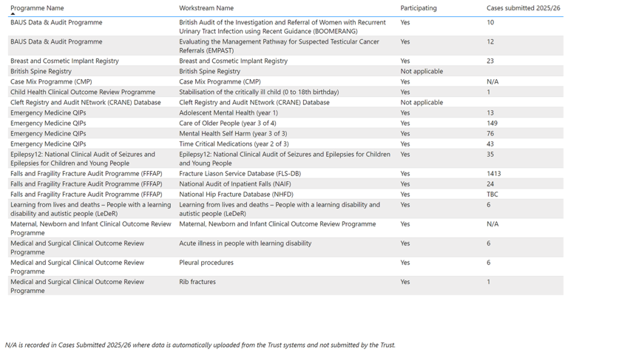

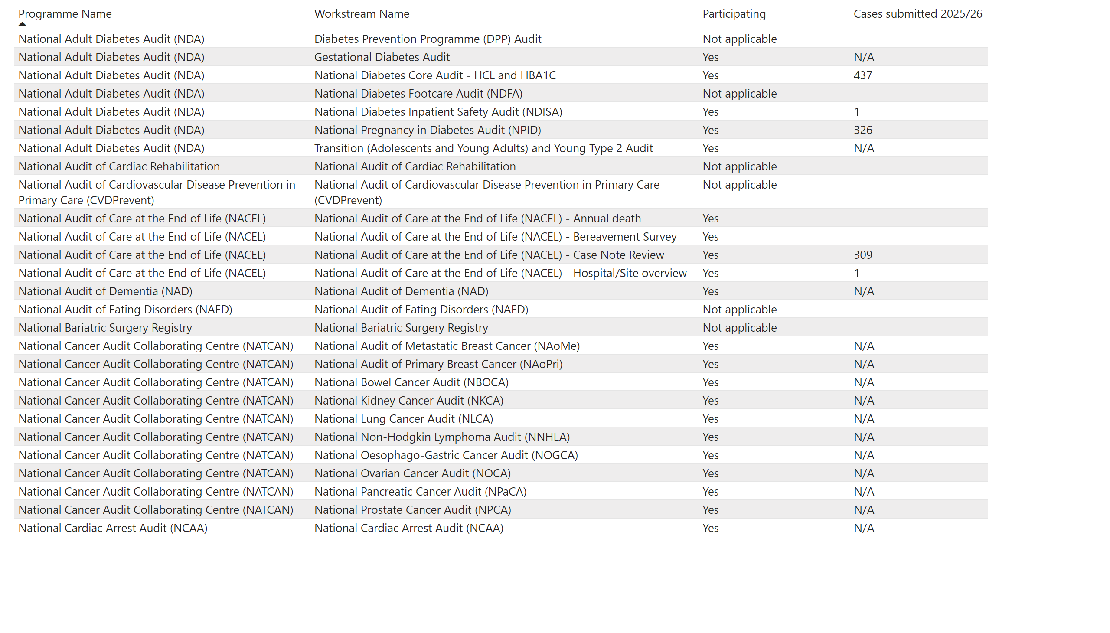
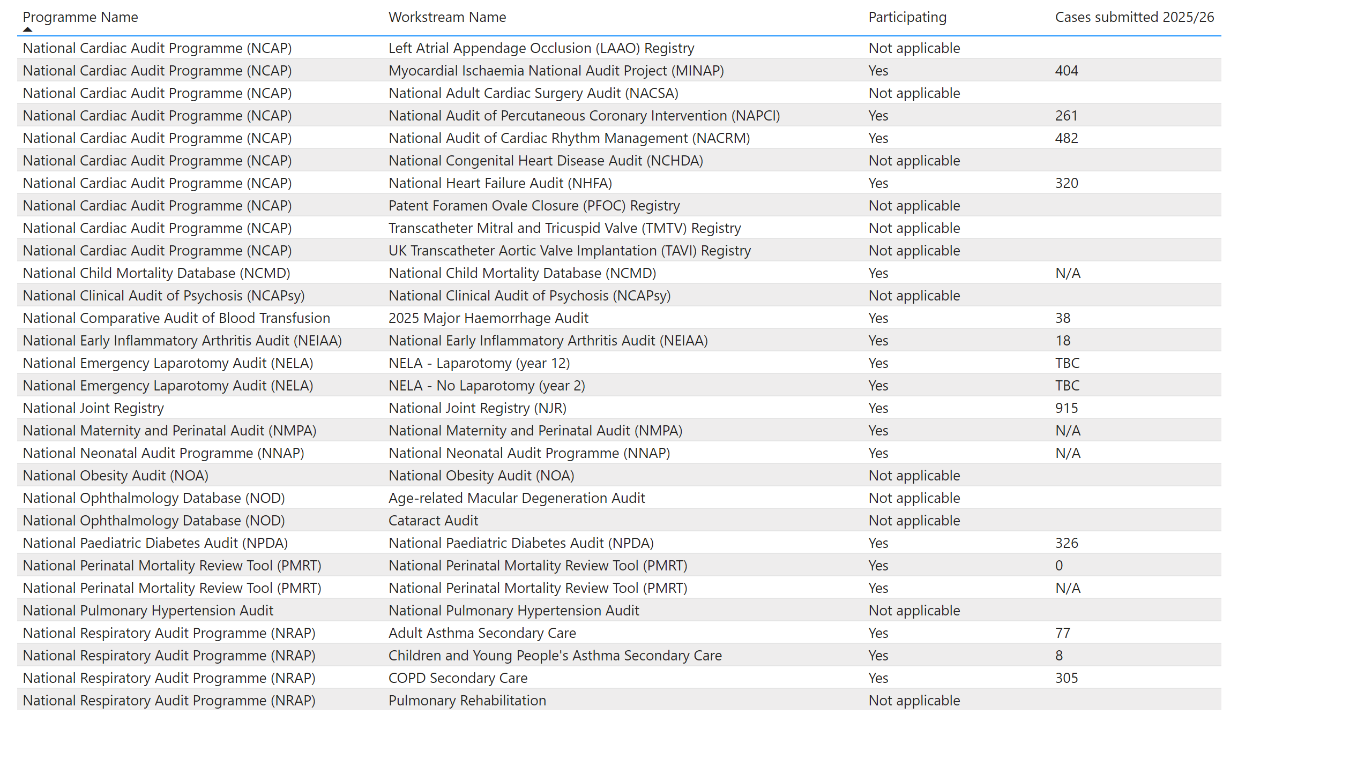
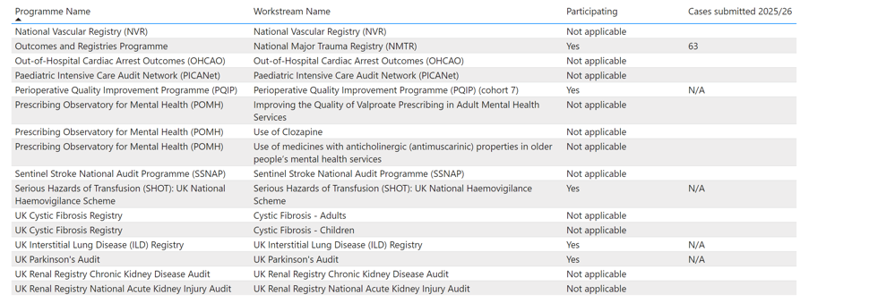

National Confidential Enquiry into Patient Outcome and Death (NCEPOD)
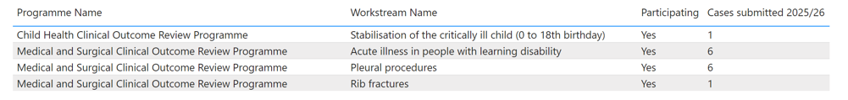

Glossary
Acronym Meaning
ASSKING Assess Risk, Skin assessment and skin care, Surface selection and use, Keep patients moving, Incontinence assessment and care, Nutrition and hydration assessment/support, Giving information
C-DIFFICLE Clostridium difficile
CNST Clinical Negligence Scheme for Trusts
CO Carbon monoxide
CQC Care Quality Commission
CQUIN Commissioning for Quality and Innovation
CRASH CRASH Bundle C= call bell, R= Review medication, A= Appropriate equipment, S = shoes (appropriate footwear), H= Hypotension (postural)
DATIX National Risk Management and reporting system
DQ Data Quality
E.coli Escherichia coli
ED Emergency Department
EoLC End of Life Care
FFT Friends and Family Test
FGR Fetal growth restriction
GRAM Gram-negative bloodstream infections
HSMR Hospital Standardised Mortality Ratio
IPC Infection Prevention and Control
KPI Key Performance Indicator
LeDER Learning Disabilities Mortality Review Programme
MRSA Methicillin-Resistant Staphylococcus Aureus
NCAA National Cardiac Arrest Audit
NELA National Emergency Laparotomy Audit
NHSI National Health Service Improvement
NIHR National Institute for Health Research
NRLS National Reporting and Learning System
PALS Patient Advice and Liaison Service
PAS Patient Administration System
PHSO Parliamentary and Health Service Ombudsman
PPE Personal Protective Equipment
PST Patient Safety Team
QIP Quality improvement project
RADG Resuscitation and Acute Deterioration Group
RTT Referred to Treatment
SHMI Summary Hospital Level Mortality Indicator
SJR Structured Judgement Review
SUS Secondary Uses service
UTI Urinary tract infection
VTE Venous Thromboembolism
Medway NHS Foundation Trust
Medway Maritime Hospital
Windmill Road
Gillingham
Kent
ME7 5NY
Tel: 01634 830000
www.medway.nhs.uk


